
HOT MELT EXTRUSION
AN EMERGING DRUG DELIVERY TECHNOLOGY OF 21st CENTURY

Rashid Mahmood, MSc. Analytical Chemistry, MS Total Quality Management

General Manager Technical Operations
SURGE Laboratories Private Limited Pakistan.

ABSTRACT

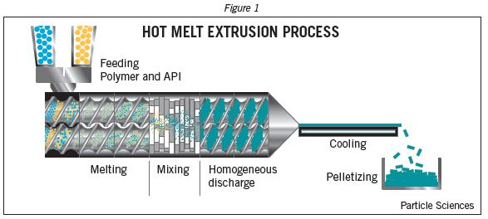
Recent Publications:
- Himanshu K. Solanki (2015) HOT MELT EXTRUSION: AN EMERGING TECHNOLOGY IN PHARMACEUTICALS 404-423.
- Mohammed Maniruzzaman (2012) A Review of Hot-Melt Extrusion: Process Technology to Pharmaceutical Products 10.5402/2012/436763.
- Mr. Sandeep Singha (2011) Hot Melt Extrusion Technique 2046-1690.
- Pramod S. Jagtap (2012) Hot melt extrusion technology, approach of solubility enhancement: A brief review 4 (1):42-53.
- Rina Chokshi (2004) Hot-Melt Extrusion Technique: A Review 3: 3-16.

Hot melt extrusion (HME) is emerging technology which is gaining high importance in the pharmaceutical industry as a novel technique for the preparation of various dosage forms and drug delivery systems, for example granules and sustained release tablets. It is a fast growing technology platform that is utilized to solve difficult formulation challenges, primarily in the area of solubilization. Due to fast processing, high degree of automation, absence of solvents, simple and continuous operation and ability to process poorly compactable material into tablet form are some of the main advantages offered over conventional processing by this emerging technique. Applications of HME in pharmaceutical industry continues to grow and recent success of this technique have made it a useful tool of consideration as a drug delivery solution.
The use of hot-melt extrusion (HME) within the pharmaceutical industry is steadily increasing, due to its proven ability to efficiently manufacture novel products. . HME involves the application of heat, pressure and agitation through an extrusion channel to mix materials together, and subsequently forcing them out through a die. Twin-screw extruders are most popular in solid dosage form development as it imparts both dispersive and distributive mixing. It blends materials while also imparting high shear to break-up particles and disperse them. HME extrusion has been shown to molecularly disperse poorly soluble drugs in a polymer carrier, increasing dissolution rates and bioavailability

Biography

Rashid Mahmood has Master Degree in Analytical Chemistry and MS in Total Quality Management. He has 15 years of experience of Pharmaceutical Quality Operations and has participated in many international conferences as a keynote speaker. He has presented various talks in USA, Canada, UK & UAE on Cleaning Validation, cGMP Guidelines, Quality Risk Management, Role of Mass Spectrometry in Pharmaceuticals and on new Drug Delivery Systems.
Currently he is working as a General Manager Technical Operations for Surge Lab.(Manufacturer of Microencapsulated APIs, Liquid & Dry Powder Parentrals) which is the best export oriented company of Pakistan.



Email: rashid.mahmood@surgelaboratories.com, rashid33hfd@gmail.com, Phone: +923006658856

Notes/Comments:

