Targeting active bowel inflammation foci by MAdCAM-1-specific nanoparticles
Truffi Marta, PhD, Department of Biomedical and Clinical Sciences “L. Sacco”, University of Milano, Italy

Abstract
Statement of the Problem: Currently, the evaluation and treatment of inflammatory bowel disease (IBD) commonly relies on aspecific clinical signs of bowel inflammation, while specific targeted devices are still lacking. Mucosal addressin cell-adhesion molecule-1 (MAdCAM-1) has been proposed as a marker of bowel inflammation. It is upregulated on gut endothelium in IBD and is finely related to IBD activity and response to therapy. Here, we investigate a smart nano-platform targeted toward MAdCAM-1 for site-specific nano-theranostics in a preclinical model of IBD.
Methodology & Theoretical Orientation: We coupled anti-MAdCAM-1 antibodies to the surface of manganese oxide nanoparticles, and analyzed nanoconjugate biodistribution and safety in a murine model of IBD, by intravenous injection at the time of early acute phase of the disease.
Findings: Manganese oxide nanoparticles revealed good stability and negligible toxicity toward endothelial cell culture. Twenty-four hours post intravenous administration in colitic mice, fluorescent anti-MAdCAM-1-nanoparticles localized in the inflamed bowel, and specifically accumulated in the proximal part of the colon. By contrast, untargeted nanoparticles were more rapidly washed out. Nanoparticles did not induce histologic lesions in non-target organs.
Conclusion & Significance: Anti-MAdCAM-1-nanoparticles uncovered active bowel inflammation foci, by following the expression pattern of MAdCAM-1 on mucosal vessels. The implementation of this nano-platform for early and specific theranostics applications appears promising for refining clinical care and management of IBD.

Image

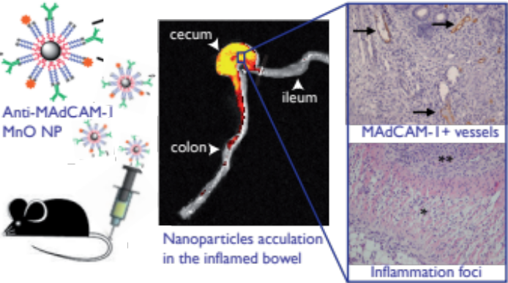
Recent Publications (minimum 5)
- Gomollón F, et al. 3. EUROPEAN Evidence-based consensus on the diagnosis and management of Crohn’s disease 2016: Part 1: Diagnosis and medical management. J Crohns Colitis Sep 22 (2016).
- Biancheri P, et al. Effect of tumor necrosis factor-α blockade on mucosal addressin cell-adhesion molecule-1 in Crohn’s disease. Inflamm Bowel Dis. 19(2), 259-64 (2013).
- Gobbo OL, et al. Magnetic Nanoparticles in Cancer Theranostics. Theranostics 5(11), 1249-63 (2015).
- Reinisch W, et al. 901a A randomized, multicenter double-blind, placebo-controlled study of the safety and efficacy of anti-MAdCAM Antibody OF-00547659 (PF) in patients with moderate to severe ulcerative colitis: results of the TURANDOT study. Gastroenterology 148:S-1193 (2015).
- Na HB, et al. Development of a T1 contrast agent for magnetic resonance imaging using MnO nanoparticles. Angew Chem Int Ed Engl. 46(28), 5397-401 (2007).

 Biography
Marta Truffi has her expertise in nano-biotechnology and cellular biology. Her current research is focused on the study of targeted nanosystems that will provide specific diagnosis and therapy of inflammatory bowel diseases. Her work involves in-depth study of the pathogenesis and identification of novel therapeutic targets, investigation of functional interactions between nanoparticles and cell cultures/tissues, development of in vitro and in vivo experimental models of human diseases, study of nanoparticles biodistribution and systemic toxicity. She is also interested in nanoparticles for breast cancer treatment, by coupling targeted delivery of chemotherapeutics with modulation of cancer-associated miRNAs, in order to improve patients’ responsiveness to therapy.

Email: marta.truffi@unimi.it

