Polymeric nanoparticles for therapeutic siRNA delivery: analysis of tissue-penetration and biological activities in tumor tissue slice cultures and in vivo xenograft models
Achim Aigner, PhD, Leipzig University, Faculty of Medicine, Rudolf Boehm-Institute for Pharmacology and Toxicology, Leipzig, Germany

Abstract
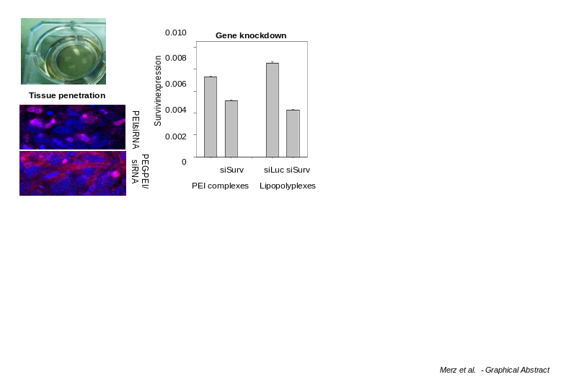
The efficient delivery of small RNA molecules like siRNAs or miRNAs still represents a major hurdle in their therapeutic application for gene knockdown or miRNA replacement. Polymeric nanoparticles e.g. based on low molecular weight polyethyleneimines (PEIs) have been successfully explored, and chemical modifications further increase efficacy and improve biocompatibility. Among those, promising strategies include the modification of PEI with amino acids like tyrosine, yielding low molecular weight Tyr-PEIs (PxY with x = 2kDa, 5kDa, 10kDa), or the combination of PEI-based polyplexes with liposomes, resulting in lipopolyplexes. Both systems demonstrate improved in vitro properties and excellent applicability in vivo, as shown in mouse tumor xenograft models.
The therapeutic success of nanoparticles depends, among others, on their ability to penetrate a tissue for actually reaching the target cells, and their efficient cellular uptake in the context of intact tissue and stroma. Thus, beyond rather artificial tissue culture or rather tedious in vivo models, efficient ex vivo systems closely mimicking in vivo tissue properties are needed.
We have established tumor tissue slice cultures for the analysis of tissue-penetrating properties and biological activities of nanoparticles. As a model system, we employed slice cultures from different tumor xenograft tissues for analyzing modified or non-modified PEI/siRNA complexes and their lipopolyplex derivatives. Excellent tissue preservation was observed for >14 days, thus allowing for prolonged experimentation and analysis. Fluorescence microscopy of cryo-sectioned tissue slices shows different degrees of nanoparticle tissue penetration, dependent on their surface charge. More importantly, the determination of siRNA-mediated knockdown efficacies of endogenous target (onco-)genes reveals the possibility to accurately assess biological nanoparticle activities in situ, i.e. in living cells in their original environment. Thus, we introduce tumor (xenograft) tissue slices for the facile ex vivo assessment of important biological nanoparticle properties in a relevant setting.

Image

Recent Publications
- Merz L, Höbel S, Kallendrusch S, Ewe A, Bechmann I, Franke H, Merz F, Aigner A (2016) Tumor tissue slice cultures as a platform for analyzing tissue-penetration and biological activities of nanoparticles. Eur J Pharm Biopharm. 2016 Nov 15. [Epub ahead of print]
- Ewe A, Panchal O, Pinnapireddy SR, Bakowsky U, Przybylski S, Temme A, Aigner A (2016) Liposome-polyethylenimine complexes (DPPC-PEI lipopolyplexes) for therapeutic siRNA delivery in vivo. Nanomedicine. 13(1):209-218.
- Ewe A, Höbel S, Heine C, Merz L, Kallendrusch S, Bechmann I, Merz F, Franke H, Aigner A (2016) Optimized polyethylenimine (PEI)-based nanoparticles for siRNA delivery, analyzed in vitro and in an ex vivo tumor tissue slice culture model. Drug Deliv Transl Res. 2016 Jun 22. [Epub ahead of print]
- Ewe A, Przybylski S, Burkhardt J, Janke A, Appelhans D, Aigner A (2016) A novel tyrosine-modified low molecular weight polyethylenimine (P10Y) for efficient siRNA delivery in vitro and in vivo. J Control Release. 2016 May 28;230:13-25.
- Ewe A, Schaper A, Barnert S, Schubert R, Temme A, Bakowsky U, Aigner A. Storage stability of optimal liposome-polyethylenimine complexes (lipopolyplexes) for DNA or siRNA delivery (2014) Acta Biomater. 10(6):2663-73.

Biography

Achim Aigner is Professor for Clinical Pharmacology with research interests in the (preclinical) development of novel therapeutic strategies based on small RNA molecules (siRNAs, miRNAs, antimiRs) in oncology. One major focus is on the development and evaluation of polymer-based nanoparticles for in vivo use, including chemical modifications. Systems are tested in various in vitro, ex vivo and in vivo models of solid tumors. To this end, different target genes (established and novel oncogenes) as well as tumor inhibitory miRNAs or the inhibition of oncogenic miRNAs are explored.

Email: achim.aigner@medizin.uni-leipzig.de

