Facile synthesis of L-Cysteine CdTe core shell system and its antioxidants properties.

Daramola A Olamide, MSc, Department of Chemistry, Walter Sisulu University, South Africa

Abstract

L-Cysteine CdTe core and CdTe/CdSe core-shell were successfully synthesized in an aqueous solution medium. The synthesized QDs were analysed using UV-vis absorption spectroscopy and florescence spectroscopy, transmission electron microscope (TEM), Fourier transform infra-red spectra (FT-IR) and X-ray powder diffraction (XRD). Systematic investigations were carried out for the determination of optimal condition namely: reaction times, pH and mole ratios. Compared to CdTe core (529nm), the core shell (601nm) demonstrate a drastic shift in wavelength to the red region proving that as extra material had been deposited unto the surface of the core. The 20, 40 and 60 days stability tests conducted proved that core-shell nanoparticles were quite stable compared to the core material. Investigation was also conducted on the total anti-oxidant capacity (TAC) and lipid peroxidation with the use of six (8) Swiss albino mice and this was done using ferric reducing antioxidant power (FRAP) and TBARS was used to malondi-aldehyde (MDA) concentration. It was discovered that the core-shell demonstrated a poor anti-oxidant property at the heart, spleen, kidney, and brain except at the liver where good anti-oxidant property was demonstrated after 24 and 72 hours of exposure. The result at the testis was not significant as against the control. Since this reaction did not involve the use of a nitrogen atmosphere nor special Ligand or buffer solutions, it suggests that the process could be easily operated on an industrial scale

Image

E
D
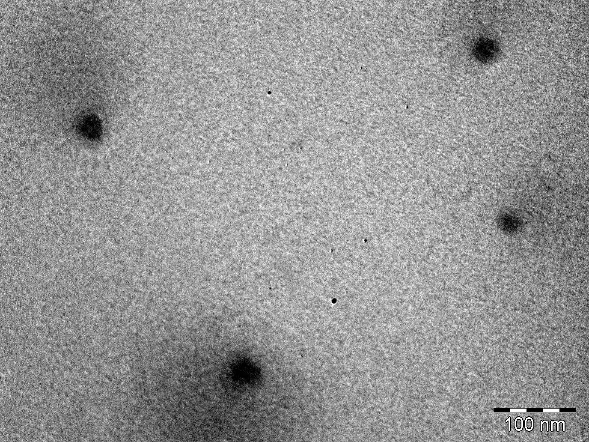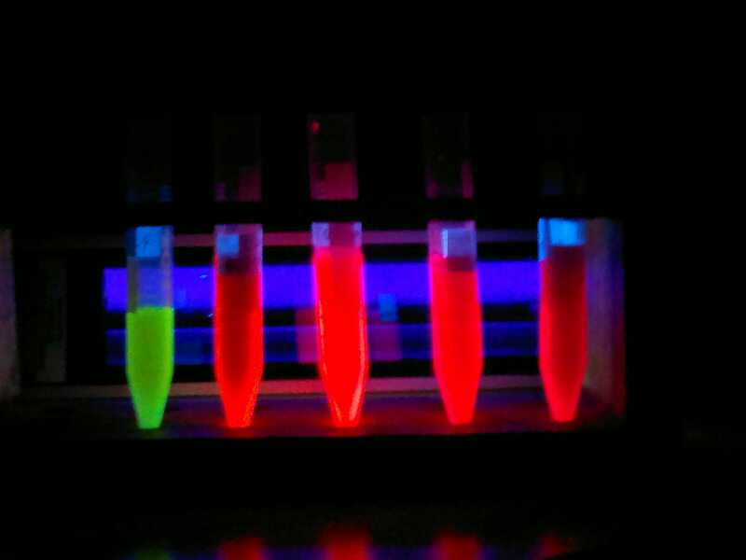
Figure 1:

A and B represent the UV and PL spectra for L-Cysteine-CdTe core at pH=11.0, while C demonstrate the Pl emission spectra of L-Cysteine-CdTe/CdSe core shell at 1:1 of Te/Se The shift in wavelength can be observed between 3 hrs CdTe core and 0 mins CdTe/CdSe core-shell.. The TEM image for L-Cysteine-CdTe/CdSe core-shell can be represented by image D while
the emission colours of the QDs can be represented by Image E .

Recent Publications:

- Oluwafemi, O.S., Daramola, A.O., Ncapayi, V. 2014. A facile synthesis of type II water soluble CdTe/CdSe core-shell nanoparticles. Material letters, 113, 9-13 (online)
- Daramola A.O, Noundou Siwe X, Krause R.W.M, Marks J.A. 2017. Facile Synthesis of Glutathione-l-Cysteine Co-Capped CdTe Core Shell System: Study on Optical and Structural Morphology. Journal of nano-science and nanotechnology, 17, 1-7. (Accepted) Manuscript)

.

Daramola Abiodun Olamide is a material scientist that specializes in the synthesis of nano-materials known as quantum dots. His passion is the applicability of these materials in drug delivery system which helps to mitigate the effects of some current epidemic diseases such as tuberculosis and cancer killing people every day. This has been achieved through the discovery of suitable method together with the unique optical and photo-physical properties produced by these materials. This process can succefully lead to the production of a simple drug model which can be used in out modern day society and recommended for large scale Industrial purposes..
truelamm@yahoo.com


