

Disubstituted Pyrazoles a New Class of Hsp90 Inhibitors in Hepatocellular Carcinoma
Samy Mohamady
Department of Pharmaceutical Chemistry, Faculty of Pharmacy, The British University in Egypt, Al-Sherouk City, Cairo-Suez Desert Road, 11837, Cairo, Egypt.

Although hepatocellular carcinoma (HCC)-related mortality has increased over the past decades, treatment options are still very limited, underlining the need for developing new therapeutic strategies. The molecular chaperone Hsp90 plays a key role in post-translational maturation of many oncogenic client proteins that are important for survival and proliferation of cancer cells. Thus, inhibitors of Hsp90 are promising targets for many cancer types. In this study, 15 diarylpyrazole compounds were screened against MCF7 and HepG2 cell lines. Compound 8, which contained a thiophene group, demonstrated the highest antiproliferative activity against HepG2 cells having an IC₅₀ of 0.083 μM. Four additional diarylpyrazoles, each containing a thiophene group, were prepared and screened for antiproliferative activity. None of these four compounds exhibited superior activity to compound 8 on HepG2 cells. Therefore, compound 8 was selected for further in vitro assays. Cell cycle arrest was observed at the G2 phase in compound 8-treated cells. Compound 8 also caused a 7.7-fold increase in caspase-3. These results confirm the apoptotic effect of compound 8 on HepG2 cells. Moreover, compound 8 inhibited HSP90 (IC₅₀ = 2.67±0.18 µM) in an in vitro assay and caused a 70.8% reduction in HSP90 levels in a cell-based HepG2 assay. Additionally, compound 8 caused significant reduction in the levels of HSP90 client proteins (Akt, c-Met, c-Raf, and EGFR) and a 1.57-fold increase in HSP70. Compound 8 induced inhibition of client proteins and increase in Hsp70 further confirmed the inhibition of Hsp90. Molecular docking studies were also performed to predict the binding mode of compound 8 and followed by molecular dynamics simulations to give further insights into the binding mode of 8.
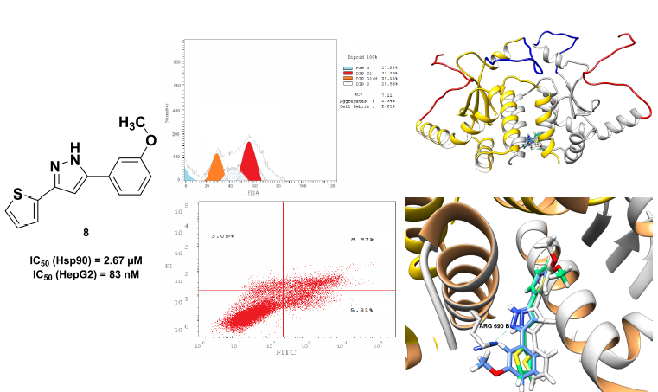

Biography
Dr. Samy Mohamady has obtained his B.Sc. Pharmacy (Honours), Tanta University Egypt. M.Sc. Bioorganic Medicinal Chemistry 2005, Department of Chemistry Dalhousie University, Canada. Master’s thesis title: “An Improved Method for the Synthesis of Nucleoside Triphosphate Analogues” Ph.D. Bioorganic Medicinal Chemistry 2013, University of Waterloo, Canada. Thesis title: “Synthesis of nucleoside polyphosphates and their conjugates”. He is currently assistant professor at the Department of Pharmaceutical Chemistry, The British University in Egypt. Dr. Mohamady’s main interests are drug discovery, medicinal chemistry as well as development of novel synthetic reaction methodologies.

Presenting author details
Full name: Samy Mohamady Mohamady Ahmed
Contact number: Mobile phone: 00201065667596
email: samy.mohamady@bue.edu.eg
Session name/ number: Medicinal Chemistry
Category: Oral presentation

