Evaluation of antioxidants in protein formulation against oxidative stress using various biophysical methods
Shavron Hada, MS, Vijayadeep Laboratories Ltd., Nepal.

Abstract
To evaluate the biophysical stability of protein as a result of oxidative stress, hydrogen peroxide (H₂O₂) was used to induce non-site-specific protein oxidation. Various biophysical analysis methods were utilized including RP-HPLC, DSC, DLS, and CD. Chicken egg white lysozyme was chosen as a model protein and three different antioxidants (ascorbic acid, N-acetyl-L-cysteine, and L-methionine) were selected to observe their effect. Significant increase in hydrodynamic size of protein molecules, decrease in the propensity of α-helix, and increase in β-sheet content evident with increasing H₂O₂ concentration and temperature suggested methionine residues as the most probable site of oxidation. Among the three different anti-oxidants, methionine proved superior in suppressing protein oxidation with its increasing concentration. As an antioxidant, methionine reacted with H₂O₂ to form methionine sulfoxide, which aided in decreasing the concentration of oxidant in the solution to react with the methionine residues in the protein. Additionally, the hydrodynamic size of methionine containing protein exposed to oxidation was retained when incubated at 40°C even after 14 days with unchanged unfolding transition temperature (T_{m}) compared to the reference. In contrast, RP-HPLC revealed oxidation alterations when the same samples were stored at 40°C, highlighting the significant impact of temperature on oxidation kinetics. N-acetyl-L-cysteine and ascorbic acid were relatively less protective than methionine. The hydrodynamic size of the protein was increased with decreasing T_{m} compared to the reference. In conclusion, methionine was a superior antioxidant, implicating amino acids as a promising component in the protein formulation for the suppression of protein oxidation.
Image
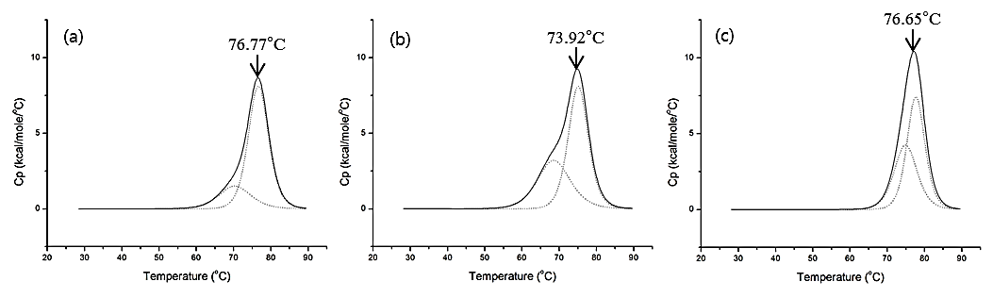

References
- M. Manning, D. Chou, B. Murphy, R. Payne, D. Katayama, Pharm Res, 27 (2010) 544-575.
- R. Torosantucci, C. Schöneich, W. Jiskoot, Pharm. Res. 31 (2014) 541-553.
- J. Bolobajev, M. Trapido, A. Goi, Chem. Eng. J. 281 (2015) 566-574.
- R. Chaudhuri, Y. Cheng, C.R. Middaugh, D.B. Volkin, AAPS J., 16 (2014) 48-64.
- R. Chaudhuri, Y. Cheng, C.R. Middaugh, D.B. Volkin, AAPS J., 16 (2014) 48-64.



Biography

Shavron Hada has done her Master’s degree focused in Pharmaceutical sciences from Dongguk University, Korea. She has gained an expertise in protein pre-formulation studies during her Master’s degree study in Korea. Along with that, she also got a chance to work with the pre-formulation study of antibody drug conjugates, siRNA and insulin nasal spray in the same university. Currently she has been working as a production incharge in Vijayadeep Laboratories Ltd., one of the oldest manufacturers of therapeutic drugs in Nepal, in the form of tablets and capsules.
- Full Name: Shavron Hada
- Personal Email: shavron.hada@gmail.com
- Mobile No.: 00977-9841282568
- Linked in: https://www.linkedin.com/in/shavron-hada-462149b0/
- Facebook: https://www.facebook.com/shavron
- Session Name/ Number: Formulations and NDDs
- Category: Poster presentation
- D.O.B :11th March, 1991
- Postal address: Deepawali Marga, House no. 282, Satdobato-15, Lalitpur, Nepal.

