Development of a Rejuvenating Formulation Using Rosehip Oil
Heyam Saad Ali, Pharmaceutics, Dubai Pharmacy College, Dubai, UAE.

Abstract (300 word limit)
Every woman all over the world is obsessed to attain beauty an all ages in her life. However, the health implications that may result from the chronic use of toxic additives present in cosmetic products, urge the consumer to go for herbal cosmetic products [1]. Therefore, the aim of this study to develop and evaluate the beneficial effects of rose hip oil (ROP) topical formulation in the suitable cream.
Therefore, the aim of this study to develop and evaluate the beneficial effects of rose hip oil.
“Rosa mosqueta” or “Rosehip”, is a generic name which covers about 70 different species of plants of the genus Rosa, as Rosa rubiginosa, Rosa moschata and Rosa canina [2]. In the cosmetic field, the RHO has been used for decades due to transretinoic acid or natural tretinoin (between 0.01% and 0.1%) [3]. The emollient properties of the oil has been attributed to its high content of essential fatty and unsaturated acids, polyunsaturated fatty acid highlights: linoleic acid (54%), linolenic acid (17%) and oleic acid (16%) [4].

The method involves 1- preparation of Rose hip oil (ROP) (1%) in different different concentrations (0.5,1.0, and1.5)%. 2- The evaluations of all formulations (F1 to F3) were done on different parameters like pH, Viscosity, good consistency, homogeneity, appearance spreadibilty and stability. All formulations shows no redness, edema, inflammation and irritation during irritancy. However, formulation F3 was slightly better than the other formulations in the extent of photo protection, permeability and moisturizing abilities [5].
Rose hip oil (ROP) in 1% formulations were efficient, stable and safe to use for skin as a multipurpose cosmetic product in skin hydration, sun protection, anti-aging and rejuvenating product. According to the findings this study is promising to further clinical studies.

Biography
Prof. Heyam Saad Ali has completed her PhD from Bradford University, UK. She is Head of Pharmaceutics Department, Dubai Pharmacy College, UAE. She has teaching and research experience of about 25 years. She has published more than 44 papers in reputed journals and has been serving as an editorial board member of several pharmaceutical Journals. She is a member of various pharmaceutical associations. In addition to attending more than 40 training courses, conferences and seminars in Quality Assurance systems.
Prof. Heyam 's expertise ranges from Preformulation, Product formulation, product testing and Stability, Quality Control, Assurance and GMP processes, validation in Pharmaceutical development of conventional dosage forms.
.
Email: heyam57@hotmail.com
Notes/Comments

Table-1 Physical Properties
Codes | Time Sec. | V | SP  (gcm/sec) | S | CH | W | pH
F1 | 11 | 632.58 | 12.78 | NS | NO | W | 5.9
F2 | 10 | 613.76 | 11.12 | NS | NO | W | 5.7
F3 | 10 | 612.30 | 10.84 | NS | NO | W | 6.1
Marketed | 9 | 602.35 | 10.12 | NS | NO | W | 5.9
V:Viscosity, SP:spreadability, S:sensitivity, CH:Color Change, W:Washability

Fig.1 SPF determination-Transmission spectroscopy. Range 290nm-400nm

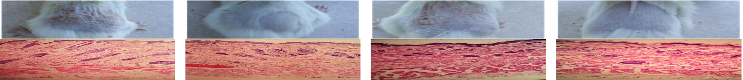 | 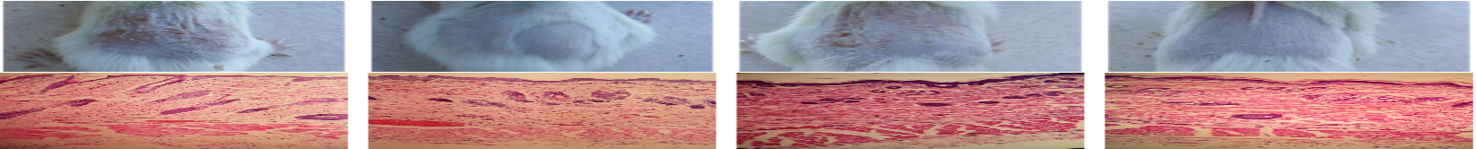 | 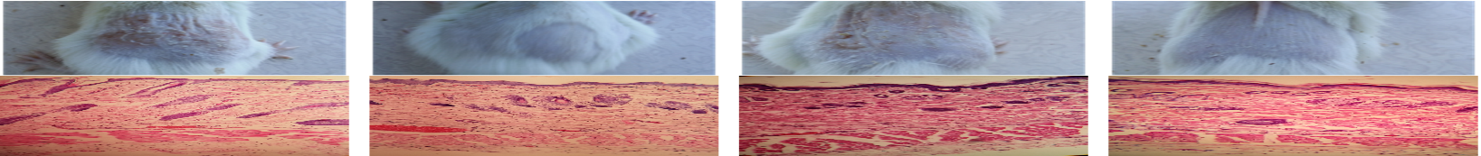 | 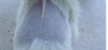
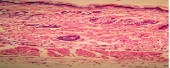 | 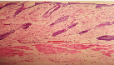 | 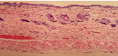 | 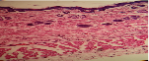

Fig. 2 The epidermal of skin size of different rehydration creams

References:

- Darbre, et al., “Concentrations of Parabens in Human Breast Tumours,” Journal of Applied Toxicology Vol. 1, January-February 2004, pp. 5-13.
- Dogan, A. and Kazankaya, A. (2006) Properties of Hose Hip Species Grown in Lake Van Basin (Eastern Anatolia Region). Asian Journal of Plant Sciences 5, 120-122. http://dx.doi.org/10.3923/ajps.2006.120.122
- Valladares, J., Palma, M., Sandoval, C. and Carvajal, F. (1986) Cream Hip Oil (Rosa aff. rubiginosa I.). Part I: Formulation, Preparation and Primary Application in Tissue Regeneration. Annals Real Acad Farm., 52, 597-612.
- Santos, J.S., Vieira, A.B. and Kamada, I. (2009) The Rosehip Not Open Wounds Treatment: A Review. Revista Brasileira de Enfermagem, 62, 457-462.
- Steiling, W.; Basketter, D.; Berthold, K.; Butler, M.; Garrigue, J.-L.; Kimber, I.; Lea, L.; Newsome, C.; Roggeband, R.; Stropp, G.; et al. Skin Sensitisation Testing—New Perspectives and Recommendations. Food Chem. Toxicol. 2001, 39, 293–301.

