Development of Spectrophotometric Methods for the Analysis of

Nicotinamide in Bulk and Dosage Forms
NOON A.A. KAMIL, SHAZA W. SHANTIER, ELRASHEED A. GADKARIEM

Abstract (300-word limit)
This study was aimed to develop simple, sensitive and accurate zero(0D), first (1D) and second (2D) order derivative spectrophotometric methods for the analysis of nicotinamide in bulk and dosage forms. Methods: The zero-order spectrum of nicotinamide aqueous solution was measured at 262 nm against its blank. This spectrum was differentiated instrumentally to generate the first and second derivative spectra which were measured at 272 nm and 278 nm, respectively. The developed methods were validated as per ICH guidelines.The absorbance ratio of nicotinamide absorbance values at 214 nm and 262 nm was also determined. Regression data of the developed methods obeyed Beer’s law over the concentration range 10-50 μg/ml with a good correlation coefficient (not less than 0.998). The developed methods demonstrated good inter-day and intra-day precision at the three modes.
The obtained recovery percentage (99.2 ± 2.6%, n=3) reflected freedom from interference by the excipients. The absorbance ratio for nicotinamide at 214 nm and 262 nm was found to be in the range between 2.8- 3.2 which can be used as identification test for Nicotinamide (qualitative analysis). Conclusion: The statistical validation at 95% confidence level proved the sensitivity, accuracy and precision of the developed methods

Image
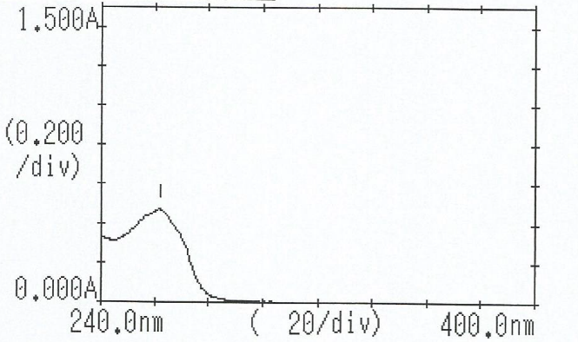

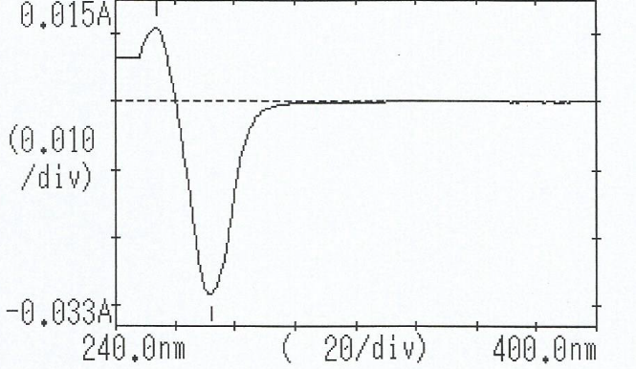
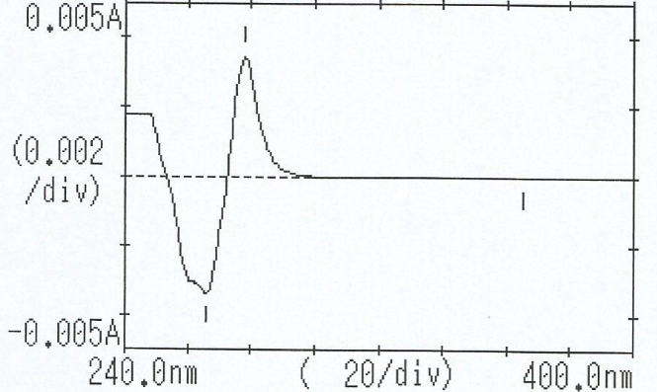
Figure 1-3: ²D, ¹D, ⁰D spectrum of NIC solution (20 µg/ml)

Recent Publications (minimum 5)
- Noon K, Shaza S, Elrasheed G (2018) Development of Spectrophotometric Methods for the Analysis of Nicotinamide in Bulk and Dosage Forms. International journal of pharmaceutical research and bio-sciences Volume 7(3): 1-10.
- Elrasheed G, Noon K, Al Obeid H (2009) A new spectrophotometric method for the determination of methyldopa. Saudi Pharmaceutical Journal 17, 289– 293

 Biography (150-word limit)
Noon Kamil has her expertise in pharmaceutical chemistry drug analysis and passion in research and pharmacy education. Her research on drug analysis creates new methods of drug analysis using simple and accurate ways. She has more than ten years of teaching pharmacy students.
Email: noonkamil@gmail.com
Phone: +971557920470

Note: Speaker biography, photograph and abstract related image are mandatory*

