Design, synthesis and biological evaluation of new anti-IPF agents
Lingyu Li, IMPLAD, Chinese Academy of Medical Sciences & Peking Union Medical College, Beijing, China

Abstract (300-word limit)

Statement of the Problem: Idiopathic pulmonary fibrosis (IPF) is a severe life-threatening disease with very poor prognosis. IPF patients die within 3 to 5 years after diagnosis mostly due to respiratory failure. To date only 2 small molecule drug (Pirfenidone and Nintedanib) were approved by FDA for IPF treatment, yet they treatment outcome were far from promising. There is an urgent need for novel anti-IPF agents. Methodology & Theoretical Orientation: Matrine and cinnamic acid was rationally hybrid by amidation reactions. An in vitro anti-fibrotic agent screening model was established based on TGF-β1 induced human fetal lung fibroblast (MRC-5) myofibroblast transformation. Extracellular total collagen accumulation was quantified by Picro-Sirius Red staining. Transient fibroblast and myofibroblast markers (ACTA2, COL1a1, FSP-1, FAP and P-4-H) expression was determined by immunocytochemistry (ICC) methods. Findings: 46 novel matrine-cinnamic acid hybrid compounds were synthesized and evaluated for their anti-fibrotic activity. 10 ng/mL TGF- β1 significantly induces myogenetic phenotype formation with elevated extracellular total collagen accumulation and myofibroblast markers expression. Pretreatment of matrine-cinnamic acid hybrid alleviated TGF- β1 induced myogenic transformation. Conclusion & Significance: Compound 3i exhibited an inhibitory effect against TGF- β1 induced total collagen accumulation in MRC-5 fibroblast with the IC₅₀ value of 1.2 μM, which was about 2000 times more potent then Pirfenidone.
Image

3i alleviated TGF-b1 induced extracellular collagen accumulation

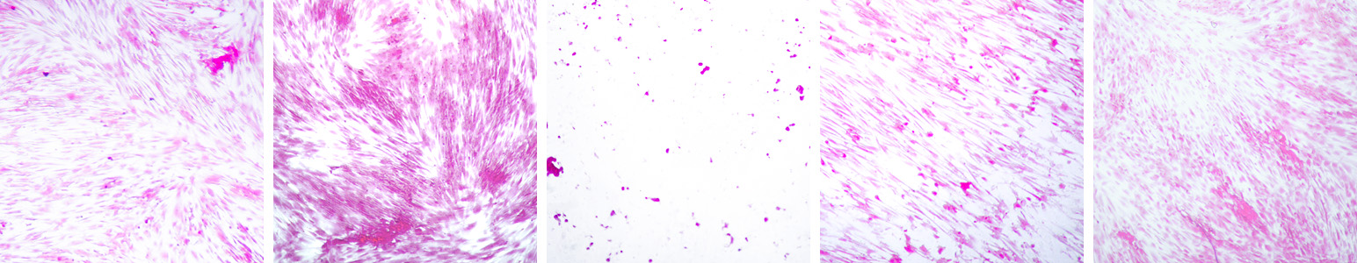
Recent Publications (minimum 5)
TGFβ1 0ng/mL
TGFβ1 10ng/mL
TGFβ1 10ng/mL + 3i
- Zhu YD, Chen RC, Wang H, Jiang H, Huang XL, Zhang ML, Li LY (2018) Two new flavonoid–triterpene saponin meroterpenoids from Clinopodium chinense and their protective effects against anoxia/reoxygenation-induced apoptosis in H9c2 cells. Fitoterapia 128:180-186.
- Chen JH, Zhang T, Zhang QB, Liu Y, Li LY (2018) Isobutylhydroxyamides from Sichuan Pepper and Their Protective Activity on PC12 Cells Damaged by Corticosterone. Journal of Agriculture and food chemistry 66:3408-3416.
- Shi LY, Li LY (2017) Total synthesis of natural spiro-trisindole enantiomers similisines A, B and their stereoisomers. Tetrahedron Letters 54:1934-1938.
- Zhou Y, Li LY (2017) Chemical constituents from the whole plants of Pilea cavaleriei Levl subsp. cavaleriei. Fitoterapia 119:100-107.
- Si JG, Sun HL, Zhang T, Zhang QB, Wang MH, Chen JH, Lingyu L (2017) Two new unsaturated fatty acids from the whole plant of Pothos chinensis. Journal of Asian Natural Products Research 19:1102-1107.

 Biography (150-word limit)
Lingyu Li is a PhD candidate dedicated in structural modification of bioactive natural products. In searching for novel and promising anti-IPF agents, he has achieved a IPF agent library of more than 100 compounds by semisynthetic methods and established a novel rapid IPF agent screening model.
Email: 3143891566@qq.com
Phone: +86-138-1164-8614

Note: Speaker biography, photograph and abstract related image are mandatory*

