Floating Polymeric Microspheres for the Delivery of Artemether / Lumefantrine

Oluwatoyin A Odeku, Department of Pharmaceutics & Industrial Pharmacy, Faculty of Pharmacy, University of Ibadan, Ibadan, Nigeria

Abstract (300 word limit)
Statement of the Problem: Malaria, an infectious disease caused by the Plasmodium genus, continues to be one of the highest causes of morbidity and mortality in the developing world. Malaria affects 3.3 billion people in the world and is the cause of death of approximately 438,000 deaths in 2015, particularly in sub-Saharan Africa, where approximately 90 % of deaths occur. Although many drugs are commercially available for use in malaria infection, the alarming emergence of multidrug-resistant strains of Plasmodium falciparum have raised an urgent need for new drugs or more efficient delivery systems. The World Health Organization (WHO) recommends the use of artemisinin-based combination therapy (ACT) for uncomplicated P. falciparum malaria. Artemether-lumefantrine was the first co-formulated ACT but the complex dose regimen has compromised adherence, and about 60-70% of the drug molecules are absorbed due to poor solubility and low permeability following oral administration. The purpose of this study is develop floating gastroretentive microspheres for the improved delivery of arthemether/lumefantrine using different polymers to prolong the gastric residence time and improve drug absorption after oral administration. Methodology & Theoretical Orientation: Arthemether/lumefantrine microspheres were prepared by ionic gelation method using different grades of sodium alginate and carrageenan, and their combinations as polymers, calcium chloride (2%w/v) as chelating agent and sodium bicarbonate (2%w/w) as gas releasing agent to impart buoyancy. Findings: Spherical discrete microspheres with size ranging from 0.84 to 1.74µm were obtained with floating lag time < 5 min and drug entrapment efficiency (DEE) of 35 to 70 %w/w. The size, DEE, swelling, buoyancy and drug release from the microsphere depended on polymer type and viscosity. Conclusion & Significance: Formulation of floating gastroretentive microspheres could provide a more efficient delivery system for arthemether/lumefantrine the treatment of malaria.

Image

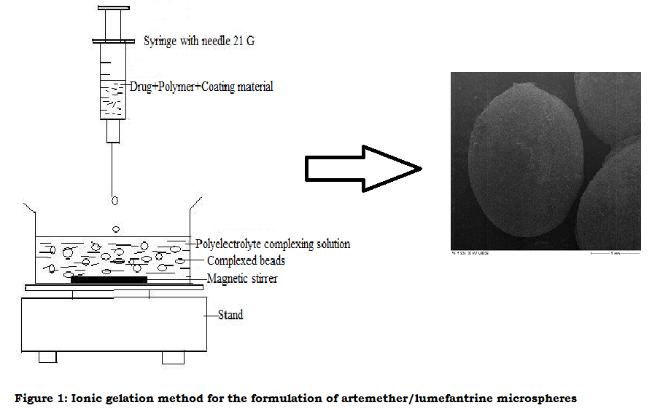
Recent Publications (minimum 5)
- WHO. World malaria report 2015. Geneva: World Health Organization; 2015.
- World Health Organization, WHO (2010) Guidelines for the treatment of malaria, 2nd ed Geneva, Switzerland WHO. Available: http://www.whqlibdoc.who.int/publications/2010/9789241547925_eng.pdf.
- Makanga M, Krudsood S. (2009) The clinical efficacy of artemether/lumefantrine (Coartem), Malar J 8 ( Suppl 1): 5
- Murray CJ, Ortblad KF, Guinovart C, Lim SS, Wolock TM, Roberts DA, et al. (2014) Global, regional, and national incidence and mortality for HIV, tuberculosis, and malaria during 1990–2013: a systematic analysis for the Global Burden of Disease Study 2013. Lancet. 384: 1005–70.
- Ma Y, Lu T, Zhao W, Wang Y, Chen T, Mei Q, Chen T (2014) Enhanced Antimalarial Activity by a Novel Artemether-Lumefantrine Lipid Emulsion for Parenteral Administration. Antimicrob. Agents Chemother. 58 (10): 5658-5665

 Biography (150 word limit)
Oluwatoyin A. Odeku is a pharmacist with expertise in drug delivery, dosage form design and development of indigenous as pharmaceutical excipient for novel drug delivery systems. She has built a career in teaching, research and administration. She is the current Dean of the Faculty of Pharmacy at the University of Ibadan, Nigeria. She utilizes her knowledge of pharmaceutics in the formulation of medicinal plants into conventional dosage forms.
Email: pejuodeku@yahoo.com; o.odeku@ui.edu.ng
Phone: +234 805 732 0466

Notes/Comments:

