Spectroscopic Analysis and Antimicrobial Studies for Novel Metal Oxytetracycline Drug Complexes

Ragab R. Amin, Alaa A.A. Anwar and Mohammed E.M. Hassouna
ª Basic Science Department, Faculty of Engineering, Nahda University, Egypt ragab.amin@nub.edu.eg
^{b} Central research laboratory, Nahda University, Beni-Sueif, analytical chemistry department, Egypt
^{c} Department of Chemistry, Faculty of Science, Beni-Sueif University, Egypt

Abstract The 1:1 and 2:1 M ratio metal complexes of new Cu(II), Co(II), Fe(III), Zn(II) and Zr(II) complexes of Oxytetracycline hydrochloride have been synthesized. Attempts have been made to ascertain their probable structures on the basis of elemental analysis, spectra (IR, Electronic) and NMR studies. The ligand forms a complexes in a molar ratio 1:1 having an empirical formula (MLSO₄.nH₂O) and 2:1 molar ratio having an empirical formula (M₂LSO₄.nH₂O) where M = Cu(II), Co(II), Fe(III), Zn(II) and Zr(II), L = Oxytetracycline and n = 2 – 6. The infrared spectral data and proton magnetic resonance studies were support the postulate that Oxytetracycline reacts with metal ions as an ionic bidentate ligand through its carboxylate oxygen and the amide carbonyl oxygen. Drug compounds are biologically active, these compounds have become of interest to be studied biologically, and compared their activities against four species of bacteria (Staphylococcus aureus, Bacillus subtilis, Escherichia coli, Pseudomonas aeruginosa), and two fungal species (Aspergillus flavus and Candida albicans). 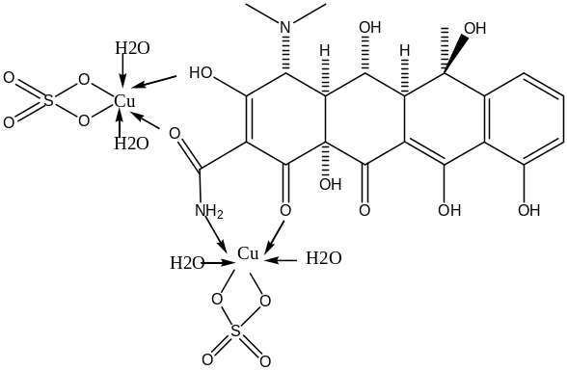

Recent Publications

- Moamen S Refat, H. M A Al-Maydama, F.Al-Azab, Ragab R Amin, Yasmin M S Jamil, Synthesis, thermal and spectroscopic behaviors of metal-drug complexes: La(III), Ce(III), Sm(III) and Y(III) amoxicillin trihydrate antibiotic drug complexes, Spectrochimica Acta Part A Molecular and Biomolecular Spectroscopy 03/2014, 128C:427-446.

- Moamen Refat, Ragab R. Amin, Yasmine Jameel, Fathi Al-Azab and Hussen Mudam, Synthesis and in Vitro Microbial Evaluation of La(III), Ce(III), Sm(III) and Y(III) Metal Complexes of Vitamin B6 Drug. Spectrochimica Acta Part A: Molecular and Biomolecular Spectroscopy, 127, 196-215.

- Moamen Refat, Fathi Al-Azab, Hussen Mudamma, Ragab R. Amin, Yasmine Jameel, Preparation, spectroscopic and thermal characterization of new La(III), Ce(III), Sm(III) and Y(III) complexes of enalapril maleate drug. In vitro antimicrobial assessment studies, J. Molecular Structure 1059, 2014, 208–224

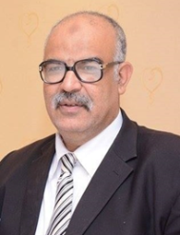
Ragab Amin El-Sakka has been working in Sana’a University. Then from 1992 to 2001 he has been working as an assistant lecturer in Qatar University. He worked as an Associate Prof. and consultant for Dean of post-graduate studies, Faculty of Science, Taif University for 5 years. From 2010 to 2012. He worked as a Vice Dean of Student Affairs for three years. Then he joined the Faculty of engineering as a Full Prof. and Head of Basic Science department in 2012. Since Nov 2016, He is working as a Vice Dean of Faculty of Engineering, Nahda University.
Email:ragab.amin@nub.edu.eg

