Renal targeted oxygen nanocarrier for enhanced chemoresistance renal carcinoma cancer
Zeyang Wang PhD, College of Pharmaceutical Sciences Zhejiang University, China

Abstract (300 word limit)
Renal cell carcinoma (RCC) which is one of solid tumors with intrinsic hypoxia feature is resistant to most chemotherapy and considered to be the most lethal urological cancer. Enhancing expression of efflux pump P-glycoprotein (P-gp) which could recognize various chemotherapeutic drugs associated with chemoresistance in renal carcinoma cancer under hypoxia. To overcome this problem and for efficient chemotherapy, a renal targeted oxygen nanocarrier (CHVNs) is constructed with a polymer crosslinked hemoglobin (HB) and vincristine (VCR) core, coated with chitosan to target renal, utilize Hb to transport oxygen and alleviate hypoxia and inhibit P-gp and enhance efficacy of VCR. iron center of porphyrin induces ferroptosis as supplementary treatment to chemotherap. Results showed that after a course of CHVNs, hypoxia of RCC was alleviated and P-gp was inhibited, and showed ferroptosis characteristics with a high level of lipid peroxidation. The anti-cancer effect of CHVNs was more effective than VCR. This study provided a novel renal targeted oxygen nanocarrier with multi-function to overcome chemoresistance in RCC.

Image
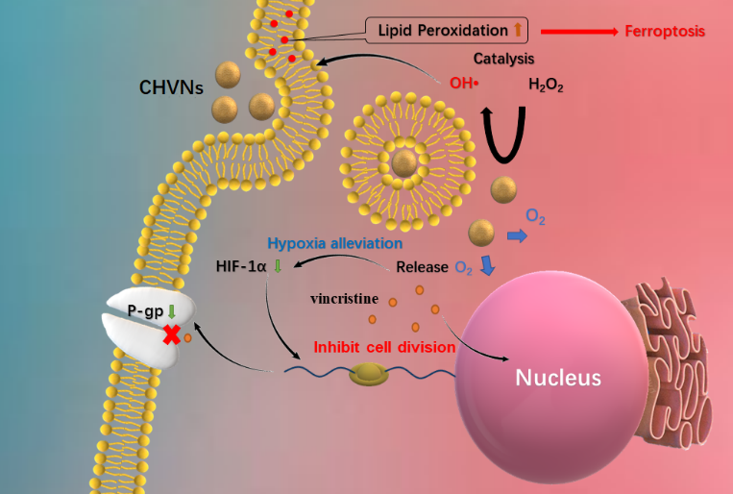
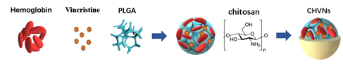
Recent Publications (minimum 5)
- Lu Chen, Zeyang Wang, Qingwen Xu, Yuxi Liu, Le Chen, Suhang Guo, Hua Wang, Kui Zeng, Junqing Liu, Su Zeng and Lushan Yua (2020) The failure of DAC to induce OCT2 expression and its remission by hemoglobin-based nanocarriers under hypoxia in renal cell carcinoma. Theranosticsl.doi:10.7150/thno.39944

 Biography (150 word limit)
Zeyang Wang, Ph.D Candidates, Zhejiang university, CHN. Master of Sicence, University of Sheffield, UK. bachelor of Scienc, Nanjing university of technology, CHN
Email: 11719003@zju.edu.cn

Notes/Comments:

