CYTOTOXIC OXINDOLE DERIVATIVES AS EGFR INHIBITIORS:, PHARMACOPHORE MODELLING AND MOLECULAR DYNAMICS STUDIES
Maadwar Sasikala, Galla Rajitha.
Geethanjali College of Pharmacy, Keesara, Hyderabad, Telangana, INDIA.
Abstract
Statement of the Problem: Epidermal growth factor receptor (EGFR) is one of the over expressed and crucially targeted protein in many solid tumours and is a fascinating target for developing new drugs: Scarcity and need of effective drugs in present therapy: In the current study we have focussed on elucidation of the mechanistic insights of cytotoxic potentials of oxindole derivatives by performing in vitro EGFR inhibition assay of cytotoxic oxindole compounds which are earlier proved for their cytotoxic activity against breast cancer (MCF7) and ovarian cancer (SKVO3) cell lines and performing various molecular modelling techniques such as Docking, Pharmacophore modelling, 3D QSAR and Molecular dynamics studies. Findings: In vitro EGFR inhibition assay revealed that compounds with substantial cytotoxic activity against breast cancer (MCF7) and ovarian cancer (SKVO3) cell lines showed potential EGFR Inhibition. Molecular docking studies against kinase domain of EGFR protein indicated the probable interactions of oxindole derivatives. Pharmacophore modelling studies had identified a pharmacophore model with three hydrogen bond acceptors and three aromatic rings (AAARRR.1003) as a potential model for cytotoxic activity against MCF7 cell lines and validated through 3D QSAR studies resulting in superior regression scores (r² = 0.92, q² = 0.80 and Pearson R = 0.95). Molecular dynamic studies revealed the conformational changes in the EGFR-compound 1b complex and EGFR-compound 1c complex during the 25 ns simulation time frame. Further simulations with longer time period may provide deeper insights of ligand interactions in the protein environment.Conclusion & Significance: Compound 1b has performed potential in vitro EGFR inhibition among the title compounds, which is supported by its molecular dynamics simulations with EGFR protein. Hence it is noteworthy to use compound 1b as a new scaffold for further development of multifunctional compounds.

Image: Pharmacophore Modelling and Molecular Dynamics simulations of Compound 1b

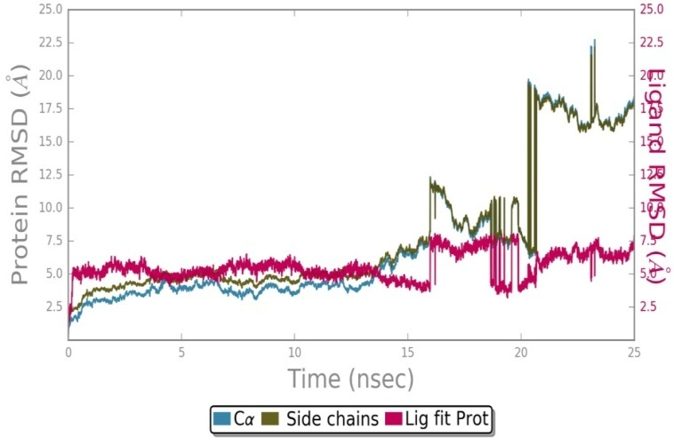

Recent Publications:
- Pulished a paper entitled “Cytotoxic Oxindole Derivatives: In Vitro EGFR Inhibition, Pharmacophore Modelling, 3D-QSAR and Molecular Dynamics Studies.” Maadwar Sasikala, Galla Rajitha. Journal of Receptor and Signal Transduction, December 9, 2019. (Impact Factor: 1.7, Taylor and Francis Publishers).
- Published a paper entitled “Efficient Synthesis And Cytotoxic Screening Of 3,3 Disubsituted Oxindole Derivatives” Maadwar Sasikala, Rajitha Galla, Santhosh G.K. International Research Journal of Pharmacy 2019, 10(4): 190-195.
- Published a paper entitled “A Facile and Efficient Synthesis 3,3-Disubstituted Oxindole Derivatives And Their Cytotoxic Properties.” Sasikala Maadwar, Rajitha Galla, Santhosh G.K. Research Journal in Pharmacy Technology, March 2019 12(3):1091-1095.
- Published a paper entitled “Zinc Mediated Entry To Functionalized 3-Substituted 3-Hydroxyindoline-2-One via A Modified Henry Reaction Of Isatin With Bromonitroalkanes In Aqueous Media” Rajitha Galla and Sasikala Maadwar in Der pharma Chemica, 2018, 10(8):62-66.
- Published a paper entitled Molecular insights of Benzodipyrazole as CDK2 inhibitors: Combined Molecular Docking, Molecular Dynamics, And 3D QSAR Studies. Varun Guttikonda, Divya Raavi, M. Sasi Kala, and Deepak Reddy Gade, in Journal Of Receptor and signal Transduction. 2015, 35(5), 439-449. (Impact Factor: 1.7, Taylor and Francis Publishers).

Biography:

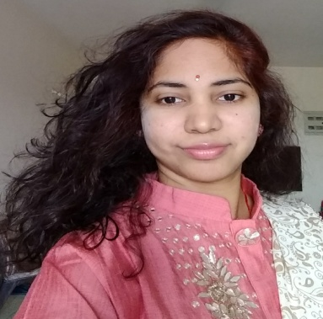

Maadwar Sasikala has submitted her Ph.D thesis entitled Design Synthesis and screening of Novel Heterocyclic compounds to Sri Padmavathi Mahila University Tirupati, currently working as Assistant professor in Geethanjali college of Pharmacy, previously worked as Project Assistant in Indian Institute of Chemical Technology, Hyderabad, India. Published nine research article in reputed Journals and attended and participated in eight National and International conferences.
Mail ID: maadwarsasikala@gmail.com

