Cyanidin-3-rutinoside increases glucose uptake by activating the PI3K/Akt pathway in 3T3-L1 adipocytes

Ji Sook Han ^{a*}, Kyung Ha Choi ^{b}, Hyun Ah Leeª, Mi Hwa Park ^{b}
ªDepartment of Food Science and Nutrition, Pusan National University, Busan 46241, Republic of Korea
^{b}Department of Food Science and Nutrition, College of Medical and Life Science, Silla University, Busan, 46958, Republic of Korea

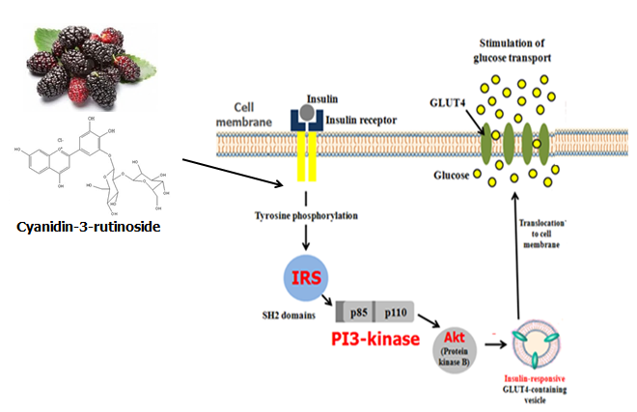
Abstract
Background: Type 2 diabetes is one of the most common and serious metabolic disorder. Disturbance in the insulin receptor signaling pathway is the major factor underlying the development of type 2 diabetes. The IRS-1/PI3K/Akt pathway plays a critical role in the signal transduction by the insulin receptor. Thus, this study investigated that cyanidin-3-rutinoside (C3R) increased glucose uptake by activating the phosphatidylinositol-3-kinase (PI3K)/Akt pathway in 3T3-L1 adipocytes. Results: C3R significantly increased glucose uptake, which was associated with enhanced plasma membrane glucose transporter type 4 (PM-GLUT4) expression in 3T3-L1 adipocytes. The potentiating effect of C3R on glucose uptake and PM-GLUT4 expression was related to enhanced phosphorylation of insulin receptor substrate 1 (IRS-1) and Akt, as well as augmented activation of PI3K in the insulin signaling pathway. C3R induced glucose uptake was inhibited only by the PI3K inhibitor, but not by an AMPK inhibitor in 3T3-L1 adipocytes. Conclusion: These results suggest that C3R likely up-regulates glucose uptake and PM-GLUT4 expression in 3T3-L1 adipocytes by activating the PI3K/Akt pathways. This finding would be beneficial for developing novel agent for the prevention and treatment of diabetes-associated metabolic syndrome.

Image
Figure 1. Increasing effect of C3R on glucose uptake by activating the PI3K/Akt pathway in 3T3-L1 adipocytes.
Recent Publications
- Lin Q, Li X, Li C, Zheng Y, Peng G (2015) 1-Deoxynojirimycin alleviates insulin resistance via activation of insulin signaling PI3K/AKT pathway in skeletal muscle of db/db mice. Molecules 20:21700-21714.
- Kamiloglu S, Serali O, Unal N, Capanoglu E (2013) Antioxidant activity and polyphenol composition of black mulberry (Morus nigra L.) products. J Berry Research 3:41-51.
- Vanhaesebroeck B, Stephens L, Hawkins P (2012) PI3K signaling: The path to discovery and understanding. Nat Rev Mol Cell Bio 13:195-203.
- Bryant NJ, Govers R, James DE (2002) Regulated transport of the glucose transporter GLUT4. J Mol Cell Biol 3:267-277.
- Khan AH, Pessin JE (2002) Insulin regulation of glucose uptatke: a complex interplay of intracellular signaling pathways. Diabetologia 45:1475-1483.

Biography
Ji Sook Han is a professor and is doing research on developing a bioactive compound from natural plants, especially seaweeds, and investigating its effect for the prevention and treatment of obesity and type 2 diabetes. The active compound containing in seaweeds may be a good anti-diabetic source by improving insulin secretary defect or insulin resistance. It may also be a potential anti-obesity source owing to its inhibitory effect on adipogenesis. She evaluates the effect and mechanism of a bioactive compound isolated from natural plant through in vitro and in vivo study.

Email: hanjs@pusan.ac.kr

