Optimization of cilostazol crystal habit by impinging jet crystallization
Timea Tari, Pharm.D., University of Szeged, Hungary
Zoltan Aigner, PhD, University of Szeged, Hungary

Abstract

The crystal habit influences the processability of active agents even in pharmaceutical, food or cosmetic industry. The small average particle size, narrow particle size distribution (PSD) and suitable crystal shape of the poorly water-soluble drugs are very important factors in the field of formulation [1; 2]. Cilostazol belongs to the BCS Class II group. Due to its poor aqueous solubility and oral bioavailability, the therapeutic usage of cilostazol is limited. Therefore several works have attempted to increase these properties [3–5]. In the present work our purpose was to produce cilostazol crystals with small average particle size, besides suitable roundness, narrow PSD and stable polymorphic form with impinging jet crystallization. The effect of various post-mixing times and temperature differences were studied by means of a full factorial design. The results were compared with the original ground material and the products of conventional crystallization methods.

The products were characterized by several analytical methods: morphology – light microscopic image analysis system, scanning electron microscope, laser diffraction particle size analyser; polymorhism – differential scanning calorimetry, powder X-ray diffraction; residual solvent content – headspace gas chromatography; dissolution rate – Ph.Eur. dissolution apparatus. The results were analysed by means of a statistical program. It was observed that impinging jet crystallization is very effective and reproducible method for reducing particle size of cilostazol. Post-mixing time and temperature difference are significant factors in case of habit modification. The PSD was appropriate, the average particle size was significantly smaller (d(0.5)=3–5µm) and more uniform compared to the original ground material (d(0.5)=15–25µm) (Fig.1). This method resulted stable polymorphic form with lower residual organic solvent quantity, also enhanced the dissolution rate in contrast to the products of conventional crystallization methods. Therefore impinging jet method is suitable for optimizing the crystal habit of poorly water-soluble drugs, if the parameters of crystallization are chosen correctly.
Image

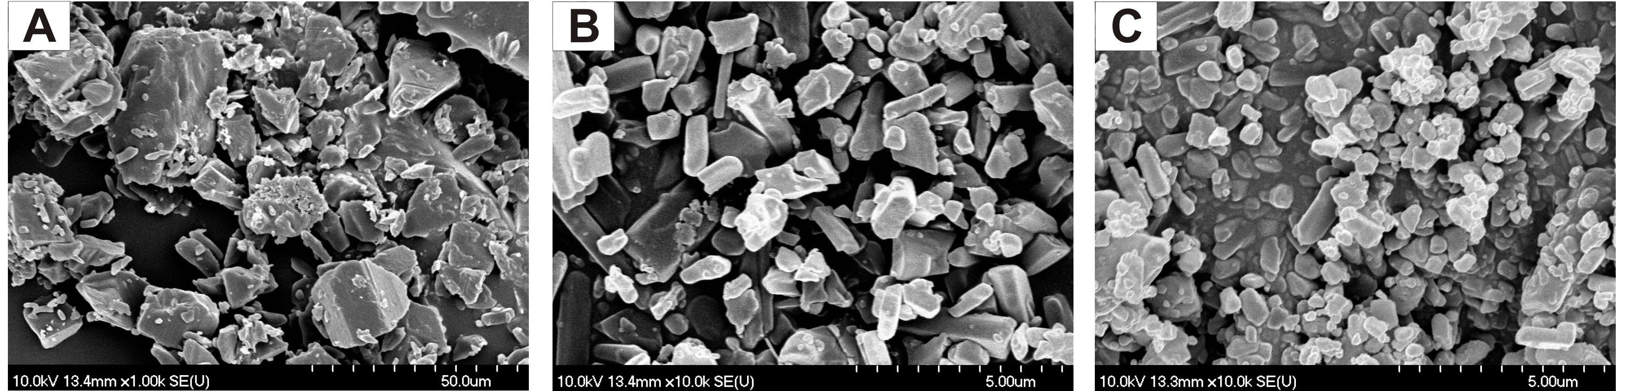
Figure 1: SEM images of cilostazol samples. A: original ground material (1000x); B: product of antisolvent impinging jet crystallization (10000x); C: product of antisolvent impinging jet crystallization combined with cooling (10000x).
Recent Publications
- Tari T, Fekete Z, Szabó-Révész P, Aigner Z (2015) Reduction of glycine particle size by impinging jet crystallization: Int. J. Pharm. 478:96–102.
- Su C-S, Liao C-Y, Jheng W-D (2015) Particle size control and crystal habit modification of phenacetin using ultrasonic crystallization: Chem. Eng. Technol., 38:181–186.
- Mustapha O, Kim K S, Shafique S, Kim D S, Jin S G, Seo Y G, Youn Y S, Oh K T, Lee B-J, Park Y J, Yong C S, Kim J O, Choi H-G (2017) Development of novel cilostazol–loaded solid SNEDDS using a SPGmembrane emulsification technique: Physicochemical characterization and in vivo evaluation: Colloid. Surface. B 150:216–222.
- Kim M-S, Lee S, Park J-S, Woo J-S, Hwang S-J (2007) Micronization of cilostazol using supercritical antisolvent (SAS) process: Effect of process parameters: Powder Technol. 177:64–70.
- Jinno J-I, Kamada N, Miyake M, Yamada K, Mukai T, Odomi M, Toguchi H, Liversidge G G, Higaki K, Kimura T J (2006) Effect of particle size reduction on dissolution and oral absorption of a poorly water-soluble drug, cilostazol, in beagle dogs: Control. Release 111:56–64.

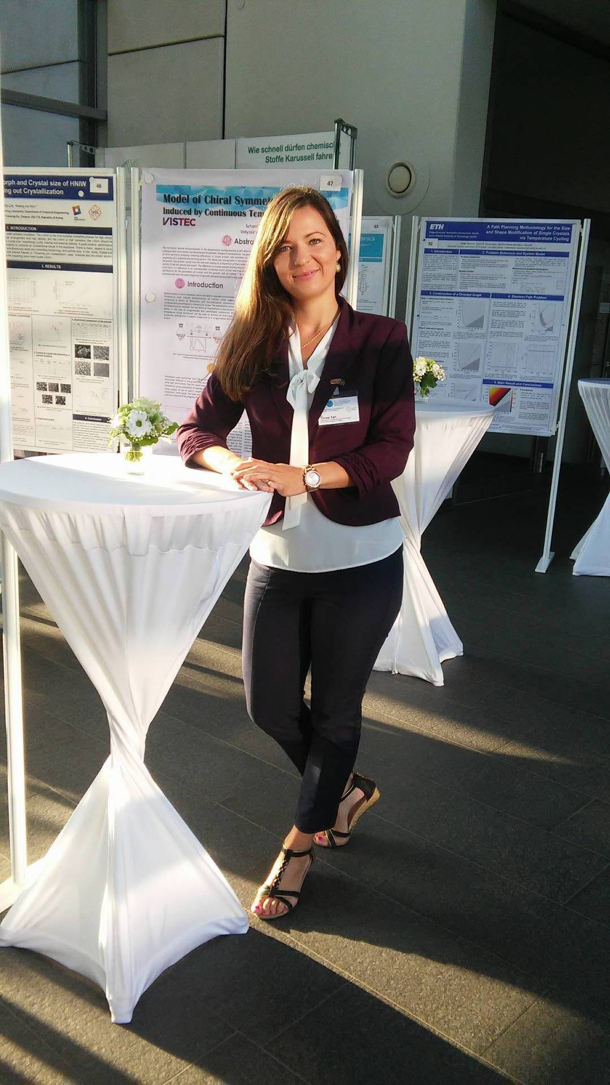Biography
Tímea Tari’s PhD research area is optimization of crystal habit of active agents with different crystallization methods (from conventional to new technics), and improve the processability, tablettability and solubility of these pharmacons. Therefore she has acquired good experiences in the field of polymorph identification, particle size analysis and other solid state analytical processes. This month she is having a new project that includes continuous crystallization process development, furthermore her aim is the optimization of filtration and drying parameters to obtain high quality product. She is motivated by new challenges, she considers herself creative, perseverant and team player. Precisity is very important for her. Last year she has started the Specialist of Biotechnology qualification at the University of Szeged, Faculty of Pharmacy, where the theoretical background, as well as experimental work of molecular biology; purification and analysis of proteins are also accomplished.
Email: tari.timea@pharm.u-szeged.hu

Notes/Comments:

