Release of Dopamine encapsulated in a TiO₂ matrix in the striatum improves the motor activity in hemiparkinsonism model of the rat

Guadalupe Valverde Aguilar PhD, CICATA-Legaría, Instituto Politécnico Nacional. Legaria 694, Col Irrigación, Miguel Hidalgo 11500, Cd. de México, México.
Patricia Vergara Aragón PhD, Departamento de Fisiología, Facultad de Medicina, Universidad Nacional Autónoma de México 04510 Mexico City.
Martha Chico Vázquez M.T.A. CICATA-Legaría, Instituto Politécnico Nacional. Legaria 694, Col Irrigación, Miguel Hidalgo 11500, Cd. de México, México.
Mónica R. Jaime Fonseca PhD, CICATA-Legaría, Instituto Politécnico Nacional. Legaria 694, Col Irrigación, Miguel Hidalgo 11500, Cd. de México, México.
Patricia Santiago Jacinto PhD, Departamento de Materia Condensada. Instituto de Física, Universidad Nacional Autónoma de México, C.P. 04510 Cd de México, México

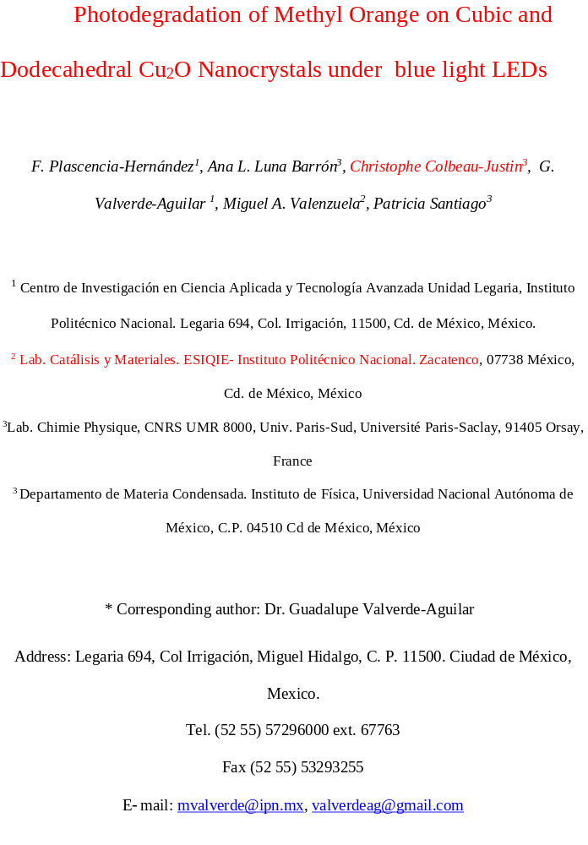

Abstract
Statement of the Problem: Parkinson´s disease is a neurodegenerative disorder characterized by progressive loss of dopaminergic neurons in the substantia nigra causing dopamine depletion in the striatum. The purpose of this research was to evaluate the temporal stability of dopamine encapsulated in a titanium dioxide (TiO₂) matrix synthesized by sol-gel method under atmospheric conditions. The formation of the oxidation products from dopamine were analyzed by colour change of the microimplant, optical absorption and infrared spectroscopy. The evaluation in vivo on the locomotor activity in the open field test of hemiparkinson rat model was studied.
Material y Methods: a) TiO₂ precursor solution. A mixture of Tetrabutyl orthotitanate and diethanolamine which prevent the precipitation of oxides and stabilize the solutions was obtained with deionized water. Tetraethyleneglycol was added to the above solution under stirring. b) TiO₂/DA solution. To 20 ml of TiO₂ solution prepared in section (a), the Dopamine was added and the sol was stirred at room temperature under darkness. The states of dopamine oxidation were evaluated using infrared spectroscopy. Forty Winstar rats were divided into 4 groups: Sham, Lx (hemiparkinsonian), Lx + TiO₂/DA matrix, and TiO₂/DA matrix only. Induced rotation test and locomotor activity task were performed on days 0, 1, 21, 90 days after the insertion of the TiO₂/DA in the caudate nucleus.
Findings: Results show that the TiO₂ matrix can protect the dopamine inhibiting its chemical instability and retarding its oxidation gradually. Less induced rotations and better performance in the locomotor activity during the 90 days of the experimental evaluation suggest that probably dopamine successfully stabilized and it was released from its reservoir in the striatum.
Conclusion: Advantages of this treatment are its easy and fast elaboration, low cost and immediate benefits on the motor disturbances presented by the animals with hemiparkinsonismo.
Recent Publications (minimum 5)
- Vázquez Matías DA et al. (2016) Fine motor performance, micro-positron emission tomography imaging and brain histopathological evaluation of hemiparkinsonian rats after dopamine supply restitution through a nano-engineered titanium dioxide reservoir placed in the striatum. European Neuropsychopharmacology 26: S358-S359.
- Velázquez-Paniagua M et al. (2016) Current treatments in Parkinson’s including the proposal of an innovative dopamine microimplant. Revista Médica del Hospital General de México 79: 79-87.
- Valverde-Aguilar G et al. (2014) Photoconductivity studies on nanoporous TiO₂/Dopamine films prepared by sol-gel method. Applied Physics A 116: 1075-1084.
- Valverde-Aguilar G et al. (2012) Photoconductivity and Stabilization of DA embedded in amorphous sol-gel TiO₂ matrix. SPIE Proceeding 8456: 1-16.
- Vergara-Aragón P et al. (2011) TiO₂-dopamine complex implanted unilaterally in the caudate nucleus improves motor activity and behavior function of rats with induced hemiparkinsonism. Proc. West. Pharmacol. Soc. 54: 15-20


Biography
Professor Valverde obtained his PhD. in Physics on 2003 at Institute of Physics, UNAM. His Postdoctoral stay was made in UCLA, USA for two years. His research is focused in electrical and optical properties from amorphous and nanostructured sol-gel materials. His field of research includes photoluminescence, drug delivery, photoconductivity and hydrogen production. Prof. Valverde has been published 58 papers international journals.

Email: valverdeag@gmail.com

