IN VITRO DISSOLUTION PROFILE OF DIFFERENT BRANDS OF LOW SOLUBILITY DRUGS AVAILABLE IN THE NIGERIAN AND BRAZILIAN PHARMACEUTICAL MARKETS

Ezeagu Henry Ifeanyi^{1*}, Issa Michele Georges², Ofoefule Sabinus Ifeanyi³, Ferraz Humberto Gomes⁴
(Corresponding Author: Ezeagu Henry Ifeanyi, Cel: +5511973216725, e-mail: henryifeanyi77@yahoo.com)
^{1*}Department of Pharmacy, Faculty of Pharmaceutical Sciences, University of Sao Paulo, Sao Paulo, 05508-000, Brazil
²Department of Pharmacy, Faculty of Pharmaceutical Sciences, University of Sao Paulo, Sao Paulo, 05508-000, Brazil
³Department of Pharmaceutical Technology and Industrial Pharmacy, Faculty of Pharmaceutical Sciences, University of Nigeria Nsukka, Enugu State, Nigeria
⁴Department of Pharmacy, Faculty of Pharmaceutical Sciences, University of Sao Paulo, Sao Paulo, 05508-000,Brazil

ABSTRACT
The present work describes the in vitro dissolution profiles of different brands of furosemide, glibenclamide, albendazole, ibuprofen, carvedilol and hydrochlorothiazide tablets available in the Nigerian and Brazilian pharmaceutical markets. The dissolution test was performed by following the recommendation of the United States Pharmacopeia (USP), FDA and developed method (carvedilol). A filter selection test was done for the drugs; the results obtained indicated that cannula filter was ideal for all the drugs with the exception of carvedilol which was centrifuged. The ANOVA of the filter selection showed no significant retention of drug with cannula filter (p > 0.05), with the exception of carvedilol (p< 0.05). The data obtained from the dissolution test was subjected to statistical analysis in a Microsoft excel and Minitab 17 (USA). Dissolution efficiency (%DE) was calculated for the formulations to evaluate their in vitro biopharmaceutical features. Tukey grouping, ANOVA and confidence interval (CI) were obtained for the comparison of the results. The ANOVA of the results indicated that the brands of (albendazole, ibuprofen, furosemide, glibenclamide, & carvedilol) were statistically different (p< 0.05). Hydrochlorothiazide brands were pharmaceutical equivalents (p > 0.05). A comparison of the results showed that 94.1% and 58.8% of the Brazilian and Nigerian brands passed respectively.
KEYWORDS: Dissolution profile, Dissolution test, Low solubility drugs, Tablets

INTRODUCTION
Drug dissolution testing is an analytical technique used to assess release profiles of drugs from medicines, generally, from oral products such as tablets and capsules. It plays an important role as a routine quality control test, for characterizing the quality of a product [1]. Dissolution profile comparison has been extensively used to assess drug product similarity after scale-up and post approval changes [2].
Dissolution testing is considered to be one of the important parameters for ascertaining drug quality [3]. This process involves the breakdown of tablets into granular or fine particulate form followed by de-aggregation, leading to its availability for systemic circulation [4]. It also involves the interaction of solid drug with the medium resulting in the movement of drug molecules into the bulk solution [5].
Systemic absorption of drugs is a prerequisite for eliciting their therapeutic activity, whenever given non-instantaneously. Drugs of low solubility have to be evaluated for in vivo bioavailability, thus, generic manufacturers must provide detailed bioequivalence evidence showing head-to-head comparative performance of their product against reference [6].
Considering that dissolution is an in vitro method that characterizes how an API is extracted out of a solid dosage form, it is related with the initial stages after oral administration, that comprises the disintegration and dissolution process, thus it is a very useful tool to evaluate the quality of immediate release tablet formulations, mainly derived from class II and IV (low solubility drugs) of BCS [7].
The Table 1 shows the various works, which have been done on the dissolution test of various brands of low solubility drugs available in the African pharmaceutical market.

Table 1: Dissolution works done on the African medicines found in the scientific literature
Drug | Number of brands | Country | Author | Year | Observation
Albendazole | 9 | Nigeria | Aondover et al[8] | 2014 | 44.4% failed
Ibuprofen | 19 | Nigeria | Eichie et al[9] | 2009 | 57.9 % failed
Hydrochlorothiazide | 3 | Nigeria | Odeniran et al[10] | 2012 | 100% passed
Furosemide | 3 | Ghana | Julide et al[11] | 2008 | 100% failed
Furosemide | 5 | Nigeria | Chinaka et al[12] | 2017 | 100 % passed
Glibenclamide | 3 | Libya | Elhamili et al[13] | 2014 | 100% failed
Metformin HCl | 15 | Nigeria | Eraga et al[14] | 2020 | 80% passed

Eraga and his collaborators did a dissolution test of 15 different brands of metformin hydrochloride tablets marketed in South-East Nigeria, the result showed that out of the 15 different brands of metformin hydrochloride tablets analyzed, 12 of the brands passed the dissolution test while 3 failed the dissolution test [14]. It shows that the situation of the quality of drugs marketed in the Nigerian Pharmaceutical market is not optimal when compared to the reference standard.
Based on the results of the dissolution tests shown in Table 1, it can be observed that most of the low solubility drugs marketed in the Nigerian market do not pass the dissolution test. A literature review of the dissolution tests of the Brazilian products done by Madureira et al. (2016)[15], Mahle et al. (2008) [16], Ferreira et al. (2016)[17] and Gianotto et al. (2007)[18], showed that 100% of the Ibuprofen, hydrochlorothiazide, furosemide and glibenclamide tablets passed.
It was also observed that most of the dissolution tests had lasted for 5, 7, 8, 10 and 13 years. Therefore, a current quality evaluation of the available products was done in this present work.
The objective of this present work was to elaborate a diagnosis of the dissolution test in Nigeria in comparison with Brazil, evaluating the dissolution profile of the low solubility drugs to ascertain their quality.

MATERIALS AND METHODS

Material
Pure drug powder was gratefully received as a gift sample from Ache, Pratti-Donaduzzi and Biolab pharmaceutical companies Ltd, Sao Paulo, Brazil. All other reagents were of analytical grade and osmotic water was used for the assay. The Brazilian brands of medicines were purchased from pharmaceutical shops in the city of Sao Paulo, Brazil. The medicines were products of Ache, Geolab, Neo Quimica, Brainfarma, Biolab, Pratti-Donaduzzi, Teuto and Cimed pharmaceutical companies Ltd, located in the city of Sao Paulo, Brazil.
The Nigerian brands were purchased from various pharmacy and drug stores in the city of Lagos, Nigeria. The products were from Zim Laboratories Ltd (Nagpur, India), Sanofi pharmaceutical company Ltd (Mumbai, India), Juhel pharmaceutical company Ltd (Enugu, Nigeria), Glaxosmithkline Ltd (Lagos, Nigeria), Surelife Pharma. Ltd (Asaba, Nigeria) and Me-Cure Industries Ltd (Lagos, Nigeria). The various brands of Brazilian and Nigerian medicines utilized in this present work were shown in Table 2.
Table 2: Nigerian and Brazilian products utilized in the study
Drug |  | Brazil |  |  | Nigeria
ALBENDAZOLE | ALBBR1 | ALBBR2 | ALBBR3 | ALBNG1 | ALBNG2 | ALBNG3
IBUPROFEN | IBUBR1 | IBUBR2 | IBUBR3 | IBUNG1 | IBUNG2 | IBUNG3
FUROSEMIDE | FURBR1 | FURBR2 | FURBR3 | FURNG1 | FURNG2 | FURNG3
GLIBENCLAMIDE | GLIBR1 | GLIBR2 | GLIBR3 | GLING1 | GLING2 | GLING3
HYDROCHLOROTHIAZIDE | HYDBR1 | HYDBR2 | HYDBR3 | HYDNG1 | HYDNG2 | HYDNG3
CARVEDILOL | CARBR1 | CARBR2 | .... | CARNG1 | CARNG2 | ....

Methods
Filter selection test
The filter used was previously subjected to a filter selection test by using cannula filter of pore size (1 µm), following the standard procedure [19]. A centrifugation method was carried out for the carvedilol drug at a revolution of about 4000 rpm for 15 min.

Dissolution test method
The dissolution test for albendazole, ibuprofen, furosemide and hydrochlorothiazide was done by following the criteria recommended by the United States Pharmacopeia [20]. Glibenclamide was assayed following the FDA recommendation [21]. A dissolution test method was developed for carvedilol. Apparatus 2 (paddle) was utilized for all the dissolution tests. A quantification of each drug was realized through a calibration curve which was previously constructed for each of the drugs, a straight-line graph generated from the calibration curve was used to calculate the percentage of drug released; the percentage of drug released was plotted against time to generate a dissolution profile.
Table 3: Dissolution test method for the medicines
Drug |  |  | Medium | RPM | UV (nm) | Tolerance (NLT)
albendazole |  |  | 0.1 N HCl, 900 mL | 100 | 311 | 80 % in 30 min
ibuprofen |  |  | phosphate buffer, pH 7.2, 900 mL | 50 | 228 | 80 % in 60 min
furosemide |  |  | phosphate buffer, pH 5.8, 900 mL | 50 | 274 | 80 % in 60 min
glibenclamide (FDA method) |  |  | phosphate buffer, pH 7.5, 900 mL | 50 | 208 | 80 % in 60 min
hydrochlorothiazide |  |  | 0.1 N HCl, 900 mL | 100 | 272 | 60 % in 60 min
carvedilol (method development) |  |  | acetate buffer, pH 4.5, 900 mL | 75 | 241 | 80 % in 60 min

NLT = not less than

Statistical analysis
The results obtained from the dissolution test were analyzed statistically by using Minitab 17 (Minitab, USA) application. This was done to determine the ANOVA, Tukey grouping and confidence interval of the samples. The analysis was evaluated with reference to the percentage of drug dissolved as a function of time.
Results and Discussions
The ibuprofen, furosemide, glibenclamide, and hydrochlorothiazide drugs respectively, yielded a 100 % recovery with the cannula filter. Carvedilol did not yield 100% recovery at all volumes of discard. An analysis of variance (ANOVA) of the % recovery was done for all the drugs and a p-value of about 0.851, 0.680, 0.284, 0.129, 0.147 and 0.003 were obtained for the albendazole, ibuprofen, furosemide, glibenclamide, hydrochlorothiazide and carvedilol respectively.
The filter selection test showed that for the albendazole, the cannula filter has to be saturated by discarding about 4 mL of the dissolution medium to obtain a 100% recovery. Furosemide, glibenclamide, hydrochlorothiazide and ibuprofen yielded 100% recovery with saturation of the filter. The carvedilol was centrifuged and a 100% recovery was obtained. With a p-value greater than 0.05 (p>0.05), cannula is ideal for the filtration of the drugs with the exception of carvedilol with a p-value of 0.03 (p<0.05).
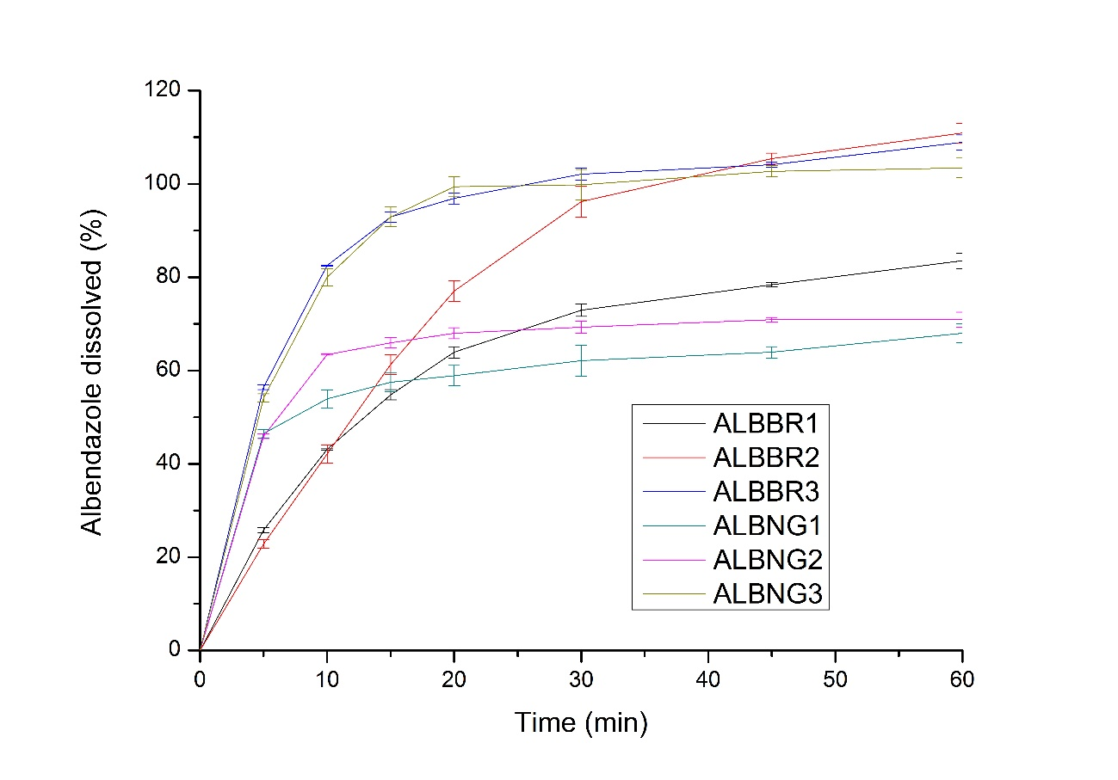
Figure 1: Dissolution profile of the brands of albendazole
Figure 1 showed the dissolution profile of the brands Nigerian (ALBNG1, ALBNG2 & ALBNG3) and Brazilian (ALBBR1, ALBBR2, ALBBR3) albendazole.
From the graph, it showed that ALBBR3 brand had more rapid release pattern followed by the ALBNG3 and ALBBR2 respectively. The profile also showed that both the ALBBR3 and ALBNG3 brands had similar characteristics release pattern. At 45min of the assay, ALBBR3, ALBNG3 and ALBBR2 have an equivalent amount of drug released. %DE was 58.7, 64.9, 90.3, 60.4, 73.7 and 91.9% for ALBNG1, ALBNG2, ALBNG3, ALBBR1, ALBBR2 and ALBBR3 products respectively.
The results of the dissolution test showed that ALBBR1, ALBNG1, ALBNG2, ALBBR2, ALBBR3 and ALBNG3 brands released 72.9±1.1, 62.1±2.5, 69.3±2.2, 96.2±0.5, 102.1±0.2 and 99.8±0.9% respectively, of their active ingredients within 30 min of the assay. The analysis of variance (ANOVA) of the % drug released was evaluated for the brands and a p-value of about 0.006 (p<0.05) was obtained.
The result of the Tukey grouping showed that ALBBR3, ALBNG3, ALBBR2, ALBNG2, ALBBR1 and ALBNG1 were placed in groups A, AB, ABC, ABC, BC and C respectively. From the confidence interval shown in figure 2; ALBBR2-ALBBR1, ALBNG1-ALBBR1, ALBNG2-ALBBR1, ALBNG3-ALBBR1, ALBBR3-ALBBR2, ALBNG1-ALBBR2, ALBNG2-ALBBR2, ALBNG3-ALBBR2, ALBNG2-ALBBR3, ALBNG3-ALBBR3, ALBNG2-ALBNG1 and ALBNG3-ALBNG2 crossed the zero line (limit of significance). ALBBR3-ALBBR1, ALBNG1-ALBBR3 and ALBNG3-ALBNG1 did not cross the zero line.
The rapid release pattern shown by ALBBR3 signified a rapid dissolution of the drug. The similar characteristics release pattern exhibited by ALBBR3 and ALBBR2 indicated that they are similar. The equivalent amount of drug released by ALBBR3, ALBNG3 and ALBBR2 at 45 min indicated that they can be considered as pharmaceutical equivalents. Dissolution efficiency (%DE) was calculated for the formulations and this value represents the area under the dissolution curve up to 60 min.
The % DE result showed that there was a similarity between ALBNG2 and ALBBR1; ALBNG3 and ALBBR3. Following the United States Pharmacopeia (USP) recommendation of not less than 80% release of the drug in 30 min of the assay [20]; it therefore, indicated that ALBBR2, ALBBR3 and ALBNG3 passed the test while ALBBR1, ALBNG1 and ALBNG2 failed. The p-value (p<0.05) signified that the brands had statistical significant difference between them. The Tukey grouping indicated that the products ALBBR2 and ALBNG2 are pharmaceutical equivalents.
The different grouping (A, AB, BC and C) signified that the brands had statistical significant difference between them, which validated the p-value of the ANOVA result shown above. A comparison between two brands was evaluated by the confidence interval shown in figure 2. The intervals which crossed the zero line (limit of significance) as shown in figure 2 means that they had some similarity between them, while the intervals which did not cross the line had statistical significant difference.
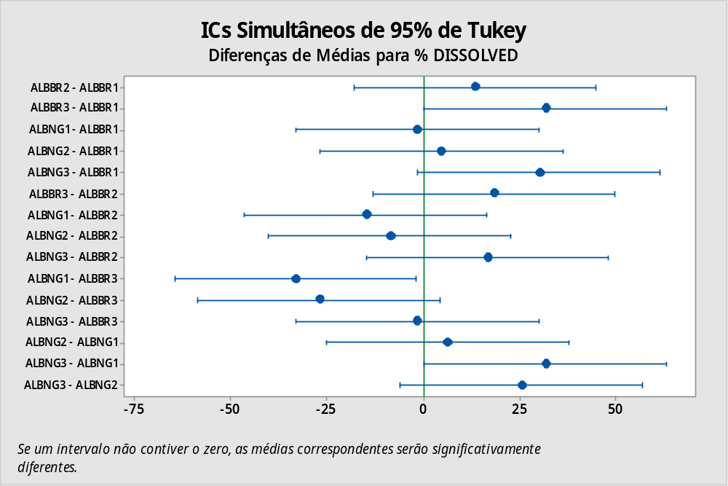
Figure 2: Confidence Interval of the Tukey grouping of the brands of albendazole.

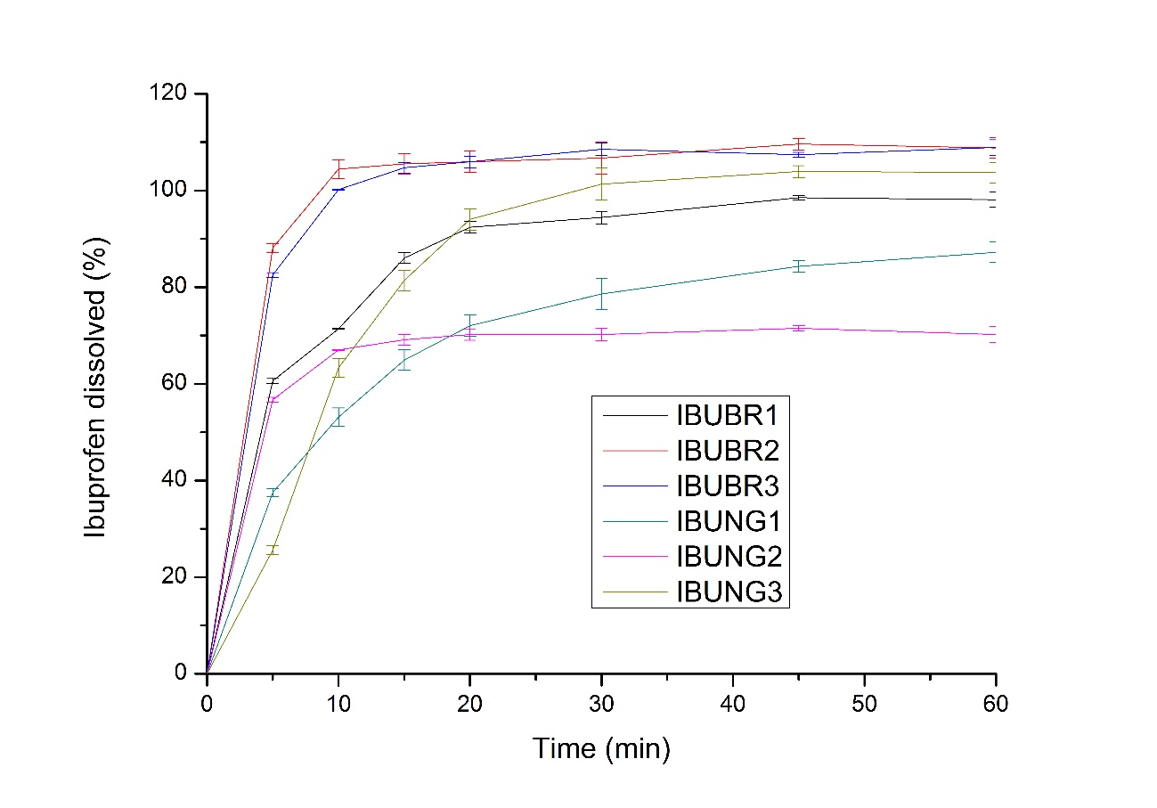
Figure 3: Dissolution profiles of the brands of ibuprofen medicines
Figure 3 showed the dissolution profile of the brands of Nigerian (IBUNG1, IBUNG2 & IBUNG3) and Brazilian (IBUBR1, IBUBR2 & IBUBR3) ibuprofen.
The profile showed that IBUBR2 brand had a more rapid drug release pattern followed by IBUBR3. The graph also showed that within 20 min of the assay, all the medicines had a steady release pattern until the 60 min time. It was also observed that from 45 until 60 min of the assay, both IBUBR2 and IBUBR3 had almost the same percentage of drug released; the same was obtainable at 15 and 20 min of the assay.
IBUNG3 and IBUBR1 showed an equivalent amount of drug released within 20 min of the assay. IBUNG2 and IBUNG1 showed the same % of drug released within 20 min of the dissolution test. Dissolution efficiency (% DE) of the IBUNG1, IBUNG2, IBUNG3, IBUBR1, IBUBR2 and IBUBR3 products gave 68.2, 67.9, 81.9, 85.9, 99.4 and 99.2% respectively. Ibuprofen dissolution showed that within 60 min of the assay, IBUBR1, IBUBR2, IBUBR3, IBUNG1, IBUNG2 and IBUNG3 had released 98.5±1.1, 108.8±2.1, 108.9±2.2, 87.2±1.3, 72.2±3.3 and 103.9±0.6% of the API content respectively.
All the medicines released more than 80% of the active ingredients with the exception of IBUNG2. The analysis of variance (ANOVA) of the ibuprofen brands gave a p-value of about 0.000 (p<0.05). A Tukey grouping of the brands placed IBUBR1, IBUBR2, IBUBR3, IBUNG1, IBUNG2 and IBUNG3 into groups AB, A, A, B, B and AB, respectively.
From the 95% confidence interval of the different brands of ibuprofen shown in figure 4, IBUBR3-IBUNG1, IBUBR2-IBUNG1, IBUBR3-IBUNG2 and IBUBR2-IBUNG2 did not cross the zero line (limit of significance), while, IBUBR2-IBUBR1, IBUBR3-IBUBR1, IBUNG1-IBUBR1, IBUNG2-IBUBR1, IBUNG3-IBUBR1, IBUBR3-IBUBR2, IBUNG3-IBUBR2, IBUNG2-IBUNG1, IBUNG3-IBUNG1 and IBUN3-IBUNG2 crossed the zero line.
The more rapid drug release pattern shown by IBUBR2 signified rapid drug dissolution. This means that IBUBR2 had a dissolution rate faster than the other products. The almost same amount of drug released by IBUBR2 and IBUBR3 from 45 until 60 min of the assay indicated that the both medicines are pharmaceutical equivalents. Similarly, IBUNG3 and IBUBR1; IBUNG2 and IBUNG1 were also equivalents. The % DE result showed that there was a similarity between IBUNG1 and IBUNG2; IBUNG3 and IBUBR1; and IBUBR2 and IBUBR3.
The result indicated that IBUBR2 and IBUBR3 had more efficient dissolution, followed by IBUBR1, IBUNG3 and subsequently, IBUNG1 and IBUNG2. This dissolution result showed that all the brands but IBUNG2, passed the dissolution test as they complied with the recommendation of the USP method, (NLT 80 %) of the API within 60 min of the assay, should be released [20].
The almost same amount of drug (108±2.1 and 108±2.2) released by IBUBR2 and IBUBR3 respectively, within 60 min of the test indicated that they are pharmaceutical equivalents. The p-value of about 0.000 (p<0.05) signified that the brands had statistical significant difference. The result of the Tukey grouping shown above indicated that the products IBUBR1 and IBUNG3, IBUBR2 and IBUBR3, and IBUNG1 and IBUNG2 were pharmaceutical equivalents. The different grouping validated the significant difference observed from the p value of about 0.000 (p<0.05). The brands which crossed the zero line as shown in the 95% confidence interval in figure 4 did not have significant difference between them while the brands that did not cross the line had significant difference.

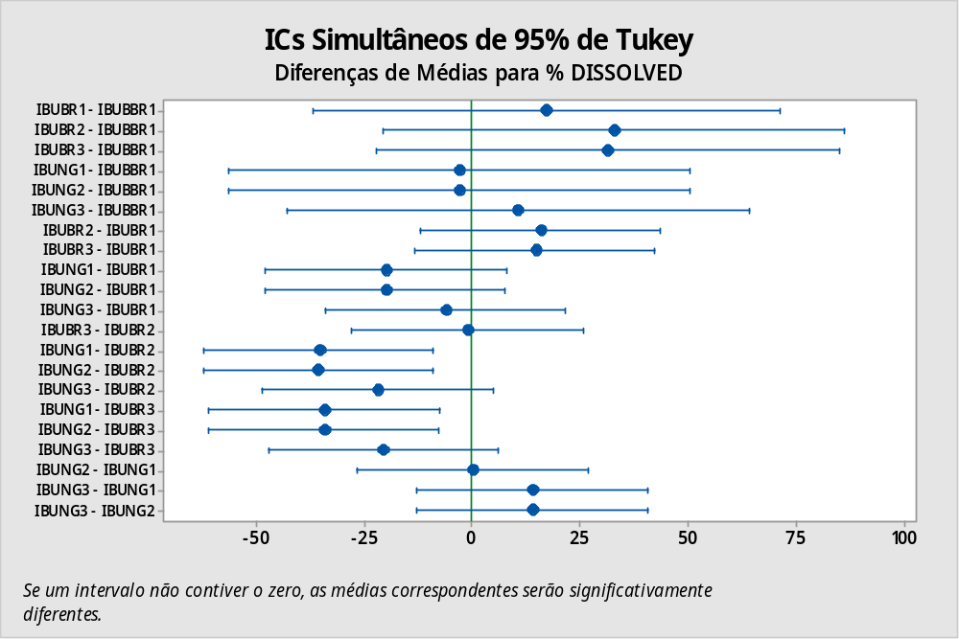
Figure 4: Confidence Interval of the Tukey of the brands of ibuprofen
.
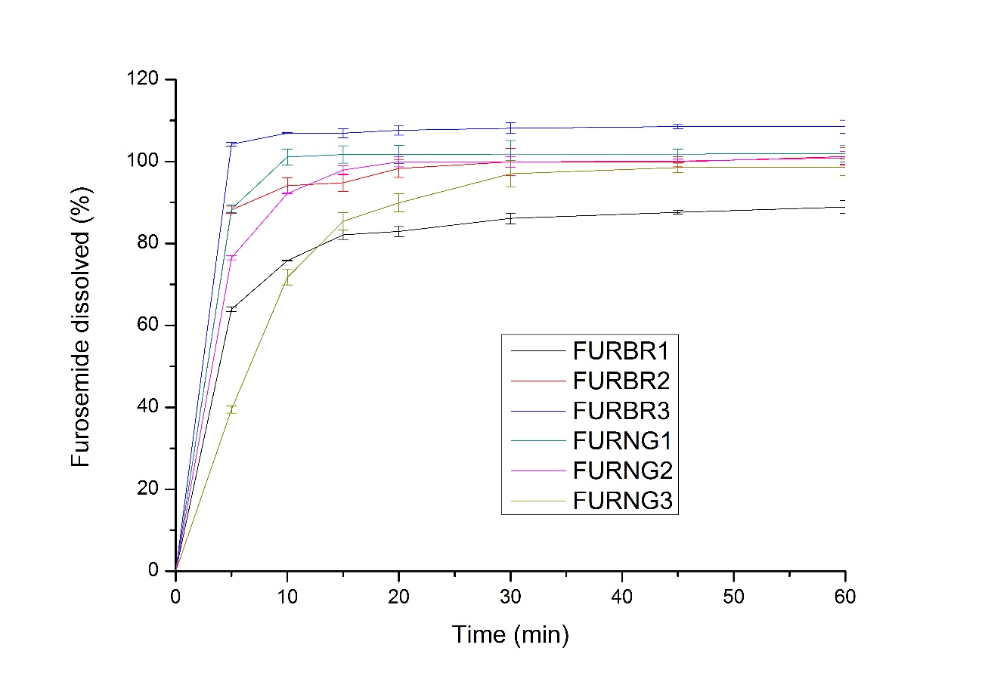
Figure 5: Dissolution profile of the brands of furosemide
Figure 5 showed the dissolution profile of the brands of Nigerian (FURNG1, FURNG2 & FURNG3) and Brazilian (FURBR1, FURBR2 & FURBR3) furosemide.
The figure showed that FURBR3 had a more rapid release pattern followed by FURNG1, FURBR2, FURNG2 and FURNG3, respectively. A steady release of the drugs were observed between 30 min of the assay until 60 min. Figure 5 also showed that within 30 min of the assay, FURBR3 and FURNG1 had released more than 100 % of their active ingredient. It was observed from the profile that within 30 min of the assay until 60 min, FURBR2, FURNG1 and FURNG2 released the same amount of active ingredients.
Dissolution efficiency (% DE) of the FURBR1, FURBR2, FURBR3, FURNG1, FURNG2 and FURNG3 products gave 81.1, 96.6, 99.1, 98.0, 95.3 and 82.9% respectively. Furosemide dissolution showed that within 60 min of the assay, FURBR1, FURBR2, FURBR3, FURNG1, FURNG2 and FURNG3 released about 88.9±3.2, 101.2±0.1, 108.5±0.3, 101.2±0.2, 100.9±0.4 and 98.6±2.1% respectively. The ANOVA of the brands gave a p-value of about 0.000 (p<0.05). A Tukey grouping of the brands classified FURBR1, FURBR2, FURBR3, FURNG1, FURNG2 and FURNG3 into groups C, ABC, A, AB, ABC and BC, respectively.
The 95% confidence interval in figure 6 showed that FURBR3-FURNG2, FURNG1-FURNG2, FURBR2-FURNG2, FURBR2-FURBR1 and FURNG3-FURBR1 crossed the zero line (limit of significance), while, FURBR3-FURBR1, FURNG1-FURBR1, FURNG3-FURBR3 and FURNG3-FURNG1 did not cross the line.
The more rapid release pattern shown by FURBR3 indicated that it had the fastest dissolution rate compared to the other brands. The steady release of the drugs observed between 30 min until 60 min meant that the drugs had similar release characteristics. The 100% release of the API observed within 30 min by FURBR3 and FURNG1 showed that they are similar. The same amount of drug released by FURBR2, FURNG1 and FURNG2 within 60 min of the assay showed that they are pharmaceutical equivalents. The % DE result showed that there was a similarity between FURBR3 and FURNG1; FURBR2 and FURNG2; and FURBR1 and FURNG3. The dissolution values indicated that all the brands passed the test, based on USP recommendation of not less than 80% in 60 min [20]. The ANOVA value signified that the medicines had significant statistical difference. The Tukey grouping showed that FURBR2 and FURNG2 are similar. FURBR3 and FURBR1 show some variations. FURBR3 and FURNG3 had significant difference. From figure 6, the intervals that crossed the zero line did not have significant difference while, those that did not cross the line had significant difference.
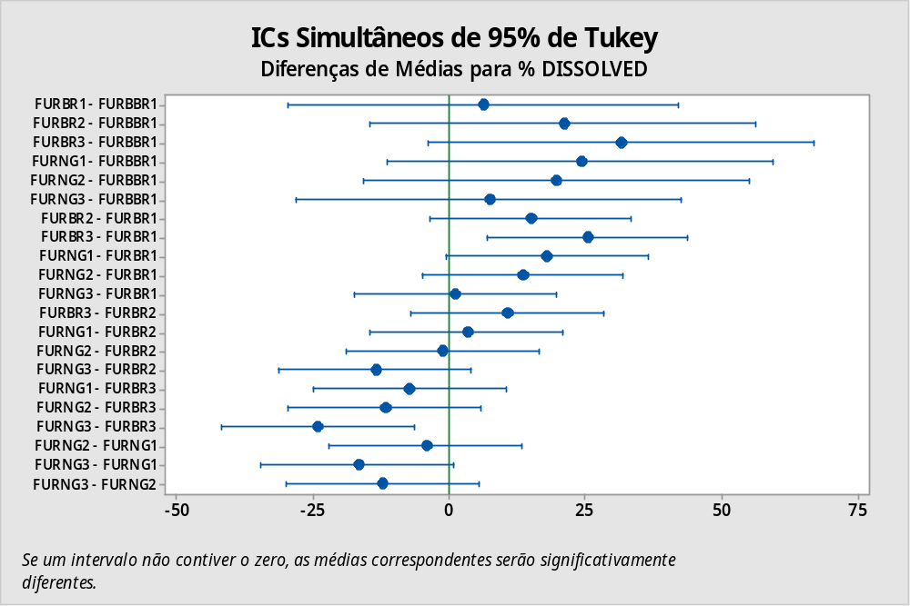
Figure 6: Confidence Interval of the Tukey of the brands of furosemide medicines.

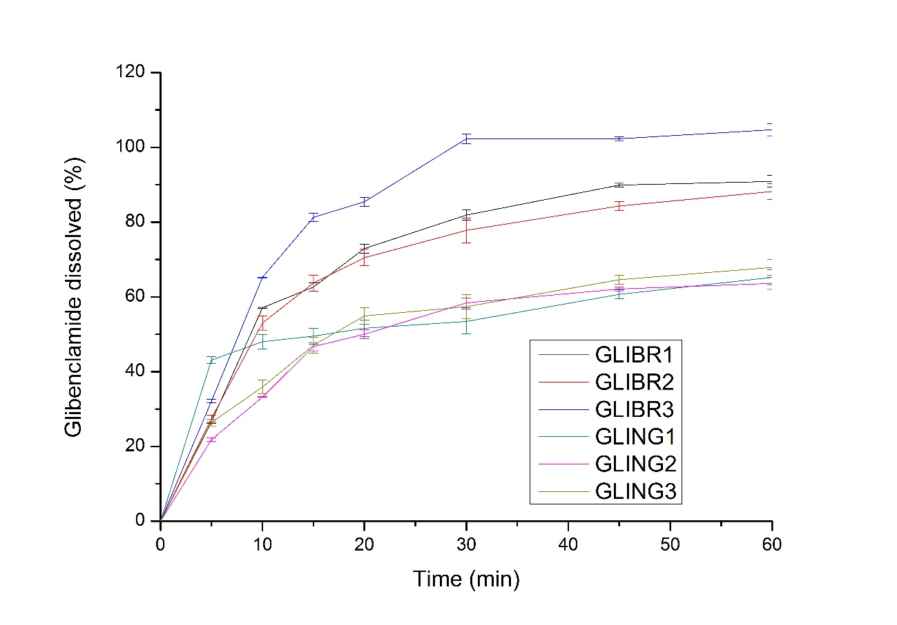
Figure 7: Dissolution profile of the brands of glibenclamide medicine
Figure 7 showed the dissolution profile of the brands of Nigerian (GLING1, GLING2 & GLING3) and Brazilian (GLIBR1, GLIBR2 & GLIBR3) glibenclamide.
The profile showed that, GLING1 had the most rapid release pattern, GLIBR1 and GLIBR2 had similar release characteristics and GLING1, GLING2 and GLING3 showed equivalent release pattern. The figure also showed that the brands of GLING1, GLING2 and GLING3 released less than 80% of the API within 60 min of the assay. A calculation of the dissolution efficiency (% DE) of the GLIBR1, GLIBR2, GLIBR3, GLING1, GLING2 and GLING3 brands gave 68.9, 66.4, 81.9, 53.1, 47.9 and 50.6% respectively.
Dissolution test showed that within 60 min, GLIBR1, GLIBR2, GLIBR3, GLING1, GLING2 and GLING3 released 90.9±1,3, 88.2±2.5, 104.7±0.1, 65.2±5.2, 63.6±6.1 and 67.9±3.2% of their active ingredients respectively. The analysis of variance of the glibenclamide brands gave a p-value of about 0.014 (p<0.05). A Tukey grouping of the brands placed the GLIBR1, GLIBR2, GLIBR3, GLING1, GLING2 and GLING3 brands into groups AB, AB, A, AB, B and B respectively. From the 95% confidence interval shown in figure 8, GLING2-GLING1, GLING3-GLING1, GLING2-GLIBR1, GLING3-GLIBR1 and GLIBR2-GLIBR1 crossed the zero line, GLIBR3-GLING2 and GLIBR3-GLING3 did not cross the line.
The rapid release pattern shown by GLING1 indicated that it had the most rapid drug dissolution rate. The similar release characteristics shown by GLIBR1 and GLIBR2 indicated that they are similar. Less than 80% of the API released by GLING1, GLING2 and GLING3 within 60 min of the assay showed that they did not pass the test and had inadequate API content also. The % DE result showed that there was a similarity between GLIBR1 and GLIBR2; GLING1 and GLING3; GLIBR3 and GLING2 show some variations to the other brands.
According to the FDA, not less than 80% of the API is dissolved in 60 min [21], therefore, based on the result of the dissolution test, GLIBR1, GLIBR2 and GLIBR3 passed the test, while GLING1, GLING2 and GLING3 failed. The p-value (0.014) indicated a statistical significant difference between the brands.
The difference in Tukey grouping justified the statistical difference observed by the p-value of the ANOVA shown above. GLIBR1, GLIBR2 and GLING1 had some similarity as they were placed in group AB, similarly, GLING2 and GLING3 had some similarity as both were placed in the same group B. The intervals that crossed the zero line in as shown in figure 8 did not have significant difference, while the intervals which did not cross the line, had significant difference.
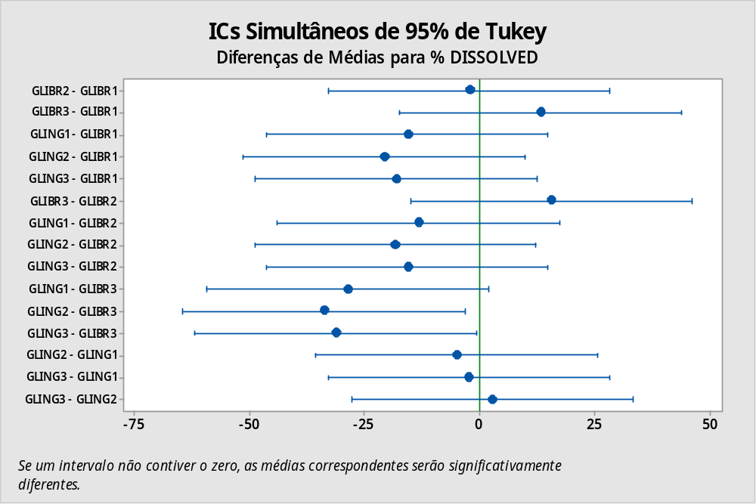
Figure 8: Confidence Interval of the Tukey of the brands of glibenclamide
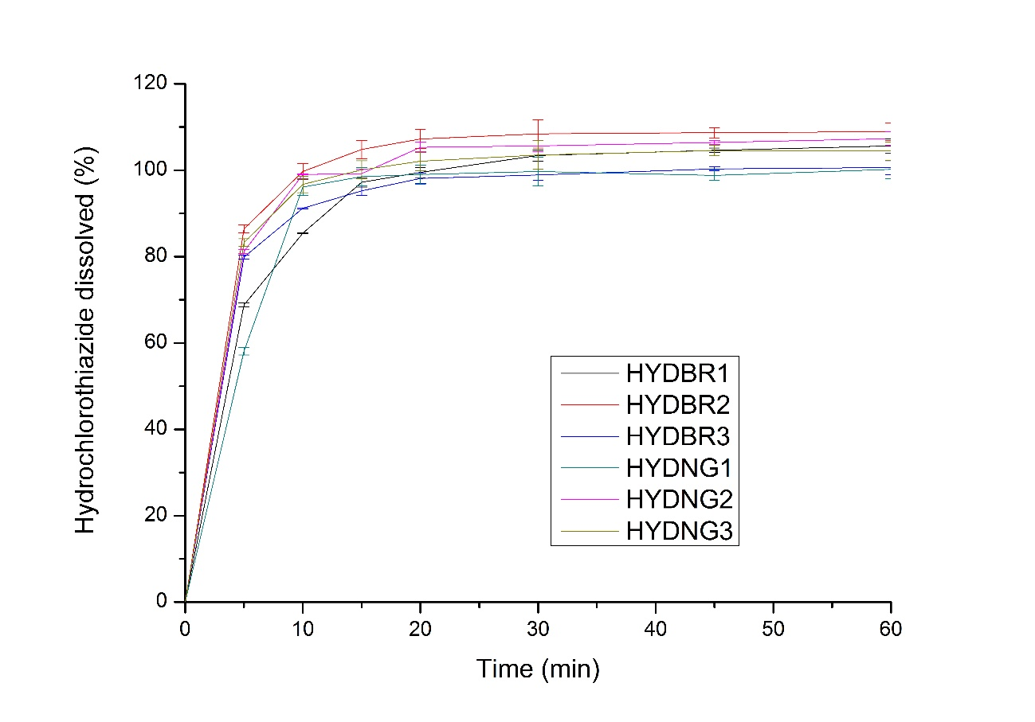
Figure 9: Dissolution profiles of the brands of HCTZ medicines
Figure 9 showed the dissolution profile of the brands of Nigerian (HYDNG1, HYDNG2 & HYDNG3) and Brazilian (HYDBR1, HYDBR2 & HYDBR3) hydrochlorothiazide. The profile showed that within 20 min of the assay until 60 min, there was a steady drug release for all the brands. Dissolution efficiency (% DE) was calculated for the brands and 94.9, 99.9, 94.9, 92.9, 99.3 and 99.2% was obtained for the HYDBR1, HYDBR2, HYDBR3, HYDNG1, HYDNG2 and HYDNG3 respectively.
Dissolution test showed that within 60 min of the assay, HYDBR1, HYDBR2, HYDBR3, HYDNG1, HYDNG2 and HYDNG3 had released 105.6±0.1, 108.9±0.3, 100.6±1.1, 100.2±2.1, 107.3±2.2 and 104.4±1.0% of the active ingredients respectively. The ANOVA of the HCT brands gave a p-value of about 0.424(p > 0.05). A Tukey grouping of the brands placed all (HYDBR1, HYDBR2, HYDBR3, HYDNG1, HYDNG2 and HYDNG3) into group A. Figure 10 showed that all the brands crossed the zero line.
The steady drug release observed for the drugs indicated that they have similar dissolution behavior. The products showed equivalent release characteristics. The % DE showed a high degree of similarity between HYDBR2, HYDNG2 and HYDNG3. Similarly, a similarity was observed between HYDBR1 and HYDBR3. HYDNG1 was different from the other brands but not statistically significant. The dissolution results complied with the USP recommendation of not less than 80% release of the API in 60 min [20]. Thus, all the products passed the test.
This ANOVA value signified that the brands had no statistical significant difference. The Tukey grouping of the medicines into group A had validated the ANOVA value of above 0.05, which signified that the different brands had no statistical significant difference. The 95% confidence interval of the brands of medicines shown in figure 10 indicated that the products did not have significant difference.
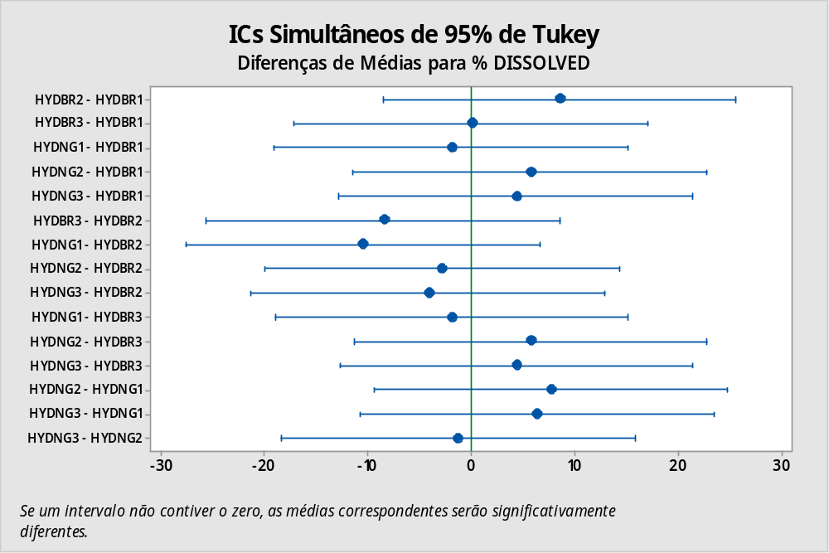
Figure 10: Confidence interval of the brands of hydrochlorothiazide medicine
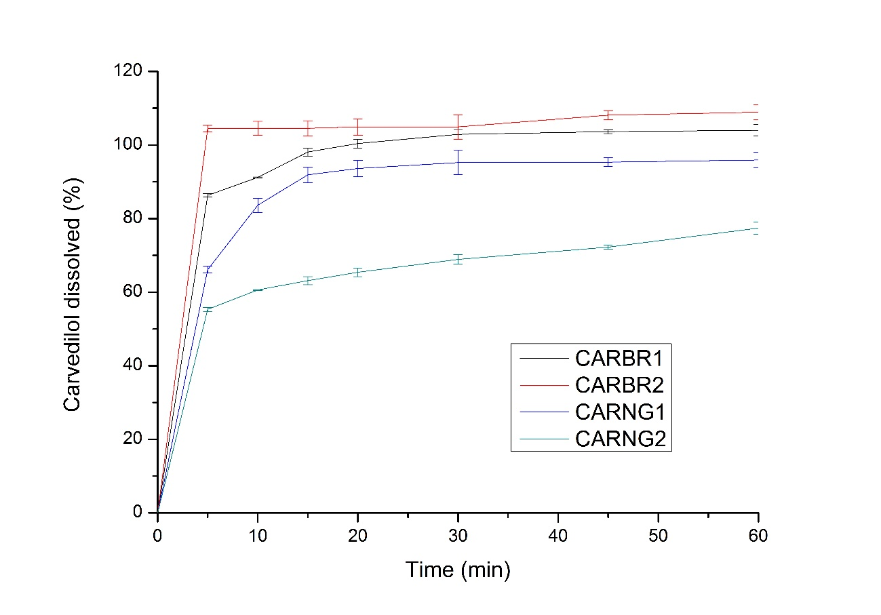
Figure 11: Dissolution profiles of the brands of carvedilol medicine
Figure 9 showed the dissolution profile of the brands of Nigerian (CARNG1, CARNG2) and Brazilian (CARBR1, CARBR2) carvedilol.
The profile showed that CARBR2 brand had the most rapid release pattern followed by CARBR1. It also showed that CARNG2 had the lowest release pattern. The medicines had steady drug release within 15 min of the assay until 60 min. All the medicines, except CARNG2 released more than 80% of their API within 15 min of the assay. CARBR2, CARBR1 and CARNG1 showed similar release characteristics.
Dissolution efficiency (% DE) of the CARBR1, CARBR2, CARNG1 and CARNG2 gave 98.1, 99.5, 88.8 and 66.1% respectively. Carvedilol dissolution showed that CARBR2 released more than 100% of its active ingredients within 5 min of the assay, CARBR1 released 100% of the API within 20 min, CARNG1 did not release 100% of the active content even at infinity time of the assay but released more than 80% within 10 min. CARNG2 did not release 100% of the API at infinity, as 83.817% release was observed. Within 60 min of the assay, CARBR1, CARBR2, CARNG1 and CARNG2 released 104.0, 108.9, 95.9 and 77.4% of the API respectively. The ANOVA of the brands gave a p-value of about 0.000 (p<0.05). A Tukey grouping placed the CARBR1, CARBR2, CARNG1 and CARNG2 into group AB, A, B and C respectively. Figure 12 showed that CARBR2-CARBR1 and CARNG1-CARBR1 crossed the zero line while, CARNG2-CARBR1, CARNG1-CARBR2, CARNG2-CARBR2 and CARNG2-CARNG1 did not cross the line.
The rapid release pattern shown by CARBR2 signified a rapid dissolution of the drug. The lowest release pattern shown by CARNG2 indicated a slow response to dissolution. The release profile shown by CARBR2, CARBR1 and CARNG1 indicated that they are similar. The % DE result showed that there was a similarity between CARBR1 and CARBR2. CARNG1 was different from CARBR1 and CARBR2 but not statistically significant. CARNG2 had statistical significant different from the other brands. Based on the result of the dissolution, CARBR1, CARBR2, and CARNG1 passed the test but CARNG2 failed.
The ANOVA p-value signified that the brands had statistical significant difference. The difference in Tukey grouping had affirmed the p-value of the ANOVA shown above, meaning that the brands had statistical significant difference. From the 95% confidence interval shown in figure 12, the brands that crossed the line did not have significant difference while the brands which did not cross the line had significant difference.

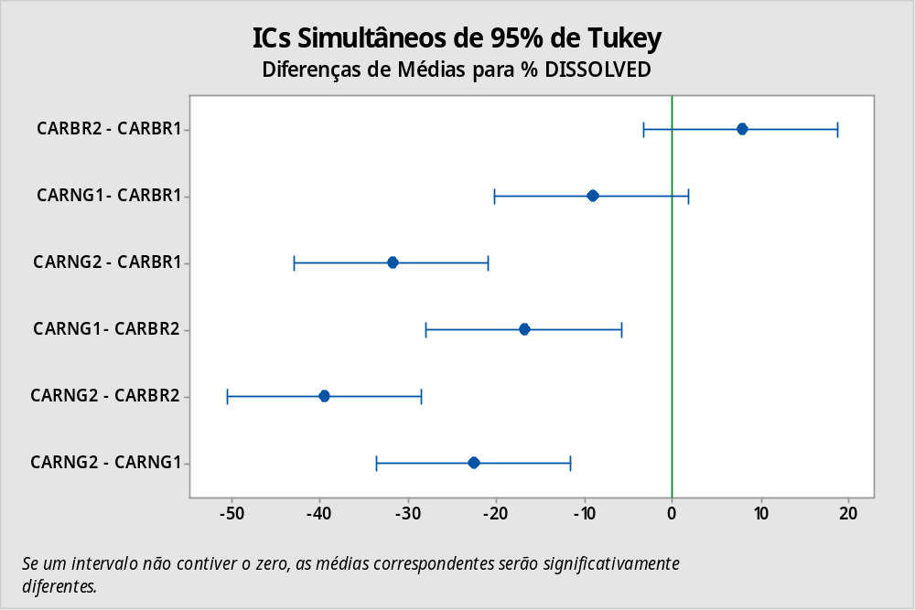
Figure 12: Confidence interval of the brands of carvedilol medicine

General evaluation of the Brazilian and Nigerian brands

Table 4: Percentage of products which passed the dissolution test.
Drug | Brazilian Brands | Nigerian Brands
Albendazole | 66.7% | 33.3%
Ibuprofen | 100% | 66.7%
Furosemide | 100% | 100%
Glibenclamide | 100% | 0 %
Hydrochlorothiazide | 100% | 100%
Carvedilol | 100% | 50%

Table 4 showed the summary of the dissolution test of the brands of medicines in this present work. It was observed that out of the 17 brands each of the Brazilian and Nigerian medicines tested, 94.1% and 58.8% passed respectively. However, none of the glibenclamide products from Nigeria passed. The furosemide and hydrochlorothiazide samples from both countries passed. It was obvious that a higher percentage of Brazilian products passed, which may be attributed to the higher availability of generic medicines in the Brazilian pharmaceutical market which makes it difficult for adulteration or faking to take place. As most Nigerian medicines were imported from foreign countries, it makes it easier for adulteration or falsification of the products.

CONCLUSION
From the results of the dissolution studies performed on the Brazilian and Nigerian brands of medicines, it can be concluded that a higher percentage of Brazilian medicines (about 94.1%) passed the dissolution test as compared to a lower percentage of the Nigerian medicines (about 58.8%) that passed. The brands of medicines tested showed statistical significant difference with the exception of hydrochlorothiazide. The presence of generic medicines in the Brazilian pharmaceutical market may be one of the contributory factors to the differences in dissolution observed between the Nigerian and Brazilian brands. This observation has enabled a diagnosis of the dissolution test in Nigeria in comparison with Brazil.

ACKNOWLEDGEMENT
I (Henry Ifeanyi Ezeagu) hereby acknowledge CNPq for awarding a scholarship which enabled me to fulfill all the financial requirements to making this project a reality.

REFERENCES

- FDA Guidance for industry: Dissolution Testing of Immediate Release Solid Oral Dosage Form. Rockville, MD: FDA. 2015.
- FDA Guidance for Industry; Dissolution Testing of Immediate Release Solid Oral Dosage Forms; U.S. Department of Health and Human Services, Food and Drug Administration, U.S. Government Printing Office: Washington, DC , FDA, 2007.
- Zhu H, Zhou H, Seitz K. Bioavailability & Bioequivalence in Developing Solid Oral Dosage Forms. USA. Academic Press, 2009: 341-364.
- Rahul M, Piyoosh S, Tekade M, Atneriya U, Dua K, Hansbroe PM. Microsponge Embedded Tablet for Sustained Delivery of Nifedipine. Pharm. Nanotechnol, 2017.
- Qiu Y, Chen Y, Zhang GG, Yu L, Mantri RV. Developing Solid Oral Dosage Forms: Pharmaceutical Theory and Practice. Academic Press, 2016.
- FDA Guidance for industry: Waiver of in vivo Bioavailability and Bioequivalence Studies for Immediate Release Solid Oral Dosage Forms Based on a Biopharmaceutics Classification System. Rockville, MD: FDA, 2017.
- Ferraz HG, Carpentieri LN, Watanabe SP. Dissolution Profile Evaluation of Solid Pharmaceutical Forms Containing Chloramphenicol Marketed in Brazil. Brazilian Archives of Biology and Technology, 50(1), 2007: 57-65.
- Aondover GF, Patrick AO, Joel AB. Quality Control Properties of Some Brands of Veterinary Albendazole Boluses Common in Nigeria. African Journal of Pharmacy and Pharmacology, 2(20), 2014:135-139.
- Eichie EF, Ikhuoria MA, Oliver CE. In vitro Evaluation of the Pharmaceutical Quality of Some Ibuprofen Tablets Dispensed inNigeria. African Journal of Pharmacy and Pharmacology, 3(10), 2009:491-495.
- Odeniran OA, Samali A, Mbah CC. A simple UV-Spectrophotometric Method for the Assay of Hydrochlorothiazide in Tablet Dosage Forms and its Application in the Quality Assessment of Some Marketed Brands in Nigeria. African Journal of Pharmaceutical Research & Development, 4(1), 2012:31-34.
- Julide A, Ayla G. Studies on Furosemide Tablets I Dissolutions of Commercial Products and Different Formulations. International Journal of Drug Development and Industrial Pharmacy, 13(1), 2008: 2199-2208.
- Chinaka CN, Nwachukwu N. Comparative in vitro Quality Assessment of Five Brands of Furosemide Tablets Marketed in Port Harcourt, Nigeria. Nigerian Journal of Pharmaceutical Research, 13(2), 2017.
- Elhamili A, Bergquist J, El-attug M, Saad S, Saad F, Hemiss G, Almog T. Pharmaceutical Evaluation of Type II Oral Anti-diabetic Agent. International Journal of Pharma Research & Review, 3(6), 2014:1-9.
- Eraga SO, Idemili CAD, Iwuagwu MA. Pharmaceutical Quality Assessment of Brands of Metformin Hydrochloride Tablets Available in South-East Nigeria. African Journal of Pharmaceutical Research & Development, 12(3), 2020:333-341.
- Madureira GLN, Brigida CRB, Fernando TAN. Avaliação do Perfil de Dissolução de Comprimidos de Ibuprofeno. Jornada de Farmácia, 2016.
- Mahle F, Goelzer F, Adriano J, Felippe M, Vier N, Carli RBG, Rosa T, Couto AG, Lucinda SRM. Evaluation of the Dissolution Profile of Hydrochlorothiazide Tablets Marketed in Brazil. Brazilian Journal of Basic and Applied Pharmaceutical Sciences, 28(3), 2008:265-271.

- Ferreira DSM, Viana CMGL, Matos AMR, Ramon RS, Fernanda ADSS, Milleno DM, Edith CLC, Hemerson IFM, Anibal DF, Santos J. Comparative In vitro Analysis of Dissolution Profiles of Furosemide Tablets Marketed in Bahia, Brazil. Latin American Journal of Pharmacy, 35(9), 2016: 2064-2070.

- Gianotto ADSE, Renata PA, Maurilio JLF, Alexandre CSCF, Marlene MFN. Dissolution Test for Glibenclamide Tablets. Quim. Nova, 30(5), 2007:1218-1221.

- USP. USP 36–NF 31, 1092 In Vitro and In Vivo Evaluation of Dosage Forms. Rockville, MD: USP; 2014:720–735.

- UNITED STATES PHARMACOPEIA (USP). Dissolution of Solid Pharmaceutical Dosage Forms. Pharmacopeial Forum, 27(3), 2016:711-2505.

- UNITED STATES FOOD AND DRUG ADMINISTRATION (USFDA). FDA’s Dissolution Guidance, 2018.

