Consistency of the drug-target proteins profile in human tumor tissues and cell lines of colorectal carcinomabased on the human protein database
Yi-wen Zhang, PhD, Luo Fang, PhD, Zong-fu Pan, PhD, Ping Huang, PhD#
Laboratory of Clinical Pharmacy, Zhejiang Cancer Hospital, Hangzhou, 310022, Zhejiang Province, China
# Correspondence author:
Email: Huangping1841@zjcc.org.cn; Tel: +86 571 8812 2438; Fax: +86 571 88122114

Abstract
Molecularly targeted therapy is the main direction of anti-tumor care. Cell line is wildly used in the preclinical researches of molecularly target drug. While, the consistency of drug-target proteins profile between the human tumor tissues and human tumor cell lines is remained uncertain. In our study, we compared the expression level of drug-target proteins in patients’ colorectal carcinoma tissue with Caco-2 cell line from human protein database to clarify the consistency.
The protein expression levels of FDA-approved target-proteins involving in both colorectal carcinoma patients and cell lines were scored base on the intension and quantity of immunohistochemical stain from the database of Human Protein Atlas. And the protein expression between individual and cell line was compared. Then the consistency profiles of total proteins between individual and cell line were evaluated. Ultimately, proteins with well or poor consistent expression were identified analyzed by Gene ontology and KEGG enrichment.
The expression levels of 176 target proteins involving in both Caco-2 cell line and colorectal carcinoma patients (n=104) were obtained and analyzed. Almost 57.4% of proteins in individual patients were consistent to cell line, which was independently from individual characteristics, such as age, gender and tumor location. About 40% and 47% of total protein, included 47 and 36 proteins with entirely consistent and inconsistent profile, were well and poor consistent expression between patients and cell line, respectively. Those inconsistent proteins were enriched in the pathways related to various types of cancer, immune, extracellular matrix receptor interactions and cytoskeleton.
There was a significant difference in the target protein expression between Caco-2 cell line and colorectal tissue, the results suggest that the consistency was important to investigate cell as the model in drug preclinical development.

Image
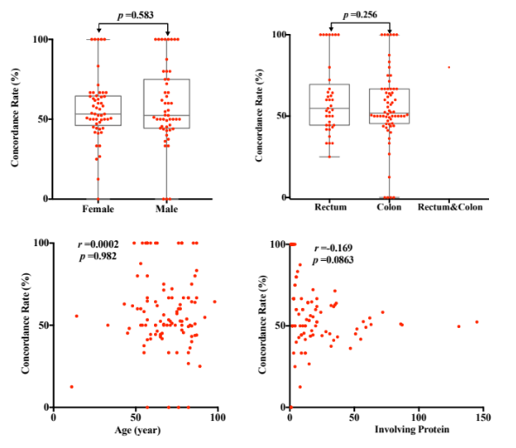
Fig. 1 Correlation of concordance rate and gender, age, type of tumor or number of involvoing protein for individual

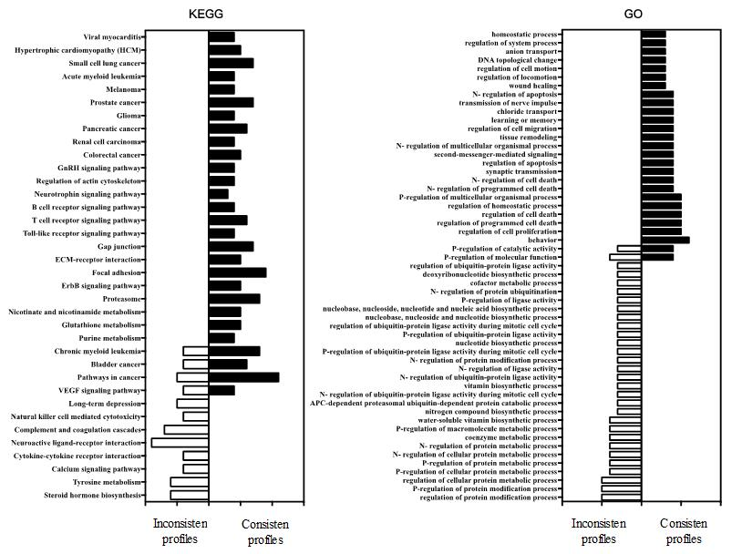
Fig. 2 Results of function and pathway enrichment between colorectal carcinoma patients and cell lines
Recent Publications
- Colwill K, Gräslund S, Renewable Protein Binder Working Group. (2011). A roadmap to generate renewable protein binders to the human proteome. Nature methods 8(7): 551-558.
- Zhao Y, Wang J, Wang Y, Huang J. (2012). A comparative analysis of protein targets of withdrawn cardiovascular drugs in human and mouse. Journal of clinical bioinformatics 2(1): 10.
- Toomey D, Hoppe H C, Brennan M P, Nolan K B, Chubb A J (2009). Genomes2Drugs: identifies target proteins and lead drugs from proteome data. PloS one 4(7): e6195.
- Banerjee S, Flores-Rozas H. (2010). Monoclonal antibodies for targeted therapy in colorectal cancer. Cancer biology & therapy 9(8): 563-571.
- Liang B, Li C, Zhao J. (2016). Identification of key pathways and genes in colorectal cancer using bioinformatics analysis. Medical Oncology 33(10): 111.

Biography
Zhang Yi-wen, PhD, has her expertise in pharmacogenetics on the in vivo process of chemotherapy drugs and endogenous substances, quantitative pharmacology research based on population pharmacokinetics. Participate in the construction of important new drug discovery platform of ‘High throughput screening and evaluation of drug metabolism in vitro in cellular and molecular level’ and response to the several study of Phase I clinical trial. Now she serves as youth committee member of chemotherapy pharmacological professional committee of Chinese pharmacological society and the precision medical branch of provincial translational medicine institute. She has undertaken four research projects, including national natural science foundation for young.
Email: zhangyw@zjcc.org.cn

Notes/Comments:

