Biosynthesis of Levan by using the strain Zymomonas mobilis

ATCC 10988 in static and shaking fermentation
Angela CASARICA, PhD, Ana Despina IONESCU, PhD,
Corina BUBUEANU, PhD, Delia Maria JITEA, Eng, Maria PETRESCU, Eng
National Chemical-Pharmaceutical for Research and Development Institute, Vitan Avenue, No.112, District 3, Bucharest, Romania

Abstract (300 word limit)
Levans are fructose polymers synthesized by a broad range of microorganisms and a limited number of plant species as non-structural storage carbohydrates and they have potential applications in the pharmaceutical, food, and cosmetic industries (1-5). The present study shows a comparative analyses of polysaccharide type Levan biosynthesis in static and shaking fermentation by using Z. mobilis ATCC 10988 strain. All fermentation processes were carried out in Erlenmeyer flasks presenting a capacity of 500 ml and working volume of 100 ml culture medium, in both fermentation types: static and on the rotary shaker, with stirring of 220 rpm, with the temperature maintenance at 32°C for 72 hours. In figure 1 we can find the results obtained by static fermentation for different initial concentrations of sucrose. The best development of the microbial culture in terms of microbial biomass was seen for the initial concentration of 15% sucrose, due probably to the favorable ratio between the source of C and N. The largest amount of polysaccharide was obtained from the experiment with 40% initial sucrose (8.9 g%), but this value is also similar to the experiment with 25% initial sucrose (8.47 g%). The Figure No. 2 shows the results obtained by the stirred fermentation with the strain Z. mobilis ATCC 10988 for different initial concentrations of sucrose. Concerning the content of polysaccharide, if the initial concentration of sucrose in the biosynthesis medium was greater than 20%, the amount of polysaccharide was about 5 g %, without any increase of production in the case of higher concentrations. By comparing the results shown in figures 1 and 2, it can be noticed that the strain Z. mobilis ATCC 10988 performs better concerning the polysaccharide biosynthesis in the frame of a static fermentation, which is not a surprise considering that this bacteria is an optional aerobic one.
Image
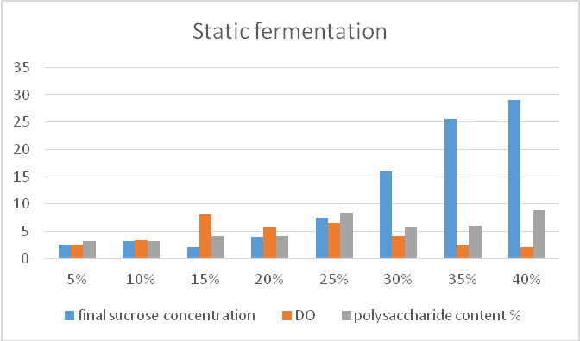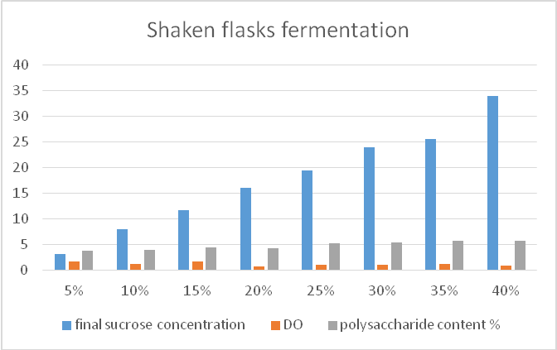
Figure 2. Results of the shaking fermentation (72 h) with Z. mobilis strain
ATCC 10988 for different initial concentrations of sucrose

Figure 1. Results of static fermentation (72 h) with
Z. mobilis
strain ATCC 10988 for different initial concentrations of sucrose

Recent Publications (minimum 5)
- Park H-E, (2003) Enzymatic synthesis of fructosyl oligosaccharides by levansucrase from Microbacterium laevaniformans ATCC 15953. Enzyme Microb. Tech. 32: 820-827.
- Rairakhwada D, (2007) Dietary microbial levan enhances cellular non-specific immunity and survival of common carp (Cyprinus carpio) juveniles. Fish Shellfish Immun. 22: 477-486.
- Gupta S, (2008) Microbial levan in the diet of Labeo rohita Hamilton juveniles: Effect on nonspecific immunity and histopathological changes after challenge with Aeromonas hydrophila. J. Fish Dis. 3: 649-657.
- Kang SA, (2009) Levan: Applications and perspectives. pp. 145-161. In: Microbial Production of Biopolymers and Polymer Precursors. Rehm BHA (ed). Caister Academic Press, Norfolk, UK.
- Jathore, N. R., (2012) Microbial levan from Pseudomonas fluorescens: Characterization and medium optimization for enhanced production. Food Science and Biotechnology, 21(4), 1045–1053. doi:10.1007/s10068-012-0136-8.

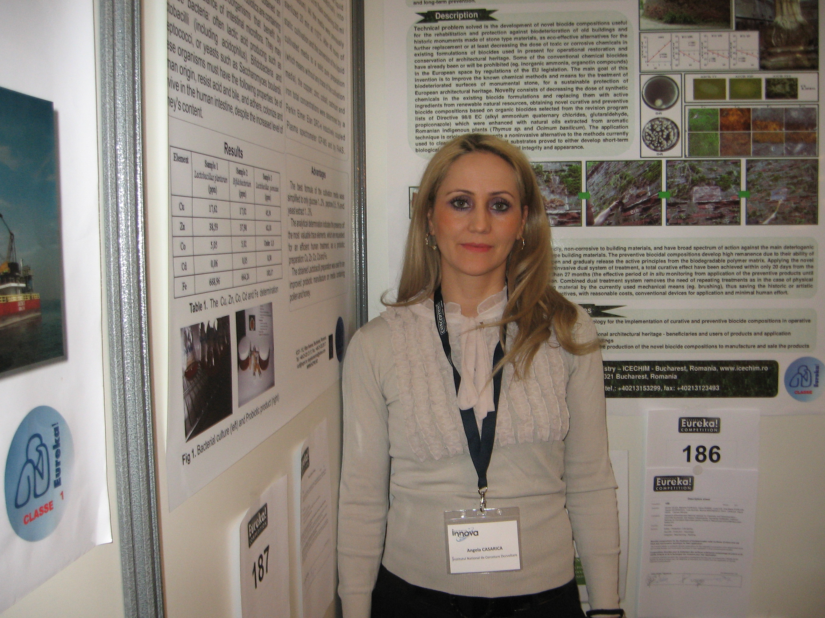 Biography (150 word limit)
Dr. Eng. Angela Casarica has her expertise as a Project Responsible of different Romanian Research Projects related to Bacterial Cellulose for pharmaceutical and industrial purposes, Studies to obtain an eyewash technology based truffle extract, Fungal chitosan: isolation and biological characterization, Curdlan-Type Polysaccharide Obtained Using a Strain of Agrobacterium Rhizogenes, Product of natural origin for ophthalmic treatment and obtaining procedure. This work and experience in biotechnology was attained by approximately 10 biotechnological processes, 7 patents and over 50 scientific papers published in specialized journals. She is a PhD in the field of Horticulture and she obtained more Medals at the International Innovation Fairs from Brussels and Geneva during the period 2008–2014. She is working as a senior scientific researcher at the National Chemical-Pharmaceutical for Research and Development Institute, Bucharest, Romania.

Email: angelacasarica@yahoo.com

Notes/Comments:

