Biotechnological studies on some plant species able to be used for the remediation of pharmaceutical industry's wastewater
Ana Despina Ionescu, PhD,
Angela Casarica, PhD, Elena Boca, Eng.
National Chemical-Pharmaceutical for Research and Development Institute, Vitan Avenue, No.112, District 3, Bucharest, Romania

Abstract (300 word limit)
A constructed wetland is an artificial wetland created for the purpose of treating anthropogenic discharge such as municipal or industrial wastewater. It may also be created for land reclamation after mining, refineries, or other ecological disturbances. Constructed wetlands are engineered systems that use natural functions of vegetation to treat different water streams (1). Plants are often thought of as a treatment pathway. With a plant mono-culture, it is possible to accurately and to model the behavior of a wetland. In additional, a detailed water characterization is necessary to determine explanatory parameters and inventory the constituents in the water (2). In this paper we provide our researches carried out a a laboratory level, concerning the use of some selected plants in order to be used for the remediation of the wastewater resulted from the pharmaceutical industry. The tested specieswere the algae Chlorella vulgaris and the aquatic plants Lemna minor and Spyrogira sp. The algae culture was obtained by successive selection works starting from an identified cell and then all plant species were kept on special selected growth media. The 5 tested solutions used as representing some natural waste waters consisted in NH₄NO₃, Pb (NO₃)₂, MgSO₄, ZnSO4 and NaCl. The ions which were analyzed concerning their concentration's evolution during a period of 72 hours (starting from 1%) were: Pb, NO₃, SO₄, Mg, Zn and Cl. The results indicates a better final situation in the case of those 2 aquatic plants, than in the case of using Chlorella.

Image

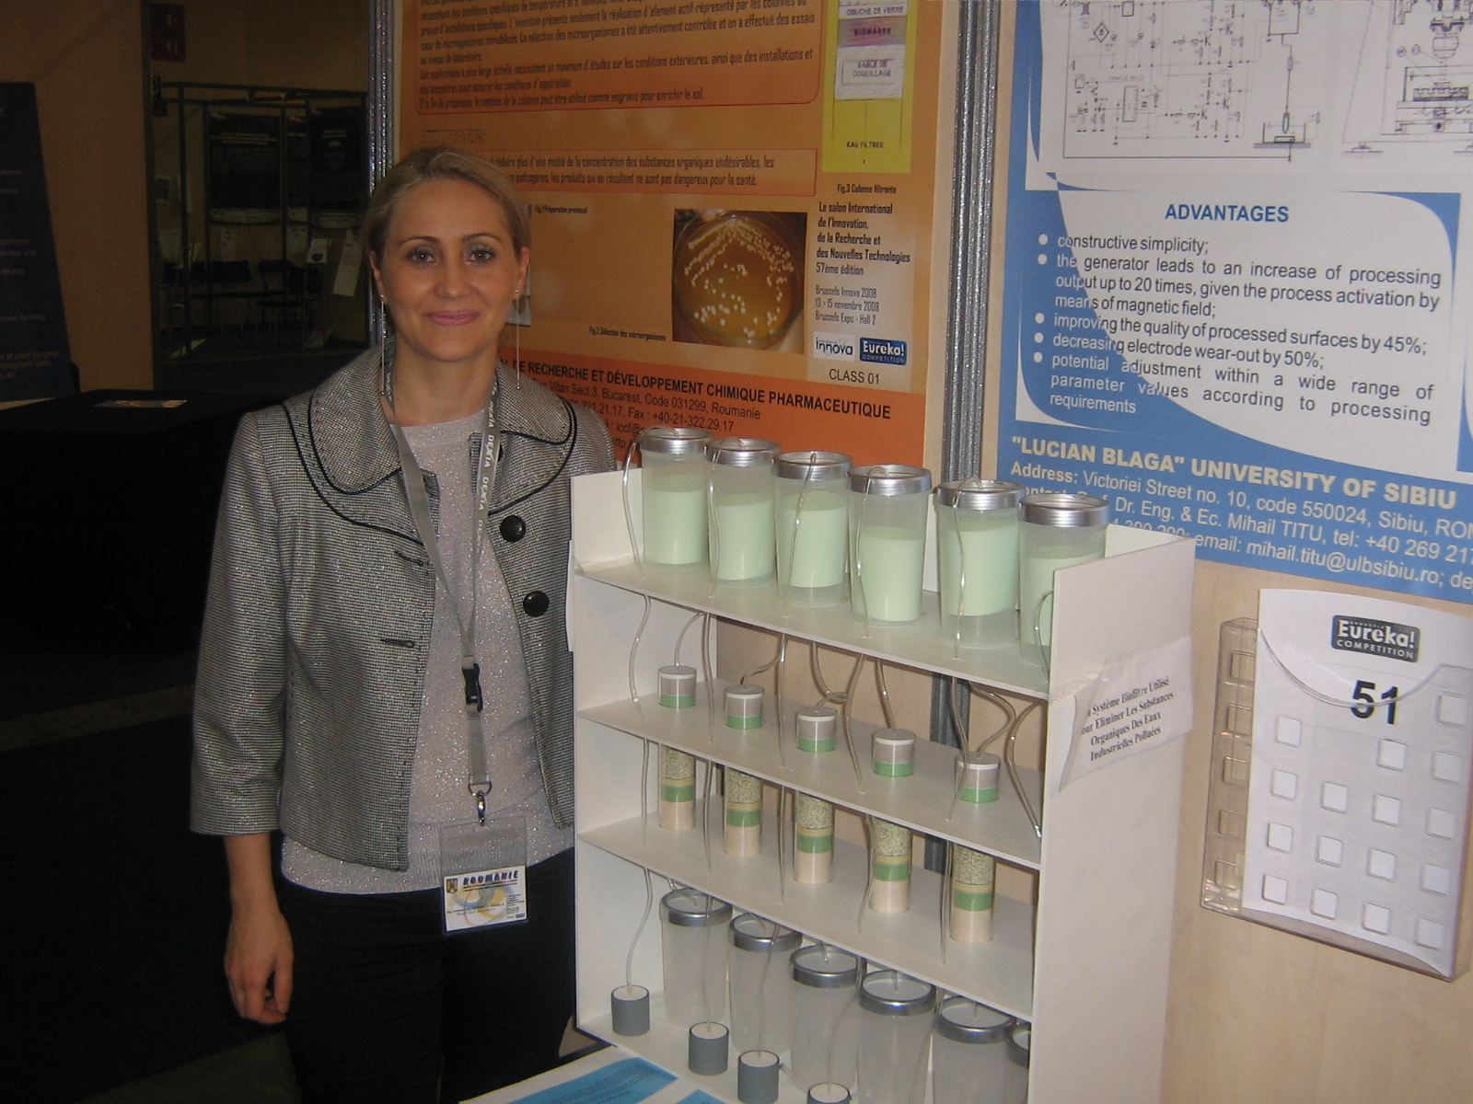

Recent Publications (minimum 5)
- Hoffmann, H. et all. (2011) Technology review of constructed wetlands - Subsurface flow constructed wetlands for greywater and domestic wastewater treatment. GmbH, Germany
- Haakensen, Monique et all (2015) Key Aspects for Successful Design and Implementation of Passive water Treatment Systems, Haakensen
- Gratão L. P. et al. (2005) Phytoremediation: green technology for the clean up of toxic metals in the environment. Braz. J. Plant Physiol. 17: 53-64.
- Elisa Garcia (2015) 5 of best plants for phytoremediation”, Environment Posts, Fresh Trends.
- Colin Withers (2014) Bioremediation of industrial pollution, Greening the desert Project,

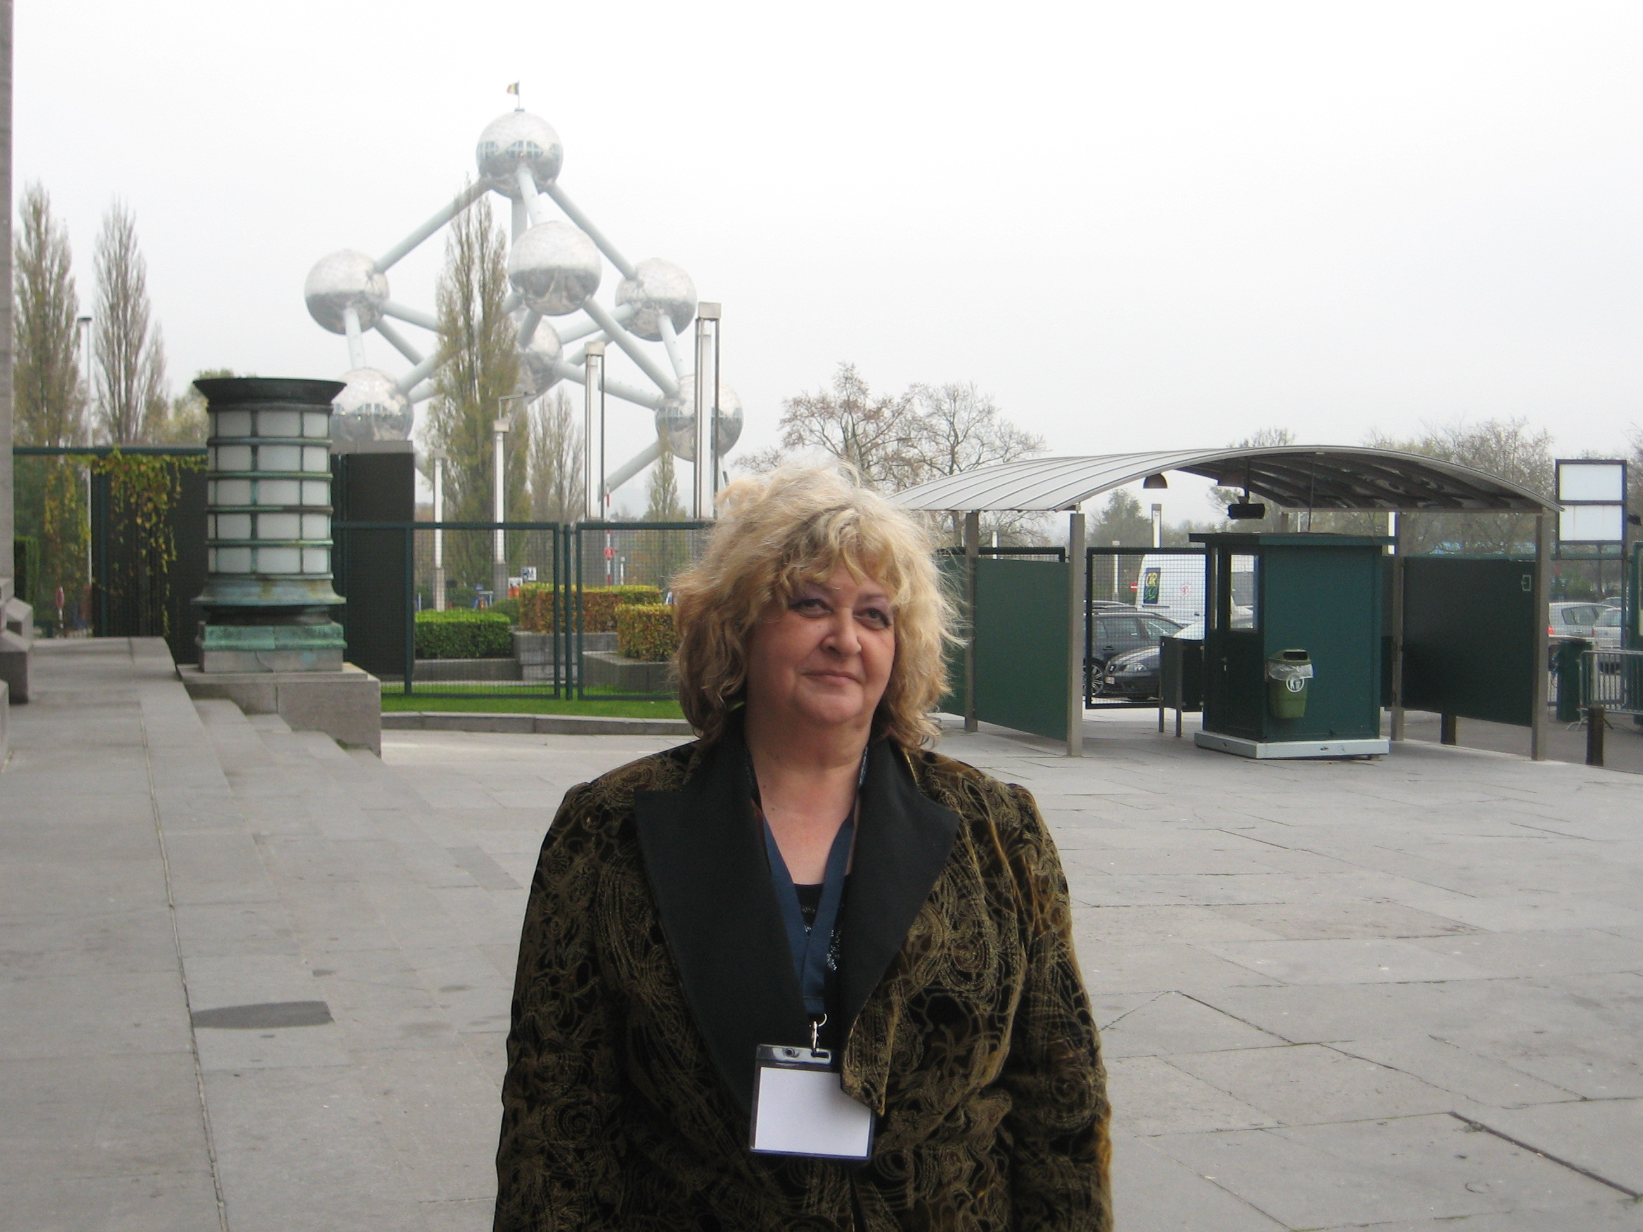Biography (150 word limit)
Dr. Biologist Ana Despina Ionescu has her expertise as a director of different Romanian Research Projects related to the bioremediation of the industrial waste waters, the use of some biological filtering systems in order to reduce the toxic contaminants of some natural water resources and the establishment of requested parameters in order to use the natural mineral water springs for the public health improvement. She is a PhD in the field of Industrial Biology and she obtained more Medals at the International Innovation Fairs from Brussels and Geneva during the period 2005 – 2014. She is working as a senior scientific researcher at the National Chemical-Pharmaceutical for Research and Development Institute, Bucharest, Romania.
Email: ionescudespina@yahoo.com

Notes/Comments:

