
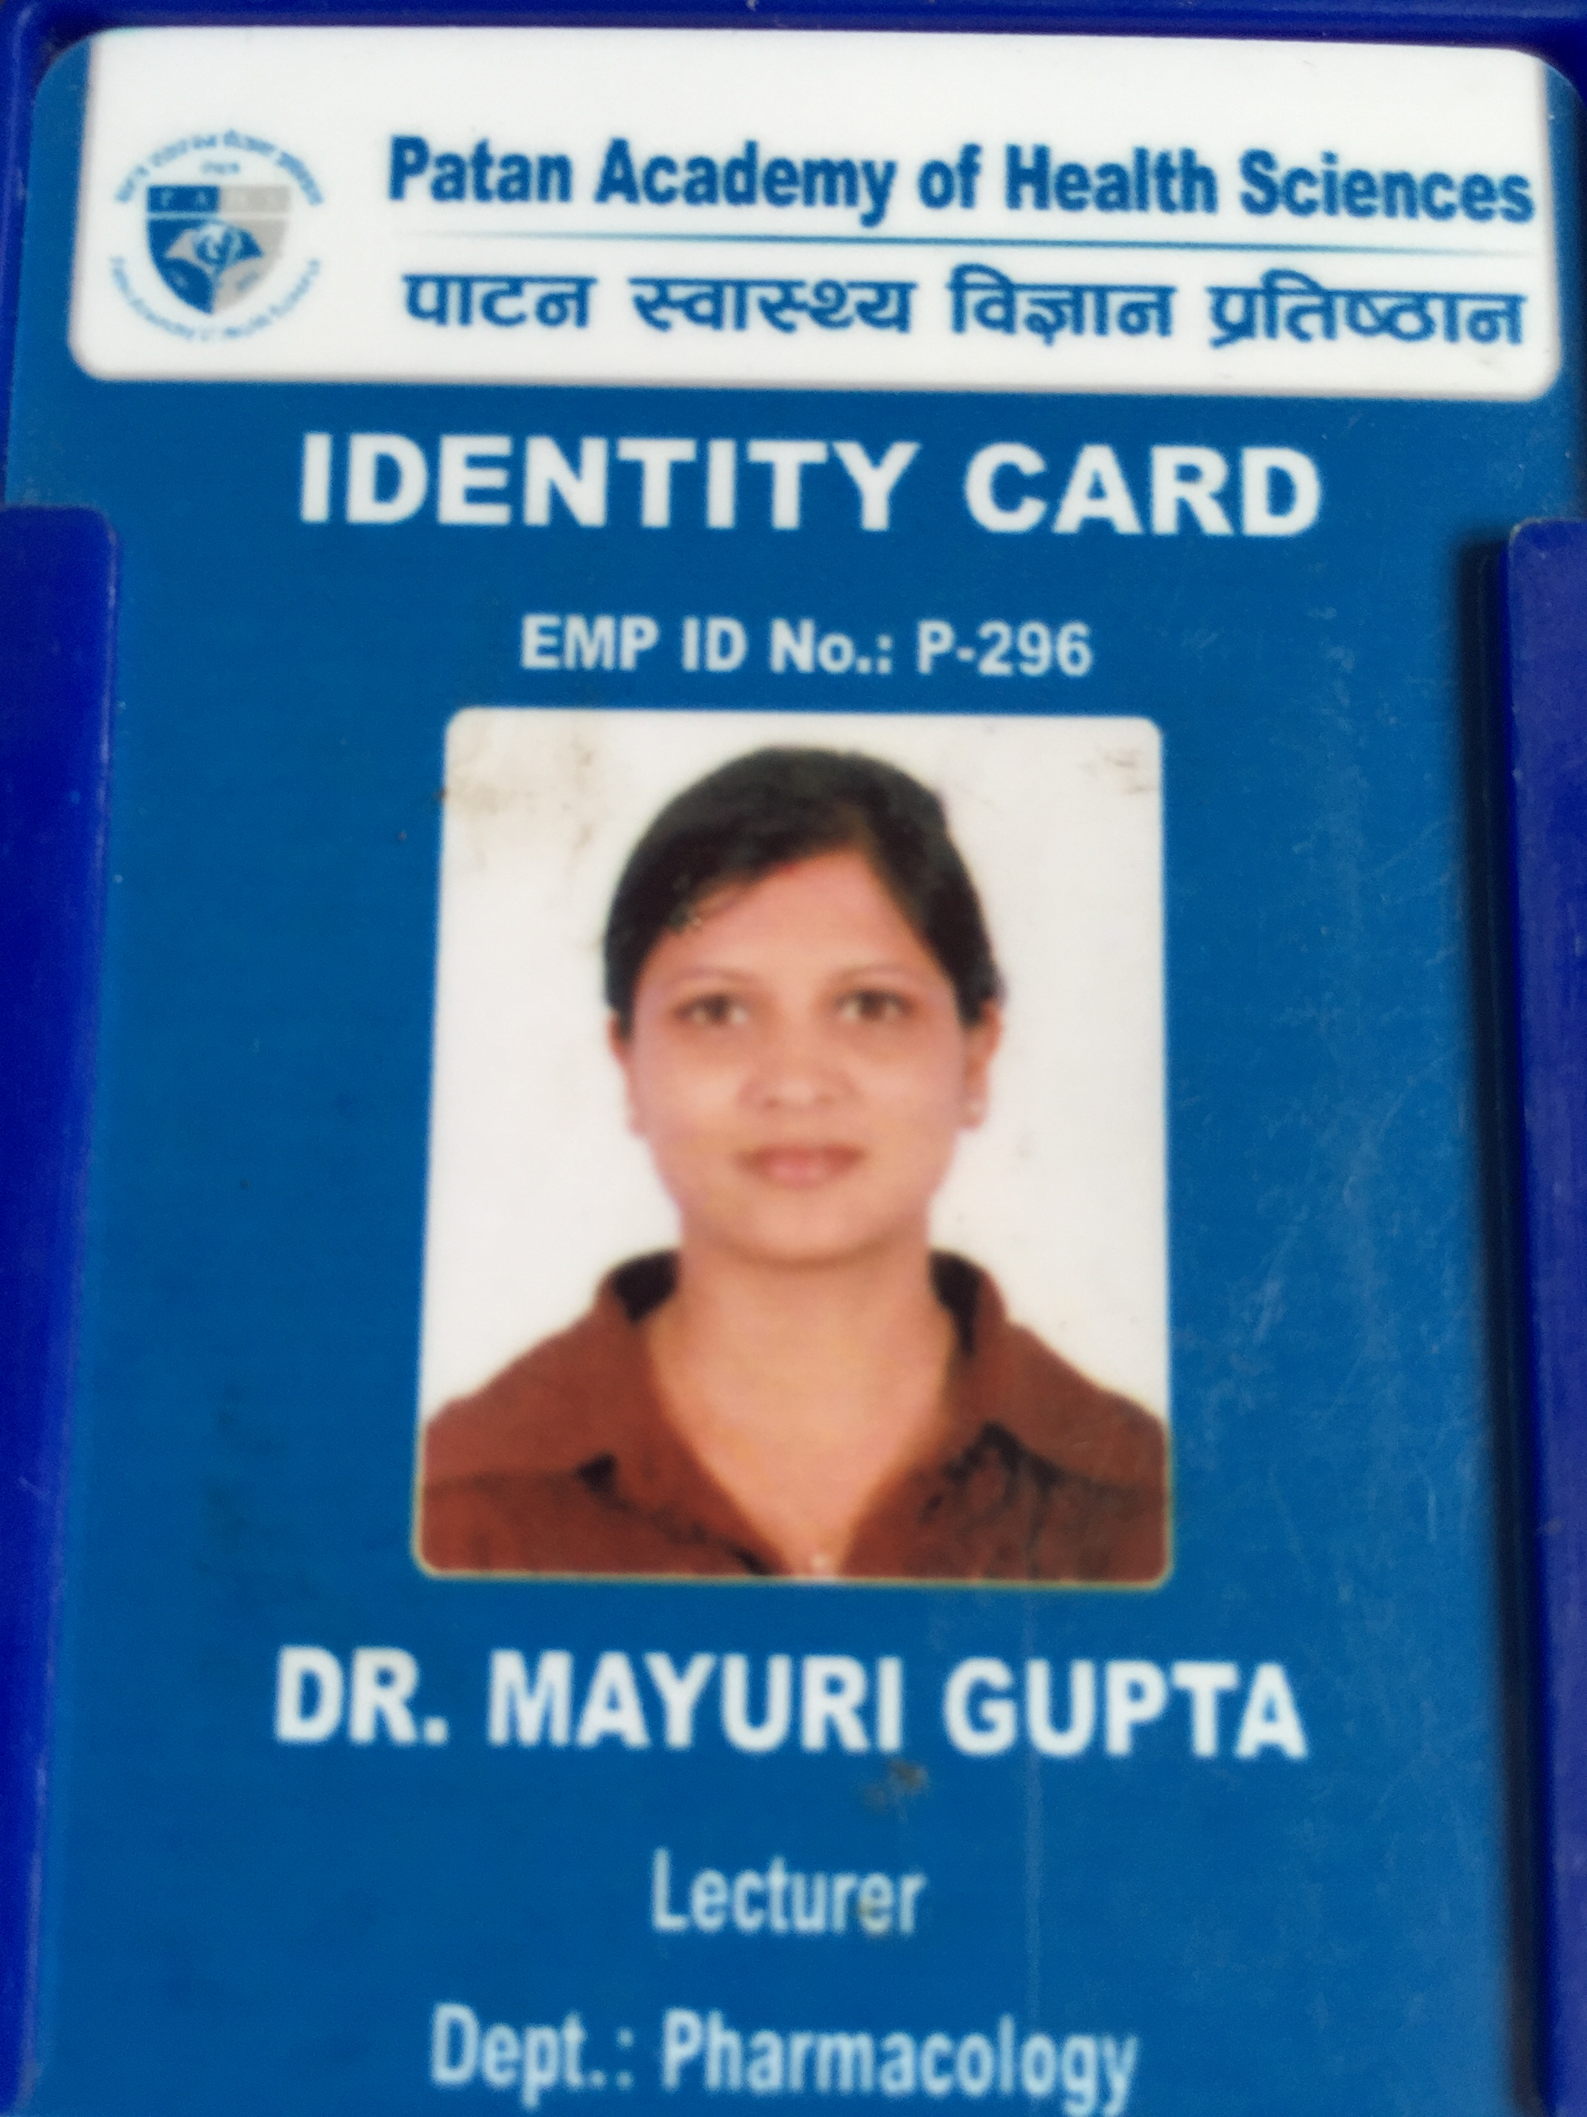

Paste you r Logo here
Paste your Photograph Here

Title: A Comparative study on efficacy of polymyxin B, Neomycin and Polymyxin B, Neomycin, Hydrocortisone in the treatment of Otitis externa
Name: Dr. Mayuri Gupta Pathak

Patan Academy of Health Sciences
Kathmandu, Nepal

Acute otitis externa is a common condition involving inflammation of the ear canal. The acute form is caused primarily by bacterial infection, with Pseudomonas aeruginosa and Staphylococcus aureus the most common pathogens. Acute otitis externa presents with the rapid onset of ear canal inflammation, resulting in otalgia, itching, canal edema, canal erythema, and otorrhea, and often occurs following swimming or minor trauma from inappropriate cleaning. Tenderness with movement of the tragus or pinna is a classic finding. Neomycin/polymyxin B/hydrocortisone preparations are a reasonable first-line therapy when the tympanic membrane is intact. Oral antibiotics are reserved for cases in which the infection has spread beyond the ear canal or in patients at risk of a rapidly progressing infection.
Aim : To compare the efficacy of polymyxin B, Neomycin and Polymyxin B, Neomycin, Hydrocortisone in the treatment of Otitis externa.
Methodology : This study was carried out in the Department of ENT, Nepal Medical College Teaching Hospital (NMCTH), Attarkhel, Kathmandu, Nepal from August 2012 to May 2014. This, prospective randomized study included patients with otitis externa. Patients of all age groups and both gender were included in this study. Patients were randomized into two groups; Group A patients, who received Polymyxin B, Neomycin and Group B patients, who received Polymyxin B, Neomycin, Hydrocortisone. Pack soaked either with polymyxin B neomycin/ hydrocortisone and applied for 48 hours. If not recover again applied for next 48 hours. The study will be conducted on the patient diagnosis, clinical features- signs: 1. Tragaltenderness. 2. Circumduction tenderness
Thus, the efficacy was compared between two drug groups.

Biography

I obtained MD in Clinical Pharmacology from Nepal Medical College Teaching Hospital (NMCTH), Kathmandu, Nepal in 2015. I obtained MBBS from Kathmandu Medical College Teaching Hospital (KMCTH), Kathmandu, NEPAL in 2006. Currently working as Lecturer at Patan Academy of Health Sciences (PAHS), Kathmandu Nepal. Worked as a tutor in Clinical Pharmacology before starting MD for 3 months in NMCTH. My trainings include Neonatal advanced life support in KMCTH, Interdepartmental clinical meeting on “Diabetics and Anesthesia” in KMCTH and advanced cardiac life support in Anesthesia in NMCTH. I have also done oral presentation at Las Vegas, USA in 2016.

Email Id: mayuri.sweetypie@gmail.com

