Durvernoy’s gland secretion of Philodryas patagoniensis: a new approach to drug development
Juliana C Badari, Master Degree Student, Butantan Institute, São Paulo - Brazil

Abstract

The snake venoms are biological resources with great pharmacological competence. The secretion produced by Philodryas patagoniensis Girard (1857) has been studied at proteomic levels aiming to characterize components and better understand the biological things of the material. It has already been shown that the molecules of snake venoms exhibit high therapeutic potential, among them relevant antimicrobial action. Our proposal in this study is carried out prospection of molecules with antimicrobial activity in Duvernoy secretions gland of P. patagoniensis. Therefore, purification steps were performed through RP-HPLC, looking to purify the molecules. The eluted fractions were tested by assay of inhibition of microbial growth in liquid medium against the microorganisms Pseudomonas aeruginosa, Bacillus subitilis and Penicillium expansum. The evaluation of the activities was done by spectrophotometry (595 nm) after 24 hours of incubation to evaluate the turbidity of the medium. The fractions that showed activity were submitted to SDS-PAGE in 20% polyacrylamide gel, to characterize the protein profile of the samples. We used mass spectrometry to characterize the molecular mass of the active fractions and subsequent sequencing. Among the molecules tested four exhibit antibacterial potential against microorganisms. Three of them have low molecular mass, varying approximately between 700 to 1900 Da. We also found a molecule with molecular mass of 24 kDa, which corresponds to the mass of a protein. Fractions were active against microorganisms at low concentrations and none of them had cytotoxic activity on animal cells. The results can be attributed to the bacterial cell wall structures, which differ in composition and possibly interact with the charges of the cationic peptides.

Image

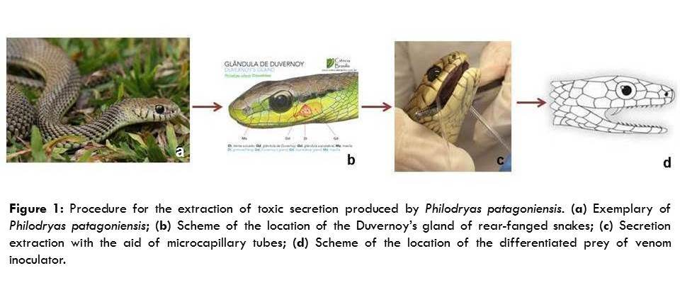
Recent Publications
- Samy RP, Sethi G, Lim LHK (2016) A brief update on potencial molecular mechanisms underlying antimicrobial and wound-healing potency of snake venom molecules. Biochemical Pharmacology 115: 1-9.
- Peichoto ME, Tavares FL, Santoro ML, Mackessy SP (2012) Venom proteomes of South and North American opstglyphous (Colubridae and Dipsadidae) snake species: A preliminary approach to understanding their biological roles. Comparative Biochemistry and Phisiologgy 7: 361-369.
- Riciluca KCT, Sayegh RSR, Melo RL, Silva Jr PI (2012) Rondonin an antifungal peptide from spider (Acanthoscurria rondoniae). Results in Immunology 2: 66-71.
- Potron A, Poirel L, Nordmann P (2015) Emerging broad-spectrum resistance in Pseudomonas aeruginosa and Ancinetobacter baumannii: Mechanisms and epidemiology. International Journal of Antimicrobial Agents 45: 568-585.
- Runti G, Ruiz MCL, Stoilova T, Hussain R, Jennions M, Choudhury HG, Benincasa M, Gennaro R, Beis K, Schocchi M (2013) Functional characterization of SbmA, a bacterial inner membrane transport required for importing the antimicrobial peptide Bac7 (1-35). Journal of Bacteriology 195: 5343-51.

 Biography
Juliana Cuoco Badari is graduated in Biological Sciences. She is pursuing her master's degree in Toxinology by the post-graduate program in toxinology of Butantan Institute, where she also works as Research Support Officer. She works with bioprospecting of therapeutic molecules (antimicrobial and antiviral). In her master’s dissertation she is working with the secretion produced by a rear-fanged snake, which is not much studied, being little known.

Email:
juliana.badari@butantan.gov.br

Notes/Comments:

