

Paper Title

Failure analysis and failure investigation of UZ/ACPT1 SS SIDUM EJECTOR CONDENSER

Abstract

The Desalination Unit in ACPT1 is designed to produce fresh or potable water. With a maximum salinity of 8ppm for the use of accommodation platform. There are 2 desalination units in ACPT1 Both are in duty except when any one unit is taken for maintenance. The same manufacturing design of desalination unit (Sidem 2T50 evaporators and Electric Boilers) are installed in ACPT2 to produce fresh potable water each able to produce 50m3/day.
In the past 4 years a frequent failure were reported for the SS Ejector Condenser. Upon inspection visual and DP inspection finding revealed that: severe corrosion takes place on 3” Nossel, Chloride SCC is proposed as one of Corrosion mechanisms, surface cracks are also observed on the shell surface and weldment areas. Due to the frequent failure of Ejector Condenser, a failure analysis shall be conducted to investigate reasons of failure and draw an recommendation accordingly.

- Introduction
The Desalination Unit in ACPT1 is designed to produce fresh or potable water. With a maximum salinity of 8ppm for the use of accommodation platform. There are 2 desalination units in ACPT1 Both are in duty except when any one unit is taken for maintenance. The same manufacturing design of desalination unit (Sidem 2T50 evaporators and Electric Boilers) are installed in ACPT2 to produce fresh potable water each able to produce 50m3/day.
In the past 4 years a frequent failure were reported for the SS Ejector Condenser. Upon inspection visual and DP inspection finding revealed that: severe corrosion takes place on 3” Nossel, Chloride SCC is proposed as one of Corrosion mechanisms, surface cracks are also observed on the shell surface and weldment areas. Due to the frequent failure of Ejector Condenser, a failure analysis shall be conducted to investigate reasons of failure and draw an recommendation accordingly.

- Scope

The scope of this report is to analyze and investigate the frequent failure of UZ/ACPT Stainless Steel SIDUM Ejector Condenser. recommendation is also drawn off for solving the problem based on technical and experienced data.

- Background

  - Steam Circuit and Process Flow
Steam produced in the boiler passes through Boiler Valve 90-11 before passing to the Hogging Ejector 45-01. The hogging ejector removes the air in Cell 2 and discharges to atmosphere. The ejector is only used during start-up of the evaporator. After start-up, the vacuum is maintained by two ejectors, whose motive force is steam produced by the boiler via Regulating Valve 90-01. The downstream ejector removes non-condensables to the first stage of the ejector condenser. The exhaust steam is condensed in the second stage ejector condenser and the non-condensables are vented to atmosphere. The upstream ejector removes air from Cell 2 of the evaporator. The exhaust steam is condensed in the ejector condenser. The condensed water from the second stage flows to the first stage of the ejector condenser via Isolation Valve 40-08 and a Trap 40-04. This trap can be bypassed if necessary. The common distilled water passes through Trap 40-07 and Isolating Valve 40-12. The trap can be bypassed to the heating bundle of Cell 1 of the
evaporator. The thermo compressor steam is supplied via Isolation Valve 90-02. The thermo compressor removes the remaining vapour from the top of Cell 2, compresses it and discharges to the heating bundle, where the vapour is condensed releasing sufficient heat for the seawater to be vaporised. A temperature switch set at 100°C monitors the temperature at the outlet of the thermo compressor. If the temperature exceeds 100°C Steam Valve 90-01 closes and a High Temperature Alarm TAH-60-10 is generated.
Figure 1 shows the Desalination Unit and steam path to the hogging ejector and ejector condenser.

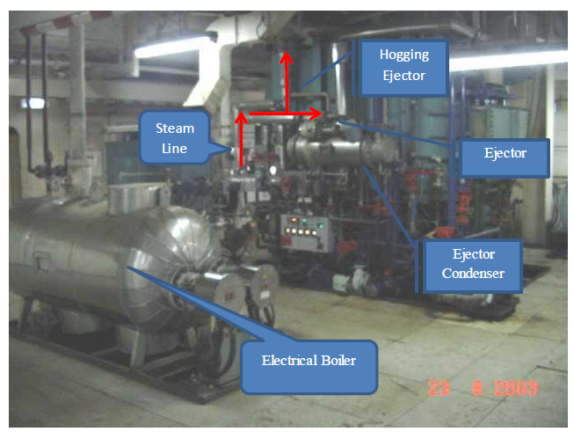

Figure 1: ACPT Desalination Unit

  - Ejector Condenser
The ejectors are operated to maintain the vacuum in Cell 2. The ejector condenser consists of Two stages. The downstream ejector removes non-condensables to the first stage of the ejector condenser. The exhaust steam is condensed in the second stage ejector condenser and the non-condensable are vented to atmosphere. Refer to Appendix 1 which shows the mechanical As built drawing of the Ejector Condenser.

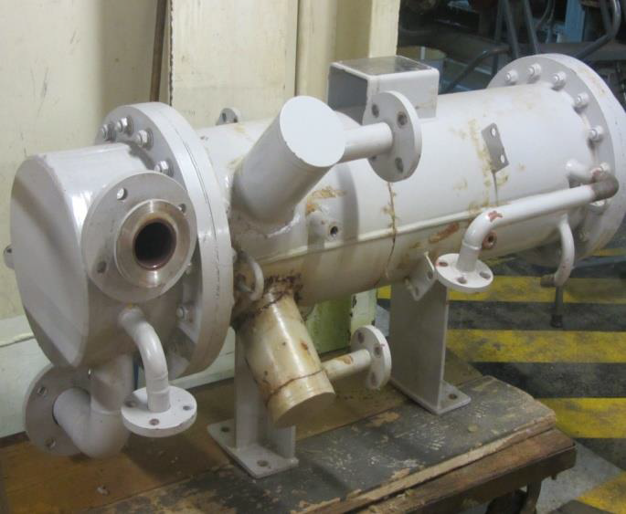
Figure 2: ACPT SIDEM Ejector Condenser

4.3 Ejector Data

Parameter | Data
Material | Stainless Steel
Steam Consumption | 20kg/hour each
Steam Pressure | 12barg

  - Ejector Condenser Data

Parameter | Data
Number of Tubes | 72
Tube Length | 1000mm
Tube Internal Diameter | 14mm
Tube External Diameter | 16mm
Tube Material Cupro-Nickel | 90/10
Tube Plate Material | Stainless Steel
Water Box | Stainless Steel

- Failure history of ejector condenser
Frequent failure are taken place for the SS ejector condenser, upon visual examination, Crack like damages are commonly taken place on the 3” 2nd stage Nossel, and near weld areas of the condenser associated nozzles. The table below shows the Inspection history findings and recommendations .inspection history shows that almost all the ejector condensers in SIDUM Desalination Plant in ACPT has failed, by frequent leak reported, and claimed that chloride SCC is the damage mechanism of shell as detailed bellow.

Year | # | Inspection Report # | Tag of Ejector Condenser | Inspection Findings | Recommendations
2010 | 1 | FIP/PRE/10/001 | Ejector Condenser of SIDEM-C | Sever External Corrosion Was found in 3” Nossel.  Reason of Sever corrosion may of CUI.
 | 2 | FIP/PRE/10/057 | Ejector Condenser of SIDEM-B | Server Internal/External Corrosion was found on 3” Nossel
 | 3 | FIP/PRE/10/066 | Ejector Condenser of SIDEM-C | 4” nossel was found cold repaired by metal putty, and previously changed the material to CS.  ¾” nossel attached to the shell found corroded.  4 tubes were plugged. | Replace 4” and ¾” nozzles with CS material .  SS309 filler material is to be used for welding CS to SS316.  4 tubes are to be replaced with new one.
 | 4 | FIP/PRE/10/240 | Ejector Condenser of SIDEM-B | Sign of leaks observed in 4” Nossel during pressure testing.  It is claimed that chloride SCC is the damage mechanism of shell, and the original design of with CS nossel is performing much better than SS nossels. Corrosion Pits observed in Inlet/Outlet | Temporary replace 4” Nossel with CS material. Using SS309 filler rod.  Repair pit in tube sheet by grinding and re-weld using ER-316.  Replace corroded 1” SS vent and drain nossel flanges connected to both end covers.
 | 5 | FIP/PRE/10/260 | EJECTOR CONDENSER of SIDEM-B | Inspection carried out for the ejector condenser according to the recommendation mentioned in previous report. | No signs for damage is observed.
2011 | 6 | UZ/OSFIP/176/11 | Ejector Condenser  from SIDEM-B | The 3” nossel found with previous cold weld repair. The original design of ejector condenser is SS shell with CS nozzels, and performing better than new SS nossels.  Minor leaks observed on both end covers to shell flange connection. | to be performed according WPS-03 using ER-309 filler wire material.
2012 | 7 | UZ/OSFIP/525/12 | Ejector Condenser from SIDEM-A, 354B04A | Two nos. cracks, approx. 160 mm and 270 mm long were observed on the 3” downstream ejector nozzle.  Other SS ejector condensers fabricated in Mussafah were suffering from pre-mature failures on the same stainless steel ejector nozzles as previously reported. The original design of the ejector condenser has SS condenser shell with CS nozzles and performing much better that the new SS nozzles.  condenser was installed/commissioned in 15/12/2011 and in service for only 8 months.  Aftab comment on march 2010:( the failure phenomenon of 3 “ SS316 Nozzle is Chloride stress corrosion cracking. As in addition to corrosion, cracking is also clearly visible on 3” Nozzle. Austenitic stainless steel 304 and 316 are highly susceptible to Chloride stress corrosion cracking at temperature above 600 C. Our seawater chloride concentration is around 25,000PPM, the operating temperature of the Nozzle is around 800 to 900C, presence of oxygen in the seawater and crevice in the nozzles accelerate chloride stress corrosion cracking of these nozzles.  For the operating condition of ejector condenser (temperature, pressure & chloride concentration) in my opinion the suitable recommended materials are 6% Mo super austenitic stainless Steel or 6% Mo  supper duplex stainless steel).  Gutham Gosh comments on 7 march 2010:( Chloride stress corrosion cracking can not be ruled out for the Stainless steel 316 (weld) in the given condition. Primarily to ensure the same, arrange to clean the surface and carry out DPT on the surface.  Pl provide process details and complete water analysis to decide material for the same)  Mathews comments on 05/01/2010.( There is no internal corrosion on nozzle or the shell. The shell and nozzle suffered from external corrosion due to CUI even though Al coating was provided) | Aftab recommendation: (as a temporary repair replacing 3” nossel with CS, as few of the ejector condensers nozzles are already of carbon steel and have given more than 6 years service life.  Sweep blast and determine the extent of Crack.  The Defective 3” SS nossel in to be replaced with CS material and will be kept as a spare.
2012 | 8 | UZ/OSFIP/538/12 | UZ/OSFIP/538/12 | As per Inspection Report No.: UZ/OSFIP/525/12 recommendations, the 3” downstream nozzle of the above ejector condenser was sweep blasted for thorough inspection of the reported cracks on the nozzle.  100% dye penetrant inspection was carried out on the ejector condenser 3” downstream nozzle. Total 2-nos circumferential cracks was observed. The approximate length of the cracks is 260.0 mm. and 280 mm. (previously reported as 160.0 mm and 270.0 mm.) | replace the defective 3” diameter stainless steel grade nozzle with carbon steel grade temporarily and kept the ejector condenser as spare  Weld using AWS E309 Mo electrode  Grit blast and coat with suitable coating the section of the ejector condenser affected by weld repairs.
2012 | 9 | UZ/OSFIP/603/12 | 354B04A Ejector Condenser (Spare) | circumferential cracks was observed on the 4” diameter nozzle.  It is recommended to replace the nozzle with carbon steel grade material based on the manufacturer material of construction | The spare ejector condenser can be put in service temporarily
2012 | 10 | UZ/OSFIP/742/12 | 354B04A – Sidem Ejector Condenser | The ejector condenser insulation was removed and revealed that the shell and stub-in nozzles was covered with metal putty. Approximately 40% of the shell section was covered with metal putty.  Total 2-nos. welded patch repairs are evident on the  shell surfaces at different locations.  Moderate to severe numerous cracking was observed on the ejector condenser 4” stub in nozzle which cause the leak in service.  Isolated crack like indications was also noted on the ejector condenser shell welded patch plates.  Moderate to severe crevice corrosion was also observed on the tube sheet circumferential weld.  One tube was found leaking and was plugged accordingly. | temporary repair is not recommended. The ejector condenser internal shell surfaces are saturated with chloride and weld repair will  result to chloride stress corrosion cracking while it is on service. It is recommeded to scrap the ejector condenser and purchase a new spare.
2013 | 11 | UZ/OSFIP/292/13 | 354B04C – Sidem Ejector Condenser | The ejector condenser was removed from service and spare refurbished ejector condenser was installed  The insulation of the ejector condenser was removed. Previous temporary repair was evident by replacing the corroded SS outlet nozzle with CS material Welded patch plate was also observed on the shell around the outlet nozzle  The top portion of the shell adjacent to the 3” inlet nozzle was covered/repaired with metal putty.  Upon removal of insulation, hole was observed on the 3” CS outlet nozzle and affecting the SS shell plate. The size of hole is approx. 160 mm x 25 mm.  The external surface of the condenser was sweep blasted. 100% dye penetrant test was carried out on the external surface of the condenser shell. Several cracks were noted on the shell with length ranges from 5 mm to 35 mm. Crack, approx. 10 mm long was observed in Nozzle #2  Approx. 60 mm long crack was observed in Nozzle #9. | Due to the present condition of the ejector condenser temporary repair is not recommended. The ejector condenser internal shell surfaces are saturated with chloride and weld repair will result to chloride stress corrosion cracking while it is on service. It is recommended to scrap the ejector condenser and purchase a new spare

- Chemical Composition analysis of 354B04C – Sidem Ejector Condenser as it is last inspected on 21/05/2013.

Body Material (SS316) |  |  | Replaced /Corrosion Condenser Nossel (CS)
Element | % | STD | Element | % | STD
Fe | 69.2 | 0.33 | Fe | 94.5 | 0.32
Cr | 16.5 | 0.16 | Zn | 5 | 0.08
Ni | 10.2 | 0.14 | Mn | 0.5 | 0.04
Mo |  | 2.2 |  | 0.03
Mn |  | 1.6 |  | 0.15
Zn |  | 0.4 |  | 0.03
Pitting Resistance Equivalent Number (PREN) =𝑪𝒓+𝟑.𝟑𝑴𝒐+𝟏𝟔𝑵  PREN=16.5+3.3x2.2+16x0  PREN=23.76 |  |  | Pitting Resistance Equivalent Number (PREN) =𝑪𝒓+𝟑.𝟑𝑴𝒐+𝟏𝟔𝑵  PREN=0+3.3x0+0  PREN=0

- General Background about Ejector Condensers
Barometric type (direct connections) are usually employed. The components vulnerable
to corrosion attack are : body, nozzles and piping. Body of the ejector condenser (CS
cladded with SS, Ti, Cu-Ni) sometimes showing metal loss has now been replaced by Fiber Reinforced Plastic (FRP) in new plants. Nozzles (SS 304 or 316) and condenser piping (316L or Cupro-nickel) are most affected by pitting, the attack is more prominent at the welded seams. On the after condenser (steam/vapor inlet pipe) severe Cl- induced S.C.C. was noted which
was attributed to high operating temperature and salt deposition. The 316L pipe was
replaced by Incoloy 825. Presence of 0.1-0.2 ppm chloride in the uncondensed gases is
sufficient to produce corrosion. Cupro-nickel and SS are replaced by 254 SMO as an
ejector condenser material in some of the plants in Qatar and Abu Dhabi due to their
poor performance.

- Chloride SCC.
Welds in the 300-series austenitic stainless steels, contain a small amount of β-ferrite to prevent hot cracking during weld solidification. In hot, aqueous chloride environment (the same environment as for ejector condenser), these duplex weldments generally shows a marked resistance to cracking, while their counterparts crack readily. The generally accepted explanations for this behavior is that the ferrite phase is resistant to chloride SCC and impedes crack propagation through the austenite phase. Electrochemical effects may also play a part however, under sufficient tensile stress, temperature and chloride concentration , these duplex weldment will readily crack.

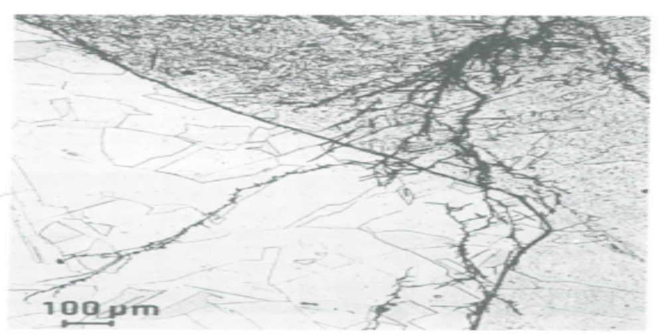

Figure 1: Chloride SCC of type 304 stainless steel base metal and type 308 weld metal in an aqueous chloride environment at 95C(200F). Cracks are branching and trans granular

  - Methods for controlling Chloride SCC.

Chloride SCC to occur it requires a chloride concentration and tensile stress focused together to cause both intergranular and transgranular cracking. This produce weakening of the metal and eventual failure. Experience indicate that the concentration of chloride in the water contacting the stainless steel is not the critical factor [2]. The main factor in the existence of conditions that allow chloride concentration cells to develop. in the absence of concentration cells or stress, chloride levels in excess of 1000 mg/L have not caused stainless steel to crack. Some desalination plants where chloride concentrations exceed 30000 mg/L have not experienced failures, when properly annealed stainless-steel construction was used. The key to preventing stress corrosion cracking is eliminating deposits and designing and fabricating stress-relieved 16

equipment that does not allow concentration cells to occur. 2 out of five methods of controlling CLSCC is addressed here in which are 1. Changing material 2. Changing design . the rest of five are not applicable in the case of Ejector condenser due to cost , operational constrain and ease of apply which are Change the Environment, Coating and electrochemical Techniques.

- Change in the material.

Acommon fix or solution of a stress corrosion cracking problem is to subtiture a more resistant alloy for the one that failed. N06600 (Alloy 600), a chromium-bearing nickel alloy, has greater resistance to cracking in high remperature chloride enviroments than does S30400(AISI 304) Austenitic stainless steel, and is often used to replace stainless steel components that fail by chloride stress corrosion cracking. [4]
It is important to identify the critical species causing the stress corrosion cracking. For example, N08800(Alloy 800) is a suitable replacement for S30400(AISI304 when chloride is the causative agent, but will fail as readily as the latter in hot caustic is the cracking agent, although it too can crack in that servise. Alloy 600 expansion joints are commonly used in chloride-and caustic –contamination steam service, despite occasional failurs, because it can offer a favorable cost: Life benefit.

2. Changing in the design.

The primery role of design changes for control of enviromental cracking is to lower the tensile stressess to bellow the threshold stress or to a level significantly less conductive to cracking. If cracking is to be alleviated. The total resultant stress from residual stresses. Thermal stresses and stresses from operational stresses, thermal stresses and stresses from operatonal loads abd oressyre must be considered.
Residual stresses from metal fabrication and unit construction are reduced by two principal methods:,

a) A stress relieving heat treatment
b) Shot-peening, sometimes reffered to as mechanical stress relief.

In the first case , a fabricated item is heated to a temperature high enough for relaxation of the residual stresses, and slowly cooled. In the second case, the metal surface is mechanically peened at an intensity sufficient to result in residual compressive stress at the surface.
A second design consideration for control of environmental cracking is to avoid geometries in which solutions accumulate. Dead spaces where steam blanketing or water evaporation can occurs are potential failure sites. Solutions with chloride concentration of 1 ppm can become concentrated to high chloride levels in crevices and other restricted geometries.
A third design consideration is the compatibility of materials throughout the system. Contact of dissimilar metals can polarize one into the potential range for environmental cracking. Chlorides leached from insulation or formed by hydrolysis of organic chlorides in elastomeric seals or plastic devises can cause stress corrosion cracking of austenitic 18-8 type stainless steels. Ammonia introduced to control pH and minimize the corrosion of steel can promote stress corrosion cracking of copper alloys in adjacent equipment. 17

The overall design should be reviewed for materials compatibility if a fix for corrosion in one part of the process is not to cause environmental cracking elsewhere in the system.

  - Performance of Alloy grouping.

The susceptibility of the respective groupings to specific environmental cracking is summarized in Table below:

Group | Alloys | Stress Corrosion Cracking
1 | Magnesium Aluminum | Aqueous Cl- Plus Oxidants  Aqueous Cl- Plus Oxidants
2 | Carbon Steels High Strength Steels 18% Maraging Steel | NaOH, NH3, NO3-, CN-, HCO3, CO/CO2/H2O See Carbon Steel Above No Information
3 | Martensitic S.S Ferritic S.S Austenitic S.S | NaOH, NaCl NaOH, Marine Tropical Atmospheres Cl-, Cl-/H2S, NaOH, H2S2O6, Supercritical Water Plus O2
4 | Lead, Tin, Zinc | No Information
5 | Copper Alloys | NH3, HNO3, SO2 Steam vs. Si Bronze
6 | Nickel N02200 Monel N04400 Alloy B, N10001 | HF plus O2, H2SiF6 HF plus O2, H2SiF6 Azo dyes, Supercritical water plus O2
7 | Inconel N06600 Alloy C N10002 Alloy C276 N10276 | NaOH(3000C), AlCl3, Supercritical Water plus O2 FeCl3, Supercritical Water plus O2. Supercritical Water Plus O2
8 | Vitallium (Cobalt) | Magnesium Chloride, NaOH
9 | Titanium Zirconium | NaCl(>2750C), 10% HCl, Chlorinated or fluorinated solvents, methanol FeCl3,I2, HCl + Fe+++ (250 ppm)
10 | Silver, gold, platinium | No identified species

- Analysis of Data and Recommendations
Reveling to the historical data, it shows that almost all the ejector condensers in SIDUM Desalination Plant in ACPT has failed, by frequent leak reported. The failure is almost located 18

3” Ejector condenser Nossel/stub inlet of steam. The 3” Nossel ejector condenser original design is CS material, as it is mentioned in inspection reports, whoever failed SS nossels was installed and then recommendations are set to replace it with CS by filler material ER309 due to the frequent failure. The CS showed a better resistance to corrosion as per inspection report , however another corrosion mechanism takes place due to dissimilar metal in contact which caused galvanic attack. The last inspected CS condenser stub showed sever oxidation deposits which caused perforation, Refer Photo of UZ/OSFIP/292/13, 354B04C – Sidem Ejector Condenser. Figure and photos shows that almost all condensers had failed on the left side 3” stub condenser rather than the right side which is still intact. Wrong design may be attributed or Material problem in which CS is failed. Crack Flaw indications was observed by DP inspection which may be attributed by Chloride SCC.
In Summary, It found that the Ejector Condenser in SIDEM Desalination Plant in ACPT had experienced frequent failure, in which it may contributed to deferent Corrosion Mechanisms. Chloride SCC may one of reasons on failure, however we still have lack of information to assess for CLSCC. Information needed are: Temperature, Chloride content pH and Oxygen level, Material is stress relived or not. Thus boiler sample is to be collected and sent to FDS Lab for Water Analysis.

  - Assessment the susceptibility of CLSCC.

Susceptibility to CLSCC is usually assessed from knowledge of environmental variables, i.e.
temperature, chloride content, temperature, pH and oxygen level.
Condensed water samples collected from Ejector Condenser body. Sample sent to FDS Lab for analysis, Appendix 3 shows water analysis results collected from ACPT1 (ejector Condenser A/B) and ACPT2 (ejector Condenser C). samples could not be collected from ACPT2 ejector condenser A/B due to operational constrain.

The following table shows the analysis results

Location | PH | Meas Conductivity (Ms/cm) | Chloride (Mg/l) or ppm
ACPT1 Ejector Condenser A | 6.78 | 0.0271 @ 68.3F | 3.69
ACPT1 Ejector Condenser B | 6.43 | 0.0147 @ 69.0 F | 2.19
ACPT2 Ejector Condenser C | 6.37 | 0.01610 @ 68.8F | 5.56

In analysisng the susceptibility of CLSCC we use the assessment by API RP 581 ‘Risk-
Based Inspection Technology Part 2.[3] which is shown in table 2 bellow.

Table 2. Proposed scheme for CLSCC susceptibility categories in aqueous
media where pH ≤ 10, and in conditions where chloride deposits may form by
drying out or by deposition. (The scheme is derived from Table 13.3M in API RP
581(2008), with the API values shown in blue.)

Temperature ° C | Chloride concentration, ppm |  |  |  | Drying out /  deposition
 | 1 to 10 | 11 to 100 | 101 to 1000 | >1000
10 to 38 | Low | Low | Low | Medium | High
>38 to 66 | Low | Medium | Medium | High | High
>66 to 93 | Medium | Medium | Medium | High | High
>93 to 149 | Medium | High | High | High | High

Note: The pH, temperature, chloride concentration and drying out/deposition rankings should
be based on the worst-case scenario including up-set conditions and short-term excursions
during operation, shut down, or maintenance.

Table 3. Change in susceptibility category for additional factors. Increase susceptibility category | Decrease susceptibility category
Sensitization is likely | Coating or wrapping with aluminium foil
History of progressive cracking where  mode has not been established | Continuous control of chloride level, pH,  or temperature during all operational and  non-operational periods.
Poor surface finish  . | Continuous dosing with appropriate  corrosion inhibitor during all operational  and non-operational periods
Surface contamination with iron
Steel manufactured before 1970
Highly cold worked and/or freemachining
steel
Pits and/or crevice corrosion already
exist
Crevice-like design features, e.g. roots
of partial penetration welds
Galvanic coupling to a more noble
Metal
Cyclic conditions – temperature or
stress

From Table 2 it shows that within Chloride Concentration 1 to 10 ppm and temperature range >66 to 149 the CLSCC category is Medium. Then the susceptibility is modified for additional factors in which the factors in yellow marks are factors attributed for the case of SIDEM Ejector Condenser. In conclusion and reveling to the assessment of susceptibility of CLSCC by API RP 581 ‘Risk-Based Inspection Technology Part 2. It can be concluded that the susceptibility 20

Category to Chloride Stress Corrosion Cracking of All Ejector Condenser in ACPT 1/2 are High.

- Conclusion And Recommendation

The result from the water analysis of ejector condenser shows that Chloride content varies from 2 to 5 ppm. Susceptibility assessment is studied b API RP581(2008), and it is shown that the ejector condenser susceptibility category to ClSCC is medium, then additional factors is considered to change the susceptibility category, and it is shows that considering the additional factors, the susceptibility of ClSCC for the ejector condenser is High. Another Damage mechanism is attributed to the Ejector Condenser is galvanic corrosion in which CS Nossel/Stub is attached to SS condenser shell (Design malfunctioning).
Avoiding ClSCC by changing the environment is not practical, because deposition of Chloride is possible either on the outer shell of condenser (CUI), nor inside the shell by vapor drying out. In addition deploying Cl scavenger chemical may affect boilers performance.
2 control methods shall be applied to control the failure of ejector condenser.
1. Changing the material to more cracking risistant alloy such as Duplex Stainless steels S32760 (Zeron 100) S31254(254 SMO), or N06625(625 Alloy)

Alloys Chemical Composition.

Alloy | Fe | C | Cr | Cu | Mn | Mo | N | Ni | P | S | Si | Al | Ti | Pitting Resistance Equevelant Number (PREN)
Zeron  100 |  | - | 25 | 0.7 | 1.0 max | 3 | 0.25 | 6 | 0.035 max | 0.010 max | 0.8 max | - | - | (PREN) =𝐶𝑟+3.3𝑀𝑜+16𝑁  PREN=25+3.3x3+16x0.25  PREN=38.9
(PREN) =𝐶𝑟+3.3𝑀𝑜+16𝑁
PREN=19.5+3.3x6+16x0.18
PREN=42.18
254 SMO | bal | 0.020 max | 19.5 | - | 1 max | 6.0 | 0.18 | 17.5 | .03 max | 0.010 max | 0.80 max | - | -
625 Alloy | 5.0 max | 0.10 max | 20.0 | - | 0.50 max | 8.0 | - | bal | 0.015 max | 0.015 max | 0.50 max | 0.4 max | 0.40 max | (PREN) =𝐶𝑟+3.3𝑀𝑜+16𝑁  PREN=20+3.3x8+16x0  PREN=46.4

Referring to approximate relative pipe cost assuming that it is applicable to exchangers also, it is noticed that Alloy 625 has much higher relative cost (22.8) compared with 254SMO alloy (9.2) and Ziron 100 (6.8). Alloy 254SMO has better pitting resistance than Ziron 100, and thus it is recommended to use Alloy 254SMO as a condenser material.
2. Residual stresses from metal facricatrion and during constructin is to be reduced by stress releiving heat treatment and shot peening1

1 the metal surface is mechanically peened at an intensity sufficient to result in residual compressive stresses at the surface.
A good insulation application is to be applied on the outer shell of condeser as per ZADCO Spec for Hot Insulation, to avoid chloride penetration and deposition on the outer shell.
3. It is recommended to monitor the corrosion of the condenser by conducting regular inspection ( 6 monthly is preferable).

APPINDIX 1: Images and Photos taken for the Ejector Condenser

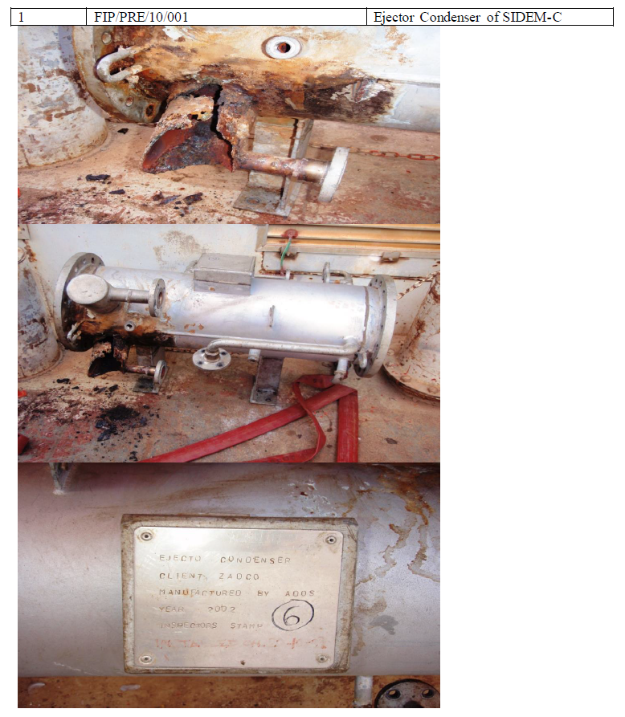

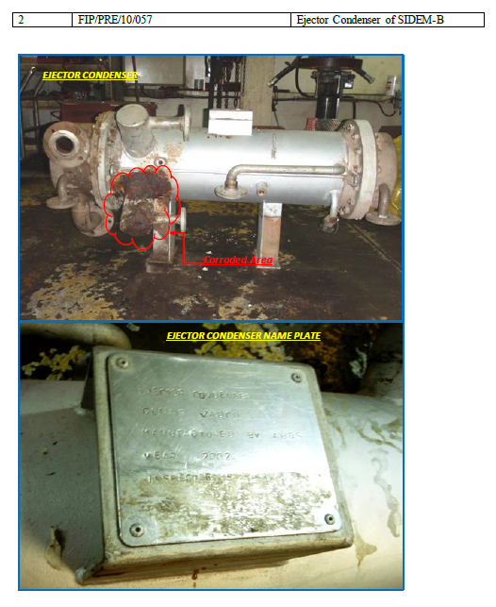

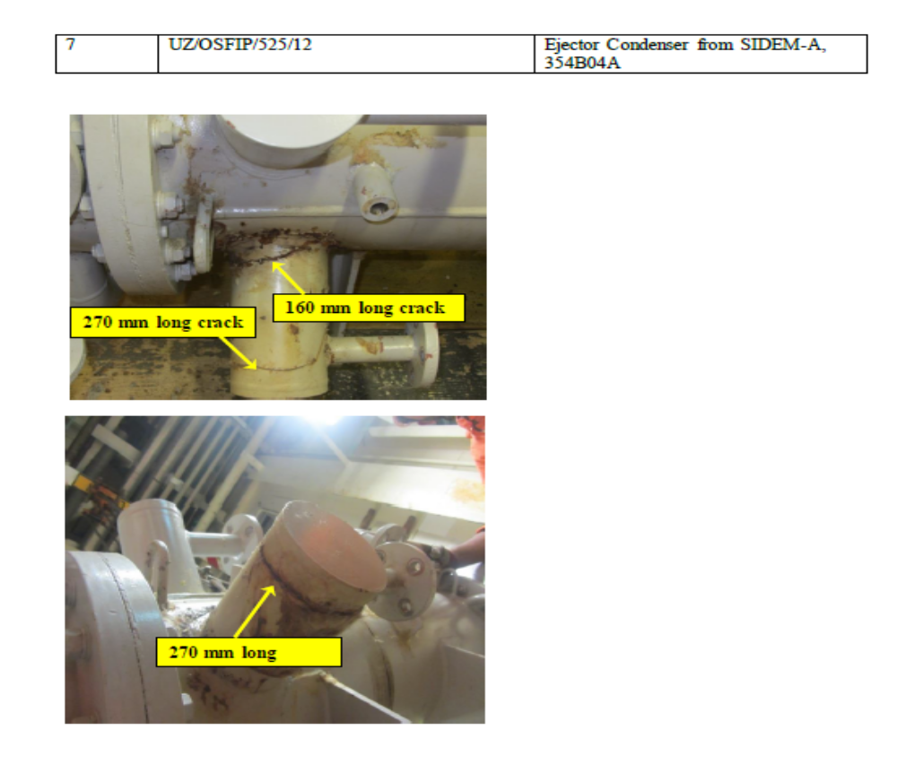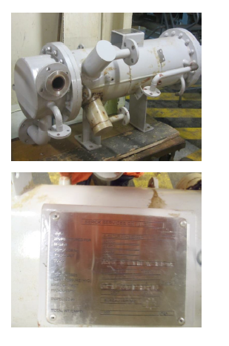

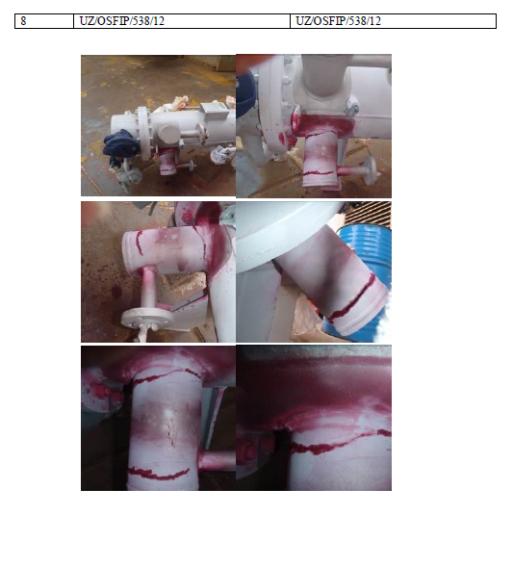

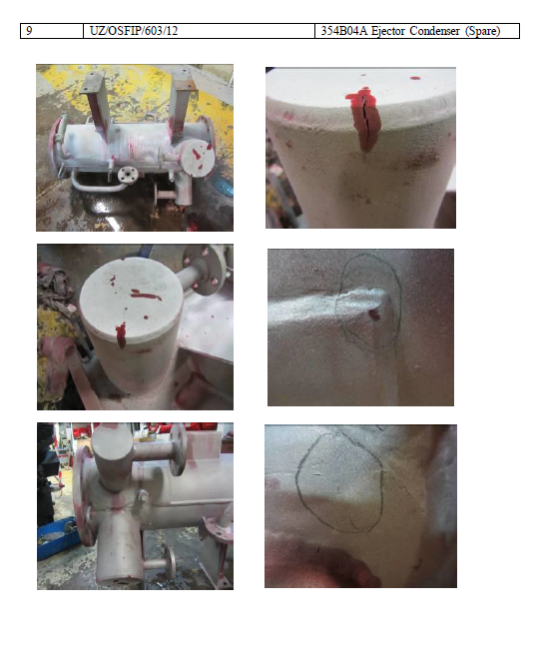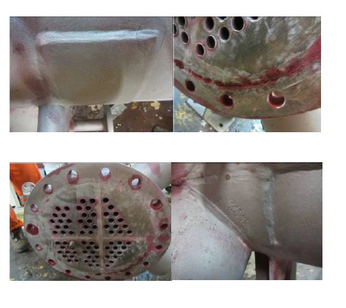

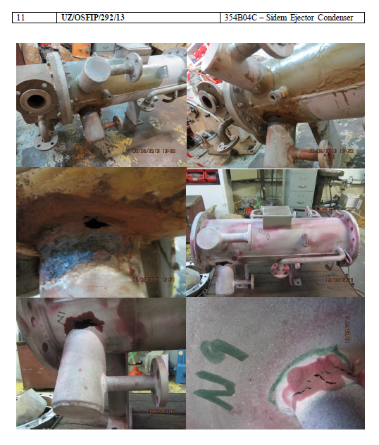

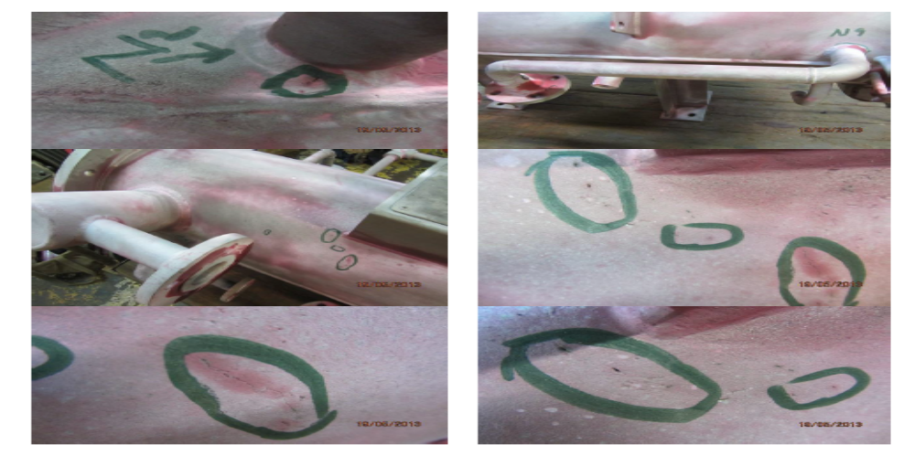

APPINDIX 2: Mechanical As Built Drawing of the Ejector Condenser

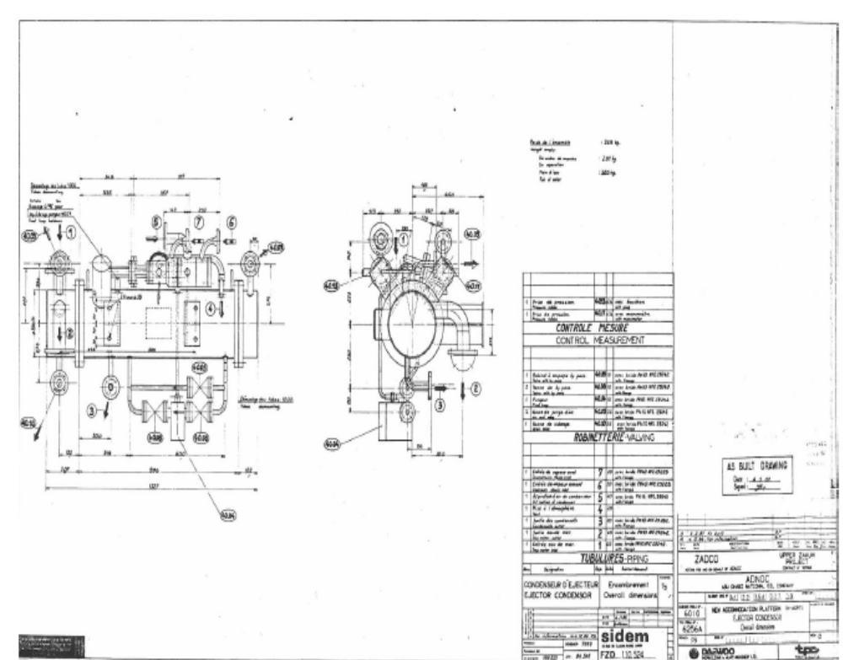

APPINDIX 3: Water Analysis Report for condensed water of ACPT1 Ejector Condenser A/B and ACPT2 Ejector Condenser C.

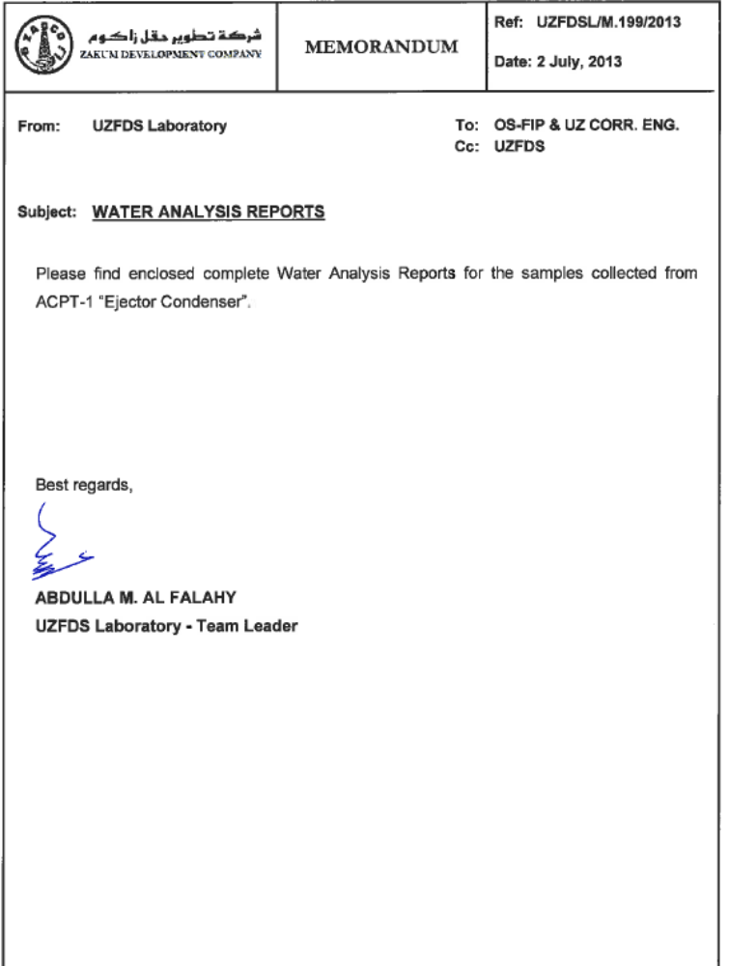

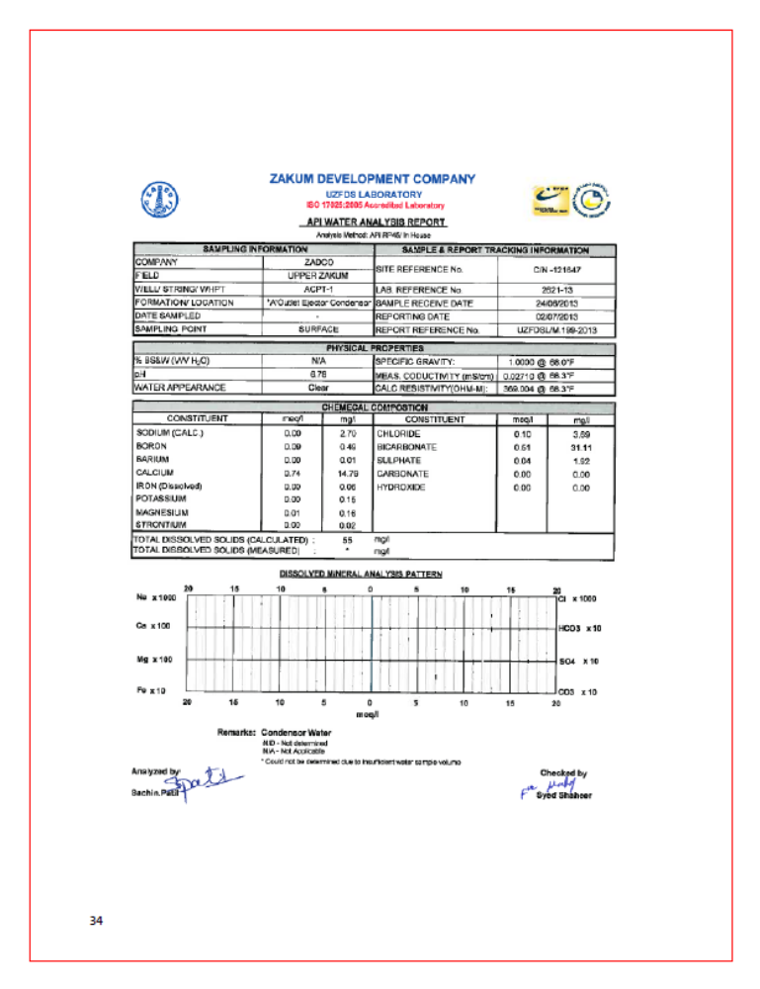
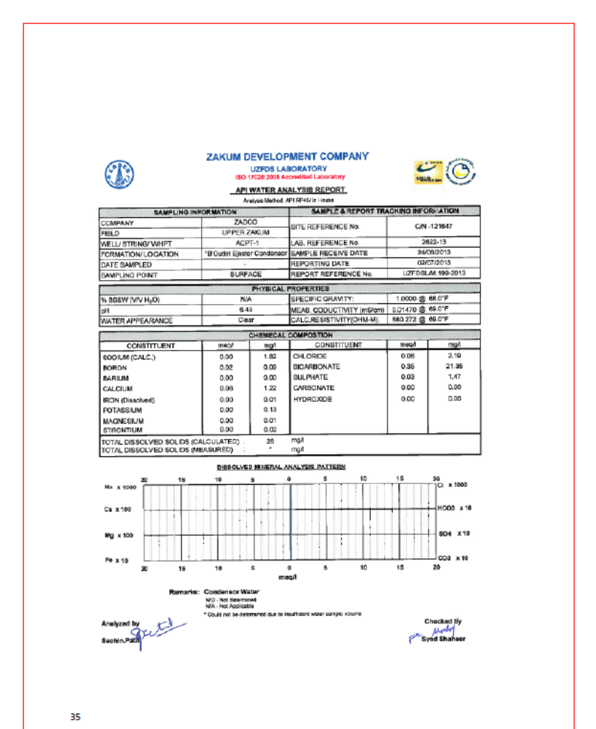

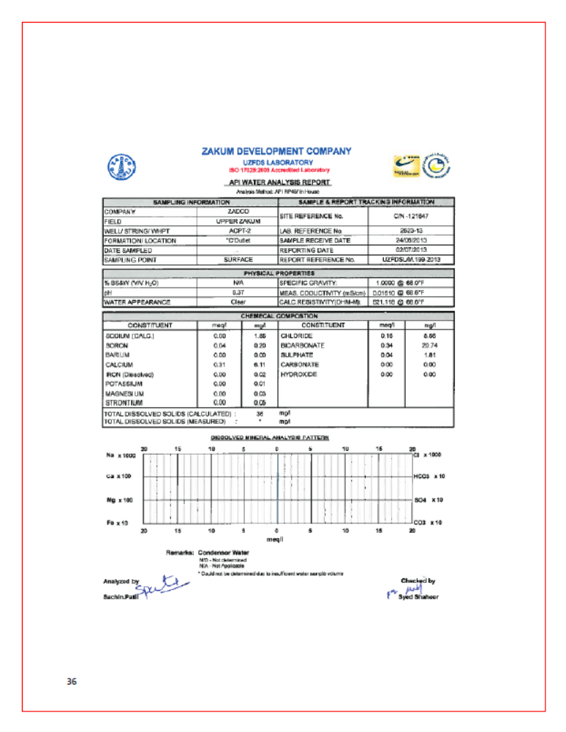

Appendix 4 Approximate relative material cost (weight basis)

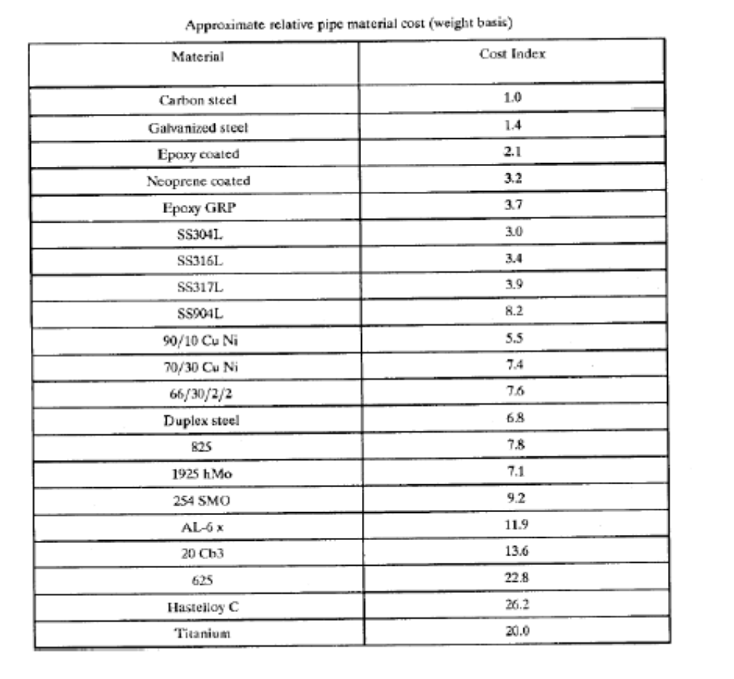

- References

[1] CORROSION AND MATERIAL SELECTION IN DESALINATION PLANTS
Anees U Malik and P.C. Mayan Kutty

[2] I. Kemmer, Frank N. The Nalco Water Handbook, McGraw-Hill, 1988, 1979 Page 20.10

[3] API RP 581, “Risk-Based Inspection Technology”, 2nd Edition, September 2008, Part 2
“Determination of Probability of Failure in an API RB Assessment”.

[4] C.P. Dillon, Editor. Forms of Corrosion Recognition and Prevention Volume1,NACE National Association of Corrosion Engineers.1982 Page 55.

[5] Edward J.Kubel Jr: “Curbing Corrosion in Marine Environments” , Advanced Materials and process, Novemver, 1988.

[6] W.R.Herda: “Materials for Seaweter Systems” , VDM Nickel –Technologies AG (1988)

