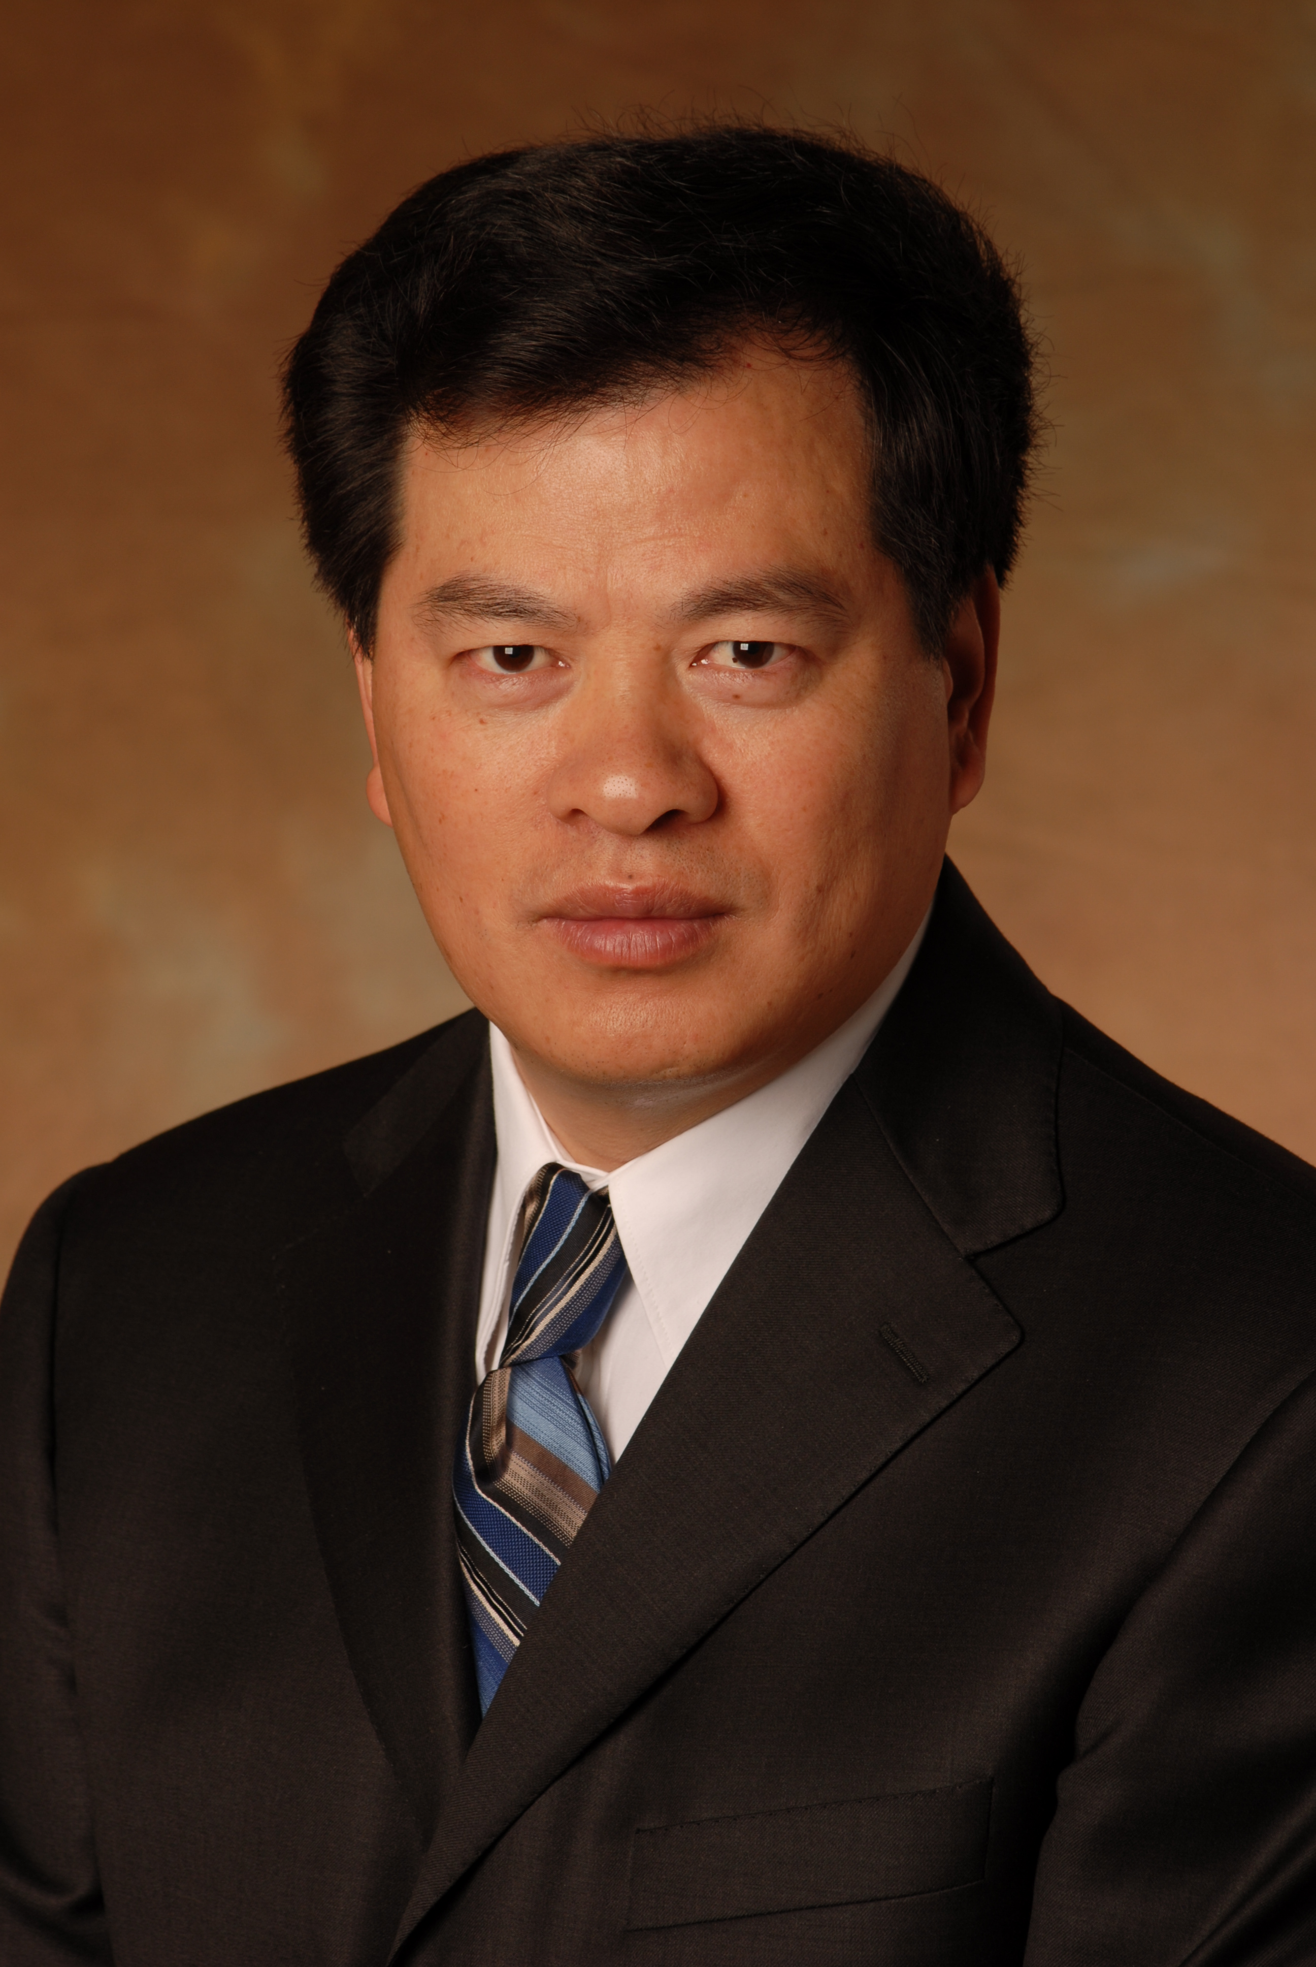
Title: Optimum Miscible CO₂-SWAG/WAG Injection in the Bakken Formation

Yongan (Peter) Gu
Petroleum Systems Engineering, Faculty of Engineering and Applied Science
University of Regina, Regina, Saskatchewan S4S 0A2, CANADA
Abstract:
The Bakken formation has approximately 271-503 billion barrels of light oil in place and becomes a vast and vital light oil resource in Western Canada and the adjacent states in USA. This tight oil formation has permeabilities of 0.01 to 1 mD and the oil recovery factor of its primary production is estimated to be 1-3%. Water is very difficult to inject in large volumes into it, whereas CO₂ may breakthrough it more easily than water. Thus how to properly inject water and/or CO₂ and maximize the oil recovery in the Bakken formation becomes a key technical question.
In this paper, miscible CO₂ simultaneous water-and-gas (CO₂-SWAG) injection and CO₂ water-alternating-gas (CO₂-WAG) injection in the Bakken formation are experimentally studied. A total of fifteen coreflood tests are conducted by applying waterflooding, miscible CO₂ flooding, miscible CO₂-WAG and CO₂-SWAG injection. The miscible CO₂-SWAG injection with an injected water‒gas ratio (WGR) of 1:3 in volume achieves the highest oil recovery factor and carbon utilization factor, which is followed by the miscible CO₂-WAG injection with the optimum slug ratio of approximately 1:1, miscible CO₂ flooding, and waterflooding. The WGR and the WAG slug size show strong effects on the fluid production trends in the miscible CO₂-SWAG and CO₂-WAG injection processes, respectively. In comparison with water or CO₂ alone, the water‒CO₂ mixture has a much lower mobility in the tight formation. Hence, the high oil recovery in the optimum CO₂-SWAG/WAG injection is attributed to a well-controlled water‒CO₂ mobility and a substantially weakened waterblocking effect.

Biography:
Dr. Yongan (Peter) Gu obtained his Ph.D. degree at the University of Alberta (Canada) in 1999. He was hired as an assistant professor in 1999, an associate Professor in 2002, and a full professor in 2006 at the University of Regina (Canada). His three major research areas are CO₂-enhanced oil recovery (CO₂-EOR), carbon capture utilization and storage (CCUS), solvent- and thermal-based EOR in post-CHOPS reservoirs. Dr. Gu has conducted 34 large research projects funded by the Canadian governments and the petroleum industry. He has co-authored over 80 refereed journal papers, 4 invited review articles, and presented 54 peer-reviewed conference papers.

Presenting author details:
Full name: Dr. Yongan (Peter) Gu
Contact number: (306) 585-4630, Peter.Gu@Uregina.Ca
Twitter account: N/A
Linked In account: N/A
Session name/ number: Track 8-3
Category: Oral presentation

