The Formation and Occurrence of the Giant Upper Palaeozoic Unconventional Gas Fields in Ordos Basin, China
Jingliang Zhang, Jiaqi Guo, Na Li, Ruoshan Wang
Faculty of Geographical Science, Beijing Normal University, Beijing, 100875, China

Abstract
The Ordos Basin is the second largest sedimentary basin in China, with Paleozoic strata deep basin gas accumulations, has become to be a typical unconventional gas research hotspot. Along with the important distinguishing characteristics include abnormal pressures, low-permeability reservoirs, and a general absence of gas water inversion. The west part of the Ordos Basin is deep depression area, and became structural slope towards north, east and south of the basin from Late Triassic to now. The fluvial and deltaic deposits constitute the dominant reservoirs, include the Taiyuan, Shanxi and Xiashihezi formations of the lower Permian sequence with the properties of regionally pervasive, low porosity (<10%) and low permeability (<1mD, in-situ). The physical properties ascending from south to north accompanied the gas in the downdip reservoir transit to the gas-water and water layer. The deep basin gas was sourced from humic, type Ⅲ kerogen contained in coal beds and carbonaceous shales in several coal-bearing intervals. The source rocks with high maturity combined with reservoir rocks throughout the whole region provide a prerequisite for the unconventional gas accumulation. The gas migration dis-tances in the accumulations are short, the gas generated in adjacent source rocks moved vertically into the sand layers and slowly migrated updip. The process lasted from Late Triassic to Late Cretaceous. The areas within the deep basin gas systems of enhanced reservoir quality (sweet spots) may be stratigraphic in nature and they most likely occur near the upper boundary of the deep basin gas systems. This study examined the stable carbon isotope data collected from the giant gas fields in the Ordos Basin. The basic geology and geochemistry of various organic rich sediment units were characterized in order to determine the likely gas-source relationships.

Image
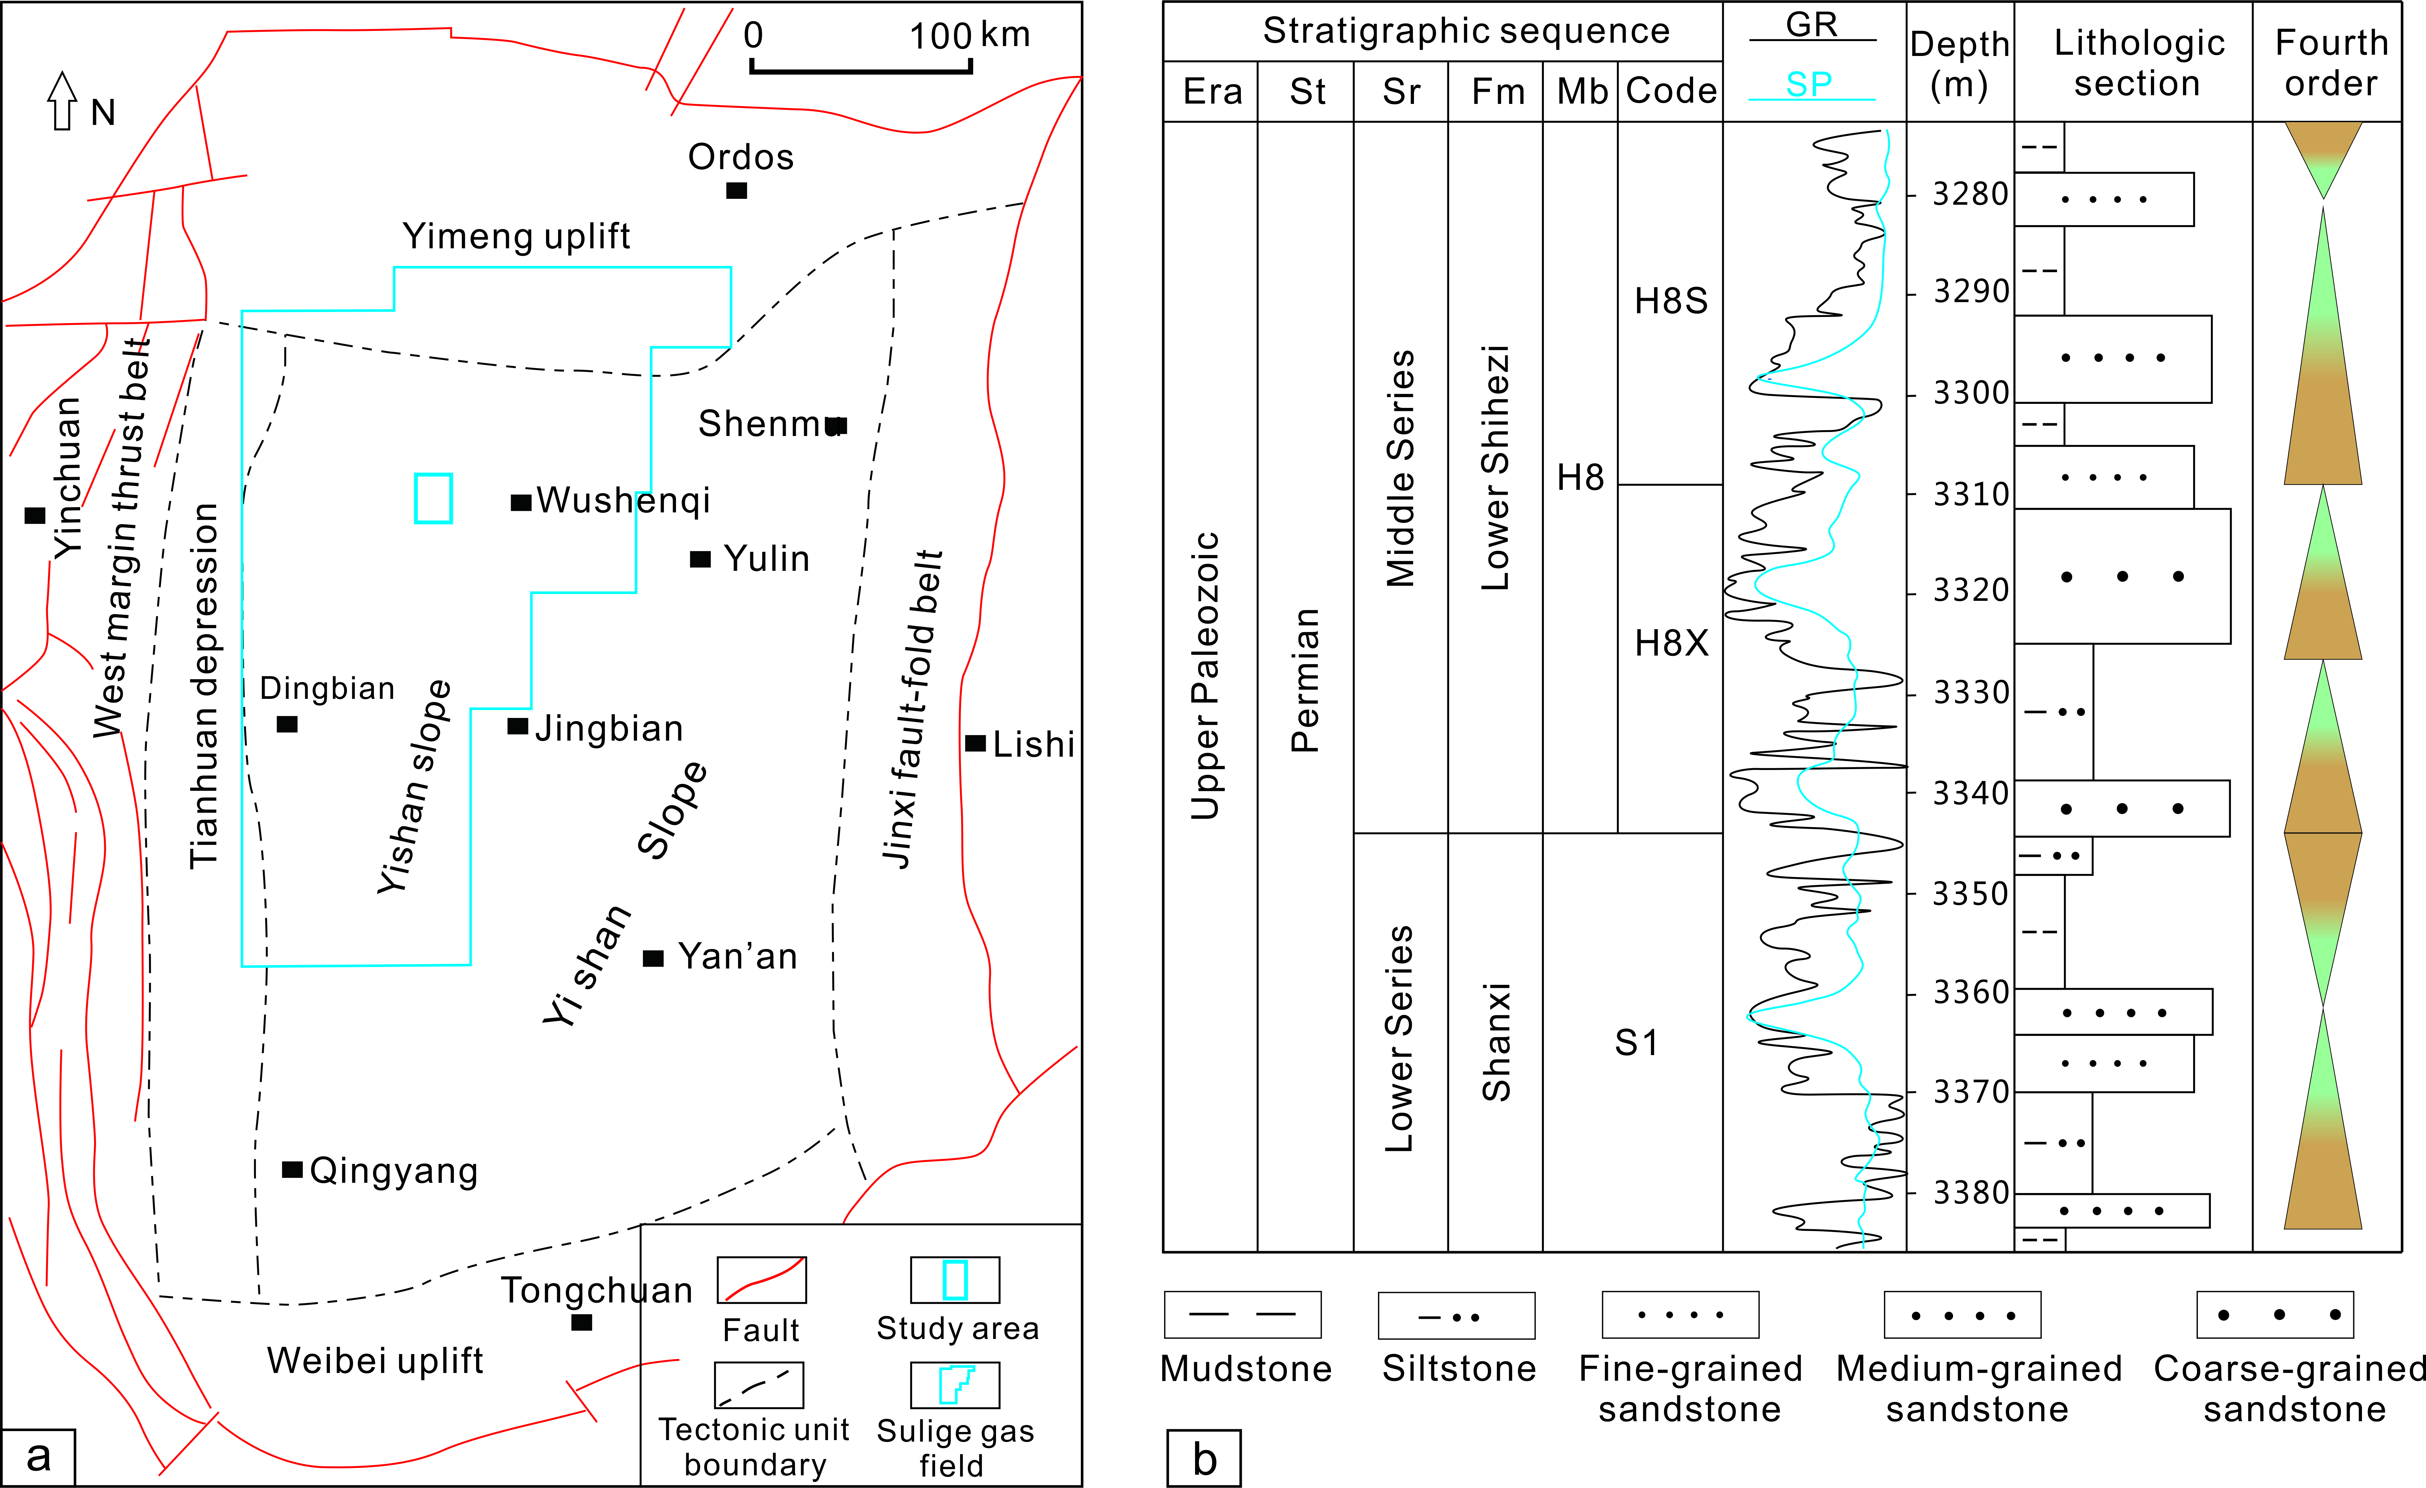
Figure 1. The location of Sulige Sag
Recent Publications (minimum 5)
- Zhao Wan-jin, Yang Wu-yang, Zhao Wei(2014) The Review of technical progress in application of seismic reservoir and hydrocarbon prediction. Progress in Geophysics 29（5）：2337-2346.
- Sa Li-ming, Yang Wu-yang, Yao Feng-chang, et al(2013) Past present and future of geophysical inversion. Oil Geophysical Prospecting 28（4）：1925-1934.

Biography
Professor Zhang Jinliang has gradually developed many stable research directions for Master's degree study and doctoral training after years of hard work, including the "theory of oil-gas reservoir formation and evaluation technology", "reservoir geology and reservoir description technology", and "development geology and remaining oil distribution and exploitation". And various research techniques are further studied by Professor Zhang, such as reservoir description technology, reservoir dynamic analysis technology, geological modeling technology, and hydrocarbon accumulation regulation analysis technology.
Email: jinliang@bnu.edu.cn

Notes/Comments:

