Automated Gas Leak Detection and Monitoring using a Gas Cloud Imaging (GCI) Video Camera System
Robert Kester, PhD, Rebellion Photonics, USA
Allison Lami Sawyer, MBA, Rebellion Photonics, USA

Abstract

Current gas leak detectors are ineffective safety monitoring and decision making tools. Alarms are often difficult to verify and require significant resources (instrumentation and trained personnel) to identify the size, direction, and origin of leak. In bad weather conditions it becomes even more difficult to find the leak and verify that there had been a true positive alarm and not a false positive alarm. Due to these difficulties, often times “problematic” gas leak detectors are de-tuned rendering them useless and/or ignored until more resources can be brought in to find the leak. This hinders the decision making process and increases risk and lost product.

To address this need, Rebellion Photonics has developed an innovative, fully automatic, gas leak detection video camera system that can be deployed around rigs and refineries for continuous (24/7) monitoring. Instead of providing a single alarm value like current gas leak detectors, the gas cloud imaging (GCI) camera provides operators with easy-to-interpret false-colored video showing the location, direction, size, and concentration of a gas leak. The GCI camera is a true decision making tool that can operate in all weather conditions as well as day and night as it does not require any external light sources. The camera's technology is based on Rebellion Photonics' patented “snapshot” hyperspectral imaging approach which can capture a gases unique infrared absorption spectral fingerprint from any point in an image instantly.

In this presentation, we will present the capabilities of the GCI camera; describe the technology, and present examples of gas leaks that have been detected by the GCI camera system.

Image

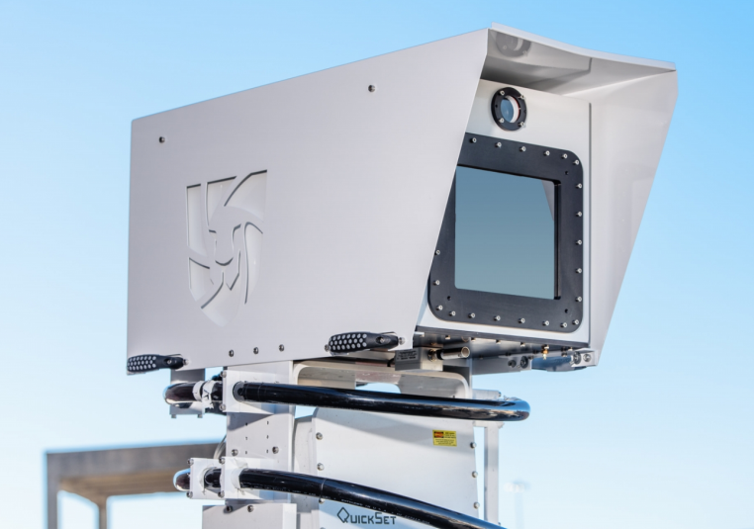
Figure 1 GCI Camera System

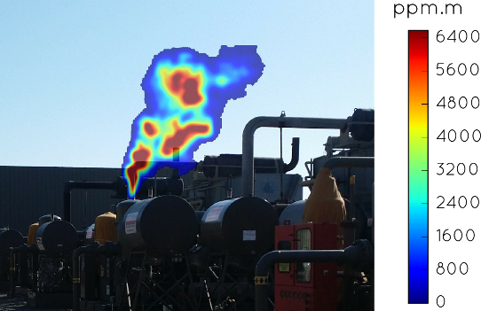
Figure 2 Capture of Realtime Gas Leak

Recent Publications
- Hagen N, Kester R, Walker C (2012) Real-time quantitative hydrocarbon gas imaging with the gas cloud imager (GCI). Chemical, Biological, Radiological, Nuclear, and Explosives (CBRNE) Sensing XIII 10.1117/12.919245:1-7.
- Hagen N, Kester R, Gao L, Tkaczyk T (2015) Snapshot advantage: a review of the light collection improvement for parallel high-dimensional measurement systems. Optical Engineering 51(11):1-8.
- Hagen N, Kester R, Morlier C, Panek M, Drayton P, Fashimpaur D, Stone P, Adams E (2013) Video-rate spectral imaging of gas leaks in the longwave infrared. Chemical, Biological, Radiological, Nuclear, and Explosives (CBRNE) Sensing XIV 10.1117812:1-7.


Biography

Robert Kester is the Chief Technology Officer and co-founder of Rebellion Photonics, a high-tech company that delivers fully autonomous video monitoring solutions for the oil & gas industry based on their novel snapshot hyperspectral imaging technology. Rebellion Photonics has won numerous awards including Wall Street Journal’s Startup of the Year and R&D 100. Robert has 15 years of optics experience, 10+ publications, 4 patents and 5 more pending. He has a M.Sc. from the College of Optical Sciences, University of Arizona, and a Ph.D. in Bioengineering from Rice University.
Email: robert@rebellionphotonics.com
Contact number: 713-218-0101

