Ultra deep water development solutions screening from a flow assurance perspective
Jorge Trujillo. SPE, GALP, Portugal

Abstract (300 word limit)
As the offshore oil & gas industry goes deeper and longer to develop new resources, more complex technical challenges arise. In the case of oil developments in ultra-deep waters, the flow assurance risks found offshore are further exacerbated. Attaining the production goals while properly mitigating flow assurance risks like for instance wax deposition, hydrate blockage, emulsion formation and terrain induced slugging throughout the full field life cycle becomes paramount.
In the lower for longer oil price environment, the “right” subsea concept is leaner yet robust. Choosing between clustered or satellite wells, flexible or rigid pipes, is an exercise of reaching the right balance of deliverability, thermal management, installability, functionality and operability, while remaining cost effective. This work presents the experience of screening and selecting subsea concepts for two oil fields in ultra-deep waters (>2000 m), examined from a flow assurance perspective. Alpha field, with significant resources in place, high deliverability wells located at relatively close distance to the FPU, but with relatively low reservoir temperature and a waxy crude, while Omega field holds a smaller resource base, with a long tie back to the FPU, and a relatively high reservoir temperature. Preferred subsea concept for Alpha field is found to be satellite wells with flexible flow lines (one production line, one service line each), while for the Omega field, a different architecture prevails: clustered wells in 4 slots manifolds with two looped rigid flow lines (for round pigging, dual depressurization, fluid displacement, etc.) and one service line (mainly for gas lift purposes).

Image
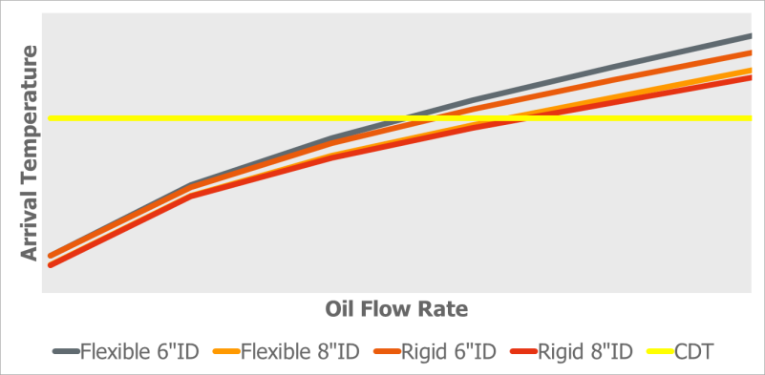
Figure 1 Alpha Field Arrival Temperatures for satellite well concept

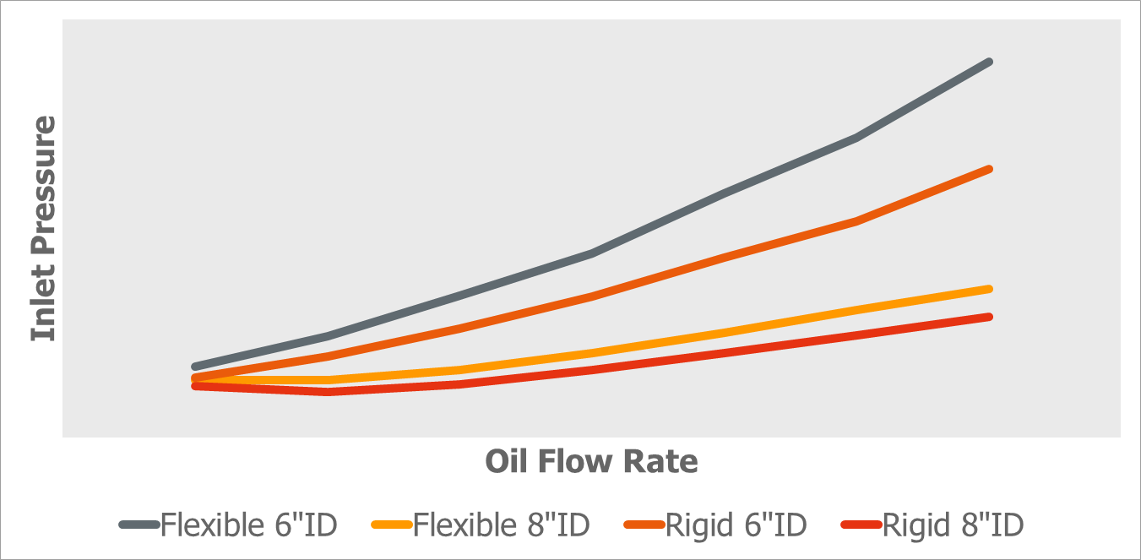
Figure 2 Omega Field Inlet Pressures for clustered well concept
Recent Publications (minimum 5)
- Brito, A. ; Cabello, R. ; Marquez, J. ; Trujillo, J. ; Guzman, N. (2015) Flow Pattern Transition Model for Gas-Highly Viscous Fluids in Horizontal Pipelines. 17th International Conference on Multiphase Production Technology. BHR Group. BHR-2015-F2.
- Brito, A.; Cabello, R.; Guzmán, N.; Marcano, L.; Márquez, J.; Trujillo, J. (2015) Hydrodynamic study of multiphase flow transport of highly viscous foamy fluids, Journal of Petroleum Science and Engineering, Volume 135, pp 367-374
- Peréz Guerra, L.; Trujillo , J.; Blanco, W. (2014) Geometric Design Optimization of a Prototype Axial Gas-Liquid Cyclonic Separator. Computational and Experimental Fluid Mechanics with Applications to Physics, Engineering and the Environment. pp 409-422.
- Arellano, Y.; Brito, A.; Trujillo, J.; Cabello, R. (2014) Comprehensive Evaluation of Gas-Liquid Cyclonic Separation Technologies. Computational and Experimental Fluid Mechanics with Applications to Physics, Engineering and the Environment. Pp 397-408.
- Nava, Z., Rojas, M., Martinez Marcano, N. G., Trujillo, J. N., Rigual, Y. C., Gonzalez, C. (2011). Hydraulic Evaluation of Transport Gas Pipeline on Offshore Production. International Petroleum Technology Conference. IPTC-15287-MS.
- Márquez, J. G., Manzanilla, C. L., & Trujillo, J. N. (2010). A Conceptual Study of Finger-Type Slug Catcher for Heavy-Oil Fields. Society of Petroleum Engineers. SPE-122829-PA. SPE Projects, Facilities & Construction. Vol 5. Issue 4.
- Trujillo, J., Brito, A. (2009). Jusepin Main Station Separation Facilities Upgrade by Means of Integrated Multiphase Solutions. Society of Petroleum Engineers. SPE-120900-MS. Latin American and Caribbean Petroleum Engineering Conference, Cartagena, Colombia.

Biography (150 word limit)
Jorge holds a Mechanical Engineering degree from “Universidad Nacional Experimental Antonio Jose de Sucre” and a MSc. in CFD from Universidad del Zulia (Venezuela). He has over 18 years’ experience, 15 of which in the flow assurance arena, working in the development of compact separation technologies and multiphase flow models as well as in Oil & Gas field development projects in Venezuela, Australia and Portugal..
Email: jorge.trujillo@galp.com
Contact number: 351 965 088 401

Notes/Comments:

