EVALUATION OF CONVENTIONAL AND UNCONVENTIONAL OILS BASED ON AWOJOYOGBE-BLOCH NMR FLOW EQUATION

O.M. Dada, Seidu Abdullahi and O.B. Awojoyogbe
Department of Physics, Federal University of Technology, Minna, Niger State, Nigeria.
Email: abamidele@futminna.edu.ng or awojoyogbe@yahoo.com.

STATEMENT OF THE PROBLEM: Petroleum oil viscosity evaluation is one of the most critical petro physical properties required when estimating hydrocarbon reservoir because viscosity is usually the major impediment parameter to the recovery of oil reservoirs especially at high temperature specifications due to climatic change. Therefore, detailed mathematical and computational analysis of oil viscosity can be extremely useful for the development of any potential oil/gas reservoir. This can enhance the present capacity for reservoir simulation and well testing.
METHODOLOGY AND THEORETICAL CONSIDERATION: In this investigation, we presented analytical solutions to the Bloch NMR diffusion equation in spherical coordinate and obtained analytical expression for the viscosity dependent signal in terms of NMR parameters. The analytical technique allows for a new definition for the Reynolds number derived in terms of NMR/MRI flow parameters and the diameter of the spherical particle with an effective hydrodynamic radius r.
FINDINGS: We explore the petro physical properties of brine, shale oil, tetraline and decaline based on equation (1) and figures1-8. This is very important because the more spherical the grains are, the more space is left between them and well-rounded sandstone will have the most oil and gas of any of the clastic rocks.
CONCLUSION AND SIGNIFICANT: Since the vast majority of the world’s remaining oil reserves are categorised as heavy / unconventional oils (high viscosity), the difficulty in petroleum oil viscosity evaluation from spherical grain distributions can be reduced very significantly by the simple relationship between oil viscosity, temperature and NMR/MRI parameters as presented in this study.
RECOMMENDATIONS: A computer programme developed with a weighting parameter for NMR flow analysis of heavy oils has the potential to estimate viscosity measurements without having extra oil sample in the laboratory especially when the new Reynolds number derived in terms of NMR/MRI flow parameters is used.

Based on the analytical solution of the Bloch NMR flow equation, we finally obtained the NMR/MRI transvers magnetization in terms of viscosity as shown in equation (1):
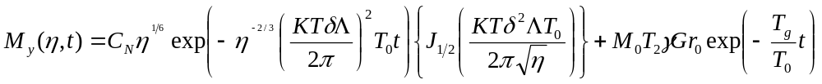 (1)
where
C_{N} is a constant
The constant γ = 42666666.67, K = 1.380658×10⁻²³
T = temperature
G = Gradient pulse
δ = pulse duration
M₀ = equilibrium magnetisation
r₀ = fixed radial distance
t = sampling tine
Λ = weighting parameter

Table 1. Relaxation times and viscosity of selected heavy oils for G = 0.18T/m, t = 6s, pulse duration = 0.02s, M_{o} = 1000, r_{o} = 0.003cm, C_{N} = 10x10⁴ - 10x10⁴ , Icp 0.0001Nsm⁻² , 1ºc = 273K.
Drilling Fluid |  |  | Temperature(k) |  | T₁ (s) |  |  | T₂(s) |  | Viscosity(cp)
Brine |  | 303 1.24 |  |  |  | 1.44 2.6E-03
Shale oil | 303 |  |  |  | 1.57 |  | 1.51 |  |  |  | 2.4E-03
Tetralin | 303 |  |  |  | 1.47 |  | 1.41 |  |  |  | 1.9E-03
Decaline | 303 |  |  |  | 1.13 |  | 1.16 |  |  |  | 2.2E-02
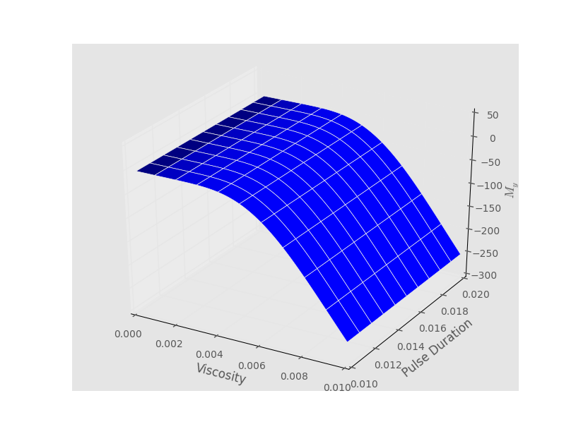(a)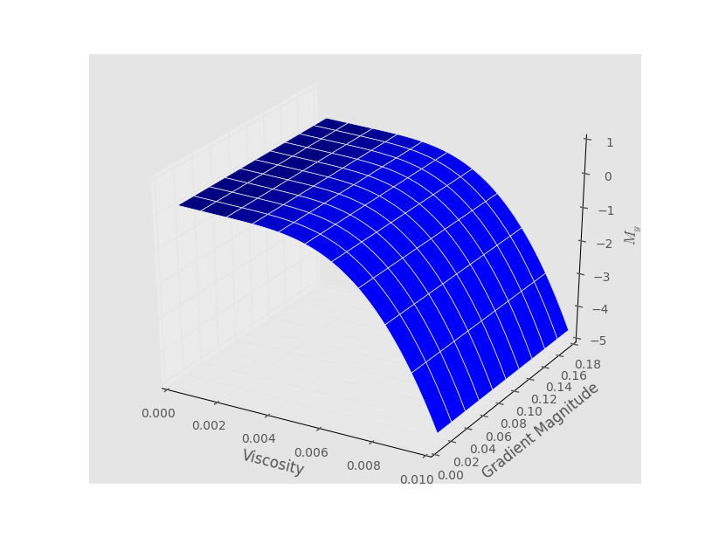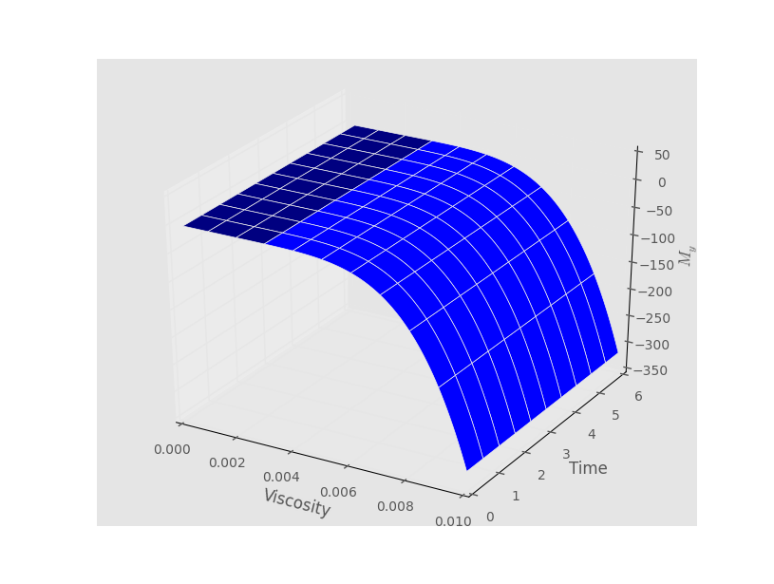(c) (d)
Figure 1: 3D plots of viscosity dependent transverse magnetisation M_{y} against (a) pulse duration (b) Gradient pulse (c) Sample time for Brine.

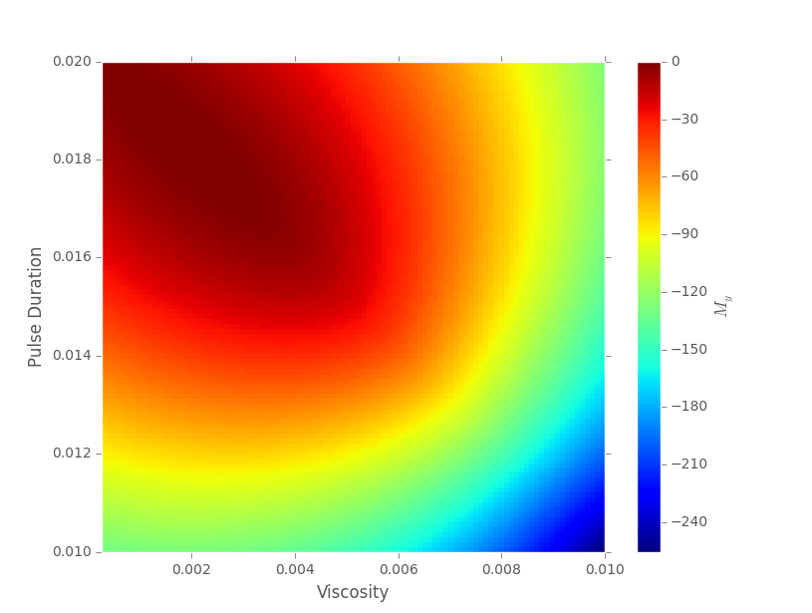(a)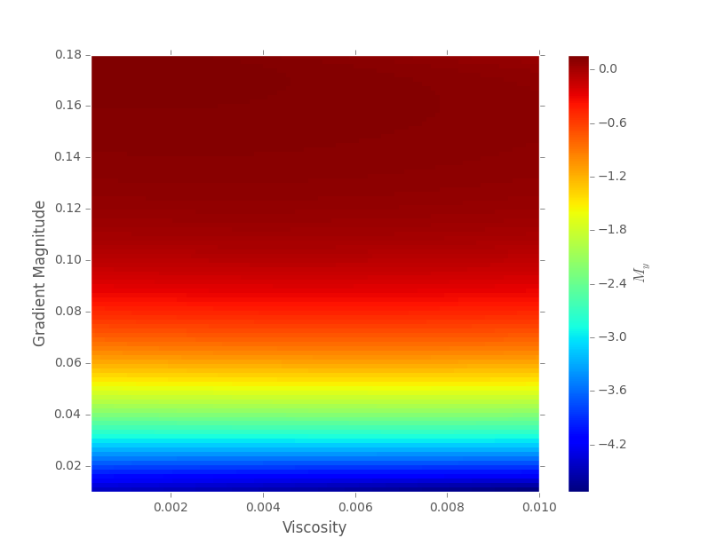 (b) 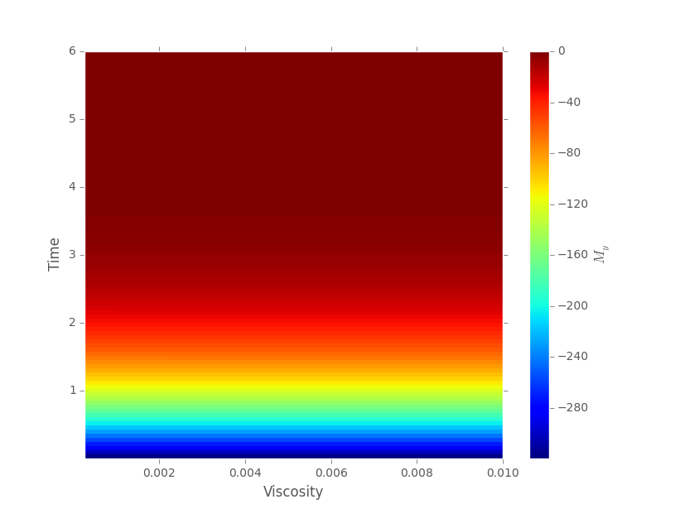(c)
Figure 2: A density plot of viscosity dependant transverse magnetization against (a) pulse duration (b) Gradient pulse (c) Time for Brine sample.

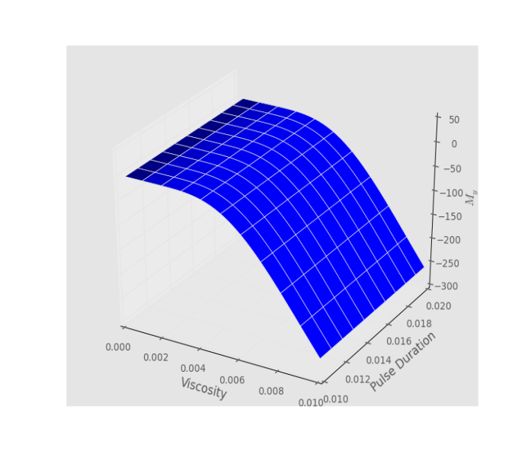(a)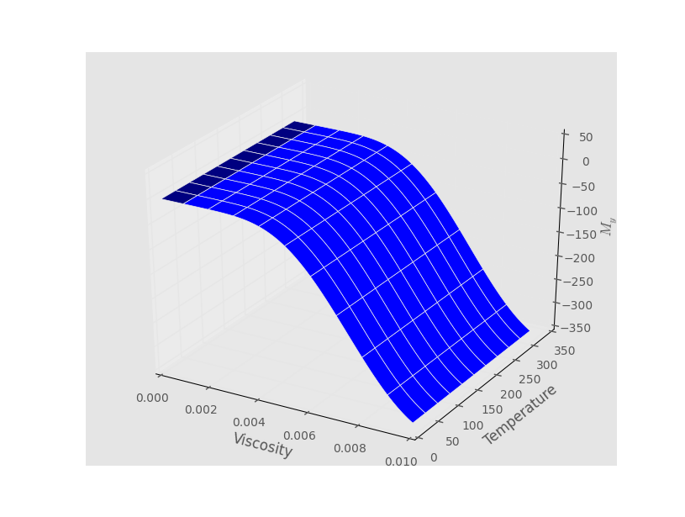(b)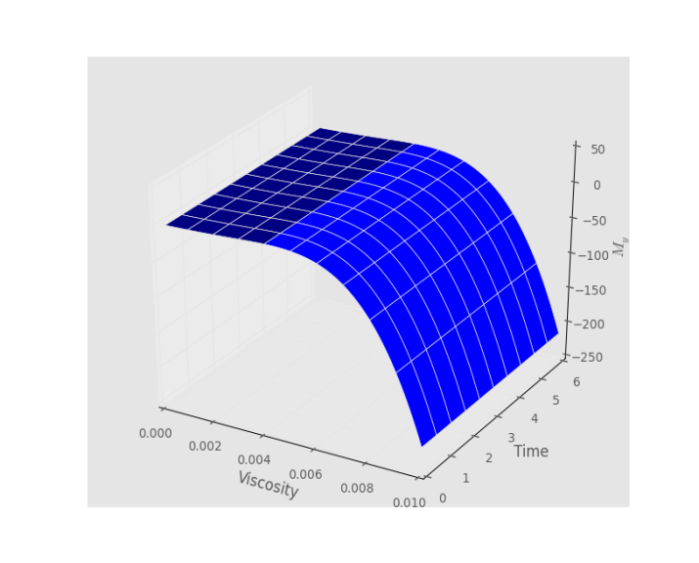(c) Figure 3: 3D plots of viscosity dependent transverse magnetisation M_{y} against (a) pulse duration (b) Gradient pulse (c) Time for shale oil,
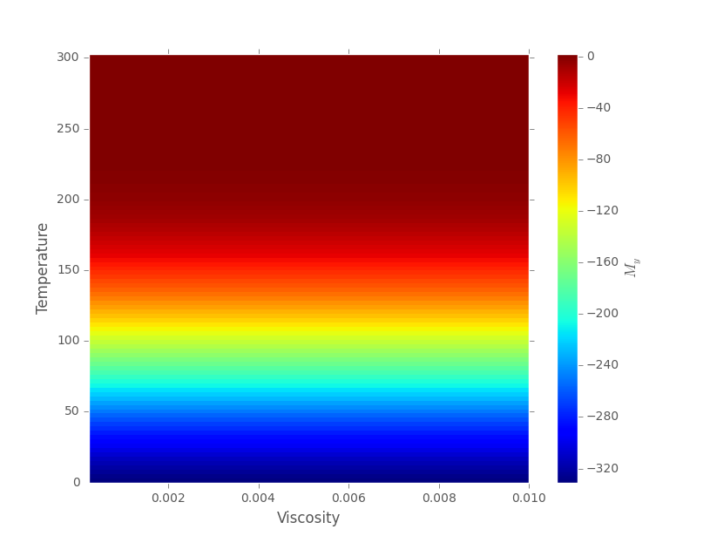(a)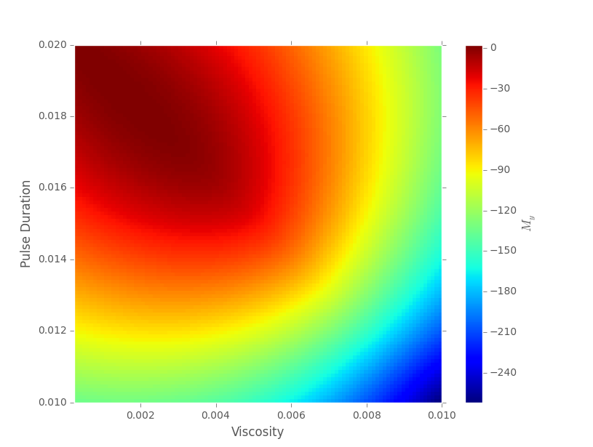(b) 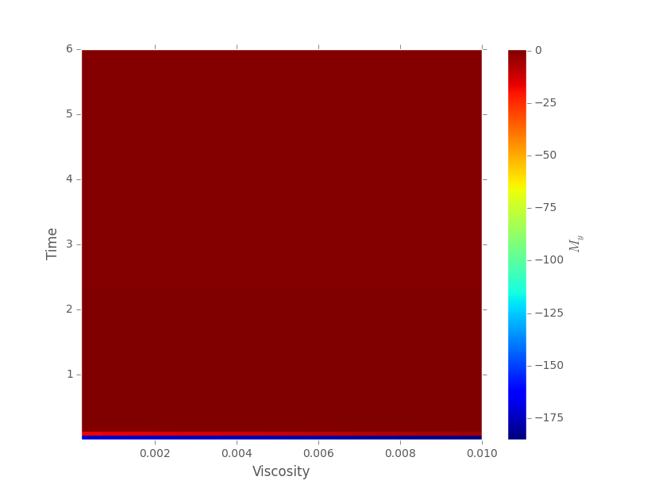 (c)
Figure 4: A density plot of viscosity dependent transverse magnetization against (a) Temperature (b) pulse duration (c) Time (d) Gradient magnitude for shale oil.

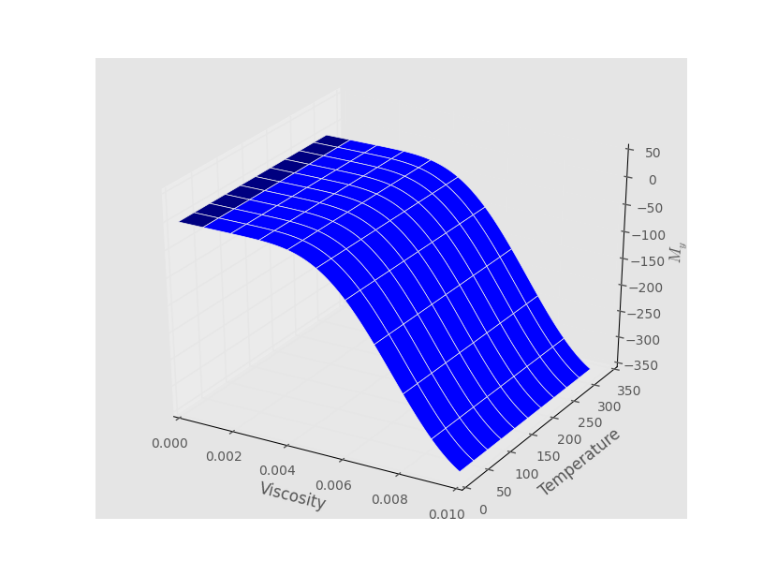(a)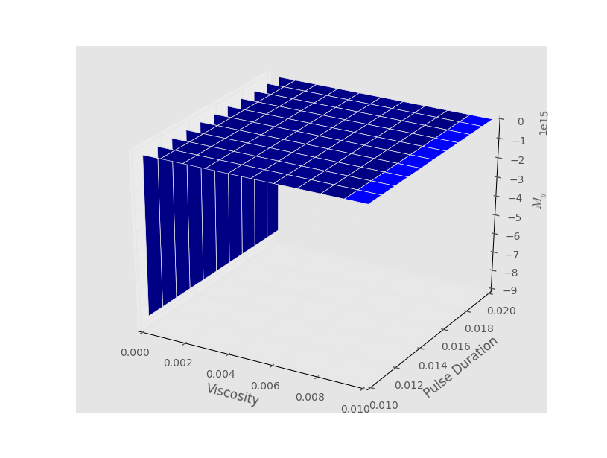(b)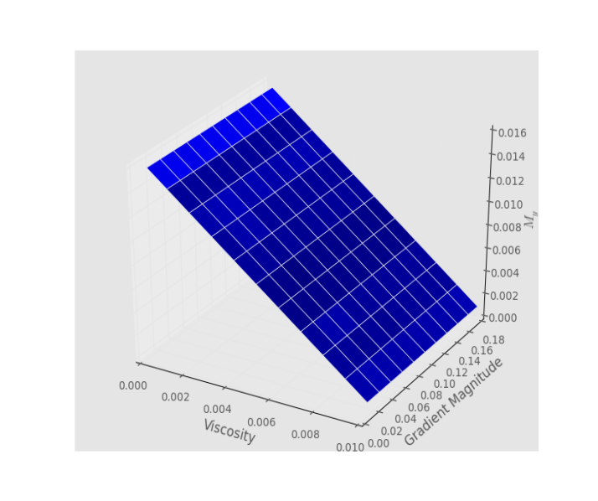(c)
Figure 5: 3D plots of viscosity dependent transverse magnetisation M_{y} against (a) pulse duration (b) Gradient pulse (c) Time for tetraline

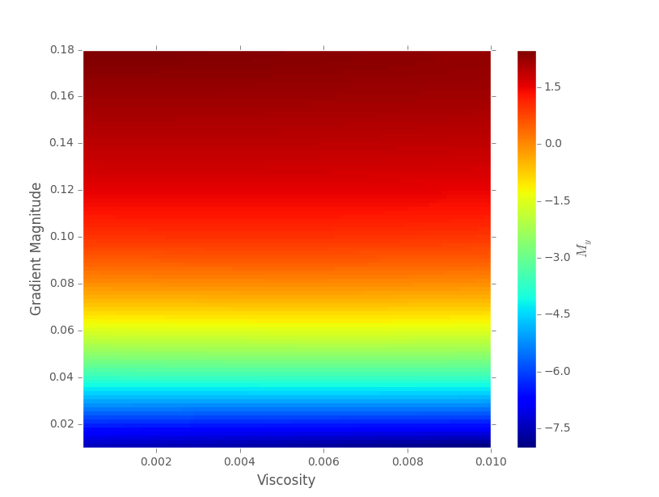 (a) 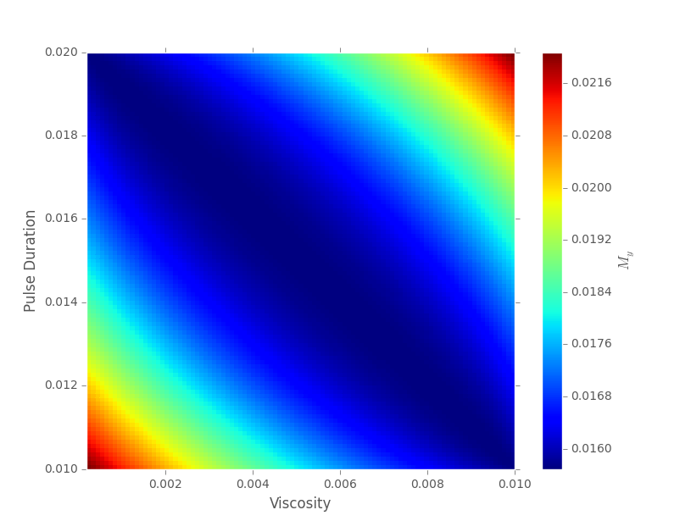(b) 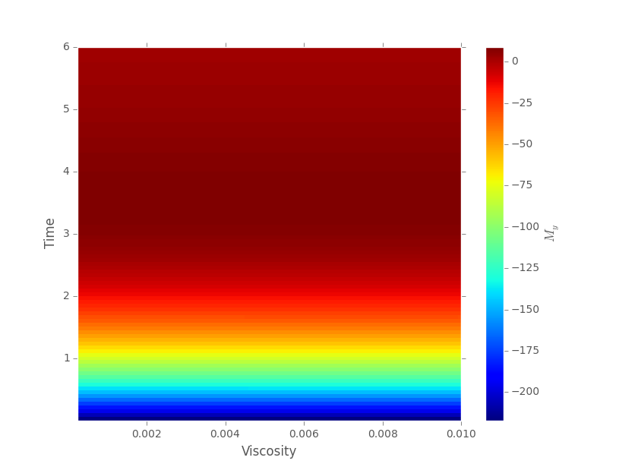(c)
Figure 6: A density plot of viscosity dependent transverse magnetization against (a) Gradient magnitude (b) pulse duration (c) Time for Tetraline.
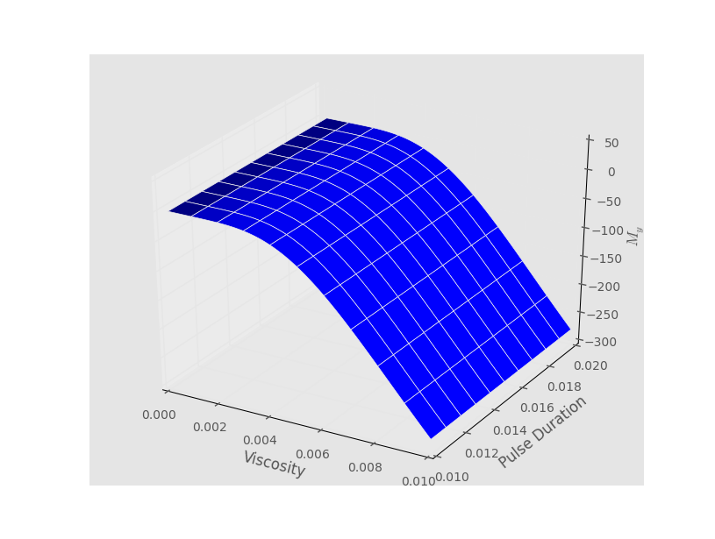(a) 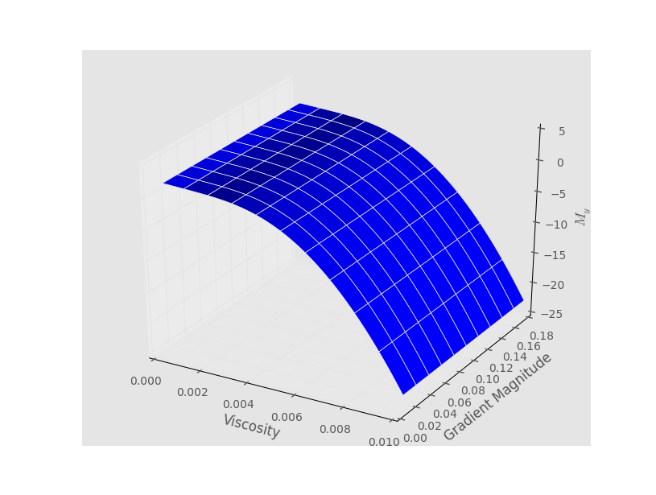 (b)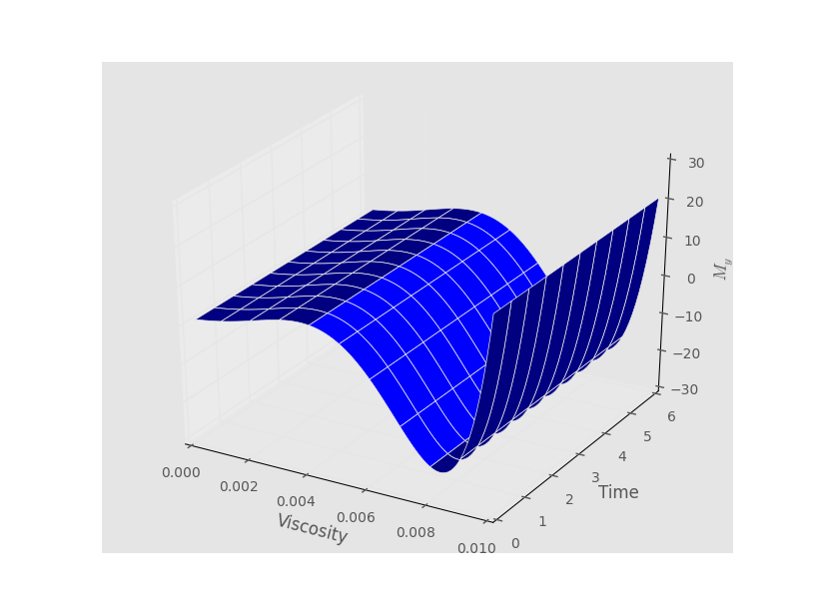 (c)
Figure 7: 3D plots of viscosity dependent transverse magnetisation M_{y} against (a) pulse duration (b) Gradient pulse (c) Time for decaline
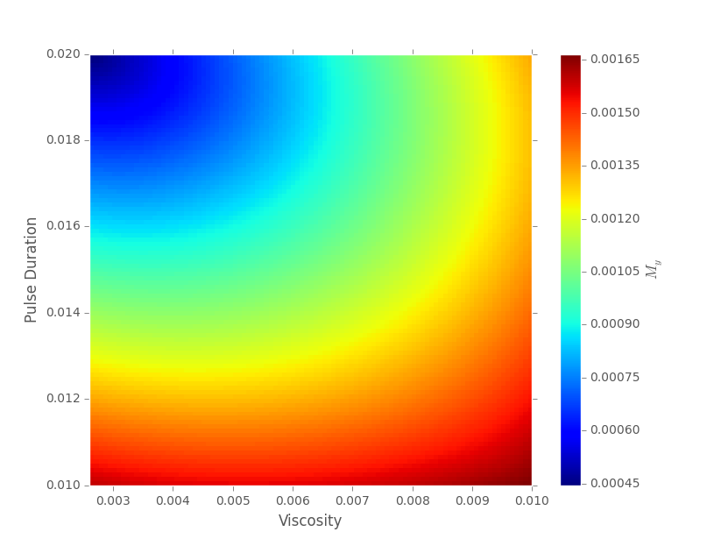 (a) (b) 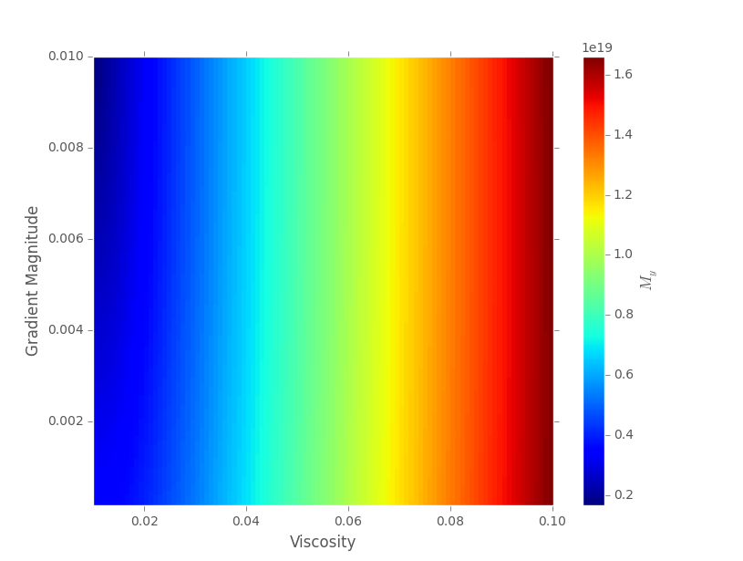 (c)
Figure 8: Density plot of magnetization M_{y} against (a) pulse duration (b) Time (c) Gradient magnitude for Decaline .

RECENT PUBLICATIONS
- Ali, A. (2009). System modelling and testing of a magnetic susceptibility device and effect of downhole in-situ temperatures on magnetic susceptibility (Doctoral dissertation, Heriot-Watt University).
- Blümich, B., Mauler, J., Haber, A., Perlo, J., Danieli, E., & Casanova, F. (2009). Mobile NMR for geophysical analysis and materials testing. Petroleum Science.
- Codd, S. L., & Seymour, J. D. (Eds.) (2008). Magnetic resonance microscopy. John Wiley & Sons.
- Dunn, K.-J., Bergman, D.J., and LaTorraca, G.A. ed. 2002. Nuclear Magnetic Resonance-Petrophysical and Logging Applications, Vol. 32. New York: Handbook of Geophysical Exploration: Seismic Exploration.
- Imhmed, S. A. A. (2012). Application of magnetic susceptibility measurements to oilfield scale management (Doctoral dissertation, Heriot-Watt University).
- Ivakhnenko, O. P. (2012). Magnetic Susceptibility of Petroleum Reservoir Crude Oils in Petroleum Engineering. INTECH Open Access Publisher.
- Potter, D. K. (2007). Magnetic Susceptibility as a Rapid, Nondestructive Technique For Improved Petrophysical Parameter Prediction1. Petrophysics, 48(03).
- Potter, D. K., Al-Ghamdi, T. M., & Ivakhnenko, O. P. (2011). Sensitive carbonate reservoir rock characterization from magnetic hysteresis curves and correlation with petrophysical properties. Petrophysics, 52(01), 50-57.
- Potter, D. K., Al-Ghamdi, T. M., & Ivakhnenko, O. P. (2011). Sensitive carbonate reservoir rock characterization from magnetic hysteresis curves and correlation with petrophysical properties. Petrophysics, 52(01), 50-57. Retrieved on (June 2015).
- Schön, J. (2011). Physical properties of rocks: A workbook (Vol. 8). Elsevier.
- Pape, H., Tillich, J. E., & Holz, M. (2006). Pore geometry of sandstone derived from pulsed field gradient NMR. Journal of applied geophysics, 58(3), 232-252.


Professor O.B. Awojoyogbe SHORT BIOGRAPHY

Awojoyogbe, Omotayo Bamidele received his B.Sc. degree in Physics and Engineering Physics from the Ondo State University, Ado Ekiti (now University of Ado-Ekiti), Nigeria, in 1987, M.Sc. in Theoretical Physics, University of Ibadan, Nigeria, in 1991, and Ph.D. from the Federal University of Technology, Minna, Nigeria, in collaboration with the Institute of Biomedical Engineering and Medical Informatics, Swiss Federal Institute of Technology (ETH Zurich), and the University of Zurich, in 1997. He is an associate member of the Abdul Salam International Centre for Theoretical Physics (ICTP), Trieste, Italy (2001-2008). His field of research is Theory, Dynamics and Applications of the analytical solutions of the Bloch NMR flow equations to solve real life problems

