Matheuristics Application to Ship Routing and Scheduling Problem in Crude Oil Transportation
Tatsushi Nishi, Associate Professor, Osaka University, Japan

Abstract (300 word limit)

The global logistics strategy is driven by the new economic structure. Oil is considered as one of the most consumed energy resource in Japan. Due to lack of the domestic resource, Japan was the second-largest importer of oil in the world after the United States in 2009. This country is primarily dependent on the Middle East for its oil imports, as roughly 80 percent of Japanese crude oil imports originate in the region up from 70 percent in the mid-1980. In this paper, we propose an optimization approach to solve the international crude oil transportation problem. In order to increase the efficiency, the assignment, the sequence and the loading volume of demands should be optimized simultaneously. In many practical situations, these decisions are executed manually by the negotiation between the human operators based on the contract with suppliers individually. In order to help the decision of human operators, the automatic generation of the practical ship scheduling is highly required to avoid the human errors and increase the efficiency of decision making.

In this paper, we present matheuristics application to we propose a solution approach to the international crude oil transportation problem based on a real loading planning case in Japanese oil industry. A column generation approach together with partial optimization metaheuristics under special intensification conditions is proposed to solve the problem efficiently. Computational results demonstrate the effectiveness of the proposed method.

Image
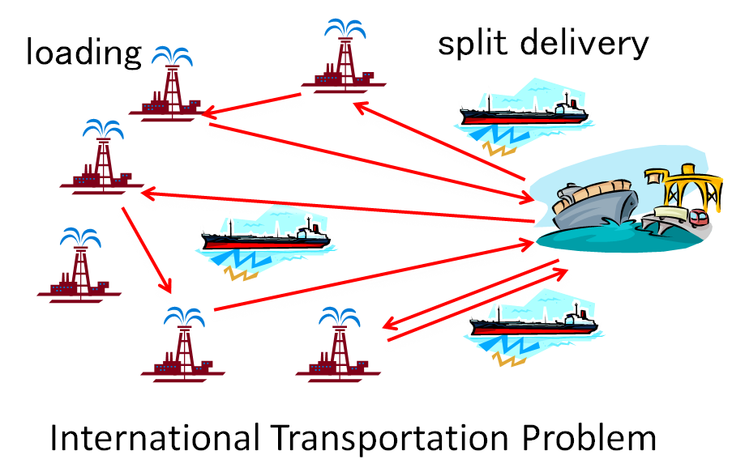
Recent Publications
- Zhang G, Nishi T, Turner SDO, Oga K, Li X (2016) An integrated strategy for a production planning and warehouse layout problem: modeling and solution approaches. Omega (Available online).
- Nishi T, Matsumoto I (2015) Petri net decomposition approach to deadlock-free and non-cyclic scheduling of dual-armed cluster tools. IEEE Transactions on Automation Science and Engineering 12(1): 281-294.
- Nishi, T, Izuno, T (2014) Column generation heuristics for ship routing and scheduling problems in crude oil transportation with split deliveries. Computers and Chemical Engineering 60: 329-338.
- Nishi T, Sugiyama T, Inuiguchi M (2014) Two-level decomposition algorithm for crew rostering problems with fair working condition. European Journal of Operational Research 237(2): 465-473.
5. Yin S, Nishi T, Izuno T (2012) A heuristic approach for integernational crude oil transportation scheduling problems. Journal of Advanced Mechanical Design, Systems and Engineering 6(5): 672-686.

 Tatsushi Nishi
Tatsushi Nishi received the B.S. degree in chemical engineering from Kyoto University, Kyoto, Japan and Ph.D. degrees in process systems engineering from Kyoto University, Kyoto, Japan. He became a Research Associate with the Department of Electrical and Electronic Engineering at Okayama University, Okayama, Japan. Currently, he is an Associate Professor with the Department of Mathematical Science for Social Systems, Graduate School of Engineering Science at Osaka University, Japan, His research interests include discrete optimization, discrete event systems, production scheduling, decentralized optimization algorithms, supply chain optimization, multiple mobile robots control and manufacturing systems. He has authored or coauthored more than 100 technical publications. He has won several awards including National Instruments Corporation Young Investigator Award from the 2006 International Symposium on Flexible Automation, 2014, 2015 Outstanding paper award from the IEEE International Conference on Industrial Engineering and Engineering Management. Email:nishi@sys.es.osaka-u.ac.jp

Notes/Comments:

