New Conception of Remershoe Against Swelling Clay
Bolewski L., MSc , GUT, Poland
Szkodo M., RN PhD, GUT, Poland

Abstract (300 word limit)
In drilling, a phenomenon of swelling clays is observed frequently, being a costly event in oil and gas industry. It has an important impact on the cementing quality. General aim of my study was to create and implement a solution for this type of event. Finally with multidisciplinary team I created downhole protector tool against swelling loams. The new type of reamer shoe tool was optimized in experimental testing on test stands and real borehole.
The designed tool was optimized using Ansys software (FEM, CFD), conduct laboratory and field tests, as well as to prove legitimacy of the tool usage on improvement of the cementing operation outcome. Tool will be located on front of casing like other guide or reamer shoes, but the way tool works is significantly different from typical types of tools. The present publication will include results of individual tests, simulations and the stages of work from idea to the final product. The concept is based on the solution elaborated at Gdansk University of Technology and is an application of the ejector principles applied in reamer shoe tool. The prototype provide the following functions: allowing to run casing in the tight spots, calibrating borehole (including removal of the mud cakes) and rock material shredding, also decreasing eccentricity in unstable rock formations (especially important due to the influence on the cementing operation quality). The designed tool is subject of notification to European Patent Office. Our reamer tool introduces a new solution for problem of swelling clay.

Image

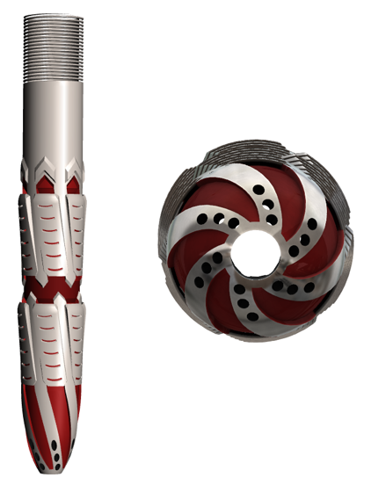

Fig. The 3d model of designed tool
Recent Publications (minimum 5)
- R.L. Anderson, I. Ratcliffe, H.C. Greenwell, P.A. Williams, S. Cliffe, P.V. Coveney (2010) Clay swelling – A challenge in the oilfield. Earth-Science Reviews 98 (2010) 201–216.
- Abhijit Y. Dandekar (2013) Petroleum Reservoir Rock and Fluid Properties, Second Edition, CRC Press, 2013, 1439876363
- Alireza Sanaei Mahmood Shakiba, Abdoljalil Varavei Kamy Sepehrnoori (2016) Modeling Clay Swelling Induced Conductivity Damage in Hydraulic Fractures, SPE-180211-MS.
- Saeed Farrokhpay, Bulelwa Ndlovu, Dee Bradshaw (2016) Behaviour of swelling clays versus non-swelling clays in flotation. Minerals Engineering 96–97 (2016) 59–66.
- Slim Boussen, Dalel Sghai, Fredj Chaabani, Bassem Jamoussi, Sofien Ben Messaoud, Ali Bennour (2015) The rheological, mineralogical and chemical characteristic of the original and the Na2CO3-activated Tunisian swelling clay (Aleg Formation) and their utilization as drilling mud. Applied Clay Science 118 (2015) 344–353.

Biography (150 word limit)
Łukasz Bolewski from 2014 is PhD student at Gdansk University of Technology (Poland). Before second half of 2014 he worked in industry as engineer in global petroleum and offshore certification and verification Norwegian company. As a member of multidisciplinary team get a foundation for research of innovative tool for solution of swelling clay problem. The designed tool get European Patent protection form 2015. Lukasz have many publication in national area in topic of designed tool, problem of swelling clay and gas migration, also he was a speaker on one international conference in Turckey (5th Mediterranean Clay Meeting 2016) and many other in Poland.

Email: lukaszbolewski@gmail.com
Contact number: +48 505 335 092

Notes/Comments

