Presentation on: Development of a Tool for Fundamental Undersating of Multipahse Non-Newtonain Flow in Annulli
Aziz Rahman, PhD., P.Eng.
Assistant Professor
Petroleum Engineering Program
Texas A&M University at Qatar

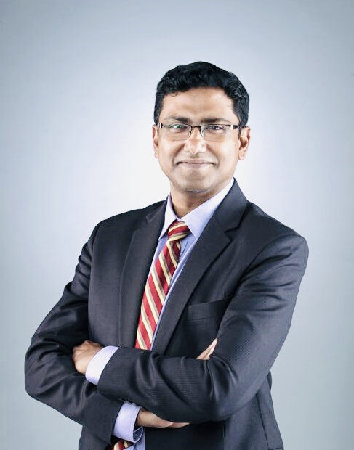

Abstract

The hydrocarbon reserves of conventional/unconventional sources will remain a major source of the world’s energy supply even with the fastest growth of other energy sources including renewable energy. The petroleum and energy industry must be capable of low-energy intensive extraction and transportation of these resources, in an environmentally benign manner. Drilling wellbores is one of the most important part of extracting petroleum resources from the reservoirs. Very complex spatio-temporal flow patterns of multiphase flow, which are often observed in annuli during drilling fluid circulation and wellbore production, are not fully understood. Fundamental understanding of the effects of complex multiphase flow regime on hydrodynamic scaling and geometric scaling is an open challenge. This understanding is essential for substantial economic growth of oil and gas industry. The talk will be based on an experiments and numerical simulations project that helps to understand the multiphase (gas/liquid/solid) flow behavior in annuli under various operating, hydrodynamic and geometric conditions. The objectives of the project are as follows: 1) to develop a tool or model which will optimize and suggest meaningful surface operating parameters for efficient wellbore cleaning and drill cuttings transmittal to surface, particularly during horizontal drilling wells (cuttings settling in the tangential section), 2) to predict multiphase volume fractions (flow metering) and pressure loss in annuli with a wide range of operating, hydrodynamic and geometric conditions, and 3) early detection of mini-kicks (formation gas invasion to circulating fluids) and provide real-time changes to surface operating parameters before it turns to a well control event and a possible blow-out.

Biography

Dr. Mohammad Azizur Rahman received his PhD in Multiphase Flow from University of Alberta, Canada in 2010. Dr. Rahman joined the Petroleum Engineering Program at Texas A&M University at Qatar as an Assistant Professor in 2016. Prior his appointment, he was an Assistant Professor at Memorial University of Newfoundland and an Instructor at University of Alberta, Canada. Dr. Rahman teaches Production Engineering courses and he developed a graduate Multiphase Flow Assurance course at TAMUQ. Dr. Rahman has received around 2 million research funding from Qatar Foundation, Natural Sciences and Engineering Research Council of Canada, and Newfoundland Research & Development Corp. He has been involved in a number of research collaborations with companies, including Total, Qatargas, Intecsea, NEL, Syncrude Canada, GRI simulations, C-Core, Petroleumsoft and Coanda Research & Development Corp. He is also involved in with a number of professional organizations, including SPE, and ASME. He is a registered Profession Engineer in Alberta, Canada. Dr. Rahman established a multiphase flow loop and he contributed to more than 100 refereed journals and conference publications related to multiphase flow experiment and computational fluid dynamics simulation.
Email ID

Presenting author details
Aziz Rahman, PhD., P.Eng.
Assistant Professor
Petroleum Engineering Program
Texas A&M University at Qatar
PO Box 23874 | Doha, Qatar
253 Texas A&M Engineering Building | Education City
E-mail: marahman@mun.ca or marahman@tamu.edu
Category: Keynote

