Sedimentary microfacies and palaeogeomorphology as well as their controls on gas accumulation within the ultra-deep-buried Cretaceous in Kuqa Depression, Tarim Basin, China
Ronghu Zhang , Junpeng, Ge Chen, Qinglu Zeng
Hangzhou Institute of Geology, PetroChina, Hangzhou, China，310023

Abstract
This paper represents the systematic research accomplished which included microfacies observation and sandstone modeling in the outcrop, the lithofacies interpretation with imaging logging data, and the recovery of nappe tectonics as well as the folding analysis based on the single sedimentary factors in order to define the characteristics of lithofacies and microfacies, the background of paleography and their effects on gas accumulation. This study illustrated that the climate was mainly hot and dry during the sedimentary period of Bashijiqike within the deep-buried Cretaceous, and the deposited water was characterized by low to medium salinity. The deep-buried areas were controlled by three provenances, namely, the Kapushaliang River, the Kelasuhe River, and the Kuqa River. The Dabei-Bozi area was mainly the proximal deposit, the silty-fine sandstone with subrounded and well-sorting features developed in the main channel areas of underwater distributary channel which was constructed in the braided (or fan）delta front. The Keshen area, on the other hand was the distal deposit, the medium-fine sandstone with subangular-subrounded and medium-well sorting features developed in the main channel areas of underwater distributary channel which was constructed also in the braided (or fan）delta front. In the latter stage of the Yanshanian Period, the silty-fine sandstone of the underwater distributary channel had developed with the background of residual palaeohigh and drought climate in Dabei-Bozi area-meanwhile the medium-fine sandstone of the underwater distributary channel had developed with the background of residual palaeohigh slopes and humid climate in Keshen area. In addition, the gas accumulation within the deep zone was evidently controlled by the lithofacies paleography. The gas in the medium-fine sandstone lithofacies of paleoslope was significantly richer than the silty-fine sandstone lithofacies of the paleohigh; the silty lithofacies in the paleohigh was relatively poor. It was supposed that systematic studies would accelerate the oil and gas exploration and development in the deep zones, not to mention provide guidance for the trillion cubic prospects of gas reserves in the deep zones.

Image
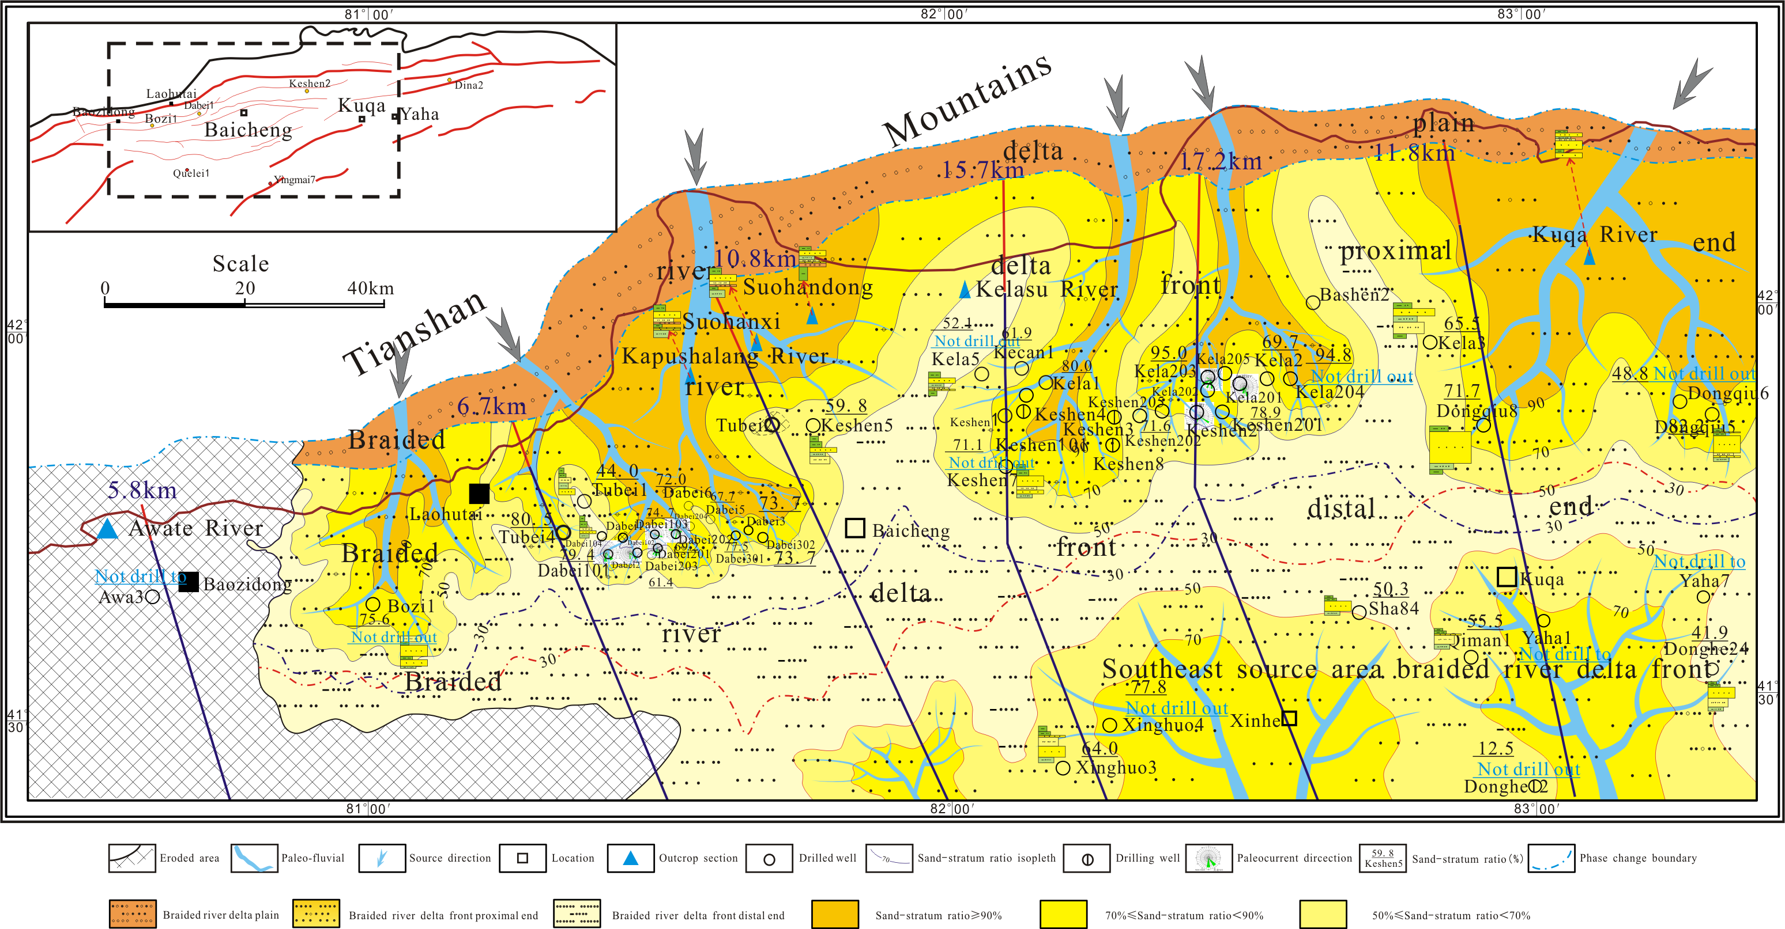
Fig. 10 The distribution of sedimentary subfacies and lithofacies of K1bs2 in the central Kuqa Depression

Recent Publications (minimum 5)
1.Jia Chengzao. Tectonic Characteristics and Hydrocarbon of Tarim Basin in China. Beijing: Petroleum Industry Press, 1997:232-240.
2.Wang Zhaoming. Formation mechanism and Enrichment regularities of Kelasu subsalt deep large gas field in Kuqa Depression,Tarim Basin. Natural Gas Geoscience,25(2):153-166.
3.Liu Baojun, Zhang Jinquan. Sedimentary Diagenesis. Beijing: Petroleum Industry Press, 1992:13-20．
4.Yu Xinghe. Hydrocarbon Reservoir Sedimentology of Clastic Rock. Beijing: Petroleum Industry Press，2002:92-104.
5.Gu Jiayu. Sedimentary Sequence Characters and Evolution in Tarim Basin. Beijing: Petroleum Industry Press,1996: 265-267.
6.Zhang Ronghu, Zhang Huiliang, Shou Jianfeng, et al. Geological analysis on reservoir mechanism of the Lower Cretaceous Bashijiqike Formation in Dabei area of the Kuqa Depression. Chinese Journal of Geology, 43(3):507-517.

Biography
Ronghu, Zhang , Master Engineer of Geology, has completed his PhD at the age of 27 years from Petrochina Research Institute of Petroleum Exploration and Development. He was mainly engaged in sedimentology, oil and gas reservoir and the accumulation of research. Nearly 30 papers have been published in domestic and international core journals.
Email: zrh_hz@petrochina.com.cn
Contact number: +8613757114878；+86057185226670

Notes/Comments:

