Experiment and Numerical Simulation Investigation of Weak-gel Flooding Multiscale Processes for Enhanced Oil Recovery in Offshore Oilfield: A Case of LD Oilfield, China.
Ma kuiqian, Li Yanlai, Sun Zhixue
CNOOC (China) co., LTD., Tianjin branch, Tianjin 300452

Address

Abstract (300 word limit)
Weak gel flooding has been widely used in petroleum industry. This paper conducted laboratory experiments and numerical simulation to obtain parameters of weak gel flooding in the core scale and to apply the parameters into the numerical simulation in the reservoir scale to improve the precision of history matching. This experiments were consisting of two parts. The first part was to research the characteristics of weak gel include of relationship of viscosity and concentration of polymer, heats stability, static adsorption, resistance coefficient and reaction kinetics by physical simulation experiments. The second part was to conduct displacement experiments consisted of water flooding, polymer flooding, weak gel flooding and multi-cycle gel flooding to obtain the data for the simulation of history matching. Combining the data obtained by the tests, the numerical simulation of weak gel core-flooding in the scale of centimeter was conducted by using the CMG simulator to obtain the parameters. The results showed that the concentration of polymer is 3g/L, the viscosity is 15.84 mPa•s, the mass concentration of weak gel is 3g/L, the viscosity of weak gel is 160.46 mPa•s. By adjusting and optimizing slightly the parameters, the history matching in the scale of field of data form year 2009 to 2013 plays well. The error of the history matching of production is in the range of 10%. It is proved that the parameters obtained by experiments can be successfully applied into the numerical simulation in reservoir scale. The study also made analysis of cross scale residual oil analysis by the technology of 3D digital rock. The results directly showed the distribution of residual oil after water flooding and weak gel flooding. Based on above facts the study finally designed the multi-cycle flooding in the scale of field, and predicted recovery factor can be enhanced by 4.3%.

Image
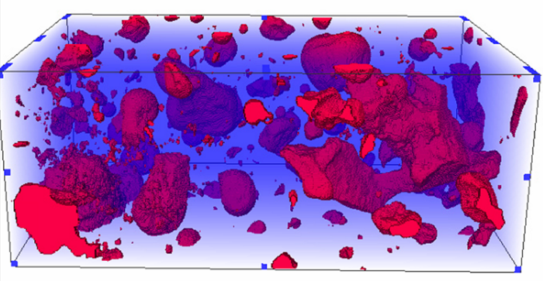
Recent Publications (minimum 5)
- MA Kui-qian, HUANG Qin,ZHANG Jun, et al. Carbon Dioxide Huff and Puff to Enhance Oil Recovery in Nanpu 35-2 Oilfield[J]. Journal of Chongqing University of Science and Technology (NATURAL SCIENCE EDITION), vol13(1):27-32.
- Ma Kuiqian, Liu Yingxian, Su Yanchun. Productivity evaluation of infill well at high water cut stage in S Oilfield, Bohai Bay[J]. FAULT-BLOCK OIL ＆ GAS FIELD, vol20(1):71-73.
- MA Kuiqian, Cui Hui, WU Xiaozhang. Application of layer fluid diversion technology of gel system in offshore heavy oilfield[J]. Offshore oil, vol31(2):65-74.
- Ma Kuiqian, Zhang Hongyou, Wang Yuejie, et al. Application of Pressure Testing Technology in the Offshore Deep Lacustrine Carbonate Reservoir[J].Well testing, vol22(5):33-37.
- Liu Chao, Ma Kuiqian, Wu Donghao, et al. Recognition of Orientation of Oligocene Reservoirs in Offshore Lüda Oil Field, Bo Hai, China[J]. Marine Origin Petroleum Geology, vol20(2):56-62.

 Biography (150 word limit)
Ma Kui, male, born in 1971, senior engineer, master, research direction for the development of oil and gas fields. It is mainly responsible for the research and management of oil recovery by chemical method in Bohai oilfield of China National Offshore Oil corporation.
Email: makq@cnooc.com.cn
Notes/Comments:

