Changing the structure of resin-asphaltenes molecules in cracking
Y.I. Imanbayev^{1,2}, Y.K. Ongarbayev^{1,2}, Y. Tileuberdi^{1,2}, Z.A. Mansurov^{1,2}

¹Institute of Combustion Problems, Kazakhstan, Almaty
²al-Farabi Kazakh National University, Kazakhstan, Almaty

Abstract
Natural bitumen in tar sands deposits represents a very rich source of energy potentially. At the same time accessible to the main part of those stocks is difficult, and for the conversion of low-sulfur liquid bitumen products you require non-standard solutions, since the properties of conventional oil and bitumen are significantly different. To extract the bitumen must first carry out hydraulic fracturing, and only after that you can use thermal production methods. Currently, commercial production of bitumen in Canada is carried out using mining methods.
The object of the study was collected as a sample of the tar sand Beke field (Kazakhstan), extract of sand and extracted asphaltenes from organic part, as well as products of their transformations during thermal processing.
The molecular weight of tars and asphaltenes of natural bitumen and their cracking products measured by cryoscopic in naphthalene created in Institute of Petroleum Chemistry on "Krion" instrument. Elemental characteristics of samples were determined by elemental analyzer Vario MICRO cube (Germany).
Monte Carlo method was used to construct the molecular structure of macromolecular compounds. Constructing molecular structure program is written in Fortran Version 6.6. The developed program for the construction of molecular structure used as input parameters analytical data and calculated using the structural-group analysis. The input parameters are the analytical data obtained from elemental analysis, PMR spectroscopy, molecular weight of tars and asphaltenes.
The calculations data determined the most stable conformation of tars and asphaltenes molecules. It was found that the stability of the molecules affect structural characteristics such as the number of structural blocks, their size and spatial arrangement of atoms with respect to each other. Consisting of more structural blocks of smaller size molecules are more thermodynamically stable in compared with monoblock structure. Constituting molecules characterized the thermodynamically more stable than a non-layered structures.

Image
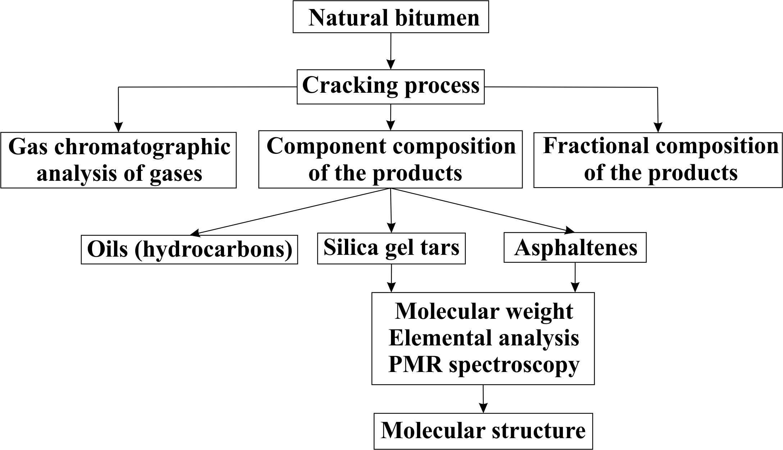

Figure 1. Experimental scheme of cracking process and analysis of the obtained products

Recent Publications (minimum 5)
- Murray R. Gray Upgrading Oilsands Bitumen and Heavy Oil. The University of Alberta Press. – 2015. – P. 514
- S. Ebrahimi, J.S. Moghaddas, M.K. Razavi Aghjeh Study on thermal cracking behavior of petroleum residue // Fuel. – 2008. – V. 87. – P. 1623-1627
- Derek D. Li , Michael L. Greenfield Chemical compositions of improved model asphalt systems for molecular simulations // Fuel. – 2014. – V. 115. – P. 347–356
- Y.K. Ongarbayev, A.K. Golovko, E.B. Krivtsov, Y.I. Imanbayev, E. Tileuberdi, B. Tuleutaev, Z.A. Mansurov Thermocatalytic Cracking Of The Natural Bitumens Of Kazakhstan // Solid Fuel Chemistry. – 2016. – V. 50. – No. 2. – P. 81-87
5. Tileuberdi E., Ongarbayev Y.K., Imanbayev Y.I., Tulepov M.I., Mansurov Z.A., Tuleutaev B.K. Production of Rubberized Bitumen by oxidation of black oil // Material Science and Environmental Engineering: Proceedings of the 3rd Annual 2015 International Conference on Material Science and Environmental Engineering. – CRC Press. – 2016. – P. 183-186


Biography
Y.I. Imanbayev is a PhD-student of al-Farabi Kazakh National University and Junior researcher of Institute of Combustion Problems (Republic of Kazakhstan, Almaty). Scientific interests are processing of heavy oils, oil sands and oxidation processing of hydrocarbons.
Email: erzhan.imanbayev@mail.ru

Notes/Comment

