Improvement of Isobutanol production by a genetically modified Escherichia coli ∆ldhA

M. Ebrahimi ¹, Gh. Amoabediny ¹,², A. Salehi-Najafabadi ³, MA. Amoozegar⁴, * E. Salehghamari*

1-Faculty of New Sciences and Technologies, University of Tehran, Tehran, Iran.
²-Research Center for New Technologies in Life Science Engineering , University of Tehran, Tehran, Iran.
^{3,4-}Extremophiles Laboratory, Department of Microbiology, Faculty of Biology and Center of Excellence in Phylogeny of Living Organisms, College of Science, University of Tehran, Tehran, Iran
5- Microbiology Laboratory, Department of cellular and molecular biology, Faculty of Biological science ,university of Kharazmi, Karaj, Iran.

Biofuels synthesized from renewable resources are of increasing interest because of global energy and environmental problems. Compared to ethanol, Isobutanol offers many advantages as a substitute for gasoline due to higher energy content and higher hydrophobicity. Escherichia coli is a well-characterized microorganism and its physiological regulation is well studied. However, it does not produce isobutanol as a fermentation product. We are engineering a synthetic pathway in E. coli to produce isobutanol. Isobutanol is produced from pyruvate through valine biosynthesis. Therefore we want to delete ldhA (lactate dehydrogenase A) that contribute lactate formation. This deletion will increase the level of pyruvate available for the valin biosynthesis. One strategy for knocking out a special gene is homologous recombination. In this way left and right homologous arms at both side of the gene in E. coli genome, were amplified by designed primers including restriction sites at their 5 ends. Left arm primers contain BamHI and EcoRI recognition sites and Right arm primers have HindIII and pstI. The PCR products were cloned separately by TA cloning kit and were confirmed by sequencing. pTZ plasmid containing arms were digested with respective restriction enzymes and the digested arms were cloned in MCS of pUC19 vector one after each other. In next step the kanamycine resistance gene was amplified with the primer which contain XbaI recognition site and it was inserted between left and right arms. When three fragments had been inserted the construct prepared, it was sent to E. coli cell and after recombination, kanamycine resistance gene stand instead of gene. Finally this strain could use as a strain which increases isobutanol production in E. coli.

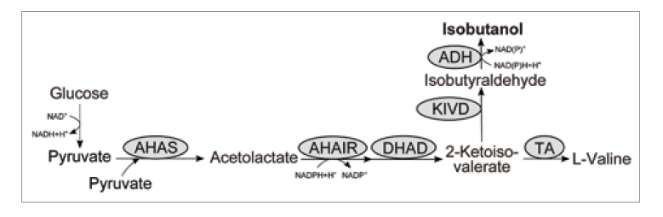

Figure 1. A novel pathway for isobutanol production

- Desai SH, Rabinovitch-Deere C, Fan Z, Atsumi. (2015) Isobutanol production from cellobionic acid in Escherichia coli. 10.1186/s12934-015-0232-6
- Ethan I. Lan, James C. Liao (2013) Microbial synthesis of n-butanol, isobutanol, and other higher alcohols from diverse resources. 10.1016/j.biortech.2012.09.104
- Miao Wen, Brooks B Bond-Watts, Michelle CY Chang (2013) Production of advanced biofuels in engineered E. coli. 10.1016/j.cbpa.2013.03.034
- 5. Pamela P. Peralta-Yahya, Fuzhong Zhang, Stephen B. del Cardayre & Jay D. Keasling (2012) Microbial engineering for the production of advanced biofuels.10.1038/nature11478
- Shota Atsumi, James C Liao (2008) Metabolic engineering for advanced biofuels production from Escherichia coli. 10.1016/j.copbio.2008.08.008

Morvarid Ebrahimi is an MSc student in Microbial biotechnology at university of Tehran, Tehran, Iran. She received her BSc degree in Biology from Shahid Beheshti University, Tehran, Iran in 2014 and joined The Department of Life Science Engineering, Faculty of New Sciences and Technologies, university of Tehran. Her main research interests are Systems Biology and Metabolic Engineering, with a focus on improved production of advanced fuel. Today, she works on fermentation of isobutanol-producing strains of Escherichia coli.
.
Email: ebrahimi93@ut.ac.ir

