
Implementation of Spinels (NiAl₂O₄, CoAl₂O₄ and Ni-Co₂O₄) as Emerging Catalysts for Upgrading of Extra Heavy Oil Including Hydrogen Production under Supercritical Water Conditions
Name: Djimasbe Richard
Department of Petroleum Engineering, Kazan Federal University, Kazan 420008, Russia
Spinel types catalysts were synthesized and employed in this work in order to consider its upgrading performance for extra heavy oil from the Taha oilfield (China) to produce light oil and mainly for gases production (methane and hydrogen). The results of synthesis and that of XRD patterns and SEM showed that the following spinel types denoted CoAl₂O₄ (2); NiAl₂O₄(3); and Ni-Co₂O₄ (4) with an average particle size around 59.13 nm, and the Ni and Co composition in catalysts is 9.29% and 4.68%, respectively. The results of the product distribution showed smaller yield of upgraded oil of 58.83 % and higher yield of coke of 33.64 % were obtained using only the supercritical water (SCW). However, using catalysts CoAl₂O₄ and NiAl₂O₄, the upgraded oil yields reach 63.34% and 61.07%, respectively. Therefore, the use of alloys of metals (Ni and Co) in form of spinel Ni-Co₂O₄, a higher yield of 67.26 % of upgraded oil was obtained with smaller yield of coke of 22%, while the greater yields 13.00% of gases is obtained in the sample (3). The viscosity of crude oil of 230000 Pa*s at 60 oC decreased to the smaller value of 54.8 mPa*s at 25 ºC. So, high conversion of asphaltenes was also observed in the sample (4), hence the decreased from 39.04 % to 1.79%. Additionally, 8.07% of hydrogen and 43.61% of methane were obtained in the gaseous product. Therefore, the alloys of Ni-Co₂O₄ catalyst with high synergetic performances demonstrate its possible use for hydrogen and methane production on the industry's scale.

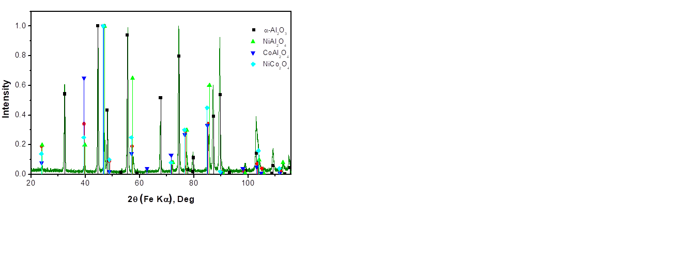
Fig 1. XRD patterns of fresh spinels catalysts.

Table 1. Results of SARA fraction of crude and upgraded oil under SCW conditions.
№ | Samples | Saturate, % | Aromatics,% | Resins,% | Asphaltenes,%
1 | Crude taha oil | 12.35 | 11.87 | 36.74 | 39.04
3 | Oil + SCW | 73.74 | 3.68 | 22.13 | 0.43
4 | Oil + CoAl₂O₄ | 63.17 | 20.43 | 14.15 | 2.22
5 | Oil + NiAl₂O₄ | 65.71 | 22.70 | 9.62 | 1.94
6 | Oil + Ni-Co₂O₄ | 57.95 | 30.40 | 9.85 | 1.79

Biography
Richard Djimasbe will complete his PhD in september 2021 at the Kazan Federal University, speciality of Petrochemistry. He complted it bachelor and master degree in chemical technology at the Kazan National Research Technological University respectively in 2015 and 2017. He is junior searcher in the rheological and thermochemical laboratory at Kazan Federal University.
Presenting author details
Full name: Richard Djimasbe
Contact number: +79046676953
Session name/ number: Petroleum Chemistry and Processing Technology
Category: (Poster presentation)

