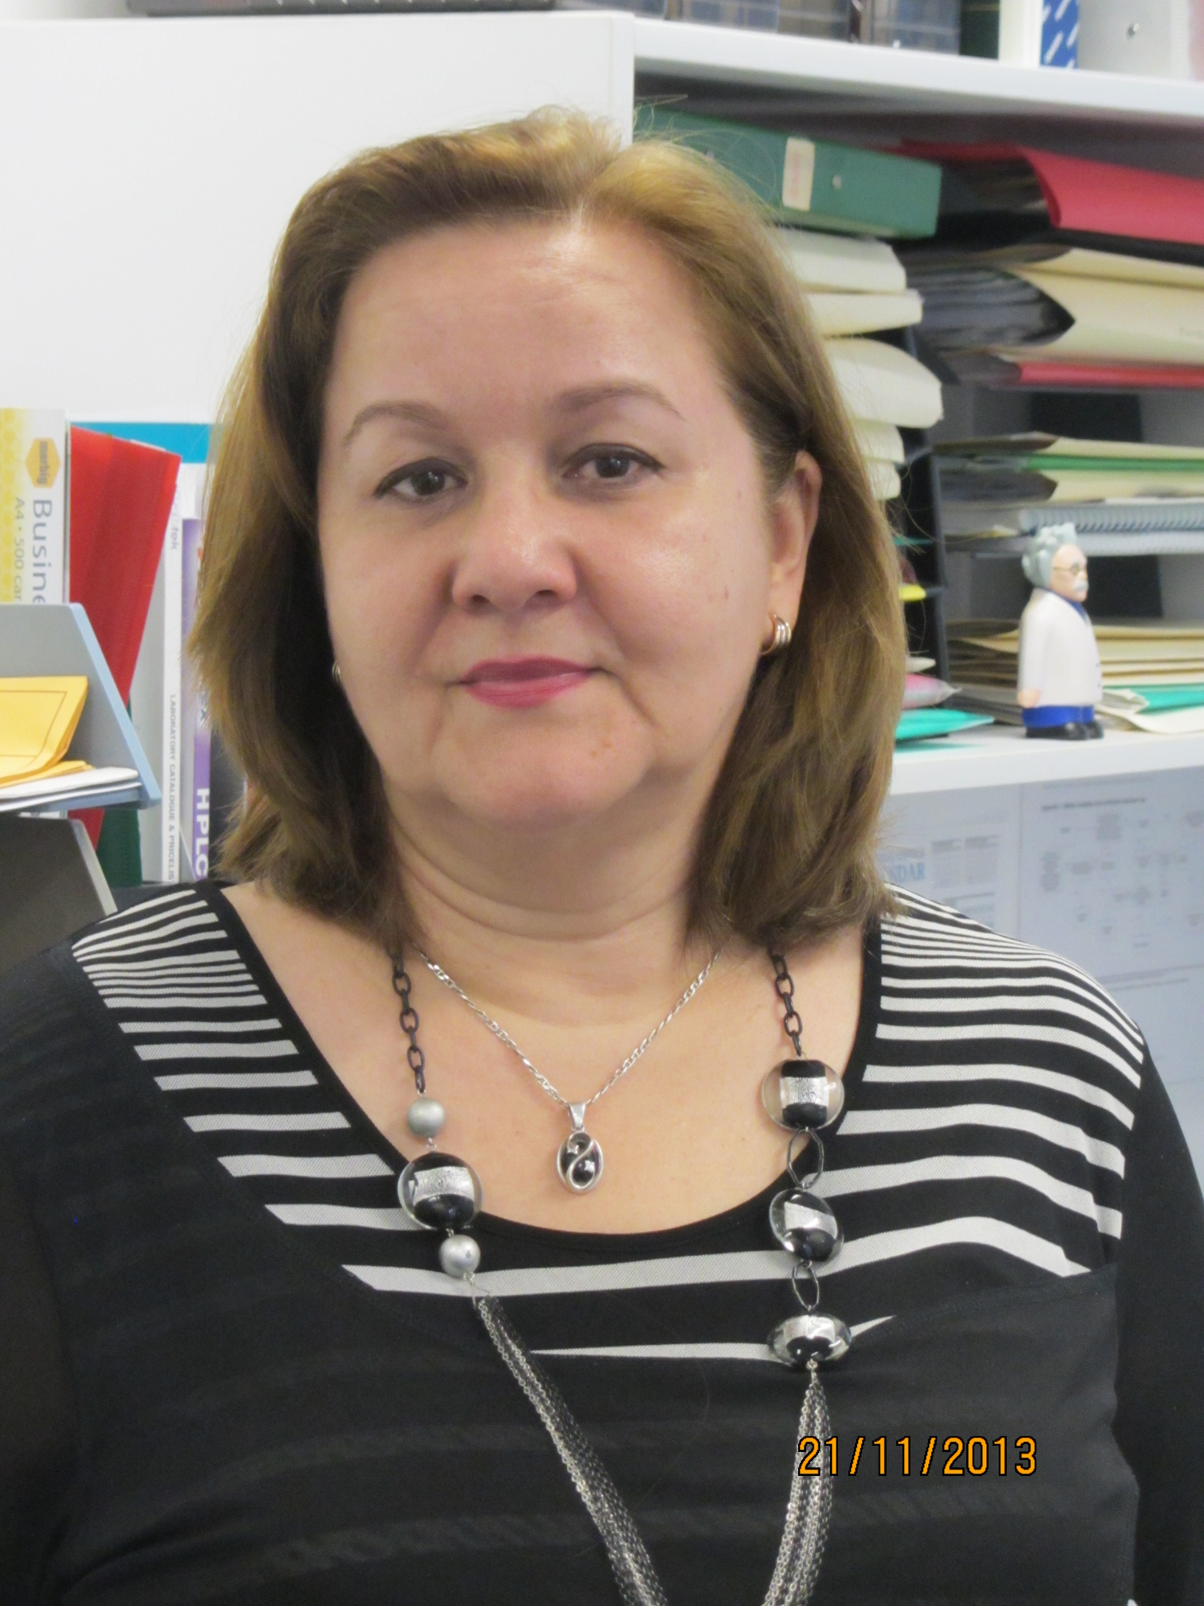

Title: Pharmacogenetic studies at the Blacktown Clinical School and Research Centre, Western Sydney University and Blacktown Hospital, Western Sydney Area Health Services.
Name: Irina Piatkov

Blacktown Molecular Research Laboratory, WSLHD, Sydney, Australia.

Pharmacogenetics (PGx) testing can help medical practitioners with drug prescription or treatment procedures in regards to more accurately predicting the starting dose, therapeutic dose, reduction in side effects and complications. It was demonstrated that PGx testing prior to prescribing psychotropic medication is associated with faster improvements in symptoms, reduction in adverse effects and health service costs. However, despite the accumulating facts that the implementation of PGx and personalized medicine can deliver effective therapy through prescriptions based on genetic profile, low acceptance and often complete rejection by medical practitioners are the main factors in preventing PGx clinical implementation.
Our Blacktown Molecular Research Laboratory (former DHI) was established in 2005 and since that time has been involved in a broad array of projects in Personalized Medicine.
Our experience in Pharmacogenetic implementation and data from the key current projects will be discussed.
- The ‘General practitioners’ awareness about individual responses to drugs’ survey was conducted by WSU year 3-4 medical students. The results demonstrate the low awareness about drug interactions, individual responses to drug and PGx application between Western Sydney general practitioners.
- Metabolic outcome in patients attending a clozapine clinic study is a cooperative project between the laboratory, endocrinologists and psychiatrists. The associations found between several genetic polymorphisms and clinical data will be discussed. Our data indicates that norclozapine is probably involved in treatment outcome more than previously considered.

Biography

Irina Piatkov, PhD, is a Senior Hospital Scientist in Charge of the Blacktown Molecular Research Laboratory at the WesternSydney University Clinical School and Research Centre, Blacktown Hospital, Western Sydney Local Health District, Australia. The laboratory supports research in Personalised Medicine, mostly in Pharmacogenetics. Since receiving her PhD in the Academy of Science USSR, Irina has been working in diagnostic, teaching and research areas of clinical biochemistry and molecular genetics.

