Emergency approach to Crying Infant
Ahmad M. Althekair, MD ¹

¹ Emergency Department, Prince Sultan Military Medical City (Riyadh, Saudi Arabia)

Abstract (300 word limit)

Crying is a common behavior of infancy that can be a signal of a broad spectrum of conditions ranging from the normal needs of hunger and sleep to significant medical or surgical pathology. Crying is a common reason that caregivers seek medical attention for infants and it is distressing for both caregivers and emergency clinicians.

While often the healthiest of patients seen in the ED, infants with unexplained, prolonged crying are challenging to evaluate and discharge especially in the care of distraught parents.

There is a broad array of diagnostic possibilities for crying infants, from the serious and life-threatening to the benign. Emergency clinicians should be aware of the clinical variables that can help distinguish among this spectrum of clinical diagnoses.

The most important elements of the ED evaluation with the highest diagnostic yield are the history and physical examination. While there are no universally recommended laboratory or imaging tests for a crying infant, urinalysis is recommended in young infants to evaluate for an occult UTI presenting as acute unexplained crying. While colic and unexplained crying are more common than serious underlying pathologies, they are diagnoses that should be made after consideration and/or evaluation of other possible causes of crying.

Image
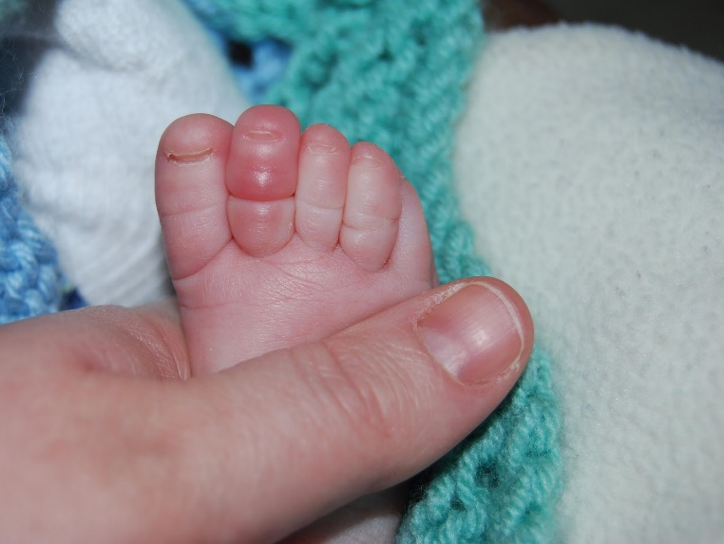
Image 1: Hair torniquet
Recent Publication:
- Alzayedi AS, Azizalrahman AA, AlMadi HA, Althekair AM, Blaivas M, Karakitsos D., J Ultrasound Med. (2017) Use and Education of Point-of-Care Ultrasound in Pediatric Emergency Medicine in Saudi Arabia

Biography (150 word limit)
Ahmad completed his Boards in Pediatric in Saudi Arabia then joined Hospital for Sick Children (SickKids) in Toronto, Canada where he achieved Pediatric Emergency Medicine fellowship, Pediatric Trauma Fellowship and an advanced training in Pediatric Point of Care Ultrasound (POCUS).
Currently, he is a Consultant Pediatric Emergency and Trauma in Riyadh. He is the Director of Pediatric POCUS training in Kingdom of Saudi Arabia. He is an international speaker in the field of Pediatric Emergency and Trauma with a major research interest in the field of Pediatric POCUS.
Email: ahmadalthekair@gmail.com
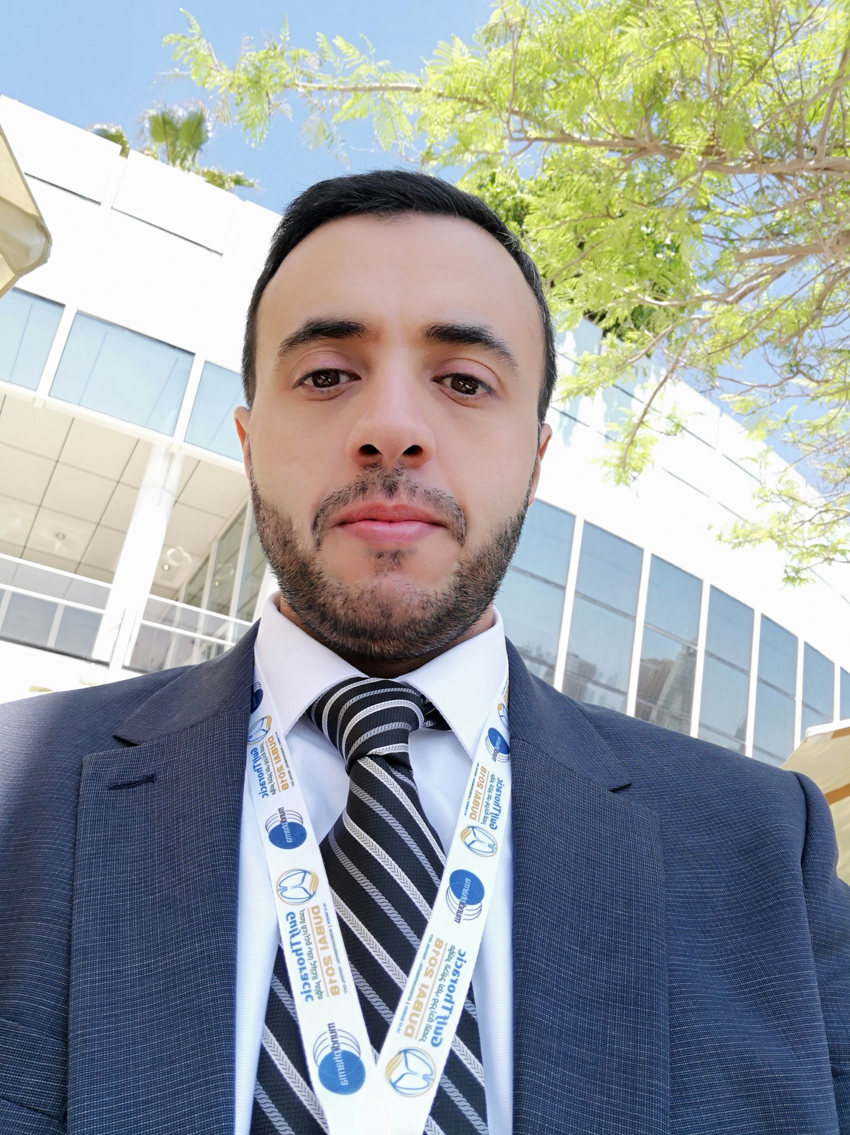

Notes/Comments:

*Photograph of presenting author, Biography and image related to the presentation are mandatory.

