The new expansion appliance with routine 3.axis expansion appliance in terms of dental arch changes and patient’s problems during treatment.

Dr Morteza Oshagh,Prof Shahla Momeni, Dr Zahra Shekoohi, Dr Khadije Hajian, Dr Amir Manouchehri

Shiraz Dental University, Fars, Iran

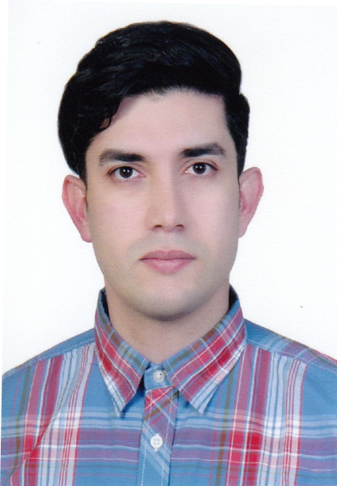
Introduction: Routine expansion screws produced heavy interrupted forces witch are unfavorable for dental movement and could be harmful to tooth structures. In vitro evaluation of a new expansion screw showed that this new screw could produce light-continuous forces.
The purpose of this study was to compare clinically the new expansion appliance with routine 3.axis expansion appliance in terms of dental arch changes and patient’s problems during treatment.
Materials and methods: 38 patients (8-14 years old) with bilateral posterior cross bite and skeletal growth potential were selected. They were randomly divided to two groups: 1) new expansion screw group. 2) 3.axis expansion screw group.
The expansion removable appliances were delivered to the patients. The measurements of dental arch dimensions on study models and requiring of patient’s problems by questionnaires were accomplished every month. For comparison the two groups t-test and Mann-Whitney U-test statistical analysis were used.
Results: There were no significant difference between two groups in terms of mean increase in intermolar, inter premolar and intercanine widths (p> 0.05). the mean score of problems during usage of appliances in two groups was not significantly different (p>0.05 ).
Conclusion: Since the changes in dental arches and problems of patients with new expansion appliance were comparable to 3.axis expansion appliance and need less cooperation of patient for activation of screw, this new expansion screw can replace routine expansion screws.
Key words: expansion, cross bite, expansion screw
Biography: Amir Manouchehri has completed his DDS at the age of 25 years from Kerman dental university in Iran. He was he director of university research community. He has done several presentations in multiple domestic and international congresses.
Amir Manouchehri
0098 (917) 7091554
oral presentation

