TORSION OF A SPLENULE IN A CASE OF SPLENOGONADAL FUSION MIMICKING STRANGULATED INGUINAL HERNIA

Dr Sujata Sai
Manipal Hospital, Bangalore, India

Abstract :

Splenogonadal fusion (SGF) is a rare congenital anomaly which occurs due to an abnormal fusion of splenic tissue with the derivatives of the perimesonephros. It usually presents as an inguinal hernia, testicular mass or undescended testis. To the best of our knowledge, this is the first time, SGF presented as a strangulated inguinal hernia.

Case :
A six-year-old boy with an acute painful left inguinal swelling since that morning.
General examination- tachycardia.
Groin exam- A tense, tender, irreducible left inguinal swelling with normal bilateral descended testes.
USG- A soft tissue swelling as the content of the hernia with reduced vascularity.
DDx- ? torsion of supernumerary testis

Intra operative findings :
Left indirect inguinal hernia
No omentum/ bowel, but a purplish mass connected distally to upper pole of the left testis and proximally entering the peritoneum through a fibrous cord
Fibrous cords – 360° torsion → early gangrenous changes
Histopathology revealed a fibroelastic capsule covering a tissue comprised of red pulp, white pulp, dilated sinusoids; consistent with an ectopic spleen.
SGF is a rare entity - less than 200 cases reported till date.The etiology is unknown.
Treatment of choice-Complete excision of the splenic tissue with preservation of gonad. Unfortunately, 37% of the reported cases underwent unnecessary orchidectomy as many surgeons were unfamiliar with SGF.

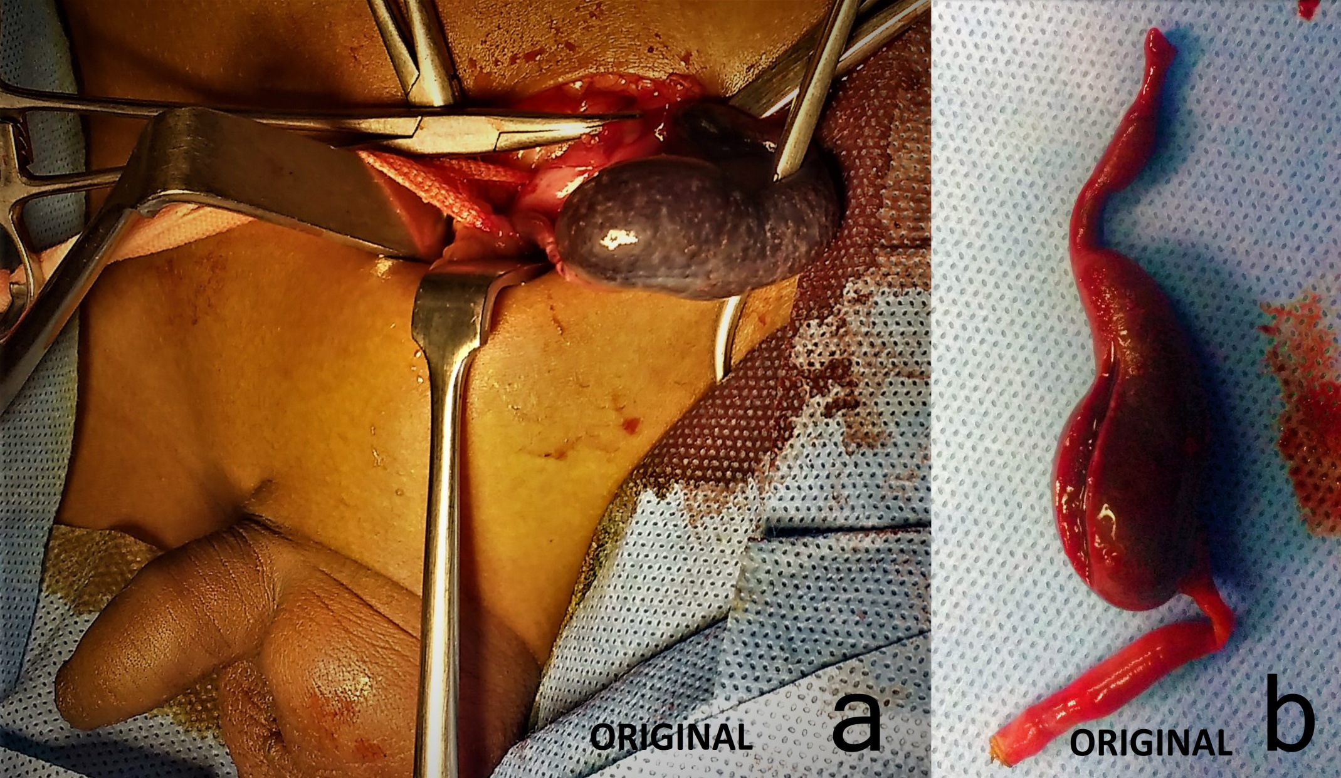

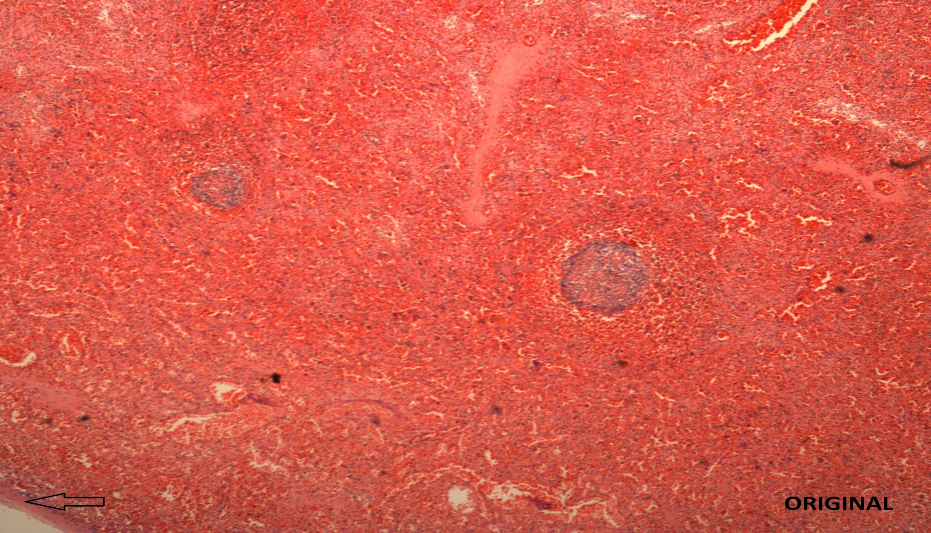

 Biography
Sujata Sai is a resident in surgery at Manipal Hospital, Bangalore. She is passionate about saving and changing lives. She also enjoys blogging about her experiences as a surgical resident. She has consistently done excellently academically, and has excelled in multiple extra curricular activities as well – She has given the Trinity College of Music Piano exams, is a part of several volunteer organisations for social service and participates in several sports as well.
Email: drsujatasai@gmail.com
Phone: +91-9886715213

Notes/Comments:

