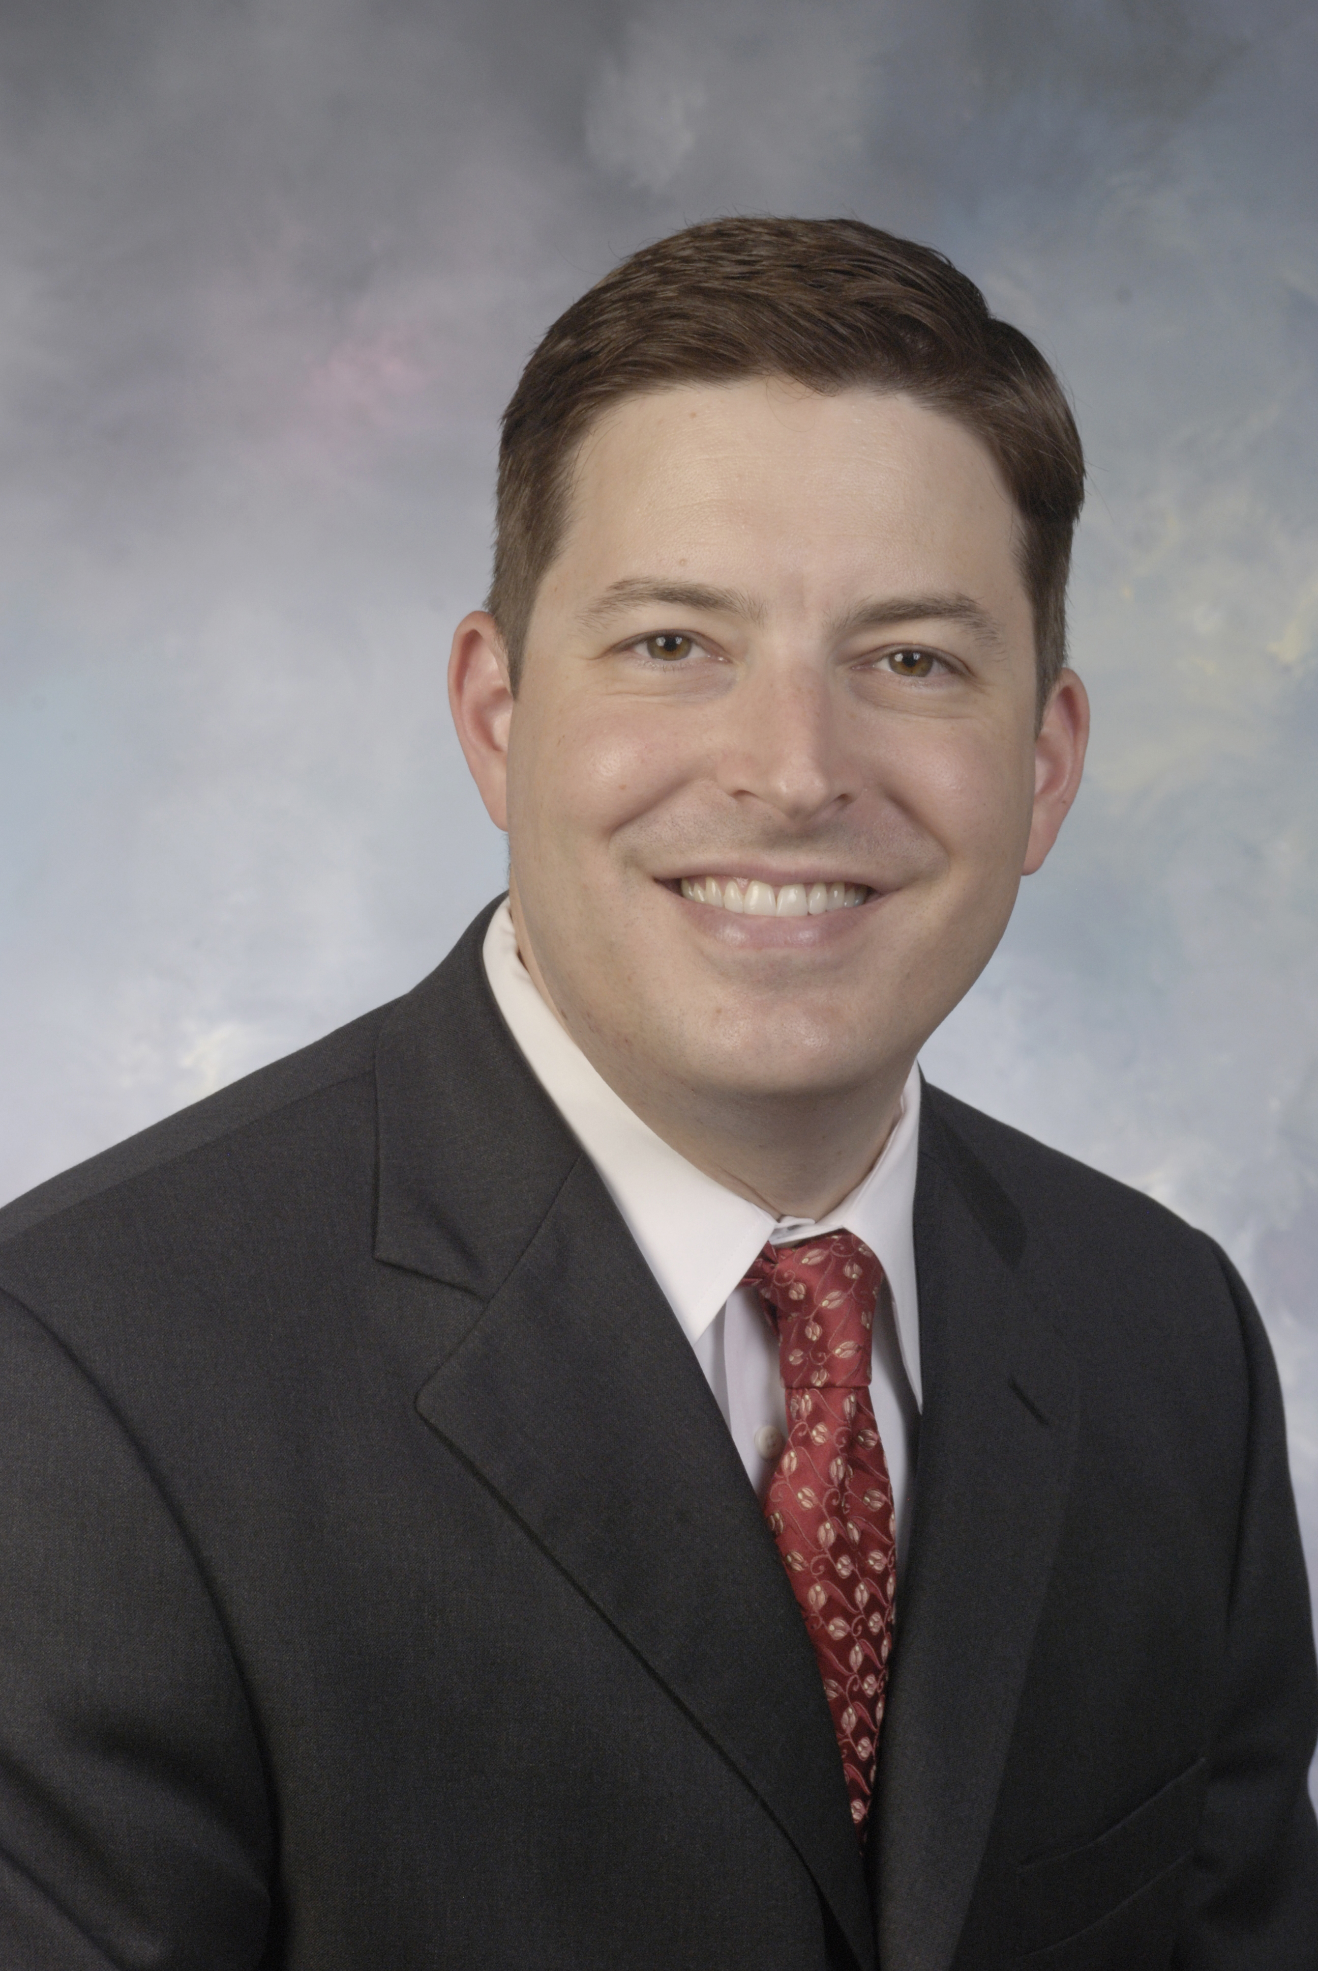

Title: USE OF TISSUE EXPANDERS IN THE REPAIR OF COMPLEX ABDOMINAL WALL DEFECTS
Name: Matthew S. Clifton, MD, Greg Mackay, MD, Richard R. Ricketts, MD

Emory University School of Medicine, GA 30322, USA

Closure of abdominal wall defects in children poses a challenge for pediatric surgeons. We describe a technique using tissue expanders placed either intraperitoneally or in the abdominal wall to aid in the reconstruction of a variety of complex abdominal wall defects. The tissue expanders are inserted under general anesthesia. Initial expansion is done in the operating room with attention to peak airway pressure, urine output, and end-tidal carbon dioxide. The expanders are inflated in the outpatient setting via percutaneous access until the calculated inflation volume is achieved. They are then removed and definitive closure accomplished using a combination of native tissue flaps, abdominal component separation techniques, biomaterials, and synthetic material. 6 patients underwent tissue expansion for treatment of abdominal wall defects (omphalocele n=3), trauma (n=1), and thoracopagus twins (n=1 pair). 1 to 4 expanders were used per patient. All patients had successful reconstruction of their abdominal walls. Two to three operations were required in order to restore abdominal domain, and consisted of expander insertion, removal with reconstruction, and possible revision of the reconstruction. Tissue expanders possess a broad range of applications for abdominal wall reconstruction, and can be used in patients of all ages.

Biography

Dr. Matthew Clifton is an Associate Professor of Surgery and Pediatrics at Emory University School of Medicine. Dr. Clifton graduated from Georgetown University School of Medicine in 2001. He completed a General Surgery residency at the University of California, San Francisco, including a 2-year research sabbatical with the Fetal Treatment Center and Center for Neurobiology of Digestive Diseases at UCSF. He completed a Pediatric Surgery Fellowship at Emory University/Children’s Healthcare of Atlanta and was recruited in 2010 to remain on faculty at Emory. He is program director of the Emory University Pediatric Surgery Fellowship and is an active, funded researcher.

Presenting author details
Full name: Matthew S. Clifton, MD, FACS, FAAP
Contact number: +1 404-354-4196
Mail id: 1263 Edmund Park Drive NE
Atlanta, GA 30306
United States of America
Contact no:
Session name/ number:
Category: Oral presentation

