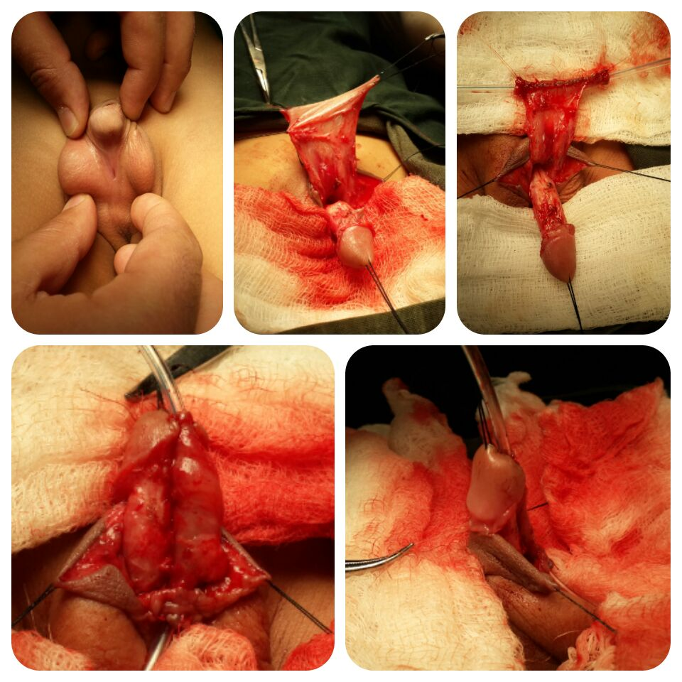
The Meatal Mobilization Technique For Distal Circumcised Hypospadias Repair

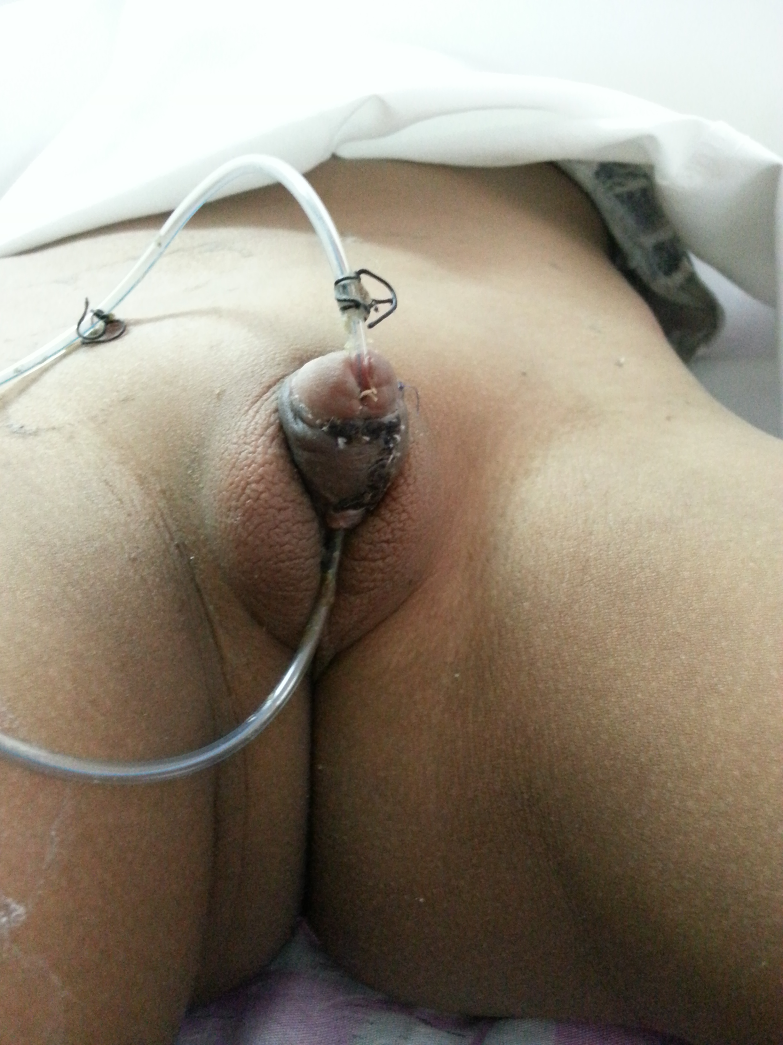
Abstract
Hypospadias is the most common anomaly in the male genital tract with an incidence of 0.8–8.2 per 1000 live male births and circumcision is an extreme common surgical intervention in our locality. Despite the existence of numerous techniques for the repair of distal penile hypospadias, we are wondering which method is applicable for circumcised hypospadias. This study aims to evaluation our experience with MEMO technique for repair of distal circumcised hypospadias.
Materials and methods: A retro and prospective study was conducted on patients with glanular, coronal and subcoronal circumcised hypospadias during the period from December 2011 to December 2013. In pediatric surgery center. Feasibility of the technique and postoperative complications were recorded.
Results: A total of 43 boys between 9 months and 7 years of age were included in the study. They underwent repair of glanular (10), coronal (18), and subcoronal (15) hypospadias. The urethra meatus was mobilized to the normal position in almost all patients. Two cases developed postoperative hematoma, which were managed conservatively and resolved spontaneously. Three patients developed wound infection and were managed with antibiotics and daily dressing until infection resolved. One patient developed urethral stenosis None of the patients had major complications such as dehiscence,urethral stricture or fistula. In one patient, the most distal of the glans approximation sutures disrupted, leading to a minor detachment in the glans. There was no recurrent chordee. Two patients underwent meatal retraction, where in the urethra migrated proximally but still within the glans.
Conclusion: The urethral mobilization technique seems to be a good method for the repair of distal circumcised hypospadias . The procedure has the advantage of avoiding the need for a second layer of tissue covering during repair.

