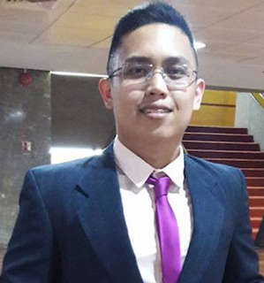

Title: A Case Report: Prolonged Fever as an Atypical Presentation
Kawasaki Disease with Coronary Giant Aneurysm
Name: Dr. Hilario Ace D. Wanasen
Dr. Jose Fabella Memorial Hospital, Department of Pediatrics, Philippines

Patients who experienced or are experiencing prolonged fever are typically associated
with illnesses like Dengue Fever. This case is not one of those. This is a case of a 14-year-old
male, with a chief complaint of headache and a prolonged, recurring fever for over a month,
found out to have Kawasaki disease with giant Coronary Aneurysm. This paper aims to discuss
and explore different variant presentations of Kawasaki disease. Kawasaki disease should be
considered in differential diagnosis of patients with prolonged and recurring fever. 2D Echo was
done to investigate the persistence of headache and fever; it revealed that the patient has
Kawasaki Disease with giant aneurysm in the right coronary artery and small aneurysm in the
left coronary artery. It was, however, too late when the giant aneurysm was detected as the
complications include, thromboembolism which can cause the vessels in the brain to occlude
and can cause stroke in the young and brain hemorrhage making him a “walking time bomb”
and caused the patient to expire a few days after hospital discharge.
Biography

Hilario Ace Wanasen, MD has completed his degree in Doctor of Medicine at the age of 24. He got his degree from the Far Eastern university-Nicanor Reyes Memorial Foundation in the Philippines. He is currently a Medical Officer III and a Second Year Pediatric Resident at the Dr. Jose Fabella Memorial Hospital.

Presenting author details
Full name: Hilario Ace Wanasen, MD
Contact number: +639234445860
Session name/ number:
Category: (Oral presentation)

