Awareness of Diabetic Retinopathy among Saudi Diabetic Patients

College of Applied Medical Sciences
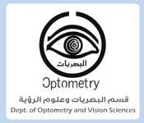
2017-2018
Made by: Assistant Prof. Dr. Mastour A Al-Hamami, Abdulrahman S Asiri, Fahad H Alessa.
Table of Contents

Abstract………………………………………………………………………………..2
Diabetes mellitus………………………………………………………………………3
Classification of Diabetes Mellitus……………………………………………………3
Type 1 Diabetes………………………………………………………………………3
Type 2 Diabetes………………………………………………………………………3
Gestational diabetes mellitus (GDM)………………………………………………...3
Other Specific Diabetes Types……………………………………………………….3
Complications of DM……………………………………………………………….…4
Diabetes effect on the brain…………………………………………………………..4
Diabetes effect on the heart…………………………………………………………..4
Diabetes effect on the kidney………………………………………………………...4
Amputations………………………………………………………………………….4
Ocular Complications of DM…………………………………………………….……5
Diabetic papillopathy (DP)…………………………………………………….…….5
Cataracts……………………………………………………………………….……..5 Neovascular Glaucoma (NVG)………………………………………………..……....5
Diabetic retinopathy (DR)……………………………………………………….…...5
Scale Severity of DR..…………………………………………………………………6
Prevalence………………………...………………………………………………...…8
Modern Technologies of DR Screening……………………...………………………..8
Statistics……………………………….………………………………………………9
Method……………………………………………………………………………….10
References……………………………………………………………………………11

Abstract

Introduction
Diabetes mellitus is a vascular disease that will affect the most important body organs such as the brain, heart, kidney and the eye as well as the pancreases. Diabetic Retinopathy (DR) is a disease of the retina; profound ischemia will lead to neovascularization of the disk (NVD), retina (NVE), iris (NVI) and the angle (NVA). World Health Organization (WHO) estimates that, globally, 422 million adults aged over 18 years were living with diabetes in 2014. In 2016 WHO has reported that Saudi Arabia took the second rank as the highest in the Middle East, and is seventh in the world for the rate of diabetes.

Method
A population-based, cross-sectional survey along with retinal imaging will be conducted. The survey will be written in English, and will be verbally translated to the Arabic language to ensure that patients fully understand each question. It consists of two main sections, the first section contains patient personal information, educational background, duration of the disease, and family history and medical history of diabetes mellitus. The second section contains questions designed to evaluate and measure the patients’ awareness of diabetic retinopathy. Each Diabetic patient will be examined using modern Optical Coherence Tomography (OCT) to measure retinal layers thickness and take an enface image of the retina.

AIM
To measure the awareness of diabetic patients of their increased risk for Diabetic retinopathy disasters. In addition, to educate diabetic patients about the complications and risk factors of diabetic eye disease, and the importance of early screening.

Diabetes mellitus is a complex chronic illness requiring continuous medical care with multifactorial risk reduction strategies beyond glycemic control.[1] Ongoing patient self-management education and support are critical to prevent acute complications and reduce the risk of long-term complications.[2] Significant evidence exists that supports a range of interventions to improve diabetes outcomes.[2]

Classification of Diabetes Mellitus:
Assigning a type of diabetes to an individual often depends on the circumstances present at the time of diagnosis, and many diabetic individuals do not easily fit into a single class.[1]
Diabetes can be classified into four clinical categories:
-Type 1 Diabetes:
This type is characterized by destruction of the insulin producing pancreatic β-cells which leads to absolute insulin deficiency. It is Usually mediated by immune mechanisms as in the LADA (latent autoimmune diabetes in adults) which is classified as type 1 diabetes.[3] This form of diabetes accounts for about 5–10% of those with diabetes.[1]
-Type 2 Diabetes:
Can range from predominant insulin resistance with relative insulin deficiency to prevailing defective secretion with insulin resistance, and it is frequently associated with other problems of the so-called metabolic syndrome.[3] This form of diabetes accounts for about 90–95% of those with diabetes.[1]
-Gestational diabetes mellitus (GDM):
GDM has been defined as any degree of glucose intolerance with onset or first recognition during pregnancy.[2]

-Other Specific Diabetes Types:
Diseases of the exocrine pancreas (e. g. pancreatitis, cystic fibrosis, hemochromatosis), Endocrinopathies (e. g. Cushing syndrome, acromegaly, pheochromocytoma), Drug induced (e. g. glucocorticoids, neuroleptics, alpha-interferons, pentamidine), Genetic defects of the β-cell function (e. g. MODY forms), Genetic defects of insulin action, Other genetic syndromes which can be associated with diabetes, Infections and Rare forms of auto-immune mediated diabetes.[3]

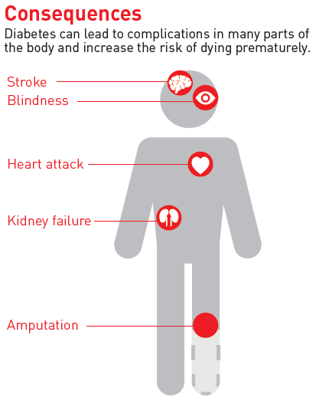
Figure 1.[4]

Complications of DM are an important health problem that induces uncomfortable complications and it causes significant morbidity owing to specific microvascular complications such as, retinopathy, nephropathy and neuropathy, and macrovascular complications such as, ischemic heart disease, and peripheral vasculopathy.[5]
-Diabetes effect on the brain:
Diabetes mellitus is associated with cognitive dysfunction and abnormalities that can be seen with brain imaging.[6] In patients with type 1 diabetes, cognitive dysfunction is characterized by a slowing of mental speed and diminished mental ﬂexibility[7], whereas modest decrements in cognitive functioning, evident on the domains of verbal and visual memory, information processing speed, and executive functioning, have been noted in people with type 2 diabetes across all age groups.[8]
-Diabetes effect on the heart:
Individuals with diabetes are not only at high risk of developing heart failure but are also at increased risk of dying from it.[9] One reason for the poor prognosis in patients with both diabetes and ischemic heart disease seems to be an enhanced myocardial dysfunction leading to accelerated heart failure (diabetic cardiomyopathy).[10]
-Diabetes effect on the kidney:
Renal disease is a common and often severe complication of diabetes.[10] Approximately 35% of patients with diabetes of 18 years’ duration will have signs of diabetic renal involvement.[10]
-Amputations:
Convincing evidence suggests that peripheral artery disease (PAD), present in half of patients with diabetic foot ulcer, confers poorer outcome.[11]

Ocular Complications of DM:
DM can lead to several ocular complications such as diabetic papillopathy, glaucoma, cataract, ocular surface diseases and diabetic retinopathy.[12]
-Diabetic papillopathy (DP): is a syndrome characterized by self-limited unilateral or bilateral optic disk swelling associated with minimal or no permanent loss of visual function, and it may affect patients with type 1 and type 2 DM.[13]
-DM is the major etiologic factor for Neovascular Glaucoma (NVG). NVG is a severe and intractable glaucoma type.[14] Also, DM is associated with other types of glaucoma such as open angle glaucoma (OAG) and angle closure glaucoma (ACG).[5] OAG is one of the most common causes of vision loss worldwide.[15] In several studies, DM was reported as a risk factor for OAG, along with other risk factors such as elevated IOP.[15] The association between DM and ACG is not very clear, but several studies showed that DM might be considered as a risk factor for ACG.[16]
-Cataracts, characterized by cloudiness or opacification of the crystalline eye lens, are the leading cause of curable blindness in the word.[17] Older-onset diabetes is associated with increased frequency of a specific age-related lens change, cortical opacity.[18]
-Diabetic retinopathy (DR), a well-known consequence of long-standing and poorly controlled diabetes mellitus (DM), causes significant vision loss and blindness in the working-age population.[19]
DR is a disease of the retina, but similar vascular and ischemic changes can be found in other areas of the eye in the more advanced stages.[19]
The incidence of DR is related primarily to duration and control of diabetes and is related to hyperglycemia, hypertension, hyperlipidemia, pregnancy, nephropathy, and anemia.[5]
Profound ischemia of the retina leads to neovascularization (growth of new vessels) of the disc (NVD), the retina (NVE), the iris (NVI) and the angle (NVA).[19]
Reasons for loss of vision are diabetic maculopathy such as diabetic macular edema and complications of PDR such as vitreous hemorrhage, tractional retinal detachment.[20] The obscure fundus makes it difficult to monitor the course of the disease and could result in delayed management of possible retinal detachments or additional application of laser treatment.[21]
Tractional retinal detachment results in separation of the neurosensory retina from the retinal pigment epithelium.[20] Detached sections of the retina cause relative visual-field defects (scotoma) and loss of visual acuity in cases with macular involvement.[20]

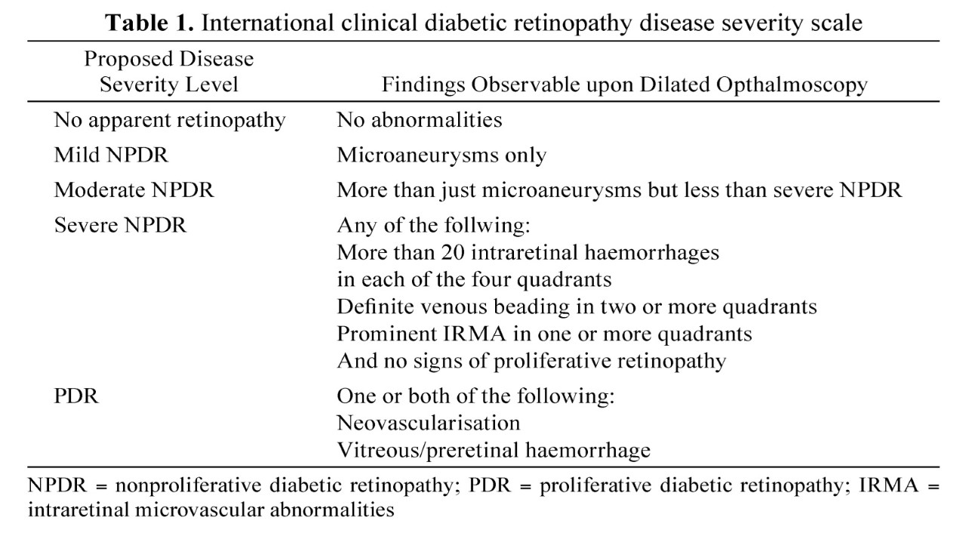
Table 1.[22]

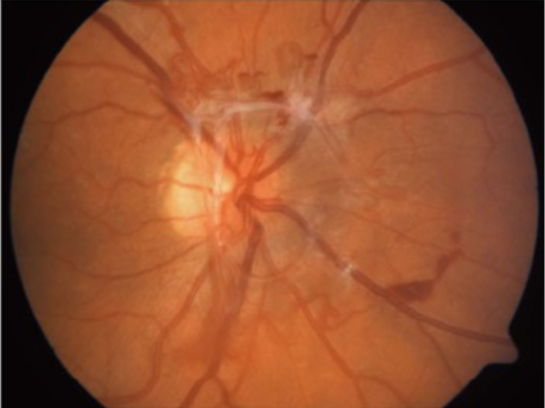

Proliferative diabetic retinopathy with neovascularization at disk.[20]

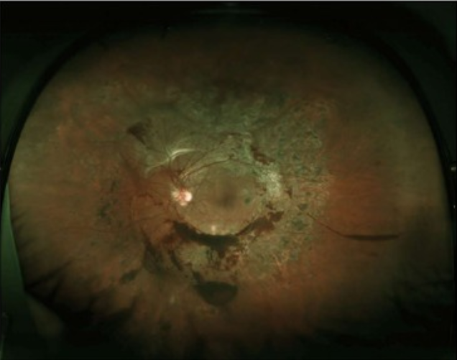

Advanced proliferative diabetic retinopathy with neovascularization and limited vitreous hemorrhage.[20]

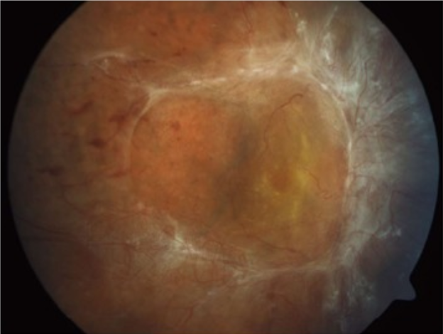

Advanced proliferative diabetic retinopathy with tractional retinal detachment.[20]

World Health Organization (WHO) estimates that, globally, 422 million adults aged over 18 years were living with diabetes in 2014.[23] Diabetic retinopathy caused 1.9% of moderate or severe visual impairment globally and 2.6% of blindness in 2010.[17] Studies suggest that prevalence of any retinopathy in people with diabetes is 35% while proliferative (vision-threatening) retinopathy is 7%.[24]
- About the WHO diabetes program:
The WHO Diabetes Program mission is to prevent type 2 diabetes and to minimize complications and maximize quality of life for all people with diabetes.[25] Our core functions are to set norms and standards, promote surveillance, encourage prevention, raise awareness and strengthen prevention and control.[25]

Modern technologies such as portable handheld nonmydriatic cameras[26], adaptive optics, retinal function assessment, retinal oximetry, metabolic imaging, and fundus auto fluorescence are starting to be used in DR management and have the potential to change the landscape further in the future.[27] Also there are some other methods such as hand-held ophthalmoscope, Slit-lamp using Volk-Lenses and portable fundoscopy .[28]
Optical Coherence Tomography (OCT) is a non-invasive technique that uses cross-sectional image.[29] OCT is now regularly used in diagnosis of a variety of diseases of the retina, in imaging and measurements of the anterior chamber and in the measurement of the eye length.[30] OCT imaging is constructed of interference between signal from a substance below inspection and a local reference signal.[30] OCT generates real hue retinal image.[31] OCT conducted from any location and does not require mydriasis.[31] OCT uses 12mm x 9mm wide field scan for optic nerve & macula.[31] OCT has longitudinal and lateral spatial resolutions of a few micrometers and can identify mirrored indications as poor as ~10−10 of the incident optical power.[29] The major framework in imaging the fundus is 800–900 nm, where water absorption is slightest. For imaging the anterior chamber, 800 nm as well as longer wavelengths, such as 1300 nm have been used. The 1020–1080 nm area of the close to-infrared spectrum appeared as an alluring choice for imaging the fundus because of a relative minimal of the water absorption coefficient at 1060 nm.[30]

In 2016 The World Health Organization (WHO) has reported that Saudi Arabia took the second rank as the highest in the Middle East, and is seventh in the world for the rate of diabetes.[32] Approximately around 7 million of the population are diabetic and almost around 3 million have pre-diabetes.[32]
A recent population based study that has been done between November 2011 and January 2012 in the Southern region of KSA has found that the prevalence of DR among the diabetic population is 36.4%.[33] While another hospital-based study in Al-Madinah region reported a similar prevalence of 34.5%.[34]

[17, 23, 32, 35]

Method:
A population-based, cross-sectional survey will be conducted. The survey was
designed to measure the awareness of diabetic patients of the disasters of diabetic retinopathy. The survey will target eligible persons who are only considered diabetic patient during the period of the study. The questionnaire is electronic and will be done using an iPad to all participant. In order to maintain confidentiality, data will be collected anonymously with the patient consent. The survey will be written in English. It consists of two main sections; the first section contains patient personal information, educational background, duration, family history and medical history of diabetes mellitus. The second section contains questions designed to evaluate and measure the patients’ awareness of diabetic retinopathy. The questionnaire will be verbally translated to the Arabic language to ensure that patients fully understand each question. The questionnaire will be answered by the patient only. Each Diabetic patient will be examined after the questionnaire using modern Optical Coherence Tomography (OCT) to measure retinal layers thickness and take a face images of the retina. OCT is very good for screening; because it is non-invasive, needs no dilation, produces colorful fundus image, and can be operated from any position. OCT uses 12mm x 9mm wide field scan for optic nerve & amp; macula. OCT can produce 50.000 A-Scans per second. OCT is fully automated operation: auto alignment, auto focus and auto shot.

Result:
This study included data from 554 participants, 380 of those do not think diabetes will affect their eyes (table 1, figure 1). In addition, almost the same percent did not know diabetic retinopathy (table 2, figure 1). The samples ranging in age from 10 to 80years, most of the samples are between 40-59years old (table 3). The samples are almost half males and half females (49.1%-50.9%) (table 4). Most of the participants have diabetes of less than 10 years (table 5) and the majority were type two diabetes (table 6).

Do you think diabetes will affect your eyes?
 |  | Frequency | Percent | Valid Percent | Cumulative Percent
Valid | Yes | 174 | 31.4 | 31.4 | 31.4
Valid | No | 380 | 68.6 | 68.6 | 100.0
Valid | Total | 554 | 100.0 | 100.0
Table 1

Do you know diabetic retinopathy?
 |  | Frequency | Percent | Valid Percent | Cumulative Percent
Valid | Yes | 172 | 31.0 | 31.0 | 100.0
Valid | No | 382 | 69.0 | 69.0 | 69.0
Valid | Total | 554 | 100.0 | 100.0
Table 2

Age
 |  | Frequency | Percent | Valid Percent | Cumulative Percent
Valid | 10-39 | 102 | 18.4 | 18.4 | 18.4
Valid | 40-59 | 321 | 57.9 | 57.9 | 76.4
Valid | 60-80 | 131 | 23.6 | 23.6 | 100.0
Valid | Total | 554 | 100.0 | 100.0
Table 3

sex
 |  | Frequency | Percent | Valid Percent | Cumulative Percent
Valid | female | 272 | 49.1 | 49.1 | 49.1
Valid | male | 282 | 50.9 | 50.9 | 100.0
Valid | Total | 554 | 100.0 | 100.0
Table 4

Duration of diabetes in years
 |  | Frequency | Percent | Valid Percent | Cumulative Percent
Valid | >20 | 28 | 5.1 | 5.1 | 5.1
Valid | 1-10 | 367 | 66.2 | 66.2 | 71.3
Valid | 11-20 | 159 | 28.7 | 28.7 | 100.0
Valid | Total | 554 | 100.0 | 100.0
Table 5

Diabetes type
 |  | Frequency | Percent | Valid Percent | Cumulative Percent
Valid | 1 | 99 | 17.9 | 17.9 | 17.9
Valid | 2 | 455 | 82.1 | 82.1 | 100.0
Valid | Total | 554 | 100.0 | 100.0
Table 6
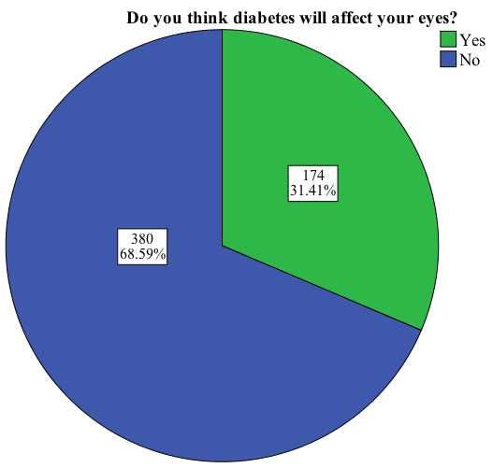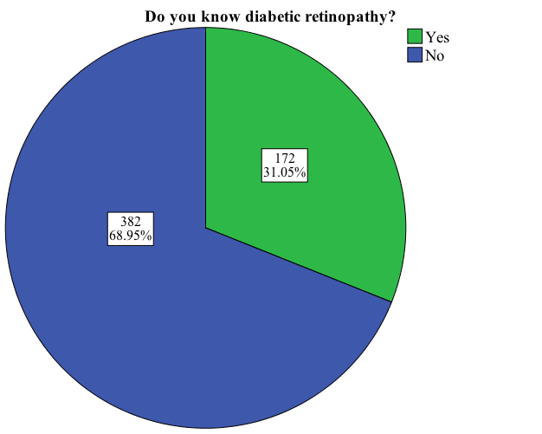Figure one these pie charts explains that the majority Do not think that diabetes will affect their Eyes (Left) and the majority does not know diabetic retinopathy (right)

Discussion:
The aim of this study was to measure the awareness of diabetic patients of their increased risk for Diabetic retinopathy disasters. In addition, to educate diabetic patients about the complications and risk factors of diabetic eye disease, and the importance of early screening. Our findings demonstrate very poor awareness of the effect of diabetes on the eye and poor knowledge of diabetic retinopathy. Figure two shows that more than half of the young patients (10-39) have visited eye doctor; this could be because they are more likely to be type one diabetes and they have had a good health care and health education compared to elderly people. Most of the elderly people have not had their eyes checked up, while in fact all of them should have had eye exam because the majority will show any sort of diabetic retinopathy or any other eye complication due to diabetes. Figure three shows that males and females are equally unaware of the importance of the eye exam for diabetic patients.
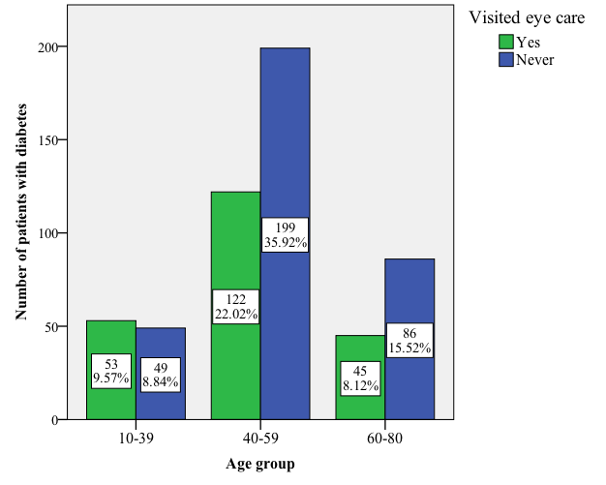
Figure two
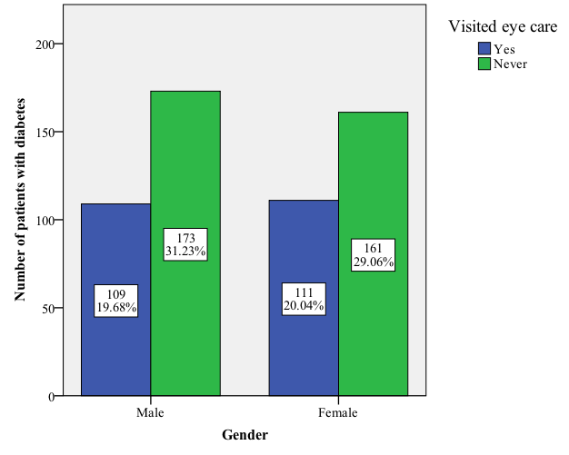
Figure three

References:
1. Association, A.D., Diagnosis and classification of diabetes mellitus. Diabetes care, 2014. 37(Supplement 1): p. S81-S90.
2. Association, A.D., Standards of medical care in diabetes—2014. Diabetes care, 2014. 37(Supplement 1): p. S14-S80.
3. Kerner, W. and J. Brückel, Definition, classification and diagnosis of diabetes mellitus. Experimental and Clinical Endocrinology & Diabetes, 2014. 122(07): p. 384-386.
4. WHO Global report on diabetes.
5. Sayin, N., N. Kara, and G. Pekel, Ocular complications of diabetes mellitus. World journal of diabetes, 2015. 6(1): p. 92.
6. Biessels, G.J., I.J. Deary, and C.M. Ryan, Cognition and diabetes: a lifespan perspective. The Lancet Neurology, 2008. 7(2): p. 184-190.
7. Brands, A.M., et al., The effects of type 1 diabetes on cognitive performance. Diabetes care, 2005. 28(3): p. 726-735.
8. Biessels, G.J. and Y.D. Reijmer, Brain changes underlying cognitive dysfunction in diabetes: what can we learn from MRI? Diabetes, 2014. 63(7): p. 2244-2252.
9. Gilbert, R.E. and H. Krum, Heart failure in diabetes: effects of anti-hyperglycaemic drug therapy. The Lancet, 2015. 385(9982): p. 2107-2117.
10. Grundy, S.M., et al., Diabetes and cardiovascular disease. Circulation, 1999. 100(10): p. 1134-1146.
11. Brownrigg, J., et al., Performance of prognostic markers in the prediction of wound healing or amputation among patients with foot ulcers in diabetes: a systematic review. Diabetes/metabolism research and reviews, 2016. 32(S1): p. 128-135.
12. Threatt, J., et al., Ocular disease, knowledge and technology applications in patients with diabetes. The American journal of the medical sciences, 2013. 345(4): p. 266-270.
13. Kim, M., J.-H. Lee, and S.-J. Lee, Diabetic papillopathy with macular edema treated with intravitreal ranibizumab. Clinical ophthalmology (Auckland, NZ), 2013. 7: p. 2257.
14. Al-Shamsi, H.N., et al., Neovascular glaucoma at king khaled eye specialist hospital–etiologic considerations. Middle East African journal of ophthalmology, 2009. 16(1): p. 15.
15. Bonovas, S., V. Peponis, and K. Filioussi, Diabetes mellitus as a risk factor for primary open‐angle glaucoma: a meta‐analysis. Diabetic medicine, 2004. 21(6): p. 609-614.
16. Saw, S.-M., et al., The relationship between anterior chamber depth and the presence of diabetes in the Tanjong Pagar Survey. American journal of ophthalmology, 2007. 144(2): p. 325-326.
17. Bourne, R.R., et al., Causes of vision loss worldwide, 1990–2010: a systematic analysis. The Lancet Global Health, 2013. 1(6): p. e339-e349.
18. Klein, B.E., et al., Older-onset diabetes and lens opacities. The Beaver Dam Eye study. Ophthalmic epidemiology, 1995. 2(1): p. 49-55.
19. Gupta, N., et al., Diabetic retinopathy and VEGF. The open ophthalmology journal, 2013. 7: p. 4.
20. Nentwich, M.M. and M.W. Ulbig, Diabetic retinopathy-ocular complications of diabetes mellitus. World journal of diabetes, 2015. 6(3): p. 489.
21. Osaadon, P., et al., A review of anti-VEGF agents for proliferative diabetic retinopathy. Eye, 2014. 28(5): p. 510-520.
22. Tarr, J.M., et al., Retinopathy in diabetes, in Diabetes. 2013, Springer. p. 88-106.
23. Collaboration, N.R.F., Worldwide trends in diabetes since 1980: a pooled analysis of 751 population-based studies with 4· 4 million participants. The Lancet, 2016. 387(10027): p. 1513-1530.
24. Yau, J.W., et al., Global prevalence and major risk factors of diabetic retinopathy. Diabetes care, 2012. 35(3): p. 556-564.
25. WHO Diabetes Programme.
26. Yogesan K, Constable IJ, Barry CJ, Eikelboom RH, McAllister IL, Tay-Kearney ML Telemed J. 2000 Summer; 6(2):219-23.
27. Yoshitake S, Murakami T, Uji A, Unoki N, Dodo Y, Horii T, Yoshimura N Eye (Lond). 2015 May; 29(5):662-9.
28. Klein, R. and B.E. Klein, Diabetic eye disease. The Lancet, 1997. 350(9072): p. 197-204.
29. Huang, D., et al., Optical coherence tomography. Science (New York, NY), 1991. 254(5035): p. 1178.
30. Podoleanu, A.G., Optical coherence tomography. Journal of Microscopy, 2012. 247(3): p. 209-219.
31. TOPCON Optical coherence tomography.
32. Abdulaziz Al Dawish, M., et al., Diabetes mellitus in Saudi Arabia: a review of the recent literature. Current diabetes reviews, 2016. 12(4): p. 359-368.
33. Hajar, S., et al., Prevalence and causes of blindness and diabetic retinopathy in Southern Saudi Arabia. Saudi medical journal, 2015. 36(4): p. 449.
34. El-Bab MF, Shawky N, Al-Sisi A, Akhtar M. Retinopathy and risk factors in diabetic patients from Al-Madinah Al-Munawarah in the Kingdom of Saudi Arabia. Clin Ophthalmol. 2012;6:269–276.
35. Elhadd TA, Al-Amoudi AA, Alzahrani AS. Epidemiology, clinical and complications profile of diabetes in Saudi Arabia: A review. Ann Saudi Med. 2007;27:241–50.

