Progressive retinal vessel malformation in a premature infant with Sturge-Weber syndrome after intravitreal anti-VEGF
Yun Li, Jian Cao,
Department of Ophthalmology, the 2nd Xiangya Hospital of Central South University, Changsha, Hunan, P.R. China;
Hunan Clinical Research Center of Ophthalmic Disease, Changsha, Hunan, P.R.China.

Abstract (300 word limit)
Case presentation
A male infant (gestational age 30 weeks, birth weight 1410g) presented for the screening of retinopathy of prematurity (ROP). On examination at age PMA 34 weeks (initial visit) a port wine stain was noted on his left eyelids and maxillary area, following the V1 and V2 distributions of the trigeminal nerve (Figure 1A). From post menstrual age (PMA) 37 weeks, he was found to have progressive ROP (Zone 2 stage 3) in his left eye and received intravitreal ranibizumab (Lucentis, Novartis) at PMA 39 weeks to treat type 1 ROP. The ridge and neovascularization (NV) regressed satisfactorily, but diffuse choroidal hemangioma became evident at 40 weeks, with typical “tomato catsup fundus”. These clinical findings characterized Sturge-Weber Syndrome. At PMA 44 weeks, the baby was then noted to have increased bulbar conjunctival vascularization and retinal vascular tortuosity. Multiple vein-to-vein anastomoses in the peripheral retina (Figure 2) and increased retinal vascular tortuosity are spotted on fundus photography and fluorescein angiography (FFA) (Figure 3). The baby has a normal IOP thus far and is under close observation for further ocular changes. No leptomeningeal angiomatosis was noted from the MRI (result not shown).
Discussion and conclusions
We describe a premature infant as a youngest SWS patient whose progressive multiple ocular vessel malformations was documented. The patient was also diagnosed with type1 ROP in his left eye at PMA 37. a lesson we should think and learn from this case is how we can differentiate the vascular abnormality in SWS and ROP. .morphology of the abnormal vessels, progression pattern and FFA under anesthesia is helpful in such situation..

Recent Publications (minimum 5)
- Harper C (2009) The neuropathology of alcohol-related braindamage. Alcohol Alcohol 44:136-140.
- Heilig M, Egli M (2006) Pharmacological treatment of alcohol dependence: Target symptoms and target mechanisms. Pharmacology and therapeutics 111:855-876.

Image
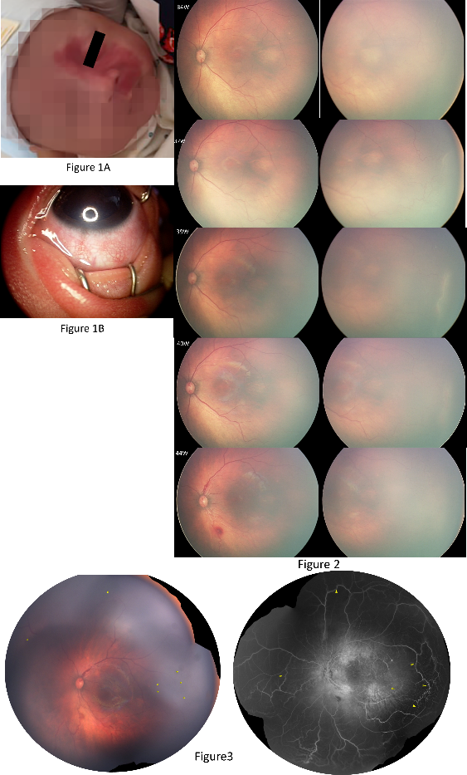

- LiX, SchwachaMG, ChaudryIH, ChoudhryMA (2008)Acutealcohol intoxication potentiates neutrophil-mediated intestinal tissue damage after burn injury. Shock 29:377.
- Room R, BaborT, Rehm J (2005) Alcohol and public health. Lancet
365: 519-530.
5. Sullivan EV, Zahr NM (2008) Neuroinflammation as a neurotoxic mechanism in alcoholism: Commentary on “Increased MCP- 1 and microglia in various regions of human alcoholic brain”. Experimental neurology 213:10-17.

 Biography (150 word limit)
Li Yun has her expertise in evaluation and passion in improving the pediatric ophthalmology clinical and translational research.
Email: 2259960885@qq.com
Notes/Comments:

