Innovative non-surgical method in complex strabismus treatment using new Prismatic Strabismus Compensators (PSC)
Yevhenia Shvets, Children’s treatment center “Nebolejka”, Ukraine

Abstract (300 word limit)
Statement of the Problem: Although there are only two main approaches in complex strabismus treatment that exist today – surgical treatment and botulinum toxin injections, the search for alternative techniques of strabismus treatment remains relevant. The purpose of this study is to evaluate the effectiveness of using Prismatic Strabismus Compensators (PSC) in therapeutic (non-surgical) treatment of complex strabismus in children. Methodology & Theoretical Orientation: Retrospective analysis of the efficacy of PSC used for the period of 5 years when treating complex strabismus in 68 patients between 6 to 72 m.o.a was utilized for this study. In 82% of the studied cases, strabismus was complicated by strabismic amblyopia of different severity. Depending on the age of the patients, PSC has been used in - prismatic glasses with PSC (23,5%); outpatient treatment using apparatuses (25%); combination treatment (51,5%). Findings: All the patients were divided into three groups based on the results obtained and the similarity between the clinical cases: patients, who became completely free of strabismus without any surgery – 48,5% (Group 1); patients, who had their squint angle reduced by 2-3 times – 36,9% (Group 2) and patients, who underwent 1-stage surgical treatment – 14,6% (Group 3). Conclusion & Significance: The visual system’s reserves are well – stimulated by using PSC in strabismus treatment, which allowed to compensate most of the motor and sensor dysfunctions causing strabismus in childhood, i. e. eliminating the cause of disorder using inartificial method. The correct usage of PSC for patients under 5 years old in most cases leads to successful non-surgical outcome.
For cases, when the surgery involvement is inevitable, the usage of PSC can eliminate the complications of strabismus (“jump symptom“, suppression scotoma etc.) and prepare for 1-stage surgical treatment.

Image

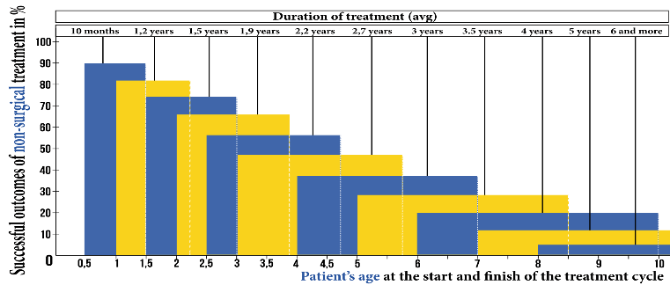
Figure 1The diagram of correlation between patient’s age, duration of treatment, and probability of successful non-surgical outcome
Recent Publications (minimum 5)
- Chang M Coleman A, Tseng V, Demer J (2017) Surgical interventions for vertical strabismus in superior oblique palsy. Cochrane Database Syst Rev 11: CD012447
- Kurochkin V, Terekhova T, Glumskova Y, Triludina Y, Shelikhova O (2018) Application of Fresnel Prism in the complex treatment of friendly strabismus. Ophtalmology in Russia 15: 98-105
- Saunders R (1984) Incomitant vertical strabismus. Treatment with posterior fixation of the inferior rectus muscle. Arch Ophthalmol 102: 1174 -7
- Serduichenko V (2018) Prisms in the treatment of strabismus: Our experience of the use of prismatic correction in children with small angle of strabismus. J Clin Exp Ophthalmol, Volume 9 DOI: 10.4172/2155-9570-C2-081
- Sharma P, Gaur N, Phuljhele S, Saxena R (2017) What’s new for us in strabismus. Indian J Ophthalmol 65: 184-190.
- Tour R (1959) Nonsurgical treatment of convergent strabismus. Calif Med 90: 429-432.

 Biography (150 words limit)
Yevhenia Shvets – Pediatric Ophthalmologist with 30 years’ experience. From 2010 – Chief Doctor for prevention oriented multi-services medical center "Neboleyka" .
2006 - implemented ophthalmological solution created by Lametesk Laboratory, Dr.Shvets developed a methodology for visual accuity improvement in children with different ophthalmic pathology complicated by amblyopia.
From 2007 Dr.Shvets has been working on the development of non-surgical pediatric strabismus treatment methodology. From 2011 she started applying prismatic strabismus compensators developed by National Academy of Science of Ukraine in strabismus treatment.
From 2011 till 2015 Dr.Shvets conducted a study of this methodology efficacy on patients from 6 m.o.a. to 15 years (the results were presented on 39th ESA meeting). From 2015 to 2017 Dr.Shvets conducted further study on patients aged from 6 to 24 m.o.a. (the results and implementation details were presented within instruction course on WOC 2018).
She is Laureate of the Pilman Prize for achievement in Pediatric Ophthalmology.
Email: anutka_poi@ukr.net

Notes/Comments:

