Surgery treatment of rhegmatogenous retinal detachments in adult retinopathy of prematurity
Zhao Xiquan, Chai Fang
Shaanxi Ophthalmic Medical Center, Xi’an No. 4 Hospital, Affiliated Guangren Hospital, School of Medicine, Xi'an Jiaotong University, Xi’an, 710004, China
Correspondence to: Xiquan Zhao, Xi’an No. 4 Hospital, Shaanxi Ophthalmic Medical Center, Affiliated Guangren Hospital, School of Medicine, Xi'an Jiaotong University, Xi’an, 710004, China;
Phone: +86-29-87480848; Fax: +86-29-87480858;
E-mail: zhaoxiquan1972@163.com

Purpose To report a treatment of rhegmatogenous retinal detachments in adult with retinopathy of prematurity.
Methods We present a case of rhegmatogenous retinal detachments in a 21-year-old female with retinopathy of prematurity. The patient had history of premature birth and treatment of ROP. After a full ophthalmic examination, scleral buckling was taken to treat the rhegmatogenous retinal detachments.
Results The fundus examination showed retinal folds in both eyes, and the retinal vessels were pulled straight, the retina of the left eye was removed from 1 to 8 o'clock, and the peripheral hole was at 5 o’clock. The silicone tape was pressed from the 4 to 6 o'clock pad at the anterior equatorial hole. Intraoperative combined retinal drainage. Postoperative follow-up observation of subretinal fluid absorption, and the retinal are flat.
Conclusion: In patients with a history of premature birth, features of fundus examinations do not correlate with the occurrence of a retinal detachment. Repair of detachment in such a patient is more likely to require multiple procedures. Physicians should consider widespread relief of vitreoretinal traction for detachment in any patient with a history of premature birth.
Key words: retinopathy of prematurity, adult, surgery treatment

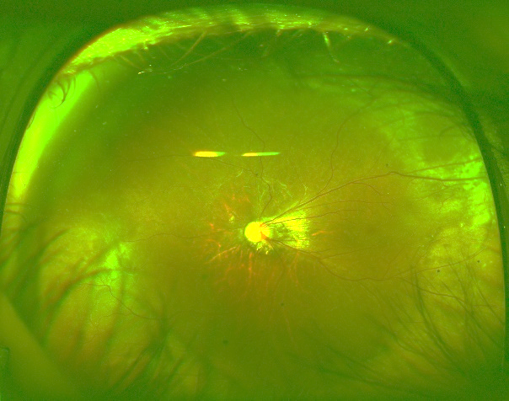
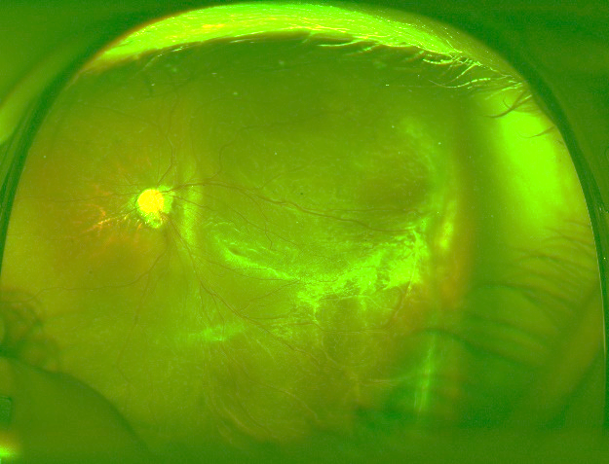
Before treatment After treatment

