Clinical observation of surgical outcomes of patients with Bielschowsky type acute acquired concomitant esotropia
Jiwen Yang,Lijing Liu ,Aier Eye Hospital Group Shenyang Aier Eye Hospital,CHINA

Abstract (300 word limit)

Purpose:To review and analyze surgical outcomes of patients with Bielschowsky type acute acquired concomitant esotropia (AACE).
Methods:Retrospective study.We enrolled 9 esotropia and diplopia patients with myopia who performed strabismus surgery in Shenyang Aier Eye Hospital between June 2018 and March 2019,including 4 males,5 females.The mean age of the patients was 22.67±5.41(range,16-30)years.They underwent monocular Medial Rectus Recession and Lateral Rectus Resection(6 cases),monocular Lateral Rectus Resection(3 cases).
Results:1.The mean time of esotropia and diplopia onset:22±15.59(range, 6-48)months.2.Incentives and treatment history:Excessive near working(2 cases),acupuncture treatment(3 cases),others with no treatment.3.The mean refractive errors in the right and left eyes were -4.05±1.34(range,-2.25~-6.50) and -3.52±0.98(range,-2.00~-5.25) diopters(D), respectively.4.The mean AC/A value:2.04±1.10(range,0.67~4).5.Esodeviations:Average preoperative esodeviations at near and distance were 22.67±12.41(range,14~48) and 29.11±9.27(range,18~46) PD, average postoperative esodeviations at near and distance were 0 and 0.44±1.33(range,0~4)PD.There were significant statistically difference between preoperative and postoperative esodeviations both at near(T=5.48，P＜0.01)and distance (T=8.65，P＜0.0 1),respectively.6.The mean Medial Rectus Recession 2.44±1.94(range,0-5)mm,3 cases had dominant diplopia at distance,so they underwent monocular Lateral Rectus Resection,the mean Lateral Rectus Resection 4.89±0.78(range,4-6)mm.7.Diplopia:9 patients all had diplopia preoperatively,all disappeared postoperatively.8.Stereopsis:5 patients had no stereopsis before surgery,3 cases regained stereopsis after surgery.

Conclusions:In case of patients with Bielschowsky type AACE,surgery is the main treatment,patients achieved successful surgical alignment and the diplopia vanished as well.For patients with myopia, they should control the near work moderately.

Image
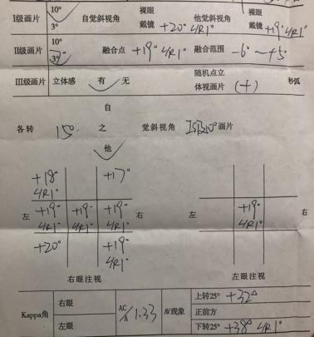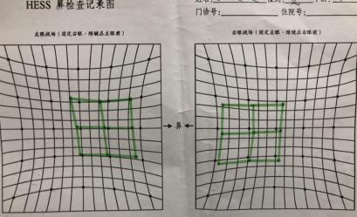
Figure 1:The synoptophore and Hess screen testing result of the same patient.
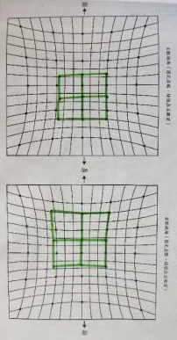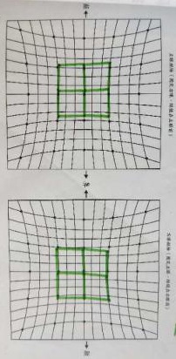
Figure 2:The Hess screen testing results before and after surgery of the same patient .
Recent Publications (minimum 5)

Limin Bu,Jiwen Yang(2016)Superior oblique weakening in treatment of A-pattern strabismus.Chinese Journal of Practical Ophthalmology 34:998-1000.

Lijing Liu,Jiwen Yang(2016)Study of changes and the correlations of the corneal sensitivity after wearing orthokeratology lens.Chinese Journal of Practical Ophthalmology 34:460-465.

Jiwen Yang,Limin Bu, Shu Xie(2014)Effect of rigid gas-permeable contact lenses on keratoconus.Chinese Journal of Optometry Ophthalmology and Visual Science 16:100-102.

Jiwen Yang,Limin Bu, Jia Liu(2013)Clinical observation of esotropia caused by Botulinum toxin A injection for forehead wrinkles.Chinese Journal of Practical Ophthalmology 31:618-619.

Jiwen Yang,Limin Bu,Huifang Ji(2012) Clinical observation of rigid gas permeable contact lenses for children with high myopia.Recent Advances in Ophthalmology 32:175-176,180.



Biography (150 word limit)
Prof. Yang got a master's degree of Strabismus and Pediatric ophthalmology in 2005, then obtained Ph.D of Optometry from China Medical University in 2008 . She engages in clinical work and scientific research,especially in diagnosis and treatment of strabismus, amblyopia and refractive error. She has completed tens of thousands strabismus correction surgery , including horizonal , vertical and rotating strabismus correction , and has fitted with Ortho-K lense and RGP for tens of thousands patients with myopia or astigmatism.
She is the master tutor of Central South University,had completed mang provincial projects,received two items of Shenyang new technology awards, two projects sponsored by Health Development Planning Commission of Hunan province，participated in formulating professional criteria of diagnosis and treatment criteria of strabismus of national third-level hospital,making many times of presentation in domestic and foreign academic conferences，doing academic communication to the United States,Japan and so on.
Email: yangjiwen@aierchina.com
Notes/Comments:

