Utilising Optos fundus photography in paediatric patients
Verlyn Yang¹ (BMed), Jason Daley² (BMedSci), Heather Russell¹ (MBChB(Hons), BSc(Hons), FRCOphth, FRANZCO)
¹ Department of Ophthalmology, Gold Coast University Hospital, Queensland, Australia
² Bond University, Queensland, Australia

Abstract

Purpose: There has been an increasing trend towards utilising ultra-wide field, non-contact fundus photography systems like the Optos P200DTx, especially in paediatric patients. As a challenging opulation, this requires the use of techniques such as modification of the equipment, development of specific holds and positioning of the child. We describe the specific techniques utilised to take fundus photos on the Optos P200DTx for paediatric patient groups, 0-1 years, 1-3 years and & above 3 years old.

Methods: A systematic literature review of techniques used to image paediatric patients on the Optos P200DTx was conducted, case reports studied, and expert opinions consulted. For primary data collection, parents were consented for clinical digital images and video recordings to be taken of their child undergoing Optos imaging in a tertiary hospital Ophthalmology clinic. The subsequent media was analysed and compared with the current literature, to develop specific techniques for each age group, 0-1 years, 1-3 years and & above 3 years old.

Results: Photos displaying the specific techniques were illustrated, accompanied by step-by-step descriptions of the methodology. The ‘Flying Baby’ position, ‘Back-to-face’ position and kneeling/seated position, were employed for each respective age group.

Conclusion: These results support the use of the Optos P200DTx for fundus photography in paediatric patients of all ages, provided, tailored techniques are utilised.
Image
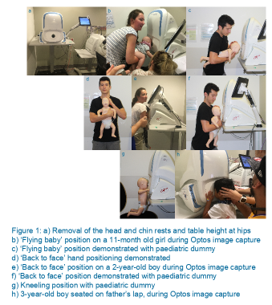
Recent Publications
- Romeo P, Yang V, Campbell-Lloyd A. Two stage foot reconstruction: a novel case of first metatarsal reconstruction in the complicated injury. Poster presented at: 88th Annual Scientific Congress of Royal Australasian College of Surgeons; 2019 May 6-10; Thailand, Bangkok.
- Romeo P, Yang V, Campbell-Lloyd A. Atypical infection in primary cosmetic procedures: a concerning case. Poster presented at: 88th Annual Scientific Congress of Royal Australasian College of Surgeons; 2019 May 6-10; Thailand, Bangkok.
- Daniel R, Yang V. Professor Graham Clark – the bionic ear. Poster presented at: 88th Annual Scientific Congress of Royal Australasian College of Surgeons; 2019 May 6-10; Thailand, Bangkok.
- Romeo P, Yang V, Sawhney R. The importance of psychosocial wellbeing in severe injuries: a historical perspective. Poster presented at: 88th Annual Scientific Congress of Royal Australasian College of Surgeons; 2019 May 6-10; Thailand, Bangkok.
- Romeo P, Yang V, Campbell-Lloyd A. Facial artery island flap for lower lip defects: a novel technique not previously described. Poster presented at: 88th Annual Scientific Congress of Royal Australasian College of Surgeons; 2019 May 6-10; Thailand, Bangkok.

Biography
Verlyn is a junior doctor in Ophthalmology practicing in a tertiary hospital in Queensland, Australia. Multiple tertiary sub-specialty services are provided in the centre. Verlyn is actively pursuing a career in Outreach Ophthalmology.
Email: verlyn.yang@health.qld.gov.au

