Lens regeneration using endogenous stem cells for treatment of congenital cataract
Yizhi Liu, China

Abstract (300 word limit)

The repair and regeneration of tissues using endogenous stem cells represents an ultimate goal in regenerative medicine. However, tissue or organ regeneration using endogenous stem cells in human has not been demonstrated. Currently, the only treatment for cataracts, the leading cause of blindness worldwide, is to extract the cataractous lens and implant an artificial intraocular lens. This procedure poses significant risks of complications for young patients. Here we isolate lens epithelial stem/progenitor cells (LECs) in mammals and show that Pax6 and Bmi-1 are required for LEC renewal. We designed a surgical method of cataract removal that preserves endogenous LECs and achieved functional lens regeneration in rabbits and macaques, as well as in human infants with cataract. Compared with the traditional procedure, we move the anterior capsulorhexis from the center to the periphery, reducing the diameter to 1-1.5mm, preserving the capsule, sub-capsular cells, and the physiological barrier between the anterior and the posterior segment. For infants and young children, this procedure reduces post-operative inflammation and the incidence of postoperative complications such as iris adhesion and secondary ocular hypertension while protecting the local milieu required for lens regeneration. Our approach conceptually differs from current practice, as it maximally preserves endogenous LECs and their natural environment, and regenerates lenses with visual function. Our findings demonstrate a novel treatment strategy for cataract and provide a new paradigm for tissue regeneration using endogenous stem cells.

Image
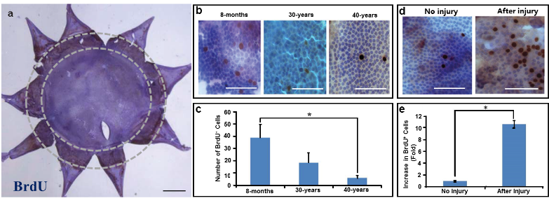

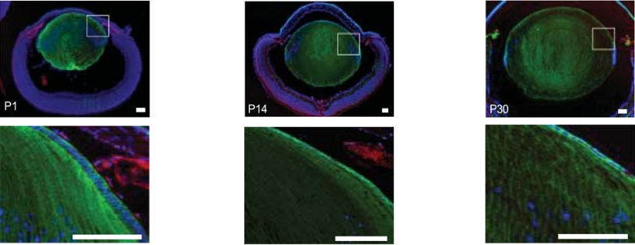
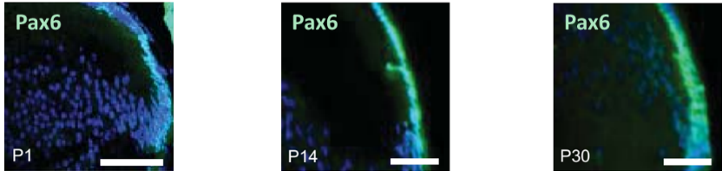
Fig 1. Whole-mount staining of lens capsule demonstrated that, BrdU+ LECs, located at the lens equator, decreased with age and increase after injury, indicating self-renewal capacity of human equatorial LECs.

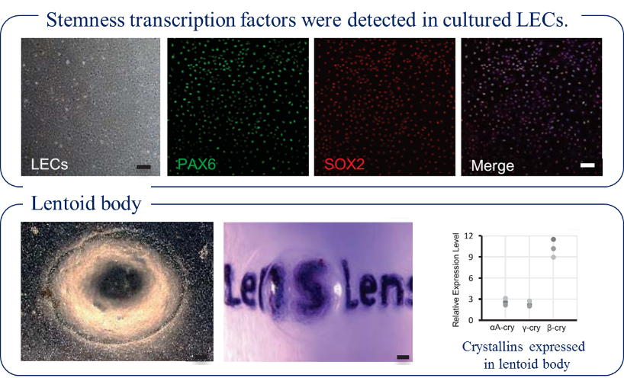
Fig 2. Lineage-tracing in mice showed that Pax6+ LECs directionally differentiated into lens fibre cells.

Fig 3. Pax6+ LECs can generate transparent lentoid body in vitro.

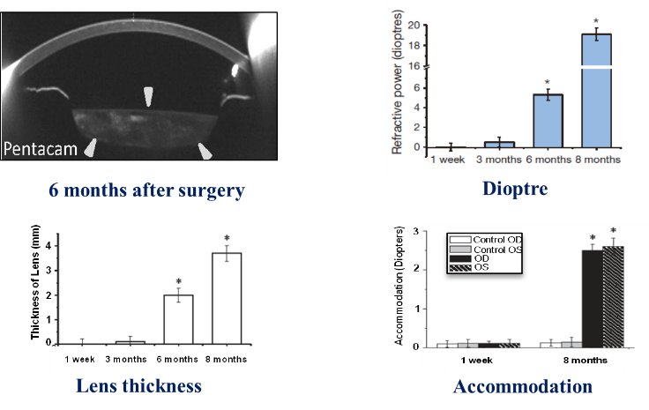
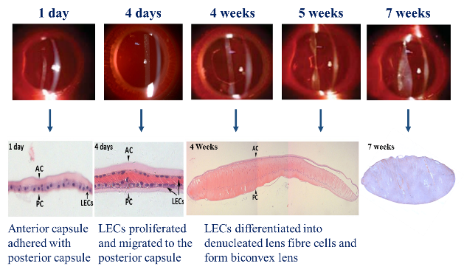
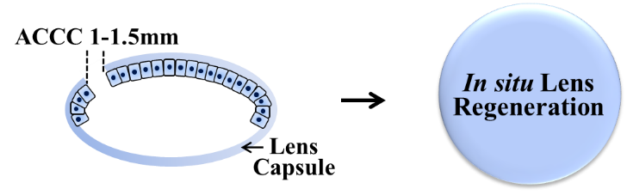
Fig 4. A novel minimally invasive surgery to maintain suitable microenvironment for regeneration.
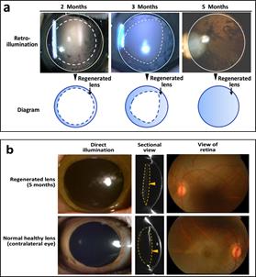
Fig 5. Lens regeneration occurs in rabbits.

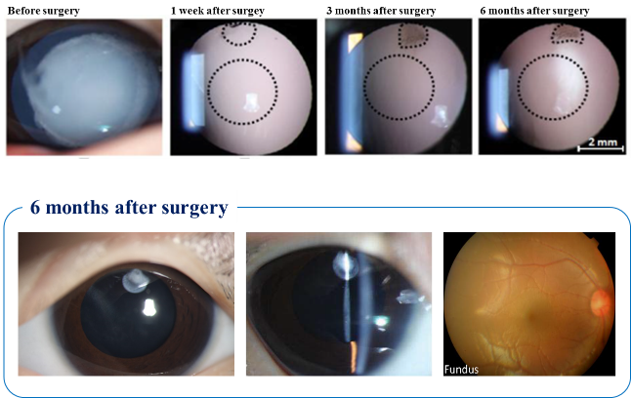
Fig 6. Similar results of lens regeneration were demonstrated in macaques.

Fig 7. Clear visual axis and fundus of young patients were demonstrated after minimally invasive surgery.

Fig 8. Functional lens was regenerated in situ after minimally invasive surgery.
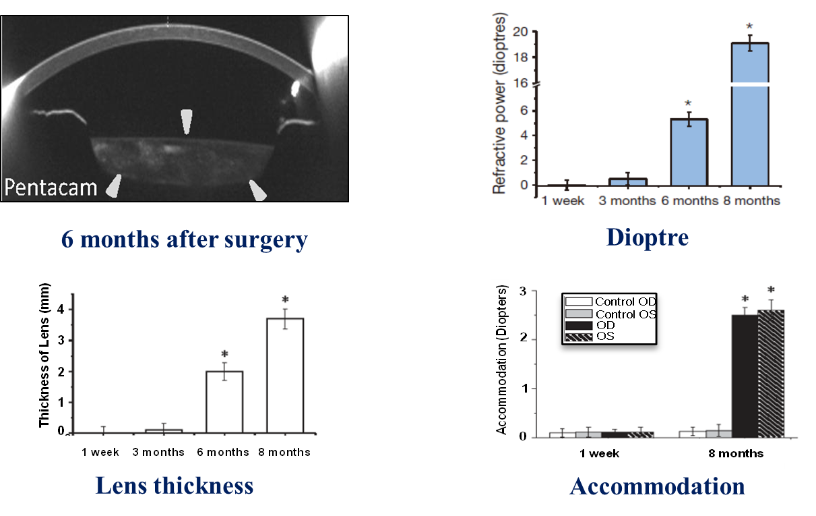

Recent Publications (minimum 5)
- Chen X, Xiao W, Chen W, Liu X, Wu M, Bo Q, Luo Y, Ye S, Cao Y, Liu Y*. MicroRNA-26a and -26b inhibit lens fibrosis and cataract by negatively regulating Jagged-1/Notch signaling pathway. Cell Death Differ. 2017 Nov;24(11):1990.
- Lin H, Ouyang H, Zhu J, Huang S, Liu Z, Chen S, Cao G, Li G, Signer RA, Xu Y, Chung C, Zhang Y, Lin D, Patel S, Wu F, Cai H, Hou J, Wen C, Jafari M, Liu X, Luo L, Zhu J, Qiu A, Hou R, Chen B, Chen J, Granet D, Heichel C, Shang F, Li X, Krawczyk M, Skowronska-Krawczyk D, Wang Y, Shi W, Chen D, Zhong Z, Zhong S, Zhang L, Chen S, Morrison SJ, Maas RL, Zhang K, Liu Y*. Corrigendum: Lens regeneration using endogenous stem cells with gain of visual function. Nature. 2017 Jan 26;541(7638):558.
- Xie SQ, Nie P, Wang Y, Wang H, Li H, Yang Z, Liu Y*, Ren J, Xie Z. RPFdb: a database for genome wide information of translated mRNA generated from ribosome profiling. Nucleic Acids Res. 2015 Oct 3.
- Skowronska-Krawczyk D, Zhao L, Zhu J, Weinreb RN, Cao G, Luo J, Flagg K, Patel S, Wen C, Krupa M, Luo H, Ouyang H, Lin D, Wang W, Li G, Xu Y, Li O, Chung C, Yeh E, Jafari M, Ai M, Zhong Z, Shi W, Zheng L, Krawczyk M, Chen D, Shi C, Zin C, Zhu J, Mellon PL, Gao W, Abagyan R, Zhang L, Sun X, Zhong S, Zhuo Y, Rosenfeld MG, Liu Y*, Zhang K. P16INK4a Upregulation Mediated by SIX6 Defines Retinal Ganglion Cell Pathogenesis in Glaucoma. Mol Cell. 2015 Sep 17;59(6):931-40.
- Zhao L, Chen XJ, Zhu J, Xi YB, Yang X, Hu LD, Ouyang H, Patel SH, Jin X, Lin D, Wu F, Flagg K, Cai H, Li G, Cao G, Lin Y, Chen D, Wen C, Chung C, Wang Y, Qiu A, Yeh E, Wang W, Hu X, Grob S, Abagyan R, Su Z, Tjondro HC, Zhao XJ, Luo H, Hou R, Perry JJ, Gao W, Kozak I, Granet D, Li Y, Sun X, Wang J, Zhang L, Liu Y*, Yan YB, Zhang K. Lanosterol reverses protein aggregation in cataracts. Nature. 2015 Jul 30;523(7562):607-11.

 Biography (150 word limit)
Yizhi Liu’s research focuses on ocular stem cells’ self-renewal, differentiation and senescence, and the role of extracellular matrix and engineered biomaterials that surround both normal and degenerated cells in cornea, lens and retina. Dr. Liu has published or co-authored more than 80 peer reviewed manuscripts in top journals including Nature, New England Journal of Medicine, Science, BMJ and PNAS. He is recognized as one of the pioneer ophthalmologists in China who perform phacoemulsification and intraocular lens implantation. He has carried out approximately 200, 000 surgical operations for cataract patients.
He is serving as the Co-Editor-in-Chief of Molecular Vision, Associate Editor-in-Chief of Current Molecular Medicine. He has received grants from the National Basic Research Program of China, the Chinese Ministry of Health Key Clinical Program, the Chinese National Natural Science Foundation and the Natural Science Foundation’s Key Program in Guangdong.
Email: yzliu62@yahoo.com
Phone: +86-20-87330378

For direct abstract submission: http://pediatricophthalmology.conferenceseries.com/abstract-submission.php

